

**Relatório Final da Prova de Aptidão Profissional**

**Anime Watcher**

Nome do Autor: Raul Rohjans

Número: 180073

Turma: TGPSI18-02

Curso: Técnico de Gestão e Programação de Sistemas Informáticos (TGPSI)

Cascais, dia 16 de junho de 2021, quarta-feira

**Índice**

**Lista de FigurasVII**

**Lista de ProgramasX**

**Introdução1**

Objetivos da Plataforma2

**Estágio3**

**Fundamentação Técnico-científica5**

Anime7

PyCharm7

Python7

Framework Django8

API8

Framwork Django-REST9

Apache9

Rclone9

Java10

Android Studio10

MariaDB11

XML (Extensible Markup Language)11

HTML (Hypertext Markup Language)12

CSS (Cascading Style Sheets)14

JS (JavaScript)17

Base de Dados20

SQL (Structured Query Language)22

**Descrição do Produto23**

Aplicação Web23

1. Conteúdo Principal24

1.1 Home24

1.2 Anime List25

1.3 Anime Page26

1.4 Episode Page27

1.5 Categories29

1.6 Category30

1.7 My List30

1.8 Submit Anime31

1.9 About Us32

1.10 Disclaimer33

1.11 Privacy Policy34

1. Autenticação35

2.1 Login & Logout35

2.2 Register37

2.3 Forgot Password39

2.4 Change Password41

2.5 Account Settings42

1. Administração43

3.1 Dashboard Admin44

3.2 Create New User44

3.3 View All Users45

3.4 Edit User46

3.5 Add New Anime47

3.6 View All Animes48

3.7 Edit Anime48

3.8 Add New Category49

3.9 View All Categories49

3.10 Delete Category50

3.11 Add New Episode50

3.12 View All Episodes51

3.13 Edit Episode51

3.14 Add New Subtitle52

3.15 View All Subtitles52

3.16 Edit Subtitle53

3.17 Add New Item to MyList53

3.18 View All MyList Items54

3.19 Edit MyList Item54

3.20 Anime Submissions55

3.21 Reported Comments55

1. API56

4.1 Authenticate User56

4.2 Check Token57

4.3 Logout User58

4.4 Submit Anime58

4.5 Get All Animes59

4.6 Get Searched Anime60

4.7 Get MyList Anime61

4.8 Add to MyList61

4.9 Remove from MyList62

4.10 Check Anime in MyList63

4.11 Get Categories Names63

4.12 Get Category Animes64

4.13 Get Episodes66

4.14 Get Latest Episodes67

4.15 Get Most Viewed Episodes68

4.16 Get Random Episodes69

4.17 Get Episode70

4.18 Get Next Episode70

4.19 Get Anime Thumbnail71

4.20 Add View to Episode72

4.21 Get Episode Subtitles72

4.22 Get Subtitle73

Aplicação Mobile74

1.1 Home74

1.2 Categories76

1.3 Category77

1.4 Anime List78

1.5 My List79

1.6 Submit Anime80

1.7 Login81

1.8 Search82

1.9 Account Management83

1.10 Anime Page84

1.11 Episode Player85

1.12 Subtitle Chooser86

**Condicionalismos87**

**Conclusão88**

**Bibliografia e Webgrafia89**

**Anexo A - Diagrama da Base de Dados90**

**Anexo B - Tabelas da Base de Dados** **91**

**Anexo C - settings.py96**

**Anexo D - urls.py99**

**Anexo E - Content\views.py102**

**Anexo F - Content\models.py107**

**Anexo G - templatetags\sectodur.py109**

**Anexo H - Authentication\views.py112**

**Anexo I - Authentication\forms.py118**

**Anexo J - Admin\views.py119**

**Anexo K - Api\views.py132**

**Anexo L - Api\serializers.py143**

**Anexo M - admin\base.html145**

**Anexo N - admin\add-anime.html152**

**Anexo O - admin\add-category.html154**

**Anexo P - admin\add-episode.html156**

**Anexo Q - admin\add-mylist.html159**

**Anexo R - admin\add-subtitle.html161**

**Anexo S - admin\anime.html163**

**Anexo T - admin\category.html166**

**Anexo U - admin\create-user.html168**

**Anexo V - admin\edit-anime.html170**

**Anexo W - admin\edit-category.html172**

**Anexo X - admin\edit-episode.html174**

**Anexo Y - admin\edit-mylist.html176**

**Anexo Z - admin\edit-subtitle.html178**

**Anexo A - admin\edit-user.html180**

**Anexo B - admin\episode.html182**

**Anexo C - admin\index.html185**

**Anexo D - admin\mylist.html188**

**Anexo E - admin\reported-comments.html190**

**Anexo F - admin\submited-animes.html192**

**Anexo G - admin\subtitle194**

**Anexo H - admin\user.html196**

**Anexo I - authentication\account-settings.html199**

**Anexo J - authentication\change-password.html202**

**Anexo K - authentication\email-activate-account.html205**

**Anexo L - authentication\email-forgot-password.html207**

**Anexo M - authentication\forgot-password.html209**

**Anexo N - authentication\login.html212**

**Anexo O - authentication\recover-password.html214**

**Anexo P - authentication\register.html217**

**Anexo Q - content\base.html220**

**Anexo R - content\about-us.html243**

**Anexo S - content\anime.html246**

**Anexo T - content\anime-player.html249**

**Anexo U - content\animes.html257**

**Anexo V - content\categories.html259**

**Anexo W - content\category.html260**

**Anexo X - content\disclaimer.html262**

**Anexo Y - content\index.html264**

**Anexo Z - content\my-list.html270**

**Anexo A - content\privacy-policy.html272**

**Anexo B - content\submit-anime.html275**

**Anexo C - account_settings.java277**

**Anexo D - anime_category.java280**

**Anexo E - anime_class.java283**

**Anexo F - anime_list.java285**

**Anexo G - anime_page.java288**

**Anexo H - anime_search.java296**

**Anexo I - categories.java300**

**Anexo J - CategoriesMainRecycleAdapter.java303**

**Anexo K - CategoriesSubRecycleAdapter.java307**

**Anexo L - episode_class.java309**

**Anexo M - EpisodeRecycleAdapter.java311**

**Anexo N - home.java313**

**Anexo O - home_latest.java316**

**Anexo P - home_most_views.java319**

**Anexo Q - home_random.java322**

**Anexo R - HomePagerAdapter.java325**

**Anexo S - HomeRecycleAdapter.java326**

**Anexo T - login.java328**

**Anexo U - MainActivity.java332**

**Anexo V - my_list.java336**

**Anexo W - RecycleAdapter.java340**

**Anexo X - SearchRecycleAdapter.java342**

**Anexo Y - submit_anime.java344**

**Anexo Z - subtitle_chooser.java348**

**Anexo A – subtitle_class.java351**

**Anexo B – SubtitlesRecycleAdapter.java353**

**Anexo C – video_player.java355**

**Anexo D – activity_account_settings.xml370**

**Anexo E – activity_anime_category.xml375**

**Anexo F – activity_anime_page.xml376**

**Anexo G – activity_anime_search.xml378**

**Anexo H – activity_login.xml379**

**Anexo I – activity_main.xml381**

**Anexo J – activity_subtitle_chooser.xml382**

**Anexo K – activity_video_player.xml383**

**Anexo L – activity_page_recycle_layout.xml386**

**Anexo M – categories_main_recycler_item.xml387**

**Anexo N –** **fragment_anime_list.xml388**

**Anexo O –** **fragment_categories.xml389**

**Anexo P – fragment_home.xml390**

**Anexo Q – fragment_home_latest.xml391**

**Anexo R – fragment_home_most_views.xml392**

**Anexo S – fragment_home_random.xml393**

**Anexo T – fragment_my_list.xml394**

**Anexo U – fragment_submit_anime.xml395**

**Anexo V – grid_layout.xml397**

**Anexo W – home_episode_rcv_item.xml398**

**Anexo X – horizontal_grid_layout.xml399**

**Anexo Y – search_recycle_layout.xml400**

**Anexo Z – search_chooser_recycle_layout.xml402**

**Anexo A – toolbar.xml403**

**Anexo B – toolbar_login.xml404**

**Anexo C – vídeo_controller_layout.xml405**

**Anexo D –** **navigation_bottom.xml406**

**Lista de Figuras**

**Figura 1.1 - Logo Anime Watcher2**

**Figura 2.1 - Logo Centrality3**

**Figura 3.1 - Esquema de Montagem da Plataforma6**

**Figura 4.1 - Relação de um-para-muitos20**

**Figura 4.2 - Relação de um-para-muitos21**

**Figura 5.1 - Cabeçalho Aplicação Web23**

**Figura 5.2 - Rodapé Aplicação Web23**

**Figura 5.3.1 - Lista de Episódios (Home)24**

**Figura 5.3.2 - Lista de Categorias (Home)25**

**Figura 5.3.3 - Lista de Animes (Anime List)25**

**Figura 5.3.4 - Informação do Anime (Anime Page)26**

**Figura 5.3.5 - Lista de Episódios (Anime Page)27**

**Figura 5.3.6 - Informações do Episódio (Episode Page)27**

**Figura 5.3.7 - Reprodução do Episódio (Episode Page)28**

**Figura 5.3.8 - Comentários (Episode Page)29**

**Figura 5.3.9 - Categorias (Categories)29**

**Figura 5.3.10 - Animes numa Categoria (Category)30**

**Figuras 5.3.11 - Animes My List (My List)30**

**Figura 5.3.12 - Formulário de Submissão (Submit Anime)31**

**Figura 5.3.13 - Sobre Nós (About Us)32**

**Figura 5.3.14 - Aviso Sobre o Conteúdo (Disclaimer)33**

**Figura 5.3.15 - Política de Privacidade (Privacy Policy)34**

**Figura 5.4.1 - Inicio de Sessão (Login)35**

**Figura 5.4.2 - Icon Logado (Home)36**

**Figura 5.4.3 - Menu User (Home)36**

**Figura 5.4.4 - Criar Conta (Register)37**

**Figura 5.4.5 - Ativar Conta (Register)38**

**Figura 5.4.6 - Recuperar Palavra-Passe (Forgot Password)39**

**Figura 5.4.7 - Email Recuperar Palavra-Passe (Forgot Password)40**

**Figura 5.4.8 - Nova Palavra-Passe (Forgot Password)40**

**Figura 5.4.9 - Alterar Palavra-Passe (Change Password)41**

**Figura 5.4.10 - Definições (Account Settings)42**

**Figura 5.5.1 - Menu User (Home)43**

**Figura 5.5.2 - Barra de Navegação (Autenticação)43**

**Figura 5.5.3 - Rodapé (Autenticação)43**

**Figura 5.5.4 - Menu de Navegação (Autenticação)43**

**Figura 5.5.5 - Estatísticas (Dashboard Admin)44**

**Figura 5.5.6 - Criar Utilizador (Create User)44**

**Figura 5.5.7 - Ver Utilizadores (View All Users)45**

**Figura 5.5.8 - Edit Utilziador (Edit User)46**

**Figura 5.5.9 - Adicionar Anime (Add New Anime)47**

**Figura 5.5.10 - Lista de Animes (View All Animes)48**

**Figura 5.5.11 - Editar Anime (Edit Anime)48**

**Figura 5.5.12 - Adicionar Categoria (Add Category)49**

**Figura 5.5.13 - Lista de Categorias (View All Categories)49**

**Figura 5.5.14 - Eliminar Categoria (Delete Category)50**

**Figura 5.5.15 - Adicionar Episódio (Add Episode)50**

**Figura 5.5.16 - Lista de Episódios (View All Episodes)51**

**Figura 5.5.17 - Edit Episódio (Edit Episode)51**

**Figura 5.5.18 - Adicionar Legenda (Add New Subtitle)52**

**Figura 5.5.19 - Lista de Legendas (View All Subtitles)52**

**Figura 5.5.20 - Editar Legenda (Edit Subtitle)53**

**Figura 5.5.21 - Adicionar item à MyList (Add New Item to MyList)53**

**Figura 5.5.22 - Lista de Itens MyList (View All MyList Items)54**

**Figura 5.5.23 - Edit Item MyList (Edit MyList Item)54**

**Figura 5.5.24 - Lista de Submissões de Animes (Anime Submissions)55**

**Figura 5.5.25 - Comentários Reportados (Reported Comments)55**

**Figura 5.6.1 - Recentes Dark (Home)74**

**Figura 5.6.2 - Mais Visualizações Dark (Home)74**

**Figura 5.6.3 - Aleatório Dark (Home)74**

**Figura 5.6.4 - Recentes Light (Home)75**

**Figura 5.6.5 - Mais Visualizações Light (Home)75**

**Figura 5.6.6 - Aleatório Light (Home)75**

**Figura 5.6.7 - Categorias Dark (Categories)76**

**Figura 5.6.8 - Categorias Light (Categories)76**

**Figura 5.6.9 - Categoria Dark (Category)77**

**Figura 5.6.10 - Categoria Light (Category)77**

**Figura 5.6.11 - Todos os Animes Dark (Anime List)78**

**Figura 5.6.12 - Todos os Animes Light (Anime List)78**

**Figura 5.6.13 - My List Dark (MyList)79**

**Figura 5.6.14 - My List Light (MyList)79**

**Figura 5.6.15 - Submeter Anime Dark (Submit Anime)80**

**Figura 5.6.16 - Submeter Anime Light (Submit Anime)80**

**Figura 5.6.17 - Login Dark (Login)81**

**Figura 5.6.18 - Login Light (Login)81**

**Figura 5.6.19 - Pesquisa Dark (Search)82**

**Figura 5.6.20 - Pesquisa Light (Search)82**

**Figura 5.6.21 - Pesquisa Dark (Search)83**

**Figura 5.6.22 - Pesquisa Dark (Search)83**

**Figura 5.6.23 - Anime Dark (Anime Page)84**

**Figura 5.6.24 - Anime Light (Anime Page)84**

**Figura 5.6.25 - Episódio Dark (Episode Player)85**

**Figura 5.6.26 - Episódio Light (Episode Player)85**

**Figura 5.6.27 - Legendas Dark (Subtitle Chooser)86**

**Figura 5.6.28 - Legendas Light (Subtitle Chooser)86**

**Lista de Programas**

Programas utilizados para a construção e desenvolvimento do projeto:

* Pycharm Versão 2021.1
* Python Versão 3.8
* Postman Versão 8.6.0
* MariaDB Server Versão 10.5.10
* Oracle VM VirtualBox
* Putty Versão 0.74
* Notepad++ Versão 7.9.2
* Android Studio Versão 2020.3.1
* Adobe Photoshop 2020
* Adobe Illustrator CC 2020

**Introdução**

Este projeto foi realizado no âmbito da Prova de Aptidão Profissional, do curso de Técnico de Gestão e Programação de Sistemas Informáticos, tendo como tema o desenvolvimento de uma plataforma de reprodução de desenhos animados japoneses (*animes*), que está dividida em duas partes principais: a aplicação web e a aplicação mobile.

A aplicação *web*, sendo esta a parte mais importante, foi desenvolvida utilizando a *framework* *Django*, que é baseada em *Python*, para tratar da parte da programação, e foi escolhida pela sua simplicidade e comunidade ativa. Já o desenho da página foi feito em HTML (*HyperText Markup Language*), em conjunto com CSS (*Cascading Style Sheets*) para definir as formas dos elementos, assim como as cores e outros aspetos físicos e JS (*JavaScript*), para implementar algumas verificações simples e animações aos elementos.

A aplicação *mobile*, sendo esta um anexo à aplicação web, foi desenvolvida em Java, utilizando a plataforma *Android Studio*, que dispõe *frameworks* e APIs (*Application Programming Interface*), que são específicas do sistema *Android*. O desenho foi realizado utilizando esta mesma plataforma, mas em XML (*Extensible Markup Language*).

O projeto inclui também uma base de dados estruturada em *MariaDB*, que é uma versão *open-source* de *MySQL*, e é utilizada para armazenar e estruturar os dados, permitindo assim a sua consulta e inclui ainda uma API (*Application Programming Interface*), que permite a comunicação entre a aplicação *mobile* e o site e base de dados.

Esta plataforma tem como principal objetivo a reprodução de *animes*, no entanto, ela permite ainda a criação de contas, que por sua vez permitem aos utilizadores adicionar *animes* a uma lista associada à conta, que na plataforma é chamada de “My List” e a postagem de comentários num episódio em específico.

A ideia para este projeto surgiu após algumas pesquisas revelarem que quase todas as plataformas deste género sofrem dos mesmos problemas, tais como a má qualidade de vídeo/imagem, carregamento lento dos vídeos, falta de suporte de legendas de várias línguas ou até mesmo constantes problemas com o serviço.

Com o tema definido, foram passados alguns dias a planear que ferramentas iriam ser utilizadas para concretizar a construção deste projeto. Depois disso, foi escolhido um *template* para a aplicação web e a partir daí foi apenas uma questão de tempo até planear a sua estrutura e pensar no seu nome atual, “Anime Watcher”.

**Objetivos da Plataforma**

Os principais objetivos desta plataforma são os seguintes:

* Permitir a reprodução de desenhos animados Japoneses (*animes*);
* Permitir que os utilizadores possam organizar os seus *animes* numa lista privada;
* Permitir a partilha de pensamentos acerca de um episódio através de comentários;
* Obter uma lista ordenada com os episódios mais recentes, mais vistos ou de forma aleatória;
* Escolher a língua das legendas ou desativá-las ao reproduzir um episódio.
* Submeter um pedido caso haja um *anime* ou episódio esteja em falta que o utilizador gostasse que a plataforma tivesse.

Existem ainda outras funcionalidades que estão apenas disponíveis na aplicação *web* e que apenas administradores têm acesso. Tais funcionalidades são:

* Efetuar a gestão dos utilizadores da plataforma (criar, editar ou eliminar);
* Gerir os todos os *animes*, episódios e legendas (criar, editar ou eliminar);
* Efetuar a moderação dos comentários, tendo acesso aos comentários reportados e tomar a decisão de eliminar ou não os mesmos;
* Gerir os pedidos de *animes*/episódios que são submetidos pelos utilizadores.



**Figura 1.1 – Logo Anime Watcher**

**Estágio**



**Figura 2.1 – Logo Centrality**

A empresa onde foi realizado o estágio foi a Centrality, na parte de desenvolvimento de *software*, que teve uma duração de 3 meses, com o âmbito de construir aplicações, sejam elas *desktop*, *web* ou *mobile* de acordo com os critérios fornecidos pelo cliente.

Ao iniciar o estágio foram propostos dois possíveis projetos à escolha para serem desenvolvidos, uma implementação de um módulo de método de pagamento da *Beam Wallet* na plataforma de comércio *Prestashop* ou a implementação da *Beam Wallet* no programa de vendas *XD*. O primeiro projeto foi o escolhido e a partir daí iniciou-se o seu desenvolvimento.

Após a conclusão deste, iniciou-se um segundo que se trata de uma aplicação de consultas e gestão de uma oficina, onde os utilizadores podem ver que carros ainda têm o arranjo pendente, assim como o histórico de carros arranjados e mais alguns detalhes dos mesmos. Após os requisitos base para este projeto terem sido concluídos, não se iniciaram novos projetos.

Em termos de expetativas em relação ao estágio, as mesmas não foram correspondidas. O principal problema foi a comunicação, uma vez que o resto da empresa se encontrava separada dos estagiários, a única pessoa com quem era possível colocar dúvidas era o orientador de estágio, que na maior parte das vezes se encontrava demasiado ocupado para responder. Devido a este grave problema, a produção e desenvolvimento dos projetos foi lenta e ineficiente, já que muito tempo foi perdido à volta dos mesmos problemas ou a aprender as novas ferramentas de forma completamente autónoma.

Apesar dos problemas com a empresa e a falta de apoio para com os estagiários, a experiência até foi positiva, pois obrigou o desenvolvimento da capacidade de trabalho autónomo, mostrou o quão importante é ter autodisciplina para não desistir, independentemente da dimensão do problema e mais importante de tudo, preparou para um futuro profissional onde problemas semelhantes acontecem constantemente, fazendo com que lidar com os mesmos seja mais fácil.

**Fundamentação Técnico-científica**

Desde o início do desenvolvimento da plataforma que ficou definido que a sua parte principal iria ser uma aplicação *web*, pois é mais fácil de manter e atualizar, não precisa de ser instalada e tem uma grande compatibilidade entre vários dispositivos diferentes. Mais tarde, surgiu a ideia de se construir também uma aplicação *mobile* para complementar o site, melhorando assim a experiência para os utilizadores de dispositivos móveis.

Como foi referido anteriormente, a aplicação *web* foi construída utilizando a *framework* *Django*, que possibilita a sua publicação num servidor com qualquer tipo de sistema operativo, desde que seja possível a instalação de *Python*. Na mesma aplicação *web*, existe ainda uma API (*Application Programming Interface*) construída utilizando a *framework* Django-REST, que permite a comunicação entre a aplicação *mobile* e *base de dados*.

A aplicação *mobile* foi construída em Java, utilizando o *Android Studio*, que é um IDE (*Integrated Development Environment*) que trabalha com bibliotecas específicas de *Android*, facilitanto assim a construção da mesma.

Para armazenar e organizar os dados da plataforma foi necessário recorrer a uma base de dados em *MariaDB*. A *MariaDB* é uma versão *open-source* de *MySQL* que foi escolhida pela sua simplicidade de implementação com a *framework Django* e por ser mais fácil de hospedar num servidor *Linux* em comparação com *SQL Server*, por exemplo. Uma vez que esta é utilizada com o *Django*, é essa *framework* que faz toda a gestão da base de dados, incluído a criação de tabelas e adição de registos, baseados nos modelos definidos no mesmo

Com o resto montado, fica a sobrar um local onde armazenar os ficheiros de vídeo e imagens que são utilizadas pelo *site* e pela aplicação *mobile*. Para tal, foi necessário recorrer a um servidor *Apache*, tornando assim possível o acesso a estes ficheiros. Uma vez estando disponíveis, o endereço dos mesmos é guardado na base de dados (exemplo de endereço de um ficheiro de vídeo: <http://79.186.239.58/video/exemplo.mp4>).

No entanto, isto seria uma opção difícil de se implementar com um orçamento baixo uma vez que os ficheiros ocupam bastante espaço. Para contornar a situação, existem duas hipóteses, com a primeira sendo sacrificar a qualidade dos mesmos, mas um dos objetivos da plataforma é garantir a maior qualidade possível, foi aí que surgiu a segunda hipótese, recorrer a *Cloud Storage*, neste caso à *Google Drive*. Para ser possível transmissão dos vídeos para a plataforma, é necessário um endereço que aponte diretamente para o ficheiro, logo não é possível utilizar os endereços de partilha fornecidos pela maior parte das plataformas. Foi então utilizado uma aplicação, *Rclone*, que comunica, neste caso, diretamente com a API (*Application Programming Interface*) da *Google Drive* e a monta como um disco físico.

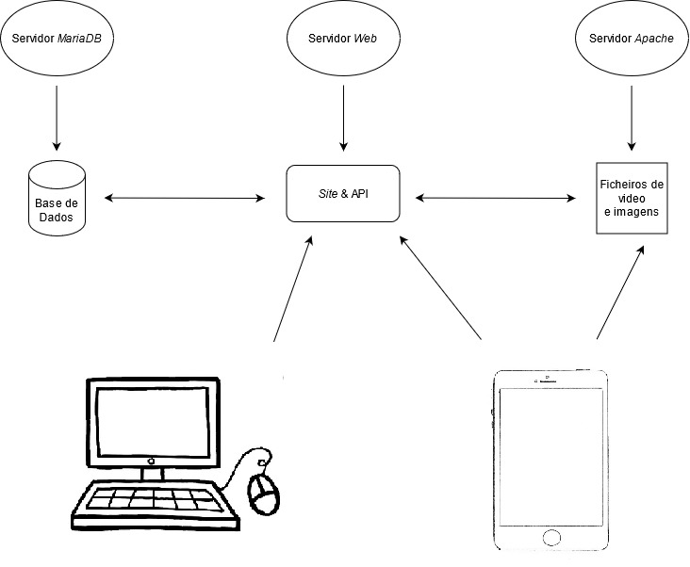

**Figura 3.1 – Esquema de Montagem da Plataforma**

**Anime**

*Anime* é um desenho animado desenhado à mão e animado no computador, com origem no Japão. A palavra *anime* vem da palavra “*animation”*, utilizado na língua Inglesa e em Japonês refere-se a todo o tipo de trabalhos animados, independentemente do seu estilo ou origem. No entanto, fora do Japão, *anime* refere-se especialmente à animação produzida no Japão.

Os *animes* começaram a ganhar muita popularidade fora do Japão no início dos anos 2000 devido a vários fatores. Ao contrário dos desenhos animados europeus e americanos, a forma como a história é contada é completamente diferente, assim como o mundo em que estão inseridos e a imaginação que vai para os personagens. Para além desses fatores, existe ainda uma variedade enorme de géneros e categorias por onde escolher, o que consegue apelar um grande leque de pessoas.

**PyCharm**

*PyCharm* é um IDE (*Integrated Development Environment*) desenvolvido pela empresa Checa *JetBrains*, suportado por uma grande variedade de sistemas operativos, com versões para *Windows*, *MacOS* e *Linux*, utilizado na programação em Python. Esta ferramenta inclui várias funções como a analise de código, um *debugger* gráfico e suporte para desenvolvimento de aplicações *web* com *Django* ou de computação com *Anaconda*.

**Python**

*Python* é uma linguagem de programação de uso geral interpretada, isto é, que não precisa de ser compilada e é maioritariamente conhecida pela sua simplicidade na sintaxe e pela sua comunidade grande e ativa. Esta linguagem é orientada a objetos, sendo assim possível estruturar classes e campos, o que ajuda a manter o código claro e organizado, e servindo assim para projetos de grande ou pequena escala. De momento, *python* é uma das linguagens mais populares.

**Framework Django**

*Django* é uma *framework web* grátis e *open-source* baseada em *Python*, que é mantida pela DSF (*Django Software Foundation*), uma organização Americana estabelecida como *non-profit*, ou seja, que não faz lucro.

O principal objetivo do *Django* é facilitar a criação de *websites* complexos com acesso a bases de dados. Esta *framework* foca-se bastante na reutilização e fácil implementação dos componentes, permitindo assim um desenvolvimento mais rápido com menos código, seguindo o princípio de “não se repetir”.

As aplicações *web* produzidas por esta *framework* são compostas por *apps*, que agem como uma espécie de módulos e que podem ser importadas/exportadas para outros projetos diferentes (daí o princípio da reutilização). É possível ainda “instalar” *apps* de terceiros, sendo bastante conveniente na produção das aplicações *web*.

**API**

Uma API (*application programming interface*) é uma espécie de interface de *software* cujo o seu principal objetivo é efetuar a comunicação entre computadores, ou mais especificamente, entre aplicações, assim como uma *user-interface* faz a ligação entre o utilizador e o computador.

Um dos objetivos de uma API (*application programming interface*) é ocultar os detalhes internos de como um sistema funciona, expondo apenas as partes que o programador necessita e permitindo assim que a API (*application programming interface*) seja atualizada sem que o resto do *software* deixe de funcionar.

**Framework Django-REST**

*Django-REST* é uma *framework* que permite criar uma API (*Application Programming Interface*) em conjunto com o *Django* como o próprio nome indica, interagindo-se um com o outro. O Django-REST conta com bastantes vantagens que o tornam fácil de se recomendar, como a sua simplicidade, a excelente interação com o *Django* e os seus componentes, a função de criação de *tokens* já vem incluída e é praticamente automática e fácil de se configurar.

**Apache**

*Apache* é um software para um servidor *web* grátis, *open-source* e *cross-*platform, isto é, suporta várias plataformas, desenvolvido e mantido pela comunidade de desenvolvedores que participaram no projeto e pela *Apache Software Foundation*.

Este software na grande maioria das vezes encontra-se em servidores *Linux*, no entanto existem também versões para *Windows*. Originalmente este foi desenvolvido em 1995 e desempenhou um grande papel no crescimento da WWW (*World Wide Web*), tornou-se popular de tal forma que em 2009 este servia mais de 100 milhões de *sites*.

**Rclone**

*Rclone* é um software *open-source* de linha de comandos utilizado para gerir ou migrar conteúdo de *clouds*. Algumas das suas principais funções são sincronizar, transferir, encriptar, unificar, compactar e montar, no entanto as duas mais populares são a sincronização e a montagem. Este software suporta uma grande variedade de plataformas de *cloud storage*, entre elas o *Google Drive* e o *Amazon S3*.

**Java**

*Java* é uma linguagem de programação compilável orientada a objetos de uso geral semelhante a C e C++, que tem como principal objetivo permitir que os programadores desenvolvam uma aplicação uma vez e seja possível correr a mesma em qualquer sistema operativo sem precisar de ser recompilada. As aplicações em *Java* são tipicamente compiladas para *bytecode* que corre em qualquer JVM (*Java Virtual Machine*) independentemente da arquitetura da máquina.

Esta linguagem de programação foi originalmente desenvolvida por James Gosling na *Sun Microsystems*, que mais tarde foi adquirida pela *Oracle*, e foi lançada em 1995 sobre essa mesma empresa com licenças pagas. Mais tarde em 2007 a *Sun Microsystems* relicenciou este projeto e a maior parte das suas tecnologias sobre a GNU (*General Public License*).

**Android Studio**

*Android Studio* é o IDE (*integrated development environment*) oficial para o sistema operativo *Android* da *Google*, disponível para download gratuito para *Windows*, *MacOS* e *Linux*. Foi desenvolvido pela empresa *JetBrains* e foi desenhado especificamente para o desenvolvimento de aplicações *Android*, sendo este um substituto para o E-ADT (*Eclipse Android Development Tools*), que era o IDE (*integrated development environment*) atual na altura.

**MariaDB**

*MariaDB* é uma versão de *MySQL* *open-source* desenvolvida e mantida pela comunidade, que foi criada por alguns desenvolvedores de *MySQL*, que tinham alguns receios já que esta foi adquirida pela *Oracle* em 2009.

Um dos principais objetivos desta ferramenta era manter um alto nível de compatibilidade com *MySQL*, assegurando a possibilidade de efetuar a troca entre as duas, sem ser necessária a alteração do software que utiliza as mesmas.

**XML (Extensible Markup Language)**

XML (*Extensible Markup Language*) é uma linguagem de marcação semelhante ao HTML (*HyperText Markup Language*) que define um conjunto de regras para efetuar a codificação de documentos num formato que torna possível a sua leitura tanto por um utilizador ou por uma máquina.

Esta linguagem rapidamente se tornou popular por causa da sua simplicidade, generalidade e fácil utilização e pelo seu suporte *Unicode*, permitindo a escrita de vários caracteres de línguas diferentes. Apesar de ter sido intencionada para documentos, o XML (*Extensible Markup Language*) é muito utilizado na representação de estruturas de dados, como nos *web services*, por exemplo.

**HTML (HyperText Markup Language)**

HTML (*HyperText Markup Language*) é a linguagem de marcação padrão para mostrar documentos num navegador *web* e pode ser assistida por outras linguagens como CSS (*Cascading Style Sheets*), que contribuem para o desenho da página *web*, ou linguagens de *scripting* como JS (*JavaScript)*, para adicionar alguma funcionalidade ou animações às mesmas.

Existem várias versões de HTML (*HyperText Markup Language*) que foram surgindo ao longo do tempo e em cada versão foi simplificando cada vez mais a sua estrutura e adicionando novos elementos. A primeira versão foi lançada em 1993 por Tim Berners-Lee e a mais recente, utilizada atualmente (HTML5), lançada em 2014.

Os ficheiros HTML (*HyperText Markup Language*) têm uma estrutura específica que tem que ser respeitada para que a página seja mostrada corretamente. O exemplo a seguir mostra uma página simples em HTML5 onde podem ser observadas algumas *tags* e elementos.

<html>

<head>

<title>Título de Teste</title>

</head>

<body>

<form>

<div>

<input type="text" />

<input type="button" value="OK" />

</div>

</form>

</body>

</html>

O exemplo tem como *tag* raiz <html> que serve para indicar o tipo de documento, esta é obrigatória em todos os ficheiros HTML (*HyperText Markup Language*). Dentro da *tag* raiz, existem ainda outras duas muito importantes, a <head>, em que dentro se pode atribuir um título à página e se faz referência a outras linguagens e a <body> que é onde o conteúdo principal da página se encontra. Neste caso podemos encontrar um <form> que como o próprio nome indica serve para conter um formulário e dentro encontra-se ainda uma <div>, cuja principal utilidade é agrupar elementos, que por sua vez contem uma caixa de texto e um botão na forma de <input>.

**CSS (Cascading Style Sheets)**

CSS (*Cascading Style Sheets*) é uma linguagem de estilo utilizada para descrever a forma de apresentação de um documento de uma linguagem de marcação, como o HTML (*HyperText Markup Language*). Esta linguagem, atualmente, é crucial para o desenvolvimento de uma aplicação *web*, em conjunto com HTML (*HyperText Markup Language*) e JS (*JavaScript*).

O principal objetivo desta linguagem é permitir a separação do conteúdo e da apresentação, isto é, cores, tipos de letra e disposição. Esta separação melhora a acessibilidade do conteúdo, dá mais flexibilidade e controlo na especificação de caraterísticas e permite que várias páginas *web* utilizem a mesma formatação, especificando um ficheiro .css o que reduz a complexidade e repetição de código.

Existem três formas de se implementar a CSS (*Cascading Style Sheets*) no código HTML (*HyperText Markup Language*). As formas são as seguintes:

**1ª Forma**

A primeira forma, que é também a mais simples, é colocando a CSS (*Cascading Style Sheets*) diretamente no elemento, através do atributo style. O exemplo a seguir mostra como mudar a cor do texto para vermelho utilizando este método.

<p style="color: red;">Texto de Demonstração</p>

**2ª Forma**

A segunda forma, apesar de ser mais complexa que a primeira, acaba por facilitar mais quando se trata de atribuir o mesmo estilo a vários elementos. Esta forma, utiliza a *tag* <style>, que fica localizada dentro da *tag* <head> e permite criar classes que depois podem ser atribuídos aos elementos através do atributo class. O exemplo a seguir mostra novamente como mudar a cor do texto para vermelho, mas desta vez, utilizando este método.

<html>

<head>

<style>

.muda-cor {

color: red;

}

</style>

</head>

<body>

<p class="muda-cor">Texto de Demonstração</p>

</body>

</html>

**3ª Forma**

A terceira forma, que é também a mais utilizada, é guardar a CSS (*Cascading Style Sheets*) num ficheiro à parte, cujo conteúdo e sintaxe são iguais ao da *tag* <style> que foi demonstrada no método anterior, e que pode depois ser importado para o HTML (*HyperText Markup Language*). O exemplo a seguir mostra a importação de um ficheiro, que deve ser colocado dentro da *tag* <head>.

<html>

<head>

<link rel="stylesheet" type="texto/css" href="/file/like/estilo.css"/>

</head>

<body>

<p class="muda-cor">Texto de Demonstração</p>

</body>

</html>

**JS (JavaScript)**

JS (*JavaScript*) é uma linguagem de programação que segue de acordo com a especificação *ECMAScript*. Esta linguagem de programação é normalmente utilizada em conjunto com HTML (*HyperText Markup Language*) e CSS (*Cascading Style Sheets*) na construção de páginas *web*, estando esta em mais de 97% dos *sites*.

Existem duas formas muito semelhantes de implementar JS (*JavaScript*) numa página HTML (*HyperText Markup Language*). As formas são as seguintes:

**1ª Forma**

A primeira forma, é também a mais simples e é muito semelhante à segunda forma de se implementar CSS (*Cascading Style Sheets*) numa página *web*. Este método consiste em colocar a função dentro de uma *tag* <script>. O exemplo a seguir mostra uma implementação de uma função que torna possível fechar uma mensagem de aviso que contenha a classe closebtn.

<html>

<head>

</head>

<body>

<div class="alert warning">

<span class="closebtn">&times;</span>

<strong>Warning!</strong>

There is a very high chance the comment section contains spoilers. Proceed at your own risk!

</div>

<script>

var close = document.getElementsByClassName("closebtn");

var i;

for (i = 0; i < close.length; i++) {

close[i].onclick = function(){

var div = this.parentElement;

div.style.opacity = "0";

setTimeout(function(){ div.style.display = "none"; }, 600);

}

}

</script>

</body>

</html>

**2ª Forma**

A segunda forma de se implementar código JS (*JavaScript*) numa página *web* é importando o ficheiro de forma semelhante à importação de um ficheiro CSS (*Cascading Style Sheets*), mas em vez de ser colocado na *tag* <head>, este fica dentro da <body>, como está retratado no exemplo a seguir.

<html>

<head>

</head>

<body>

<script src="/file/js/exemplo.js"></script>

</body>

</html>

**Base de Dados**

Uma base de dados é uma ferramenta, cujo seu principal objetivo é armazenar dados de forma organizada, tornando-os acessíveis a partir de um computador. Todas as bases de dados têm uma estrutura e forma de organizar os dados para, como foi referido acima, os manter organizados. Esta estrutura consiste em várias tabelas de dados interligadas umas às outras através de relações, permitindo assim “cruzar” os dados, facilitando a pesquisa dos mesmos. Existem três tipos de relações de tabelas que podem existir numa base de dados.

**Relação de um-para-muitos**

Este tipo de relação é o mais utilizado nas bases de dados e usa-se, como o próprio nome indica, quando se tem duas tabelas e uma delas pode ter muitos registos da outra. O exemplo a seguir mostra duas tabelas, city e customer, em que se pode aplicar este tipo de relação já que podem existir vários clientes da mesma cidade, no entanto um cliente apenas pode ter uma cidade.

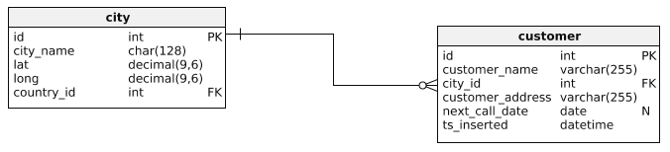

**Figura 4.1 – Relação de um-para-muitos**

**Relação de muitos-para-muitos**

Este tipo de relação é o mais complexo e utiliza-se, como o próprio nome indica, quando ambas as tabelas podem ter vários registos uma da outra. Neste caso é necessário recorrer a uma tabela intermédia que contem os ids de ambas as tabelas como chave primária, como é mostrado no exemplo a seguir.

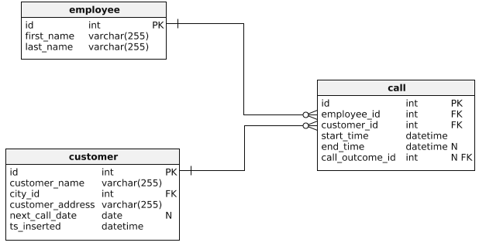

**Figura 4.2 – Relação de um-para-muitos**

**Relação de um-para-um**

Este tipo de relação, comparado com os dois anteriores, quase nunca é utilizado, usa-se quando existe apenas um registo de ambas as tabelas. Para efetuar esta relação, existem duas opções, ou se adiciona tudo numa só tabela, ou, no caso de serem necessárias duas tabelas, elas ligam-se de forma semelhante ao exemplo da relação de um-para-muitos, mas apenas com a chave primária, obrigando assim com que apenas existe apenas um registo de cada.

**SQL (Structured Query Language)**

SQL (*Structured Query Language*) é uma linguagem de pesquisa estruturada utilizada maioritariamente na gestão de estruturas de dados, como por exemplo, na incorporação de relações entre entidades e variáveis.

Esta é a linguagem declarativa padrão para bases de dados relacionais, pois é simples e fácil de se utilizar e com ela é possível especificar a forma de como aparece o resultado, ao contrário das outras, em que é apenas possível executar a instrução.

Em termos de sintaxe, esta linguagem reflete bastante a língua Inglesa, o que facilita a escrita das instruções. O exemplo a seguir mostra uma simples instrução que seleciona o nome de todos os registos de uma tabela em que a quantidade seja igual a 5.

select nome from tabela_exemplo where quantidade=5

É possível ainda executar outros tipos de instruções para além do select, como o update, que é utilizado para atualizar um registo da tabela, o insert, que, como o próprio nome indica, é utilizado para inserir registos na tabela e o delete, que serve para eliminar registos da tabela. Os seus respetivos exemplos são os seguintes:

update tabela_exemplo set quantidade=5

insert into tabela_exemplo (grau_qualidade) values (5)

delete from tabela_exemplo where quantidade=5

**Descrição do Produto**

**Aplicação Web**

Como já foi referido anteriormente, esta plataforma tem como principal objetivo permitir a reprodução de *animes* com boa qualidade de vídeo de uma forma fácil e gratuita. Para além da reprodução dos episódios, existem outras funcionalidades como uma lista privada para cada utilizador, uma secção de comentários para cada episódio e listas de animes organizadas por categorias.

O produto, na parte *web*, tem uma estrutura que se mantém comum ao longo de todas as páginas, para facilitar a sua navegação tornando-a assim mais simples e interativa para os utilizadores, já que as opções se encontram todas nos mesmos locais. Esta estrutura é constituída por três partes, o cabeçalho, o corpo, onde se encontra o conteúdo, que varia consoante a página e um rodapé.

No cabeçalho encontram-se as opções para navegar no site, assim como pesquisar *animes*, através da caixa de pesquisa ou aceder à gestão do perfil clicando no *icon* do utilizador no lado direito.



**Figura 5.1 – Cabeçalho Aplicação *Web***

No rodapé encontram-se mais algumas informações com *links* para outras páginas informativas como a política de privacidade e um *disclaimer*.

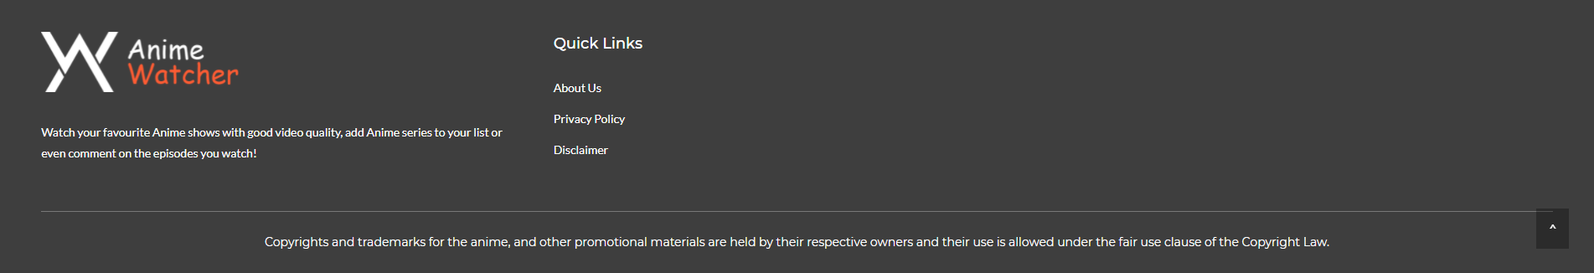

**Figura 5.2 – Rodapé Aplicação *Web***

1. **Conteúdo Principal**
   1. **Home**

Ao entrar no *site*, esta é a primeira página com que os utilizadores se irão deparar. Nesta página inicial podemos imediatamente encontrar vários elementos que dão algumas informações básicas ao utilizador.

O elemento principal da página é uma lista de episódios, que pode ser organizada por mais recentes, mais vistos ou de forma aleatória, dependendo da opção que estiver selecionada. Estes episódios são de vários *animes* diferentes e servem para manter o utilizador atualizado.

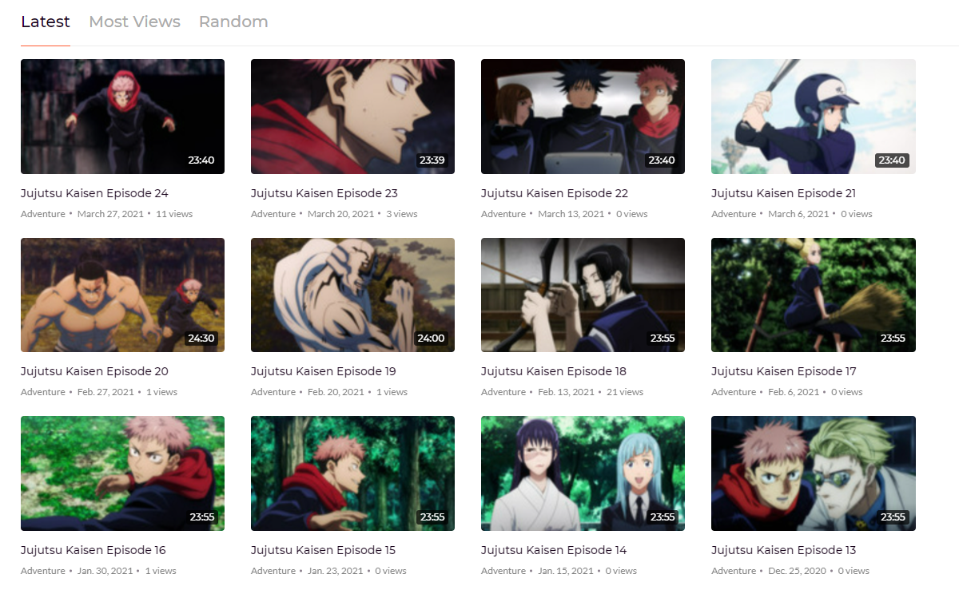

**Figura 5.3.1 – Lista de Episódios (Home)**

Do lado esquerdo dos episódios, encontra-se uma lista com todas as categorias da plataforma, assim como a quantidade de *animes* de cada uma, permitindo ao utilizador navegar para a página da categoria correspondente à que for pressionada.

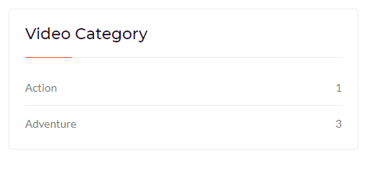

**Figura 5.3.2 – Lista de Categorias (Home)**

* 1. **Anime List**

Nesta página é possível encontrar uma lista completa com todos os *animes* que estão disponíveis na plataforma organizados por ordem alfabética, assim como um contador no canto superior esquerdo que permite ao utilizador saber quantos *animes* existem. Ao ser pressionada uma das opções, o utilizador é levado para a página do *anime* correspondente.

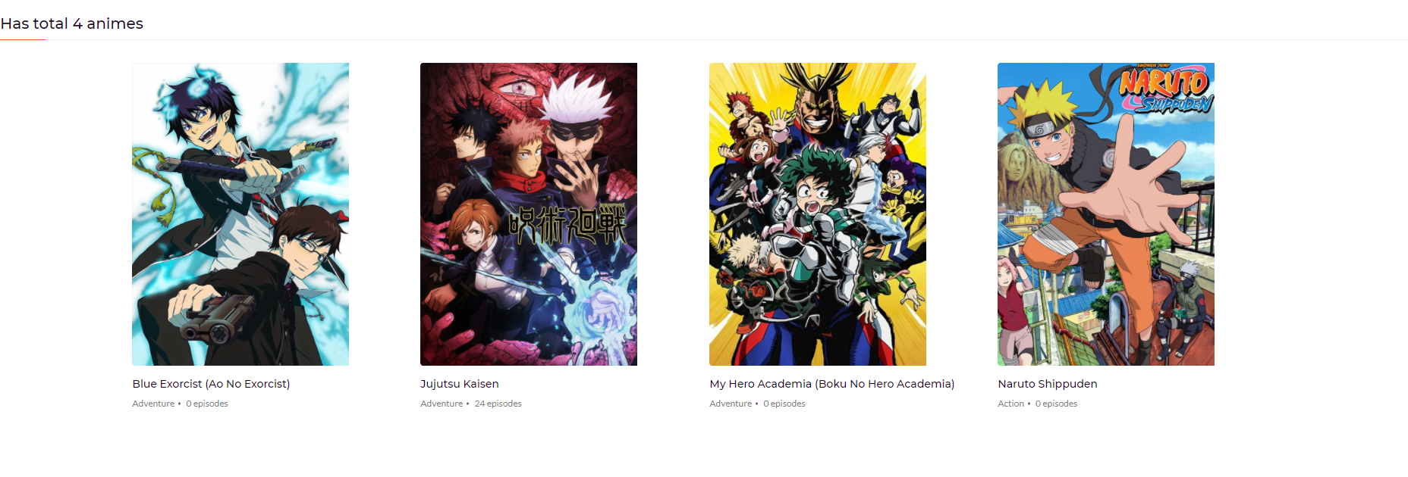

**Figura 5.3.3 – Lista de Animes (Anime List)**

* 1. **Anime Page**

Após um *anime* ter sido selecionado, o utilizador é levado para esta página, que contém um cabeçalho onde é possível obter algumas informações extra sobre o anime, como a data de lançamento, uma descrição, uma lista completa com as categorias e se ainda estão a sair episódios, assim como a sua imagem e um botão para o adicionar à *MyList*.

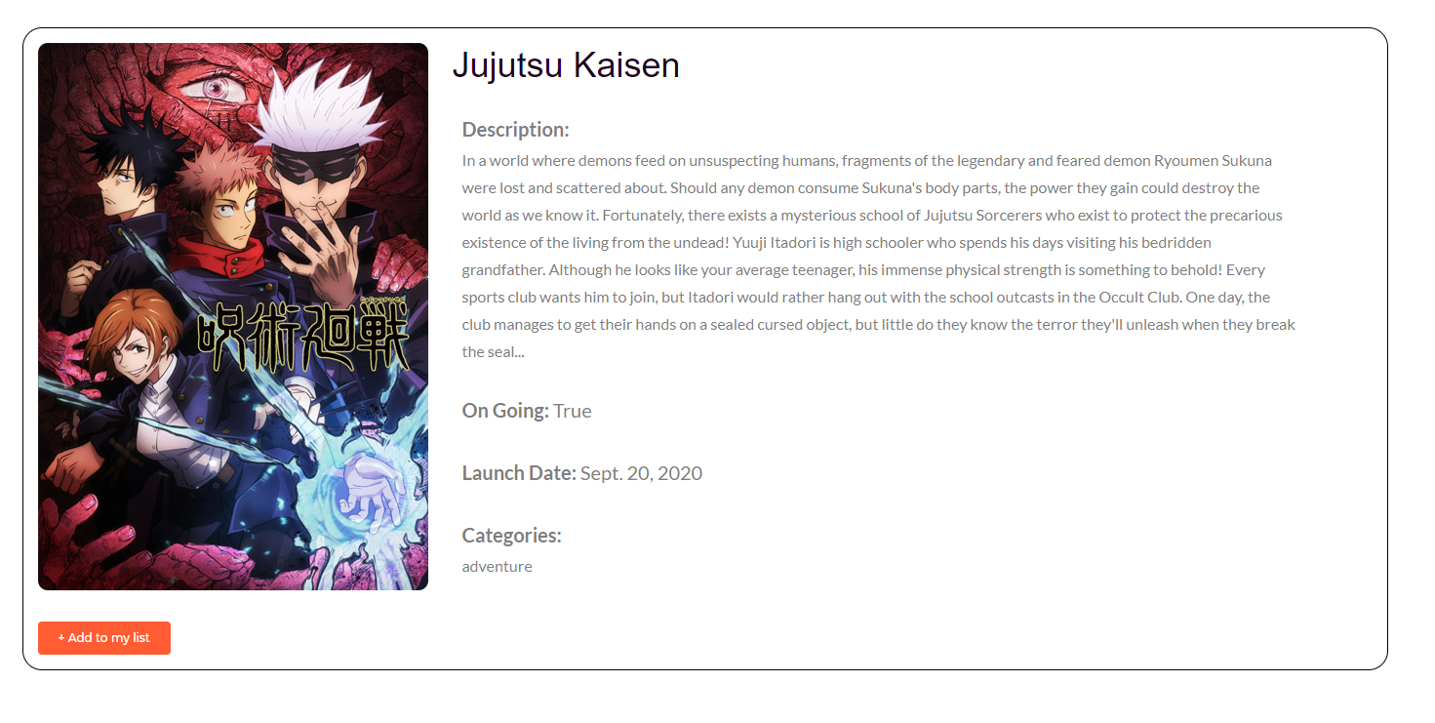

**Figura 5.3.4 – Informações do Anime (Anime Page)**

Em baixo deste bloco com informações, é possível encontrar a lista de episódios para o *anime*, que contém apenas o número do episódio, o nome e a data de lançamento do mesmo.

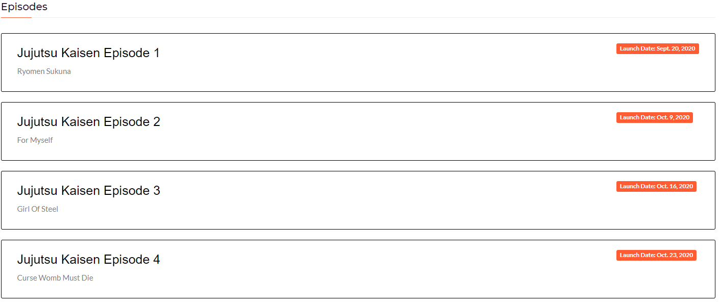

**Figura 5.3.5 – Lista da Episódios (Anime Page)**

* 1. **Episode Page**

Após se pressionar num episódio, quer seja na página inicial ou na página de um *anime*, o utilizador é levado para esta página. No topo encontra-se o nome e imagem do *anime*, assim como o título do episódio, data de lançamento e as categorias a que pertence.

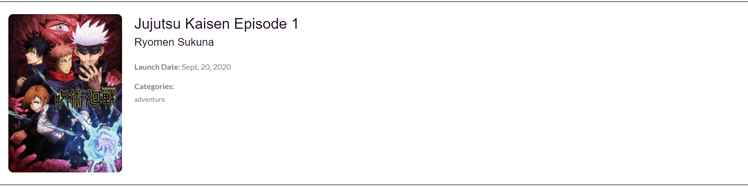

**Figura 5.3.6 – Informações do Episódio (Episode Page)**

Em baixo dessa secção de informações encontra-se a parte principal da página, com o leitor de vídeo, por cima um botão para ver todos os episódios e setas para passar ao seguinte ou anterior, à esquerda do leitor encontra-se um menu com uma lista mais simples com os episódios e em baixo, está um aviso a comunicar a presença de *spoilers* na secção dos comentários.

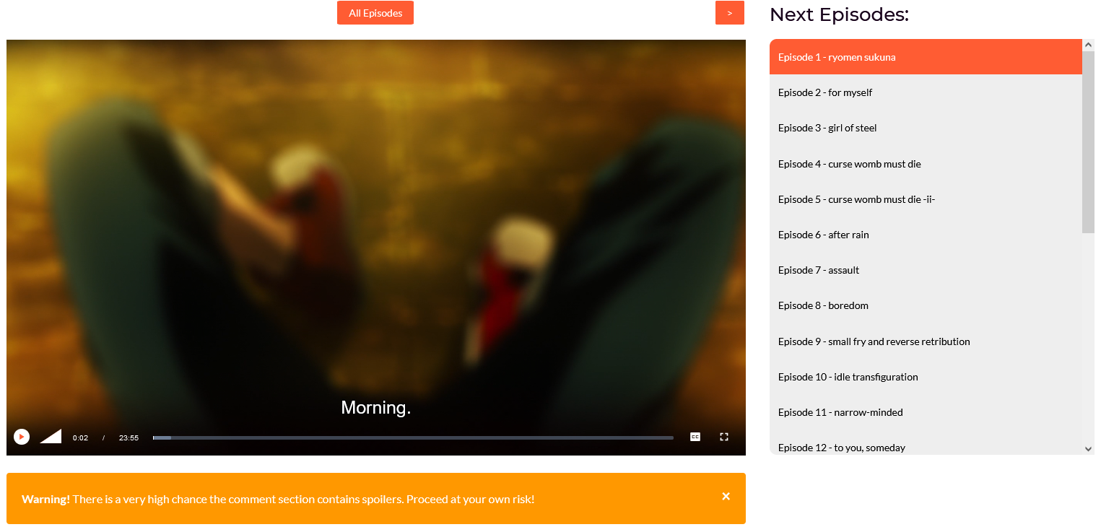

**Figura 5.3.7 – Reprodução do Episódio (Episode Page)**

Por último, no fundo da página, encontra-se uma pequena secção com comentários do episódio, onde os utilizadores podem partilhar algumas ideias e interagir uns com os outros. Para poder comentar, é preciso efetuar o *login* na plataforma. Um utilizador normal tem ainda permissões para apagar os seus comentários ou reportar comentários de outras pessoas. No caso de um administrador, este tem permissões para remover comentários de outros utilizadores e ao comentar aparece com uma *tag* diferente.

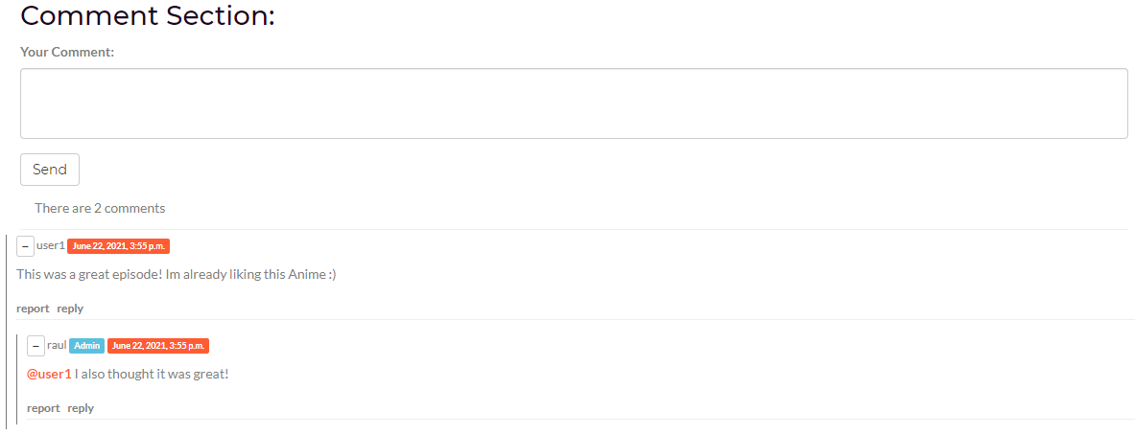

**Figura 5.3.8 – Comentários (Episode Page)**

* 1. **Categories**

Nesta página encontra-se uma lista com todas as categorias de *animes* da plataforma ordenadas por ordem alfabética, que ao serem pressionadas, levam o utilizador para a página dessa categoria. É possível chegar a esta página pressionando na opção *categories* da barra de navegação.

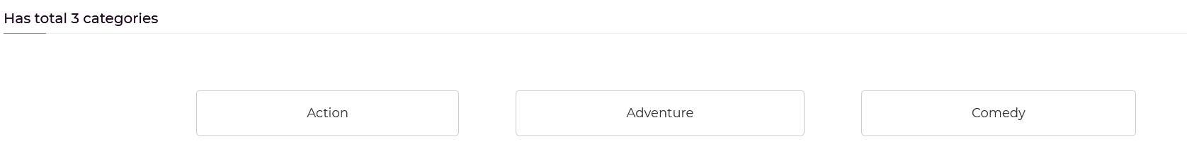

**Figura 5.3.9 – Categorias (Categories)**

* 1. **Category**

Após ter selecionado numa opção da página das categorias, o utilizador é levado para esta página, onde se encontram todos os animes da categoria selecionada. O desenho e disposição dos itens desta página é muito semelhante ao da página da lista de *animes*.

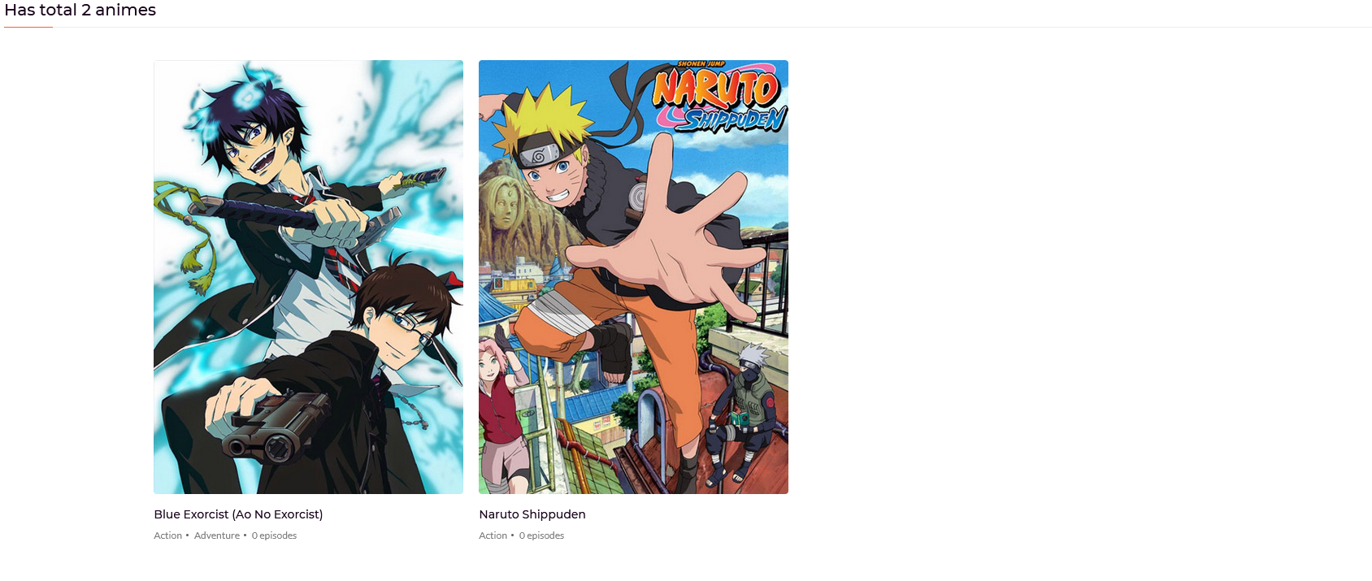

**Figura 5.3.10 – Animes numa Categoria (Category)**

* 1. **My List**

Para poder aceder a esta página é necessário efetuar o *login*, e nela encontram-se todos os animes que o utilizador adicionou à sua lista. Para adicionar ou remover itens desta basta, na página do anime, pressionar o botão laranja que se encontra em baixo da imagem do mesmo.

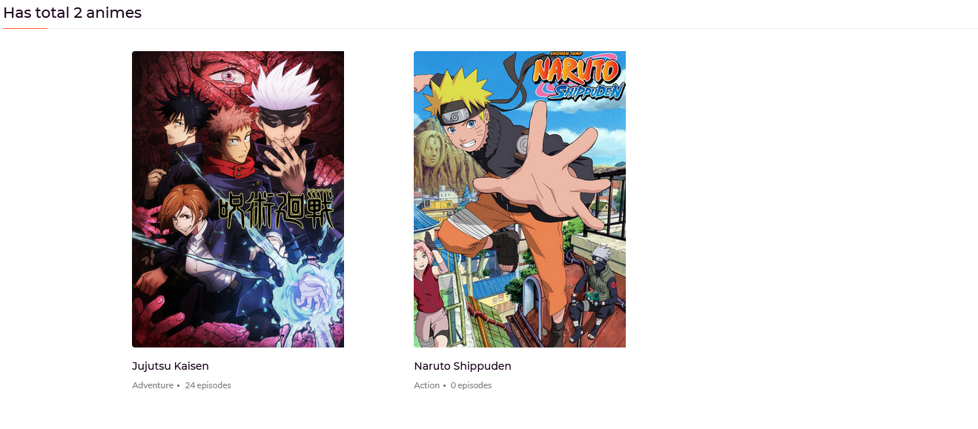

**Figura 5.3.11 – Animes My List (My List)**

* 1. **Submit Anime**

Esta página foi criada para ser possível recolher informações sobre os *animes* e episódios que os utilizadores gostavam que a plataforma tivesse. Para preencher o formulário o utilizador nem sequer precisa de ter uma conta na plataforma, é apenas necessário fornecer um *username* e *email*. A informação submetida pode ser depois vista por um administrador.

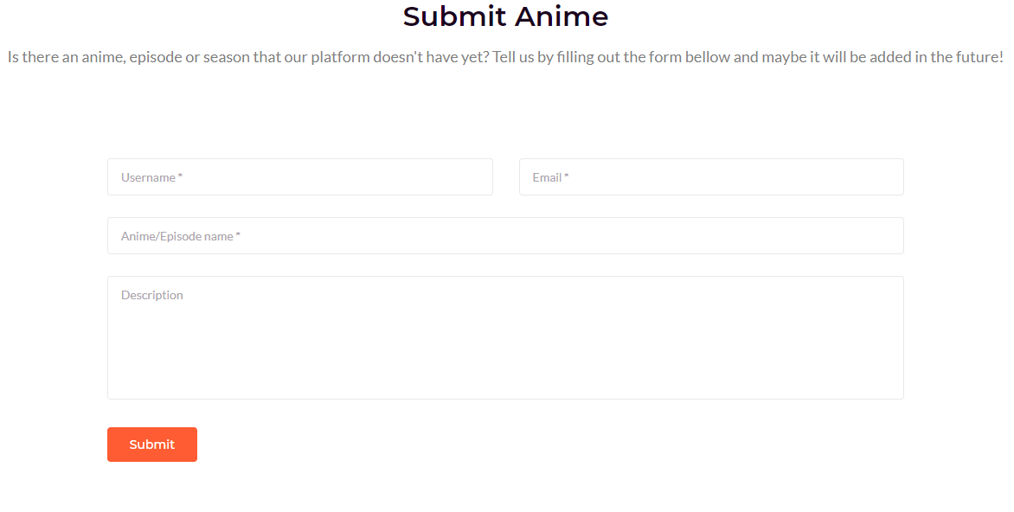

**Figura 5.3.12 – Formulário de Submissão (Submit Anime)**

* 1. **About Us**

Esta é uma página simples onde o utilizador pode obter algumas informações sobre “os criadores” da plataforma e qual a sua razão de existência.

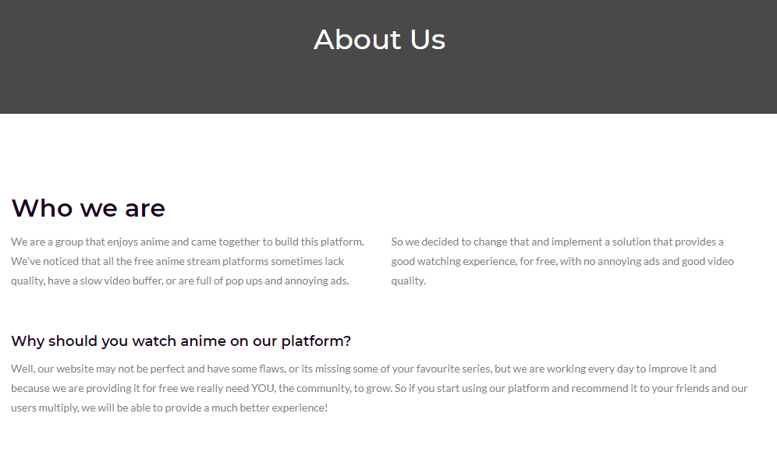

**Figura 5.3.13 – Sobre Nós (About Us)**

* 1. **Disclaimer**

Esta é uma página informativa com um desenho semelhante à About Us que, muito resumidamente, informa as pessoas que os conteúdos da plataforma pertencem aos seus respetivos criadores e que o conteúdo foi disponibilizado na internet por terceiros.

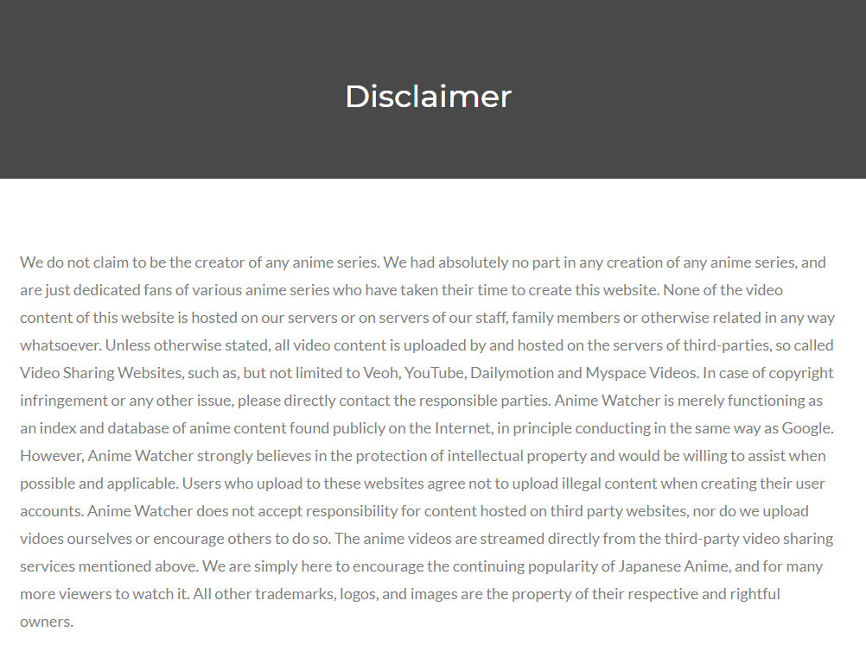

**Figura 5.3.14 – Aviso Sobre o Conteúdo (Disclaimer)**

* 1. **Privacy Policy**

À semelhança da página anterior, esta serve também para informar os utilizadores de algumas políticas no site, que no caso são sobre a recolha de dados dos utilizadores e dos anúncios, que a plataforma ainda não possui, mas que podem ser implementados no futuro.

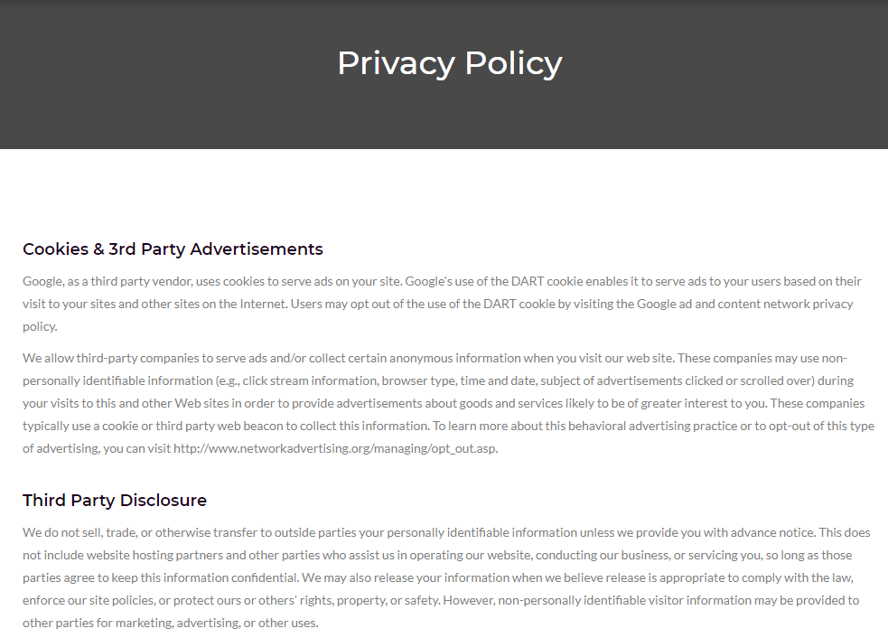

**Figura 5.3.15 – Política de Privacidade (Privacy Policy)**

1. **Autenticação**

É nesta parte do site que os utilizadores podem criar e fazer a manutenção das suas contas, alterando dados do perfil. Podem também alterar a palavra-passe ou, se for o caso, recuperar a mesma indicando o email associado à conta. Esta parte não respeita a mesma estrutura definida na parte do conteúdo principal.

* 1. **Login & Logout**

Na barra de navegação, ao ser pressionado o *icon* que se encontra encostado ao lado direito, o utilizador é levado para a página de login, isto é, se ele ainda não o tiver efetuado. Nesta página encontram-se duas caixas de texto obrigatórias, uma para o *username* e uma para a palavra-passe, como está representado na figura a seguir.

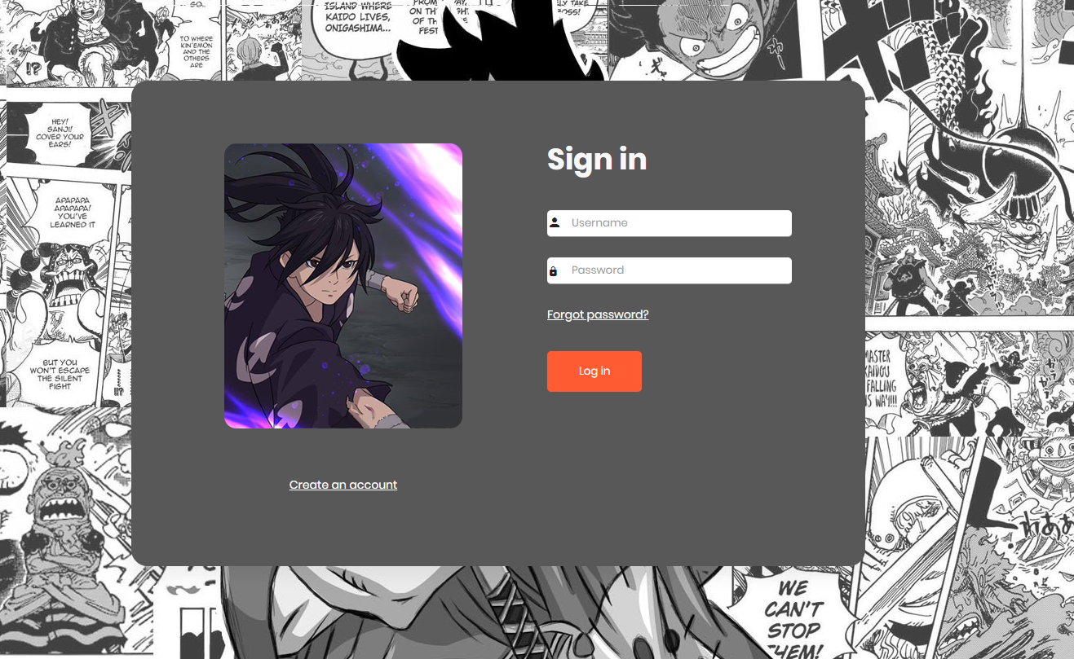

**Figura 5.4.1 – Inicio de Sessão (Login)**

Após o *login* ter sido efetuado com sucesso, o utilizador é levado para a página inicial do *site*. Caso contrário, as mensagens de erro correspondentes irão aparecer por debaixo do botão de *Login*.

Ao ser redirecionado para a página de início, à direita, perto do *icon*, encontra-se agora o nome do utilizador que fez login e ao colocar o cursor em cima, aparece um menu com opções relacionadas com a gestão da conta. Uma das opções é a *Logout*, que permite ao utilizador terminar a sessão e que após ser pressionada o leva novamente para a página de *Login*.

 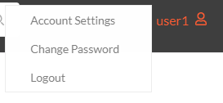

**Figura 5.4.2 – Icon Logado (Home) Figura 5.4.3 – Menu User (Home)**

* 1. **Register**

Caso o utilizador não tenha conta criada na plataforma e pressione no texto “*Create na Account*”, que se encontra na página de *login*, ele é levado para esta página, onde se pode registar.

Para se registar, existem quatro campos que têm que ser preenchidos, o *username* que é onde se coloca o nome de utilizador, um endereço de *email* e os dois últimos campos que são para a palavra passe, que é repetida para garantir que o utilizador não se enganou. A palavra passe tem que ter um comprimento mínimo de 8 caracteres e conter letras e pelo menos um número. Por último, para a conta ser criada, o utilizador tem que concordar com os termos e condições e pressionar no botão “*Register*”.

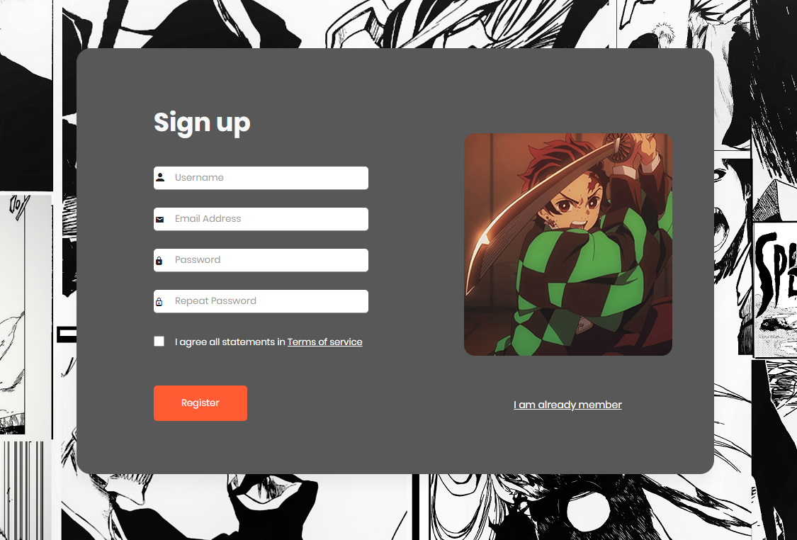

**Figura 5.4.4 – Criar Conta (Register)**

Após a conta ter sido criada com sucesso, é enviado um email de ativação para o utilizador com um botão que ao ser pressionado o leva para a página de *login*. Este botão apenas deixa de ser válido quando a conta for ativada, o que significa que se ocorrer algum erro, este pode ser reutilizado na segunda tentativa de ativação.

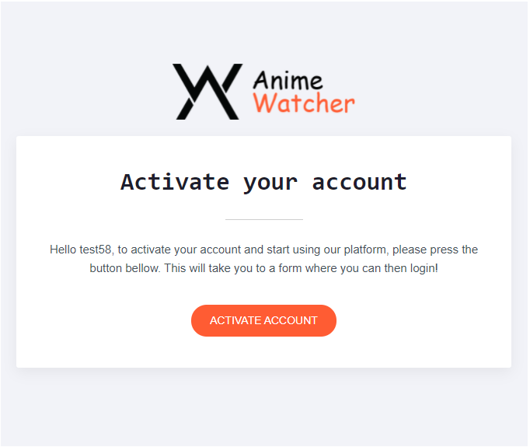

**Figura 5.4.5 – Ativar Conta (Register)**

* 1. **Forgot Password**

No caso de um utilizador ter perdido a sua palavra passe e, por sua vez, ter perdido acesso à conta, basta dirigir-se a esta página, pressionando no texto “*Forgot your password*”, que se pode encontrar na página de *Login*. Para recuperar a palavra passe, basta inserir o email na caixa de texto e pressionar o botão “*Request New Password*”.

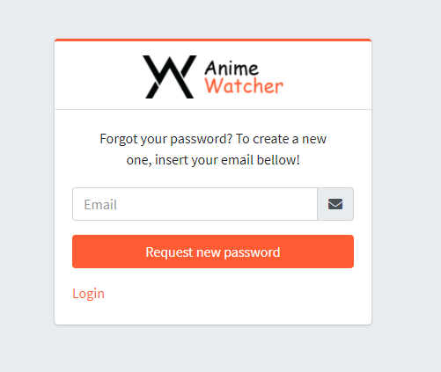

**Figura 5.4.6 – Recuperar Palavra-Passe (Forgot Password)**

Após o botão ser pressionado, é enviado um email muito semelhante ao de ativação de conta para o utilizador, mas desta vez, para recuperar a palavra-passe.

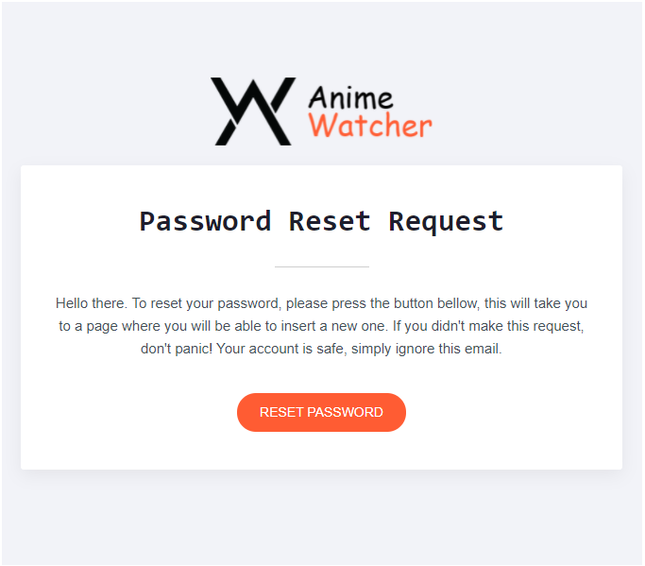

**Figura 5.4.7 – Email Recuperar Palavra-Passe (Forgot Password)**

Ao pressionar no botão este deixa de funcionar, ou seja, apenas pode ser utilizado uma vez e leva o utilizador para uma página onde pode inserir a sua nova palavra passe.

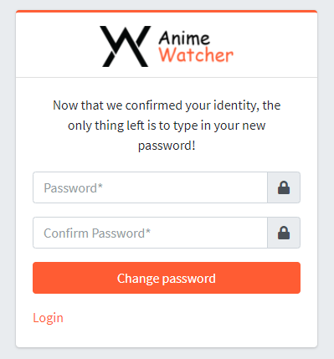

**Figura 5.4.8 – Nova Palavra-Passe (Forgot Password)**

* 1. **Change Password**

Enquanto o utilizador estiver autenticado na plataforma ele tem o direito de alterar a sua palavra-passe a qualquer momento. Para tal, no menu do *icon* de utilizador existe uma opção que torna isto possível e que quando pressionada o traz para esta página.

Na página existem quatro caixas de texto. A primeira encontra-se desativada pois o seu propósito é apenas mostrar o nome de utilizador, nada mais. A segunda caixa de texto é onde é inseria da palavra-passe atual. As últimas duas é onde é colocada a nova palavra-passe, que tem que ser repetida duas vezes, à semelhança da página de registo e de reposição da palavra-passe, para garantir que o utilizador não se engana a fazê-lo.

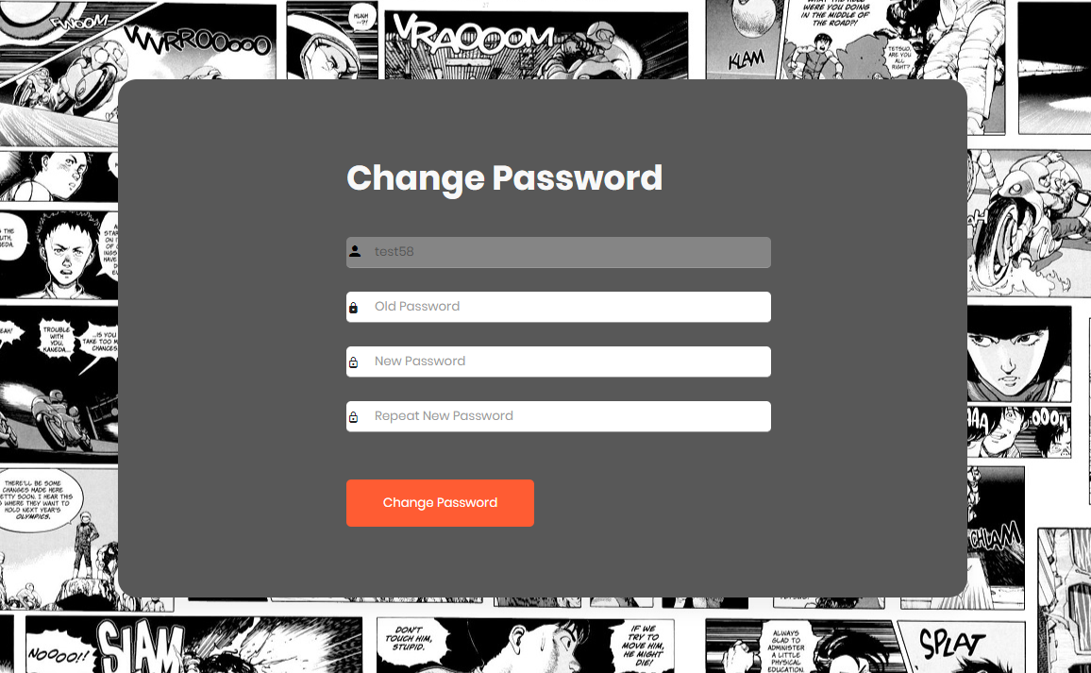

**Figura 5.4.9 – Alterar Palavra-Passe (Change Password)**

* 1. **Account Settings**

Esta página permite ao utilizador alterar algumas definições básicas da sua conta e, para navegar até ela, à semelhança da página de alteração de palavra-passe, há uma opção no menu do *icon* de utilizador.

A página é composta por quatro caixas de texto, que permitem alterar o nome de utilizador, primeiro nome, último nome e email, correspondentemente, e cuja maior parte já vem pré-preenchida com a informação atual da conta. No futuro podem ser implementadas mais opções, como uma imagem de perfil, por exemplo.

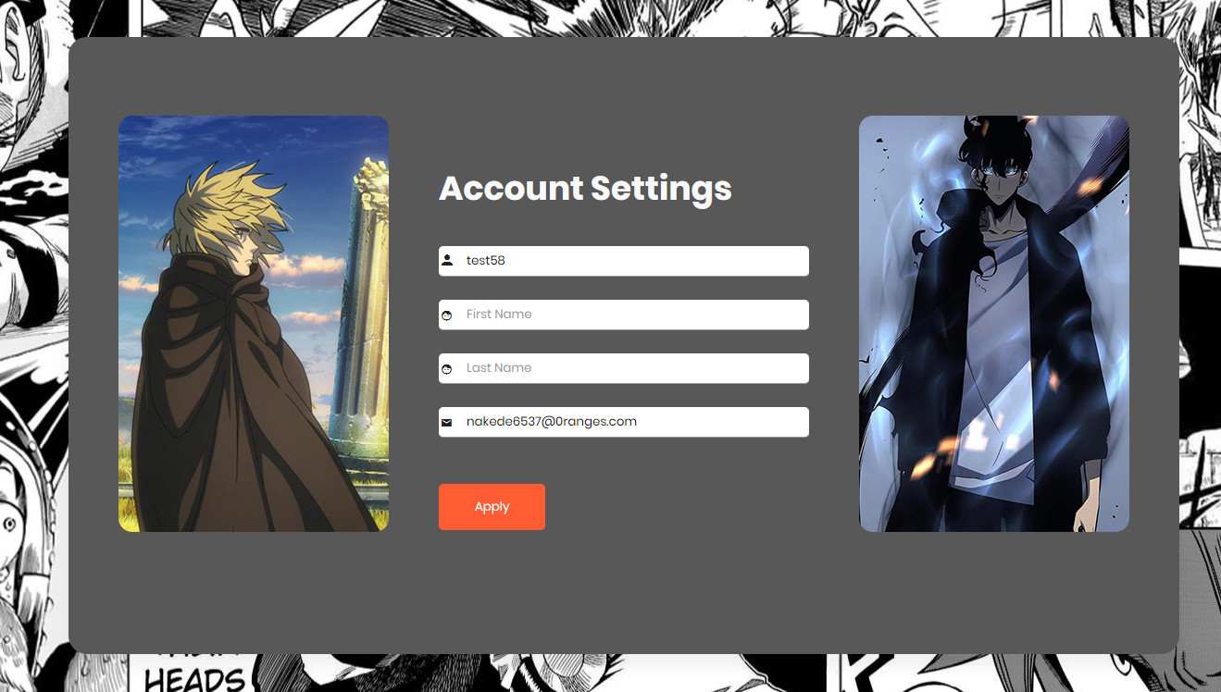

**Figura 5.4.10 – Definições (Account Settings)**

1. **Administração**

Ao efetuar o login como administrador é adicionada, automaticamente, uma opção ao menu do *icon* de utilizador que se encontra na barra de navegação do site. Ao pressionar nesta opção, o administrador é trazido esta parte do site onde toda a informação pode ser gerida facilmente, desde adicionar novos *animes*, episódios, legendas, ou até mesmo fazer a moderação dos utilizadores e dos seus comentários.

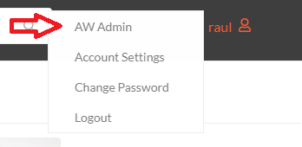

**Figura 5.5.1 – Menu User (Home)**

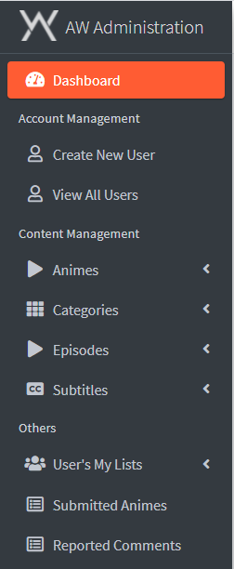Esta parte do *site* tem uma estrutura diferente das outras, com uma barra de navegação no topo, semelhante à do conteúdo principal, um pequeno rodapé com alguma informação de *copyright* e um menu à esquerda para navegar entre as páginas.



**Figura 5.5.2 – Barra de Navegação (Autenticação)**



**Figura 5.5.3 – Rodapé (Autenticação)**

**Figura 5.5.4 – Menu de Navegação (Autenticação)**

* 1. **Dashboard Admin**

Esta é a primeira página com que o utilizador se depara ao aceder à parte da administração. Aqui apenas se encontram algumas estatísticas da plataforma para o manter informado.

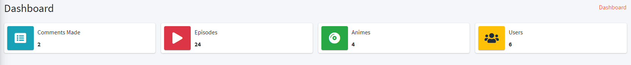

**Figura 5.5.5 – Estatísticas (Dashboard Admin)**

* 1. **Create New User**

Nesta secção, é possível adicionar um novo utilizador à plataforma manualmente, sem a necessidade de ativar o email, sem restrições de palavra passe e com a opção de o tornar administrador. Existem alguns campos cujo seu preenchimento é obrigatório, como o “*Username*”, “*Email Address*”, “*Password*” e “*Repeat Password*” e outros que são opcionais, “*First Name*” e “*Last Name*”.

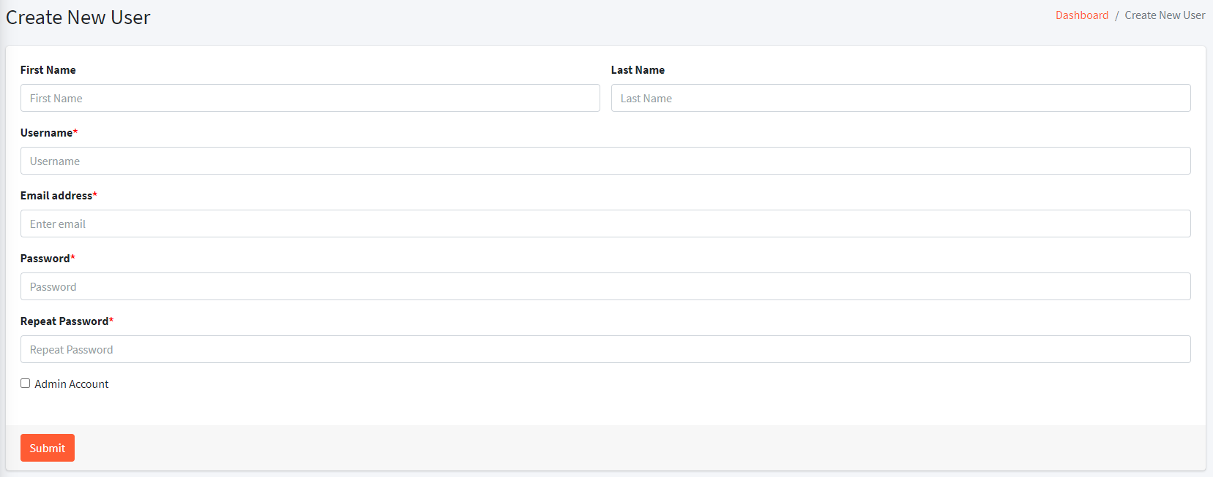

**Figura 5.5.6 – Criar Utilizador (Create User)**

* 1. **View All Users**

Esta página permite ao utilizador ver todos os utilizadores e um pouco de informação sobre cada, assim como fazer uma pesquisa pelo *username*. Ao pressionar num dos *itens* da tabela, é levado para uma outra página onde pode alterar as definições do utilizador pressionado ou eliminar este.

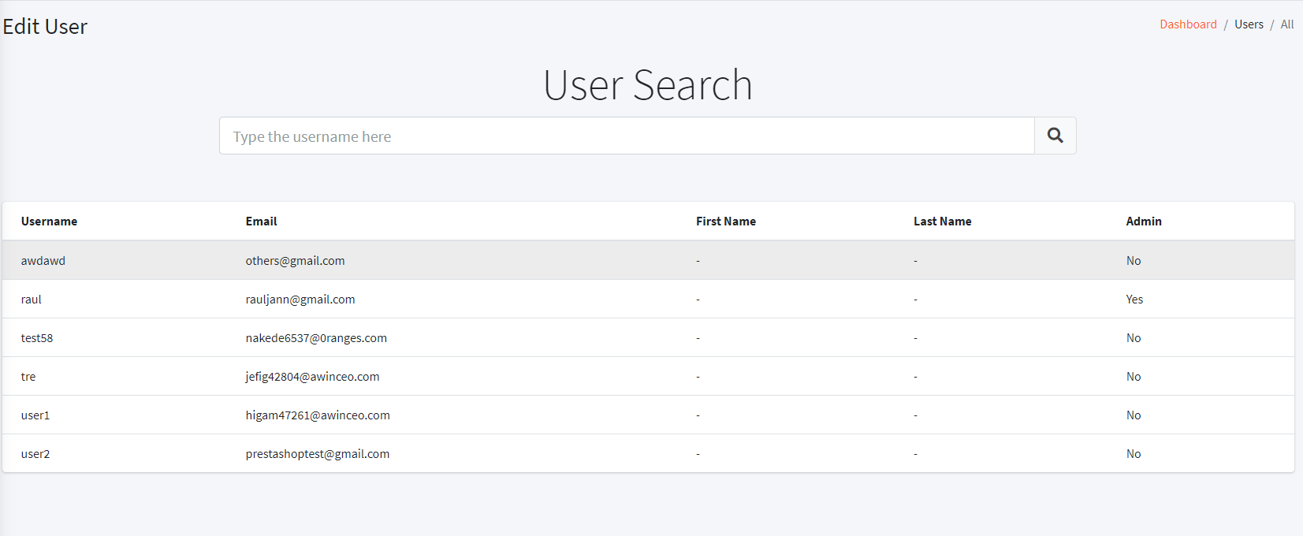

**Figura 5.5.7 – Ver Utilizadores (View All Users)**

* 1. **Edit User**

Como foi mencionado acima, é possível chegar a esta página pressionando num dos *itens* da tabela de utilizadores, cujo desenho é extremamente semelhante ao da página de criação de um utilizador. Aqui é possível alterar todas as informações de alguém em específico, assim como alterar a sua palavra-passe sem qualquer tipo de restrição ou até mesmo eliminá-lo.

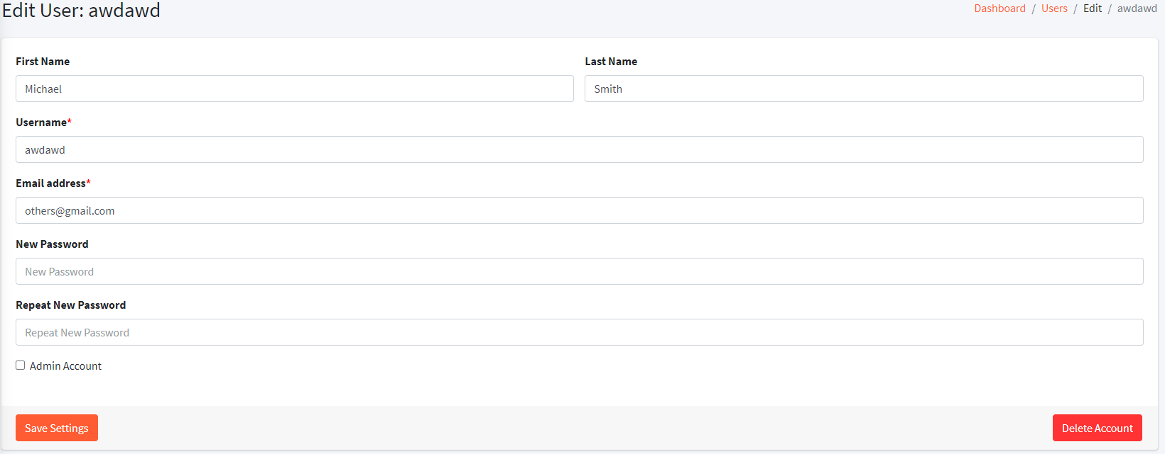

**Figura 5.5.8 – Editar Utilizador (Edit User)**

* 1. **Add New Anime**

Nesta página é possível adicionar um novo *anime* à plataforma, de uma forma muito semelhante à criação de novos utilizadores, até mesmo em termos de desenho da página. Existem alguns campos obrigatórios, como o nome em inglês, a descrição, que tem um limite máximo de 750 caracteres, a *thumbnail*, ou seja, a imagem de capa e tem que conter pelo menos uma categoria. É ainda possível adicionar um nome em japonês se existir e marcar o anime como “*On Going*”, isto é, ainda saem episódios.

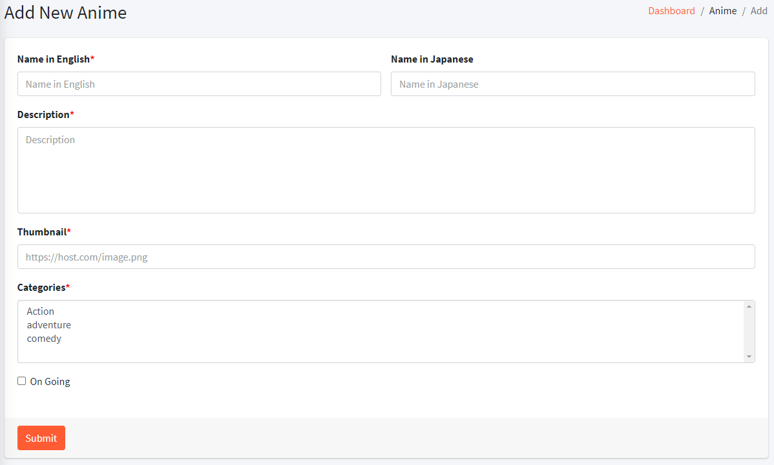

**Figura 5.5.9 – Adicionar Anime (Add New Anime)**

* 1. **View All Animes**

À semelhança da página “*View All Users*”, esta permite ver todos os *animes* da plataforma, assim como algumas informações básicas. É ainda possível efetuar uma pesquisa pelo nome do *anime*.

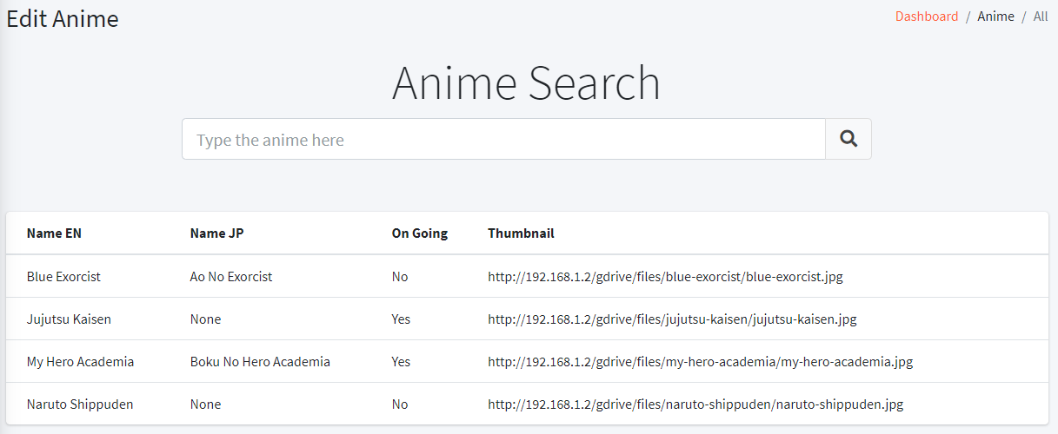

**Figura 5.5.10 – Lista de Animes (View All Animes)**

* 1. **Edit Anime**

Ao ser pressionado um *item* da lista anterior, o utilizador é levado para uma página muito semelhante à de criação de um anime, onde pode editar toda a informação, à exceção do nome em Inglês, do *anime* correspondente ou eliminar o mesmo.

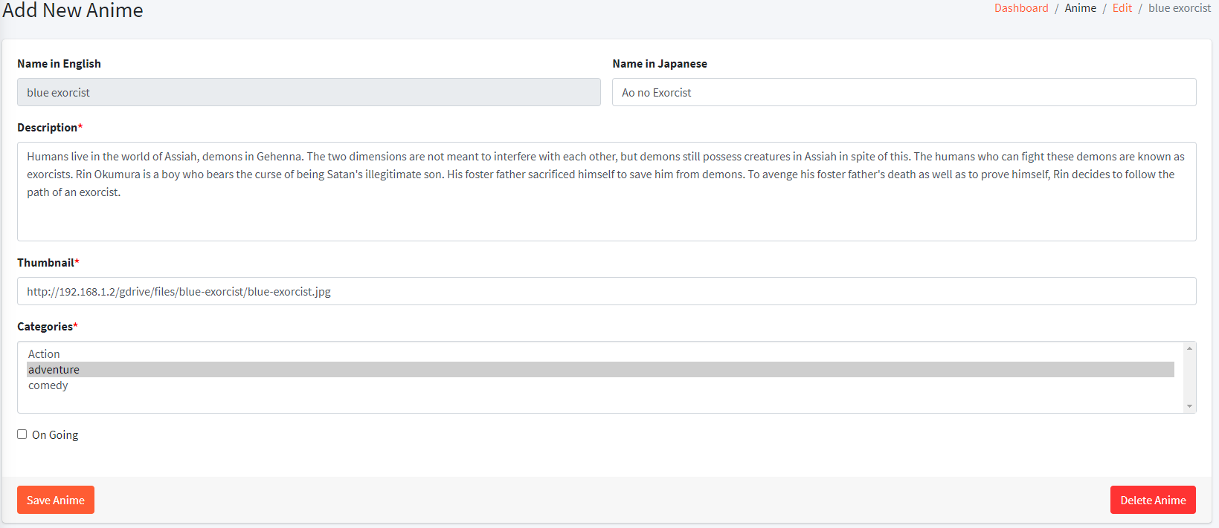

**Figura 5.5.11 – Editar Anime (Edit Anime)**

* 1. **Add New Category**

Nesta página é possível adicionar uma nova categoria à plataforma, apenas indicando o seu nome, que tem que ser único, ou seja, não pode ser repetido, e pressionando no botão “*Submit*”.

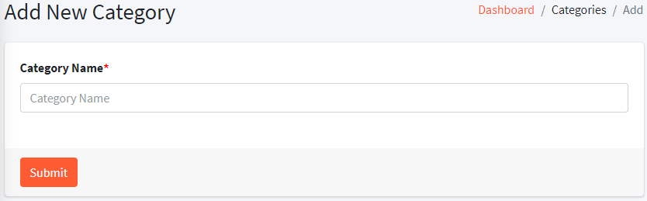

**Figura 5.5.12 – Adicionar Categoria (Add Category)**

* 1. **View All Categories**

Assim como nas outras páginas que mostram uma listagem de itens, esta mostra também uma lista com todas as categorias e a quantidade de *animes* de cada, que quando pressionadas, levam o utilizador para a página da categoria correspondente.

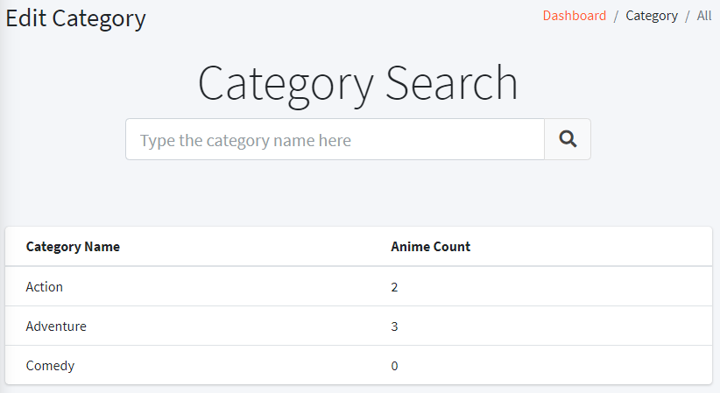

**Figura 5.5.13 – Lista de Categorias (View All Categories)**

* 1. **Delete Category**

Ao contrário dos outros *itens* que se podem gerir nesta parte da plataforma, as categorias são as únicas que não são editáveis, sendo estas apenas elimináveis. Para eliminar uma categoria, como foi mencionado acima, basta selecionar um item da lista e nesta página pressionar o botão “Delete”.

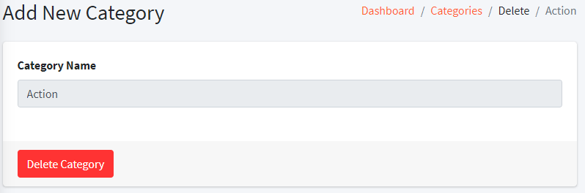

**Figura 5.5.14 – Eliminar Categoria (Delete Category)**

* 1. **Add New Episode**

Esta página permite ao utilizador adicionar um episódio novo à plataforma. Para efetuar esta operação, existem alguns campos obrigatórios como o nome em inglês, duração, número do episódio, data de lançamento, endereço do ficheiro de vídeo, *thumbnail* e *anime*. É ainda possível adicionar um nome em japonês e uma hora de lançamento.

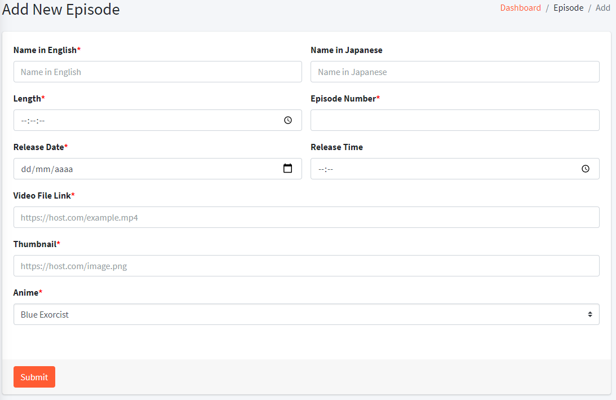

**Figura 5.5.15 – Adicionar Episódio (Add Episode)**

* 1. **View All Episodes**

À semelhança das outras páginas do mesmo tipo, esta permite ver todos os episódios com algumas informações extra como o anime a que pertencem, por exemplo, e fazer pesquisas através no nome.

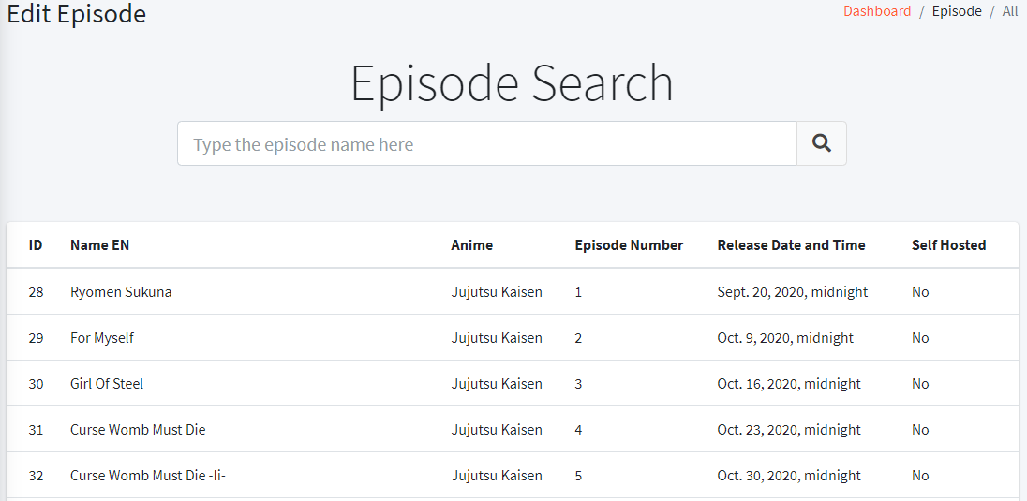

**Figura 5.5.16 – Lista de Episódios (View All Episodes)**

* 1. **Edit Episode**

Ao ser pressionado um item da lista mostrada anteriormente, o utilizador é levado para esta página semelhante à de criação de episódios, onde pode alterar qualquer tipo de informação ou até mesmo apagar o mesmo.

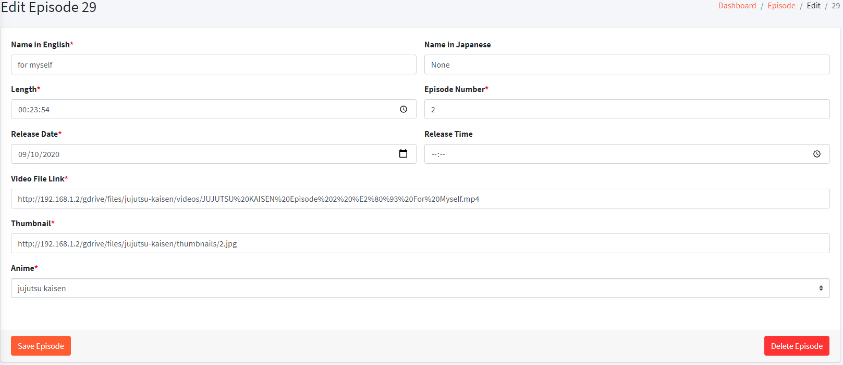

**Figura 5.5.17 – Editar Episódio (Edit Episode)**

* 1. **Add New Subtitle**

Nesta página, o utilizador pode acrescentar uma legenda para um dado episódio, apenas inserindo a língua e o código dela e fazendo upload do ficheiro. Depois de estar tudo preenchido basta pressionar o botão “*Submit*”.

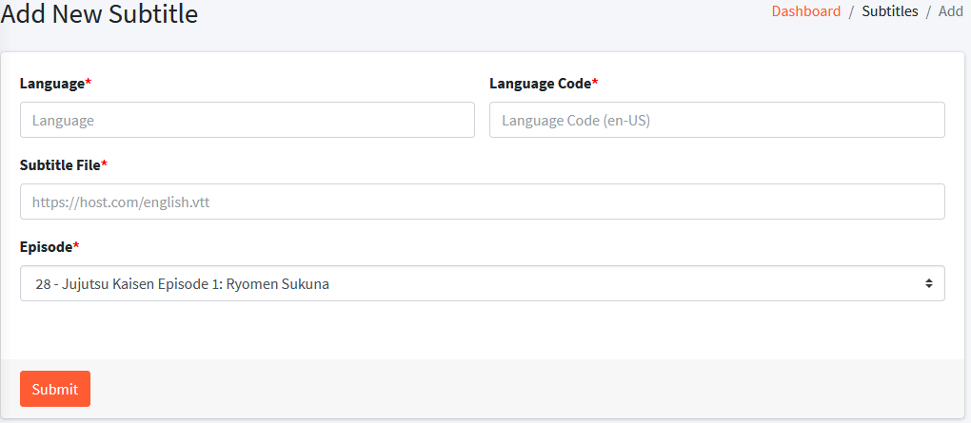

**Figura 5.5.18 – Adicionar Legenda (Add New Subtitle)**

* 1. **View All Subtitles**

À semelhança das outras páginas do mesmo estilo, esta mostra uma lista com todas as legendas ordenada pelo ID, que contém mais umas informações básicas, sendo ainda possível efetuar uma pesquisa pelo nome do episódio.

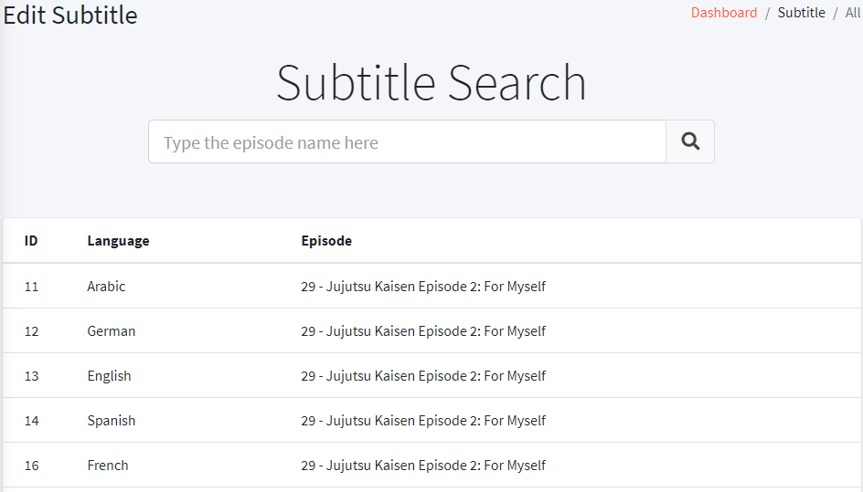

**Figura 5.5.19 – Lista de Legendas (View All Subtitles)**

* 1. **Edit Subtitle**

Ao pressionar um item da lista anterior, o utilizador é levado para esta página, onde pode alterar a toda informação da legenda ou apagar a mesma.

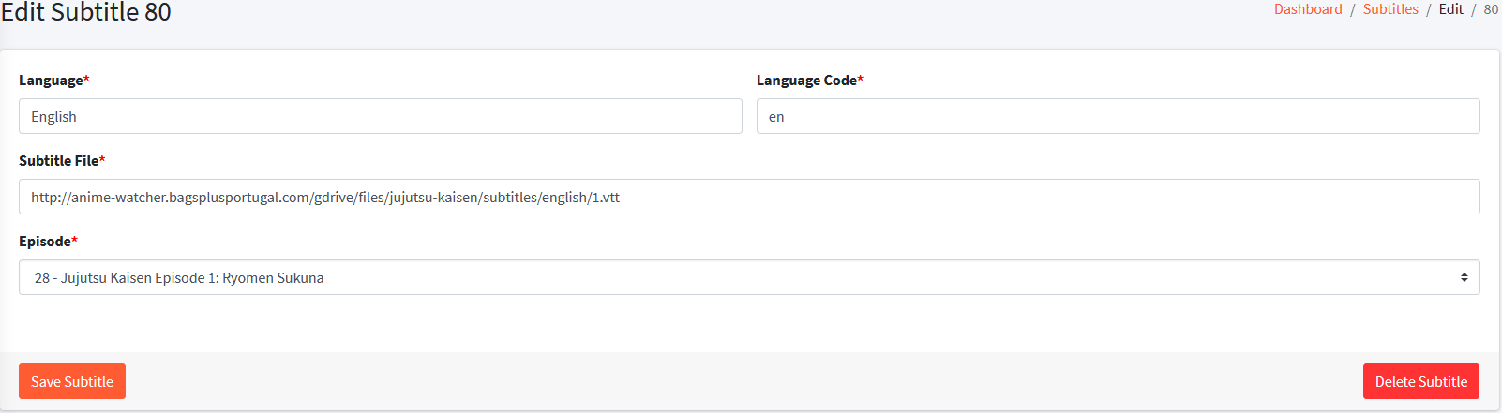

**Figura 5.5.20 – Editar Legenda (Edit Subtitle)**

* 1. **Add New Item to MyList**

Nesta página é possível adicionar um *anime* a uma *MyList* de um utilizador em específico, apenas selecionando as duas nas listas correspondentes e pressionando no botão “Submit”.

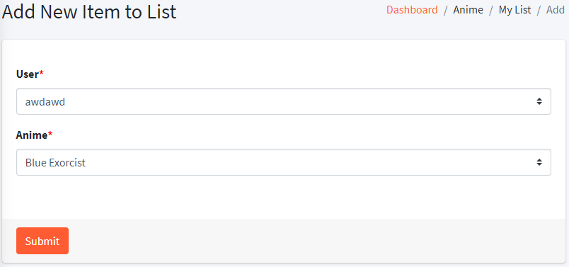

**Figura 5.5.21 – Adicionar item à MyList (Add New Item to MyList)**

* 1. **View All MyList Items**

À semelhança das outras páginas do mesmo tipo, esta permite obter uma lista ordenada pelo ID de todos os *itens* de todas as *MyList*, que pode ser filtrada pesquisando pelo *username* ou *email*.

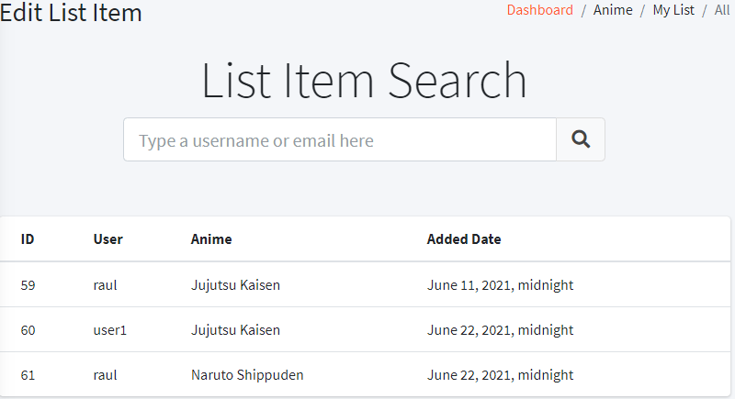

**Figura 5.5.22 – Lista de itens MyList (View All MyList Items)**

* 1. **Edit MyList Item**

Nesta página é possível fazer a alteração e eliminação do item correspondente ao que foi selecionado da lista anterior. Para alterar, basta mudar as opções das listas e pressionar “*Save Item*”.

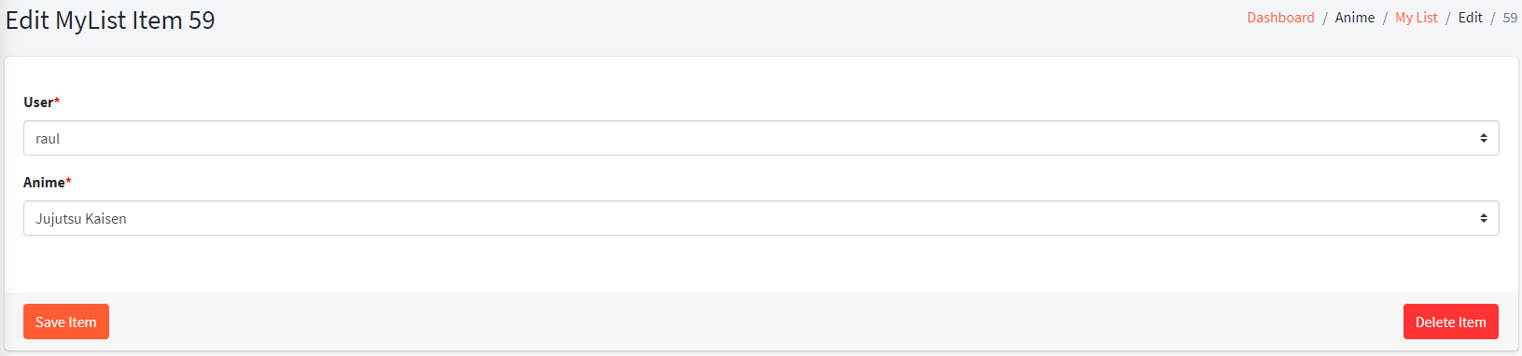

**Figura 5.5.23 – Editar item MyList (Edit MyList Item)**

* 1. **Anime Submissions**

Nesta página é possível ver e eliminar todas as submissões de *animes* e episódios. Para eliminar itens, selecione os pretendidos na caixa localizada no lado esquerdo e pressione o botão “Delete Items”.

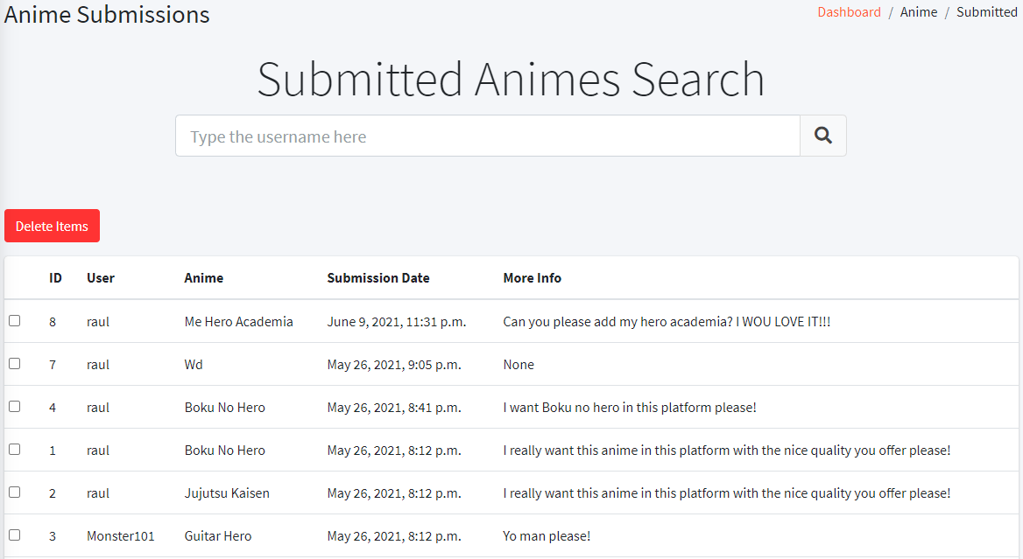

**Figura 5.5.24 – Lista de Submissões de Animes (Anime Submisssions)**

* 1. **Reported Comments**

Esta página é muito semelhante à das submissões de *animes*, onde é possível ver todos os comentários que foram reportados e eliminar, ou o registo, ou o próprio comentário.

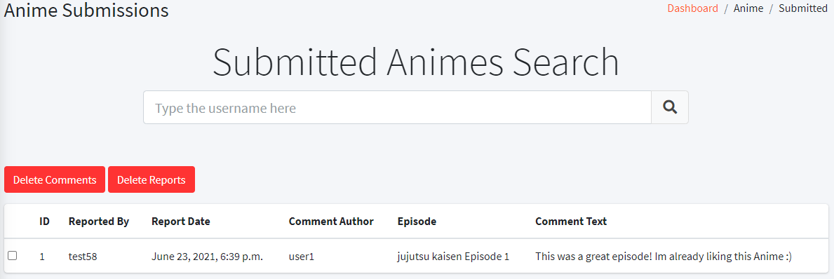

**Figura 5.5.25 – Comentários Reportados (Reported Comments)**

1. **API**

Esta parte do *site* difere de todo o resto, pois tem um propósito diferente, em vez de mostrar algo ou ser acessível ao utilizador comum, o principal objetivo desta é, como foi referido anteriormente, efetuar a comunicação entre a aplicação *mobile* e o resto da plataforma.

Nesta existem várias funções, cada uma com um endereço diferente. Para conseguir os dados pretendidos das mesmas, na grande maioria das vezes, é necessário enviar um JSON (*JavaScript Object Notation*) com informação sobre os dados pretendidos. No resto dos casos, basta fazer um *GET* para buscar a informação.

Nas representações de endereço das funções será utilizado um domínio fictício para simplificar e uniformizar os exemplos. Esse domínio é o seguinte:

anime-watcher.com

* 1. **Authenticate User**

Aqui é onde o utilizador é autenticado, isto é, são enviadas as credenciais (*username* e palavra-passe) e é recebida a informação do utilizador e uma *token* que pode ser utilizada mais tarde noutras operações da API (*application programming interface*).

Endereço da função (POST):

https://www.anime-watcher.com/api/authenticate-user

Pedido de Exemplo:

{

    "username": "test58",

    "password": "RobloxFixe123"

}

Reposta de Exemplo:

{

    "Status": "Authenticated",

    "Token": "21a4746dda248e143dde01f7637728bbccfdf07a",

    "id": 9,

    "username": "test58",

    "email": "nakede6537@0ranges.com",

    "password": "pbkdf2_sha256$260000$PJli780NQVVAddfdjZSx18$ixFxXAL0eJCQPOAMXnSYRydc7EODEiH3no8MDCH8Xlo=",

    "first_name": "",

    "last_name": "",

    "is_superuser": **false**,

    "is_staff": **false**,

    "is_active": **true**,

    "last_login": "2021-06-24T14:21:38.047132",

    "date_joined": "2021-06-23T15:04:01.492317Z"

}

* 1. **Check Token**

O objetivo desta função é verificar a validade de uma dada *token*. Esta é necessária pois cada vez que é iniciada a aplicação *mobile*, a *token* tem que ser verificada para garantir que o resto das funções funciona corretamente.

Endereço da Função (POST):

https://www.anime-watcher.com/api/check-token

Pedido de Exemplo:

{

    "Token": "21a4746dda248e143dde01f7637728bbccfdf07a"

}

Resposta de Exemplo:

{

    "Status": "Success"

}

* 1. **Logout User**

Esta função ainda não tem utilidade, mas serve para efetuar o *logout* em todos os dispositivos, eliminando a *token*. Futuramente pode ser implementada uma opção na aplicação *mobile* ou na aplicação *web* para realizar o *logout*.

Endereço da Função (POST):

https://www.anime-watcher.com/api/logout

Pedido de Exemplo

{

    "Token": "21a4746dda248e143dde01f7637728bbccfdf07a"

}

Resposta de Exemplo:

{

    "Status": "Success"

}

* 1. **Submit Anime**

É através desta função que os dados inseridos pelos utilizadores, no formulário de submissão de um *anime* ou episódio, são enviados para a base de dados.

Endereço da Função (POST):

https://www.anime-watcher.com/api/submit-anime

Pedido de Exemplo:

{

    "mAnimeName": "Test Anime",

    "mUserEmail": "example@example.com",

    "mUsername": "test58",

    "mMoreInfo": "Please add this!!",

    "mSubDate": "2021-06-24T14:49:52"

}

Resposta de Exemplo:

{

    "Status": "Success"

}

* 1. **Get All Animes**

Esta função, ao contrário das outras, não requer qualquer tipo de submissão de dados e devolve toda a informação de todos os animes da plataforma ordenados por ordem alfabética.

Endereço da Função (GET):

https://www.anime-watcher.com/api/get-all-anime

Resposta de Exemplo:

[

    {

        "mNameEN": "blue exorcist",

        "mNameJP": "Ao no Exorcist",

        "mDescription": "Humans live in the world of Assiah, demons in Gehenna. The two dimensions are not meant to interfere with each other, but demons still possess... ",

        "mThumbnail": "http://192.168.1.2/gdrive/files/blue-exorcist/blue-exorcist.jpg",

        "mEpisodeCount": 0,

        "mOnGoing": **false**,

        "mCategories": [

            "Action",

            "adventure"

        ]

    },

    {

        "mNameEN": "jujutsu kaisen",

        "mNameJP": **null**,

        "mDescription": "In a world where demons feed on unsuspecting humans, fragments of the legendary and feared demon Ryoumen Sukuna were lost and scattered about. Should any demon consume Sukuna's body parts, the power they gain could destroy the world...  ",

        "mThumbnail": "http://192.168.1.2/gdrive/files/jujutsu-kaisen/jujutsu-kaisen.jpg",

        "mEpisodeCount": 24,

        "mOnGoing": **true**,

        "mCategories": [

            "adventure"

        ]

    }

]

* 1. **Get Searched Anime**

À semelhança da função anterior, esta também devolve uma lista de animes, mas desta vez, apenas mostra os que contêm no nome as letras são enviadas no pedido, servindo assim para fazer pesquisas.

Endereço da Função (POST):

https://www.anime-watcher.com/api/get-search-anime

Pedido de Exemplo:

{

    "Keywords": "jujuts"

}

Resposta de Exemplo:

[

    {

        "mNameEN": "jujutsu kaisen",

        "mNameJP": **null**,

        "mDescription": "In a world where demons feed on unsuspecting humans, fragments of the legendary and feared demon Ryoumen Sukuna were lost and scattered about. Should any demon consume Sukuna's body parts, the power they gain could destroy the world as we know it. Fortunately, there exists a mysterious school of Jujutsu Sorcerers who exist to protect the precarious existence of the living from the undead! Yuuji Itadori is high schooler who spends his days visiting his bedridden grandfather. Although he looks like your average teenager, his immense physical strength is something to behold! Every sports club wants him to join, but Itadori would rather hang out with the school outcasts in the Occult Club. One day, the club manages to get their hands on a sealed cursed object, but little do they know the terror they'll unleash when they break the seal... ",

        "mThumbnail": "http://192.168.1.2/gdrive/files/jujutsu-kaisen/jujutsu-kaisen.jpg",

        "mEpisodeCount": 24,

        "mOnGoing": **true**,

        "mCategories": [

            "adventure"

        ]

    }

]

* 1. **Get MyList Anime**

Com esta função é possível obter todos os *animes* da *MyList* da pessoa correspondente à *token* enviada no pedido, de forma muito semelhante às últimas duas funções.

Endereço da Função (POST):

https://www.anime-watcher.com/api/get-mylist-anime

Pedido de Exemplo:

{

    "Token": "21a4746dda248e143dde01f7637728bbccfdf07a"

}

Resposta de Exemplo:

[

    {

        "mNameEN": "naruto shippuden",

        "mNameJP": **null**,

        "mDescription": "It has been two and a half years since Naruto Uzumaki left Konohagakure, the Hidden Leaf Village, for intense training following events which fueled his desire to be stronger. Now Akatsuki, the mysterious organization of elite rogue ninja, is closing in on their grand plan which may threaten the safety of the entire shinobi world. Although Naruto is older and sinister events loom on the horizon, he has changed little in personality—still rambunctious and childish—though he is now far more confident and possesses an even greater determination to protect his friends and home. Come whatever may, Naruto will carry on with the fight for what is important to him, even at the expense of his own body, in the continuation of the saga about the boy who wishes to become Hokage. ",

        "mThumbnail": "http://192.168.1.2/gdrive/files/naruto-shippuden/naruto-shippuden.jpg",

        "mEpisodeCount": 0,

        "mOnGoing": **false**,

        "mCategories": [

            "Action"

        ]

    }

]

* 1. **Add to MyList**

Uma das funções da aplicação *mobile* é adicionar *animes* à *MyList*. Como tal, é crucial ter uma função que trate desta parte de adicionar o *anime* à base de dados.

Endereço da Função (POST):

https://www.anime-watcher.com/api/my-list-add

Pedido de Exemplo:

{

    "Token": "21a4746dda248e143dde01f7637728bbccfdf07a",

    "mNameEN": "jujutsu kaisen"

}

Resposta de Exemplo:

{

    "Status": "Success"

}

* 1. **Remove from MyList**

Para complementar a função anterior, é possível também remover um *anime* da lista, de forma muito semelhante a como ele é adicionado, apenas indicando o seu nome e a *token* do utilizador.

Endereço da Função (POST):

https://www.anime-watcher.com/api/my-list-remove

Pedido de Exemplo:

{

    "Token": "21a4746dda248e143dde01f7637728bbccfdf07a",

    "mNameEN": "jujutsu kaisen"

}

Resposta de Exemplo:

{

    "Status": "Success"

}

* 1. **Check Anime in MyList**

É possível ainda, para além de adicionar ou remover um *anime* à MyList, verificar se ela tem um *anime* em específico adicionado através desta função.

Endereço da Função (POST):

https://www.anime-watcher.com/api/my-list-check

Pedido de Exemplo:

{

    "Token": "21a4746dda248e143dde01f7637728bbccfdf07a",

    "mNameEN": "naruto shippuden"

}

Resposta de Exemplo:

{

    "Added": **true**

}

* 1. **Get Categories Names**

Esta função, à semelhança da “*Get All Animes*”, não necessita de submissão de dados, utilizando assim o método *GET*. Com ela, é possível obter uma lista com todas as categorias da plataforma.

Endereço da Função (GET):

https://www.anime-watcher.com/api/get-string-categories

Resposta de Exemplo:

[

    {

        "mCategoryName": "Action"

    },

    {

        "mCategoryName": "adventure"

    },

    {

        "mCategoryName": "comedy"

    }

]

* 1. **Get Category Animes**

Esta função devolve uma lista ordenada por ordem alfabética com todos os *animes* e a sua respetiva informação de uma dada categoria.

Endereço da Função (POST):

https://www.anime-watcher.com/api/get-category-anime

Pedido de Exemplo:

{

    "mCategoryName": "adventure"

}

Resposta de Exemplo:

[

    {

        "mNameEN": "blue exorcist",

        "mNameJP": "Ao no Exorcist",

        "mDescription": "Humans live in the world of Assiah, demons in Gehenna. The two dimensions are not meant to interfere with each other, but demons still possess creatures in Assiah in spite of this. The humans who can fight these demons are known as exorcists. Rin Okumura is a boy who bears the curse of being Satan's illegitimate son. His foster father sacrificed himself to save him from demons. To avenge his foster father's death as well as to prove himself, Rin decides to follow the path of an exorcist. ",

        "mThumbnail": "http://192.168.1.2/gdrive/files/blue-exorcist/blue-exorcist.jpg",

        "mEpisodeCount": 0,

        "mOnGoing": **false**,

        "mCategories": [

            "Action",

            "adventure"

        ]

    },

    {

        "mNameEN": "jujutsu kaisen",

        "mNameJP": **null**,

        "mDescription": "In a world where demons feed on unsuspecting humans, fragments of the legendary and feared demon Ryoumen Sukuna were lost and scattered about. Should any demon consume Sukuna's body parts, the power they gain could destroy the world as we know it. Fortunately, there exists a mysterious school of Jujutsu Sorcerers who exist to protect the precarious existence of the living from the undead! Yuuji Itadori is high schooler who spends his days visiting his bedridden grandfather. Although he looks like your average teenager, his immense physical strength is something to behold! Every sports club wants him to join, but Itadori would rather hang out with the school outcasts in the Occult Club. One day, the club manages to get their hands on a sealed cursed object, but little do they know the terror they'll unleash when they break the seal... ",

        "mThumbnail": "http://192.168.1.2/gdrive/files/jujutsu-kaisen/jujutsu-kaisen.jpg",

        "mEpisodeCount": 24,

        "mOnGoing": **true**,

        "mCategories": [

            "adventure"

        ]

    }

]

* 1. **Get Episodes**

Esta função permite obter uma lista de toda a informação de todos os episódios ordenados pelo número, de um dado *anime*. Com ela, é possível carregar todos os episódios da página de um *anime* na aplicação *mobile*.

Endereço da Função (POST):

https://www.anime-watcher.com/api/get-episodes

Pedido de Exemplo:

{

    "mNameEN": "jujutsu kaisen"

}

Resposta de Exemplo:

[

    {

        "mID": 28,

        "mEpisodeNumber": 1,

        "mNameEN": "ryomen sukuna",

        "mNameJP": "None",

        "mLengthSecs": 1435,

        "mViews": 167,

        "mReleaseDate": "2020-09-20T00:00:00Z",

        "mThumbnail": "http://192.168.1.2/gdrive/files/jujutsu-kaisen/thumbnails/1.jpg",

        "mVideoFileLink": "http://192.168.1.2/gdrive/files/jujutsu-kaisen/videos/JUJUTSU%20KAISEN%20Episode%201%20%E2%80%93%20Ryomen%20Sukuna.mp4",

        "mAnime": "jujutsu kaisen"

    },

    {

        "mID": 29,

        "mEpisodeNumber": 2,

        "mNameEN": "for myself",

        "mNameJP": "None",

        "mLengthSecs": 1434,

        "mViews": 15,

        "mReleaseDate": "2020-10-09T00:00:00Z",

        "mThumbnail": "http://192.168.1.2/gdrive/files/jujutsu-kaisen/thumbnails/2.jpg",

        "mVideoFileLink": "http://192.168.1.2/gdrive/files/jujutsu-kaisen/videos/JUJUTSU%20KAISEN%20Episode%202%20%E2%80%93%20For%20Myself.mp4",

        "mAnime": "jujutsu kaisen"

    }

]

* 1. **Get Latest Episodes**

Esta é uma função muito semelhante à anterior, mas devolve uma lista com todos os episódios, ordenada pela data de lançamento, a começar pela mais recente. Esta também não precisa de submissão de dados, utilizando-se o método *GET*.

Endereço da Função (GET):

https://www.anime-watcher.com/api/get-episodes-latest

Resposta de Exemplo:

[

    {

        "mID": 51,

        "mEpisodeNumber": 24,

        "mNameEN": "accomplices",

        "mNameJP": "None",

        "mLengthSecs": 1420,

        "mViews": 12,

        "mReleaseDate": "2021-03-27T00:00:00Z",

        "mThumbnail": "http://192.168.1.2/gdrive/files/jujutsu-kaisen/thumbnails/24.jpg",

        "mVideoFileLink": "http://192.168.1.2/gdrive/files/jujutsu-kaisen/videos/JUJUTSU%20KAISEN%20Episode%2024%20%E2%80%93%20Accomplices.mp4",

        "mAnime": "jujutsu kaisen"

    },

    {

        "mID": 50,

        "mEpisodeNumber": 23,

        "mNameEN": "the origin of blind obedience: 2",

        "mNameJP": "None",

        "mLengthSecs": 1419,

        "mViews": 3,

        "mReleaseDate": "2021-03-20T00:00:00Z",

        "mThumbnail": "http://192.168.1.2/gdrive/files/jujutsu-kaisen/thumbnails/23.jpg",

        "mVideoFileLink": "http://192.168.1.2/gdrive/files/jujutsu-kaisen/videos/JUJUTSU%20KAISEN%20Episode%2023%20%E2%80%93%20The%20Origin%20of%20Blind%20Obedience%20-%202%20-.mp4",

        "mAnime": "jujutsu kaisen"

    }

]

* 1. **Get Most Viewed Episodes**

Esta função é extremamente semelhante à anterior, com a única diferença sendo a ordem em que os episódios são apresentados, que desta vez são pela quantidade de visualizações.

Endereço da Função (GET):

https://www.anime-watcher.com/api/get-episodes-most-views

Resposta de Exemplo:

[

    {

        "mID": 28,

        "mEpisodeNumber": 1,

        "mNameEN": "ryomen sukuna",

        "mNameJP": "None",

        "mLengthSecs": 1435,

        "mViews": 167,

        "mReleaseDate": "2020-09-20T00:00:00Z",

        "mThumbnail": "http://192.168.1.2/gdrive/files/jujutsu-kaisen/thumbnails/1.jpg",

        "mVideoFileLink": "http://192.168.1.2/gdrive/files/jujutsu-kaisen/videos/JUJUTSU%20KAISEN%20Episode%201%20%E2%80%93%20Ryomen%20Sukuna.mp4",

        "mAnime": "jujutsu kaisen"

    },

    {

        "mID": 45,

        "mEpisodeNumber": 18,

        "mNameEN": "sage",

        "mNameJP": "None",

        "mLengthSecs": 1435,

        "mViews": 21,

        "mReleaseDate": "2021-02-13T00:00:00Z",

        "mThumbnail": "http://192.168.1.2/gdrive/files/jujutsu-kaisen/thumbnails/18.jpg",

        "mVideoFileLink": "http://192.168.1.2/gdrive/files/jujutsu-kaisen/videos/JUJUTSU%20KAISEN%20Episode%2018%20%E2%80%93%20Sage.mp4",

        "mAnime": "jujutsu kaisen"

    }

]

* 1. **Get Random Episodes**

À semelhança das últimas duas funções, esta é também praticamente igual em termos de funcionalidade, com a única diferença sendo, mais uma vez, a ordem em que os episódios são apresentados, que desta vez é de forma aleatória.

Endereço da Função (GET):

https://www.anime-watcher.com/api/get-episodes-random

Resposta de Exemplo:

[

    {

        "mID": 37,

        "mEpisodeNumber": 10,

        "mNameEN": "idle transfiguration",

        "mNameJP": "None",

        "mLengthSecs": 1435,

        "mViews": 0,

        "mReleaseDate": "2020-12-04T00:00:00Z",

        "mThumbnail": "http://192.168.1.2/gdrive/files/jujutsu-kaisen/thumbnails/10.jpg",

        "mVideoFileLink": "http://192.168.1.2/gdrive/files/jujutsu-kaisen/videos/JUJUTSU%20KAISEN%20Episode%2010%20–%20Idle%20Transfiguration.mp4",

        "mAnime": "jujutsu kaisen"

    },

    {

        "mID": 49,

        "mEpisodeNumber": 22,

        "mNameEN": "the origin of blind obedience",

        "mNameJP": "None",

        "mLengthSecs": 1420,

        "mViews": 0,

        "mReleaseDate": "2021-03-13T00:00:00Z",

        "mThumbnail": "http://192.168.1.2/gdrive/files/jujutsu-kaisen/thumbnails/22.jpg",

        "mVideoFileLink": "http://192.168.1.2/gdrive/files/jujutsu-kaisen/videos/JUJUTSU%20KAISEN%20Episode%2022%20%E2%80%93%20The%20Origin%20of%20Blind%20Obedience.mp4",

        "mAnime": "jujutsu kaisen"

    }

]

* 1. **Get Episode**

Esta função permite obter a informação completa de um episódio em específico através do seu ID, o que significa que, ao contrário das funções anteriores, esta já requer a submissão de dados.

Endereço da Função (POST):

https://www.anime-watcher.com/api/get-episode

Pedido de Exemplo:

{

    "mID": "49"

}

Reposta de Exemplo:

{

    "mID": 49,

    "mEpisodeNumber": 22,

    "mNameEN": "the origin of blind obedience",

    "mNameJP": "None",

    "mLengthSecs": 1420,

    "mViews": 0,

    "mReleaseDate": "2021-03-13T00:00:00Z",

    "mThumbnail": "http://192.168.1.2/gdrive/files/jujutsu-kaisen/thumbnails/22.jpg",

    "mVideoFileLink": "http://192.168.1.2/gdrive/files/jujutsu-kaisen/videos/JUJUTSU%20KAISEN%20Episode%2022%20%E2%80%93%20The%20Origin%20of%20Blind%20Obedience.mp4",

    "mAnime": "jujutsu kaisen"

}

* 1. **Get Next Episode**

Esta função é muito semelhante à anterior, tanto no envio do pedido, como na reposta recebida. A diferença é que esta devolva a informação completa do episódio que vem depois do episódio correspondente ao ID enviado.

Endereço da Função (POST):

https://www.anime-watcher.com/api/get-episode-next

Pedido de Exemplo:

{

    "mID": "49"

}

Resposta de Exemplo:

{

    "mID": 50,

    "mEpisodeNumber": 23,

    "mNameEN": "the origin of blind obedience: 2",

    "mNameJP": "None",

    "mLengthSecs": 1419,

    "mViews": 3,

    "mReleaseDate": "2021-03-20T00:00:00Z",

    "mThumbnail": "http://192.168.1.2/gdrive/files/jujutsu-kaisen/thumbnails/23.jpg",

    "mVideoFileLink": "http://192.168.1.2/gdrive/files/jujutsu-kaisen/videos/JUJUTSU%20KAISEN%20Episode%2023%20%E2%80%93%20The%20Origin%20of%20Blind%20Obedience%20-%202%20-.mp4",

    "mAnime": "jujutsu kaisen"

}

* 1. **Get Anime Thumbnail**

Esta é mais uma função é mais para auxiliar a aplicação *mobile*, ou seja, não é tão crucial assim. O seu único propósito é devolver a *thumbnail*, isto é, a imagem de um *anime*.

Endereço da Função (POST):

https://www.anime-watcher.com/api/get-anime-thumbnail

Pedido de Exemplo:

{

    "mNameEN": "jujutsu kaisen"

}

Resposta de Exemplo:

{

    "mThumbnail": "http://192.168.1.2/gdrive/files/jujutsu-kaisen/jujutsu-kaisen.jpg"

}

* 1. **Add View to Episode**

Esta função tem um papel muito importante, pois todos os episódios têm um contador de visualizações. Na aplicação *web*, este contador de é incrementado automaticamente, para fazer o mesmo efeito na aplicação *mobile*, é necessário recorrer a esta função.

Endereço da Função (POST):

https://www.anime-watcher.com/api/episode-add-view

Pedido de Exemplo:

{

    "mID": "49"

}

Reposta de Exemplo:

{

    "Status": "Success"

}

* 1. **Get Episode Subtitles**

Com esta função, é possível obter uma lista com toda a informação de todas as legendas que estão disponíveis para um dado episódio, apenas indicando o seu ID. Isto permite que as legendas sejam mostradas corretamente na aplicação *mobile*.

Endereço da Função (POST):

https://www.anime-watcher.com/api/get-episode-subtitles

Pedido de Exemplo:

{

    "mID": "29"

}

Resposta de Exemplo:

[

    {

        "mID": 11,

        "mEpisode": 29,

        "mLink": "static/subtitles/JUJUTSU_KAISEN_Episode_2__For_Myself.arME.vtt",

        "mLanguage": "Arabic",

        "mShortLanguage": "ar-ME"

    },

    {

        "mID": 13,

        "mEpisode": 29,

        "mLink": "static/subtitles/JUJUTSU_KAISEN_Episode_2__For_Myself.enUS.vtt",

        "mLanguage": "English",

        "mShortLanguage": "en-US"

    }

]

* 1. **Get Subtitle**

À semelhança da função anterior, esta permite buscar uma legenda específica e toda a sua informação, através do seu ID.

Endereço da Função (POST):

https://www.anime-watcher.com/api/get-subtitle

Pedido de Exemplo:

{

    "mID": "11"

}

Resposta de Exemplo:

{

    "mID": 11,

    "mEpisode": 29,

    "mLink": "static/subtitles/JUJUTSU_KAISEN_Episode_2__For_Myself.arME.vtt",

    "mLanguage": "Arabic",

    "mShortLanguage": "ar-ME"

}

**Aplicação Mobile**

Após a conclusão da construção da aplicação *web*, apercebeu-se que a experiência das pessoas que o visitassem através de um dispositivo móvel não era a melhor, com alguns elementos que não se redimensionam corretamente, o que acaba por estragar a experiência desses utilizadores. Foi assim que surgiu a ideia para uma aplicação móvel que tenha como base o *site*. Em termos de estrutura e organização, esta é muito semelhante à da aplicação *web*, com um tema escuro e um tema claro que pode ser alterado nas definições do dispositivo, no entanto existem ainda algumas funcionalidades em falta, como os comentários, por exemplo.

* 1. **Home**

Assim que o utilizador abre a aplicação, esta é a primeira página com que ele se depara. Imediatamente, é possível ver a semelhança entre esta página e a *home* do *site*, que contém vários episódios que podem ser organizados com uma ordem diferente através das abas, ou fazendo *swipe* para os lados.

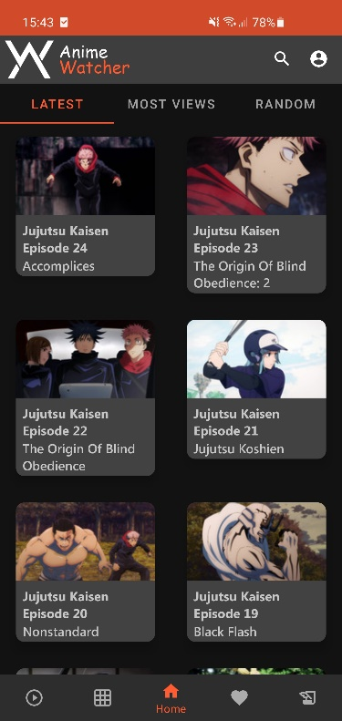 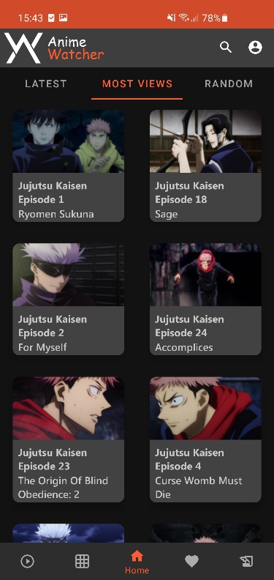 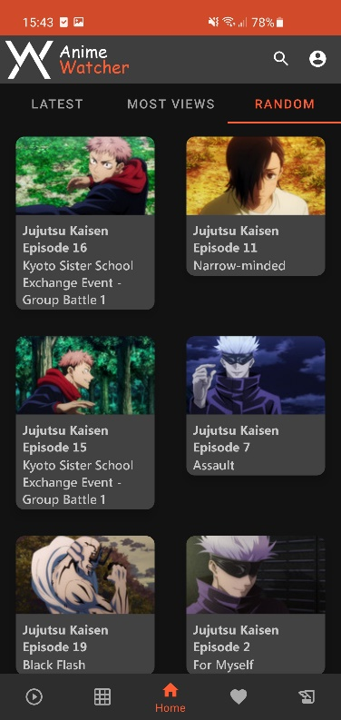

**Figura 5.6.3 – Alteatório Dark (Home)**

**Figura 5.6.2 – Mais Visualizações Dark (Home)**

**Figura 5.6.1 – Recentes Dark (Home)**

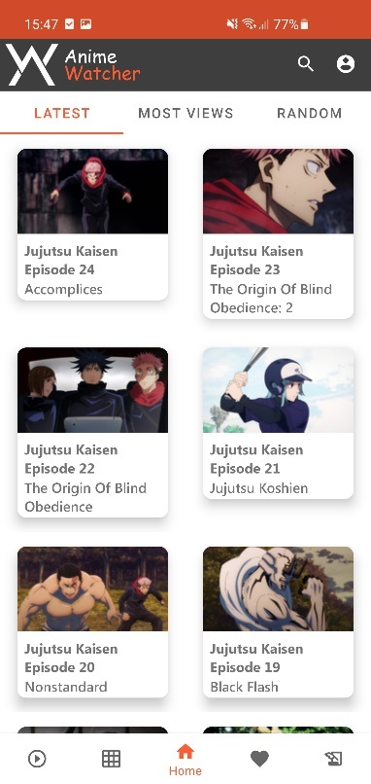 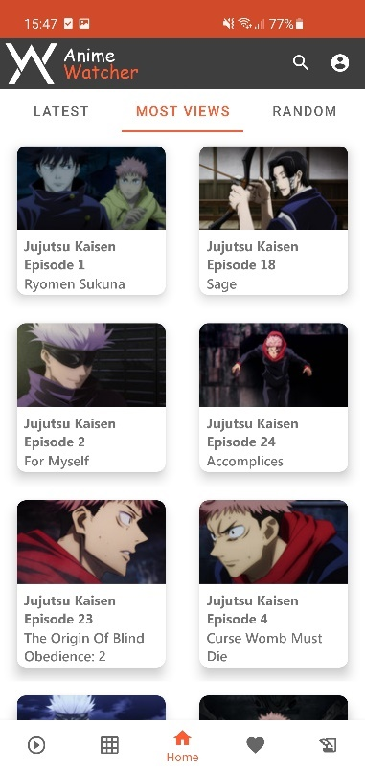 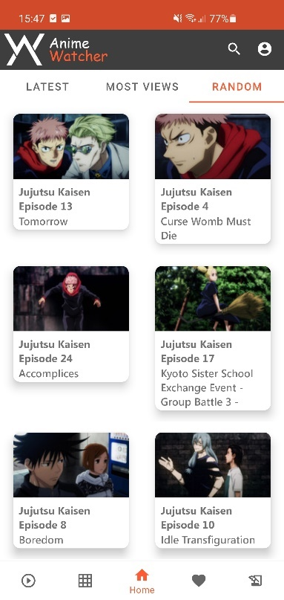

**Figura 5.6.6 – Alteatório Light (Home)**

**Figura 5.6.4 – Recentes Light (Home)**

**Figura 5.6.5 – Mais Visualizações Light (Home)**

* 1. **Categories**

Nesta aba, o utilizador pode obter uma lista com todas as categorias, assim como alguns dos *animes* pertences a cada uma das mesmas. É possível ainda obter uma lista completa com todos os *animes* dessa mesma categoria pressionando no *icon* da seta à frente do nome da categoria.

Caso uma das categorias não tenha *animes* para mostrar, aparece uma mensagem a informar o utilizador.

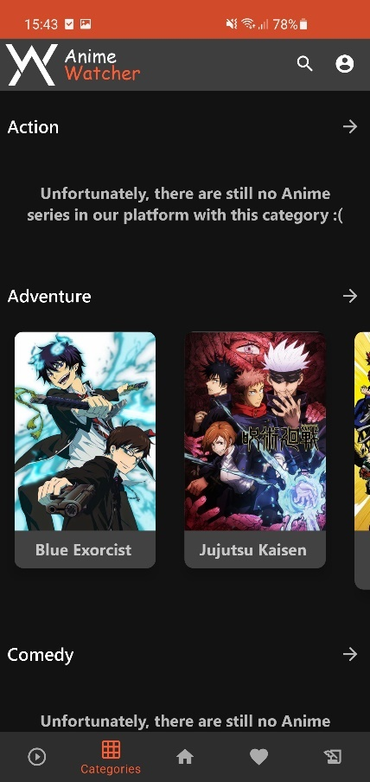 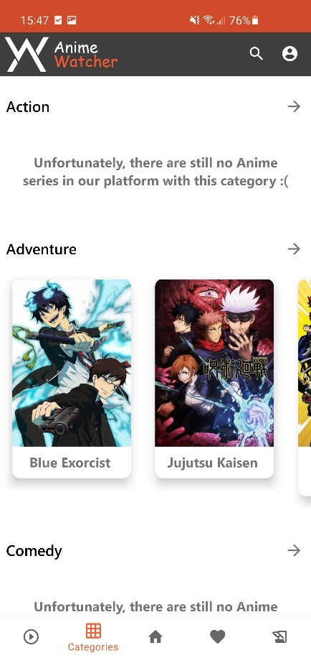

**Figura 5.6.8 – Categorias Light (Categories)**

**Figura 5.6.7 – Categorias Dark (Categories)**

* 1. **Category**

Como foi mencionado na descrição da página anterior, ao ser pressionado o *icon* da seta em frente ao nome da categoria, o utilizador é levado para esta página onde pode obter uma lista com todos os *animes* pertencentes à mesma.

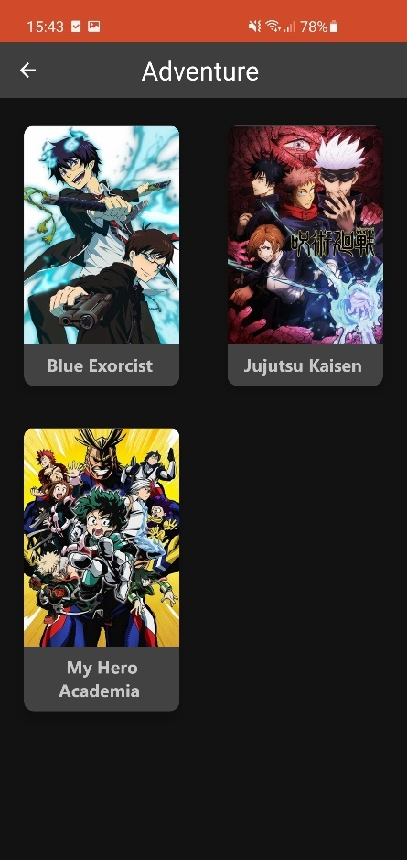 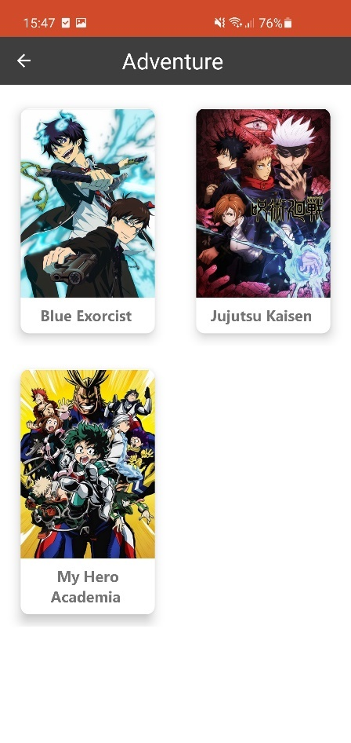

**Figura 5.6.10 – Categoria Light (Category)**

**Figura 5.6.9 – Categoria Dark (Category)**

* 1. **Anime List**

Nesta aba é possível ver todos os *animes* disponíveis na plataforma, organizados por ordem alfabética. Esta página, em termos de desenho e orientação, é muito semelhante à lista de animes de uma categoria.

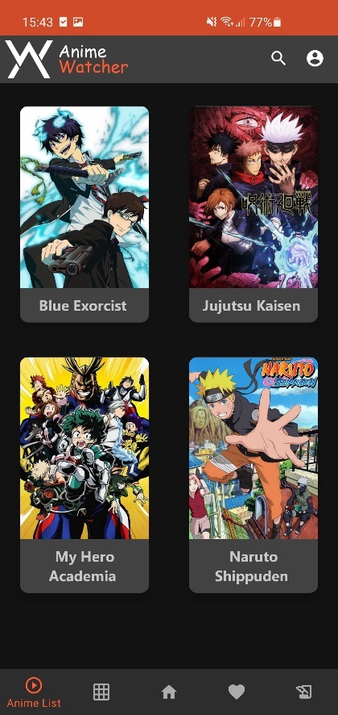 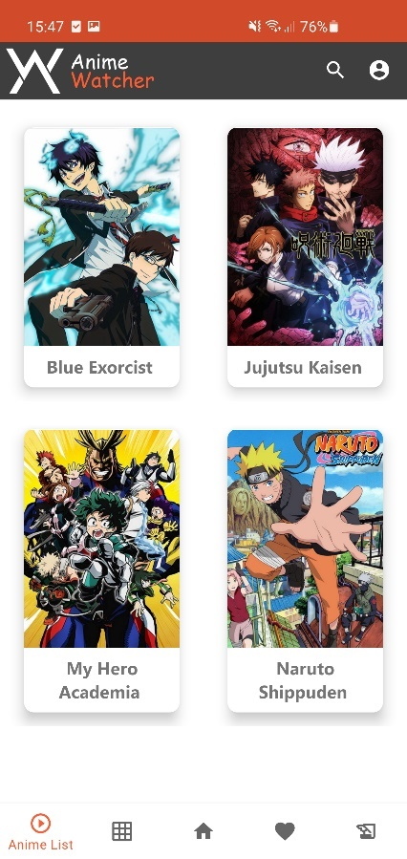

**Figura 5.6.12 – Todos os Animes Light (Anime List)**

**Figura 5.6.11 – Todos os Animes Dark (Anime List)**

* 1. **My List**

Nesta aba, é possível ver todos os animes que estão adicionados à *MyList* do utilizador. É importante referir que este deve ter o *login* efetuado na aplicação para conseguir visualizar os conteúdos da página. Caso esta seja acedida sem *login* é mostrada uma mensagem de erro e o utilizador é automaticamente reencaminhado para uma página onde o pode efetuar.

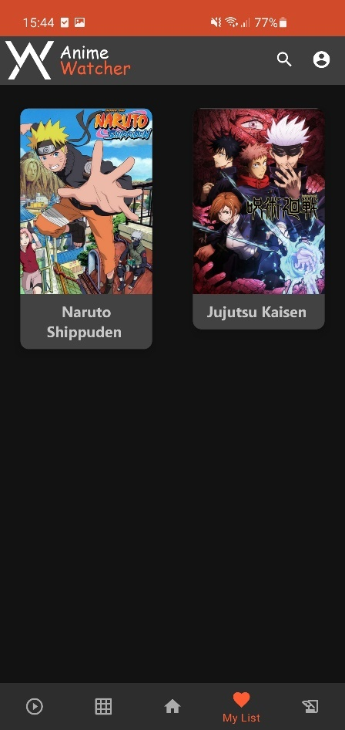 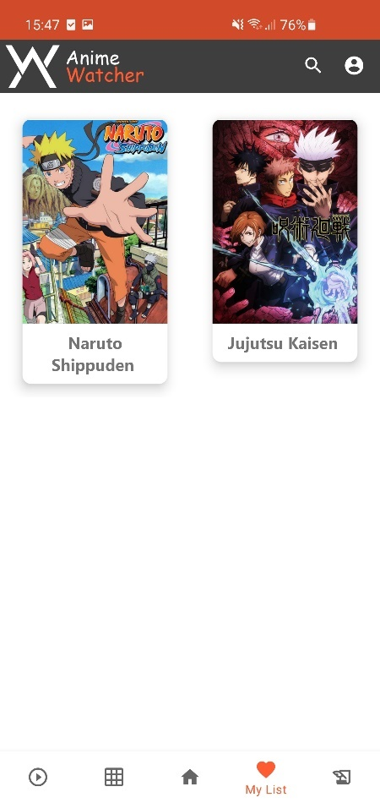

**Figura 5.6.14 – My List Light (MyList)**

**Figura 5.6.13 – My List Dark (MyList)**

* 1. **Submit Anime**

Tal como na aplicação *web*, aqui também é possível efetuar uma submissão de um *anime* ou episódio que se encontre em falta na plataforma. Esta submissão pode ser depois lida e filtrada por um administrador no painel *admin* do *site*.

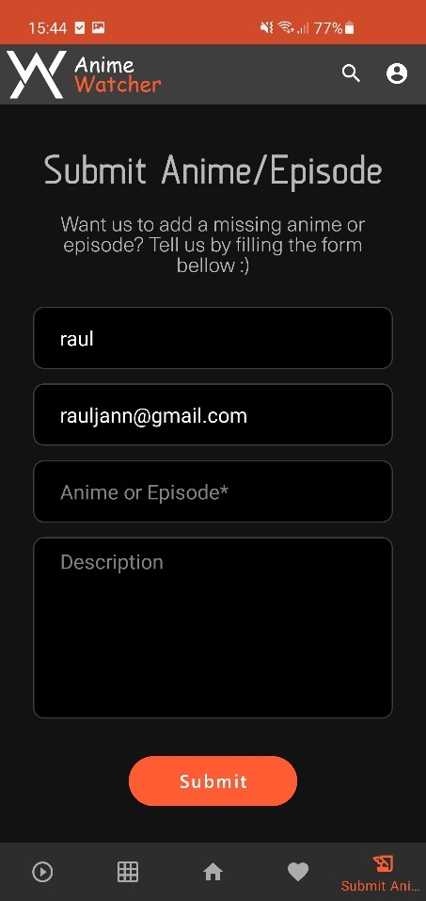 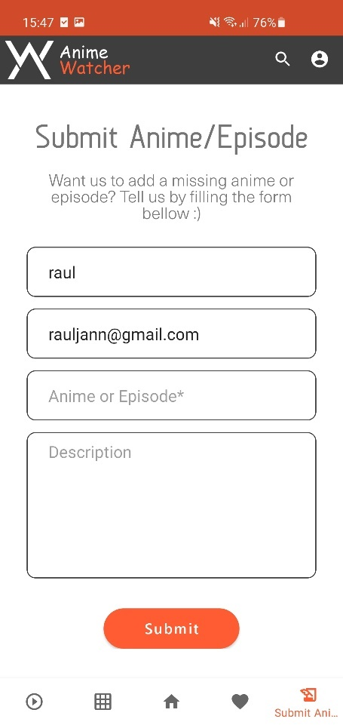

**Figura 5.6.16 – Submeter Anime Light (Submit Anime)**

**Figura 5.6.15 – Submeter Anime Dark (Submit Anime)**

* 1. **Login**

É nesta página que é possível efetuar o login na aplicação. É possível navegar até ela pelo *icon* de utilizador na barra de navegação superior ou ao tentar aceder a uma parte a aplicação que necessite de *login*.

À semelhança da aplicação web, esta página tem também uma opção de “*Forgot Pasword*” e de “Register”, que ao serem clicadas levam o utilizador para o *site*.

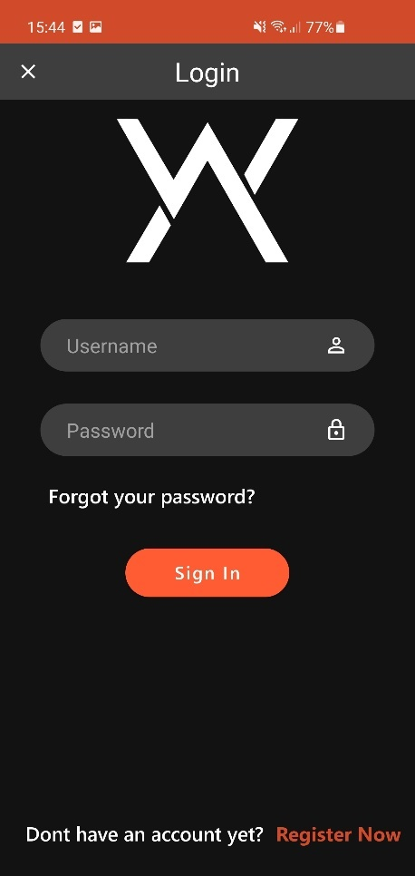 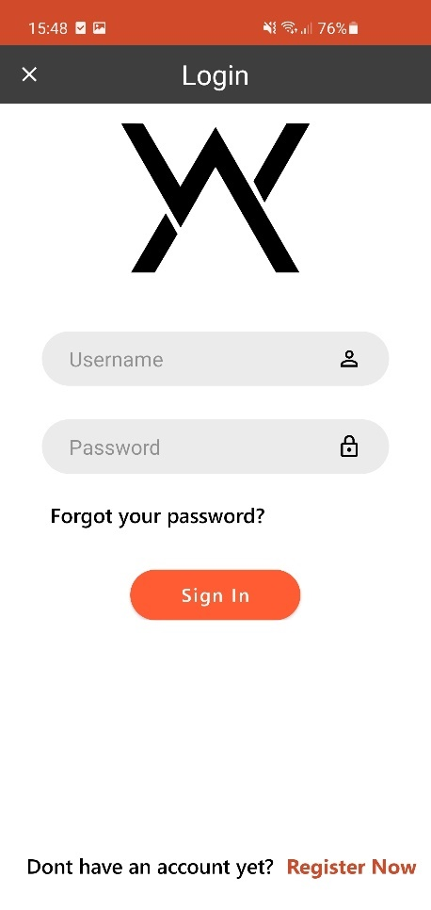

**Figura 5.6.18 – Login Light (Login)**

**Figura 5.6.17 – Login Dark (Login)**

* 1. **Search**

Na barra de navegação superior existe um *icon* em formato de lupa, quer permite a pesquisa que qualquer anime que se encontre presente na plataforma, de forma semelhante à pesquisa do *site*.

Os resultados da pesquisa são apresentados em formas retangulares que contêm uma imagem do *anime*, nome e descrição e ao serem pressionados, levam o utilizador para a página do *anime* correspondente.

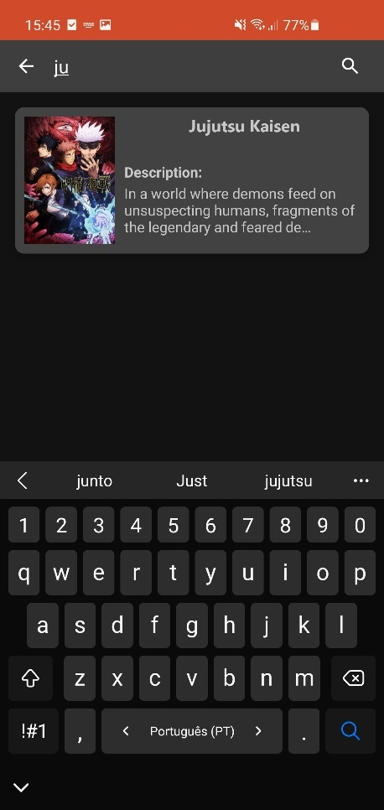 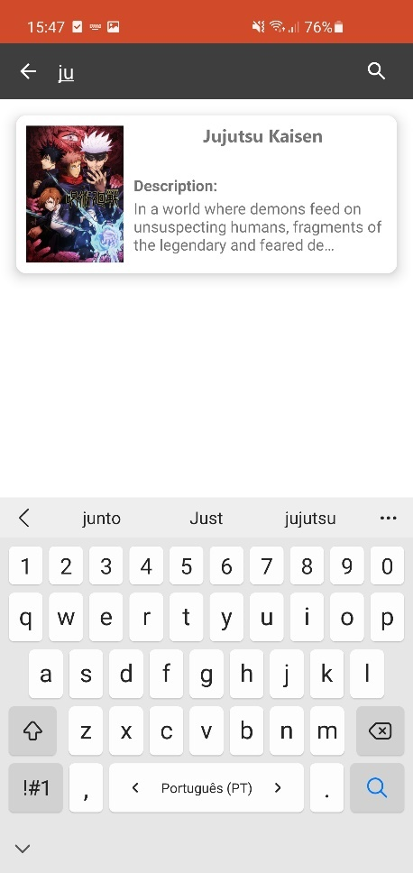

**Figura 5.6.20 – Pesquisa Light (Search)**

**Figura 5.6.19 – Pesquisa Dark (Search)**

* 1. **Account Management**

Depois de o utilizador ter efetuado login na aplicação, o *icon* de utilizador, que antes ao ser pressionado levava para a página de login, leva agora para uma página com várias opções relacionadas com a gestão da conta.

As primeiras duas opções são meramente informativas, as outras duas, quando pressionadas, levam o utilizador para as páginas respetivas no *site*. Existem ainda mais três opções, duas das quais são apenas informativas e a última para efetuar o *logout*.

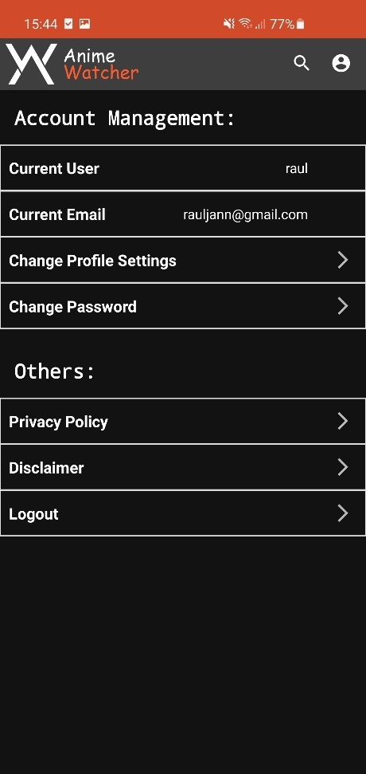 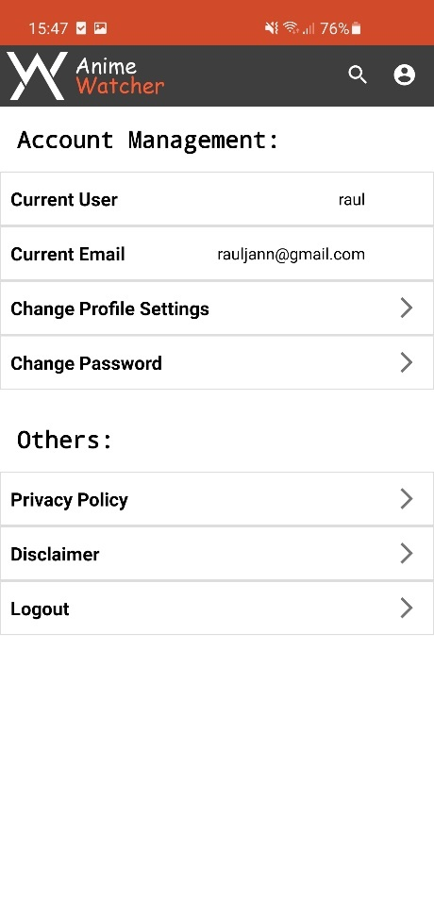

**Figura 5.6.22 – Pesquisa Dark (Search)**

**Figura 5.6.21 – Pesquisa Dark (Search)**

* 1. **Anime Page**

Ao ser pressionado um *anime*, o utilizador é levado para esta página, onde pode ver todos os episódios, assim como o título do anime e a sua imagem correspondente e adicioná-lo ou removê-lo da sua *MyList* através do botão laranja.

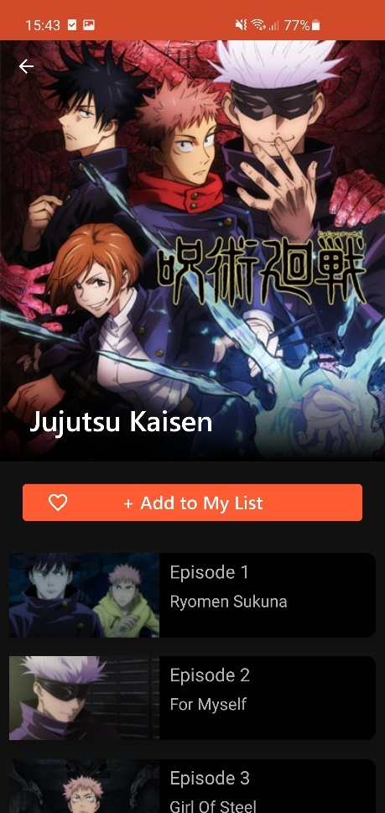 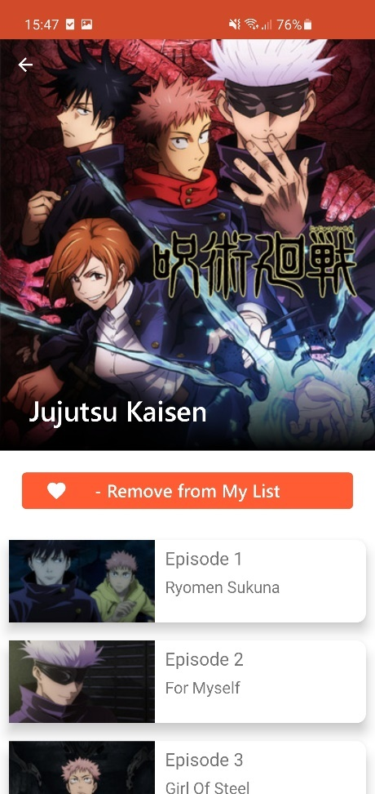

**Figura 5.6.24 – Anime Light (Anime Page)**

**Figura 5.6.23 – Anime Dark (Anime Page)**

* 1. **Episode Player**

Após um episódio ter sido pressionado, seja na página do *anime* ou na página principal, o utilizador é levado para esta página. Aqui, para além de ser possível assistir ao vídeo, é também dada alguma informação, como o título do *anime*, nome do episódio, episódio seguinte que pode ser pressionado para ver o mesmo e um botão para ver todos os episódios do *anime*.

Por cima do vídeo há ainda um menu que permite um controlo básico sobre o mesmo, com opções para saltar ou recuar 10 segundos, pausar e resumir o vídeo, colocar em ecrã inteiro, aceder ao menu das legendas e voltar atrás.

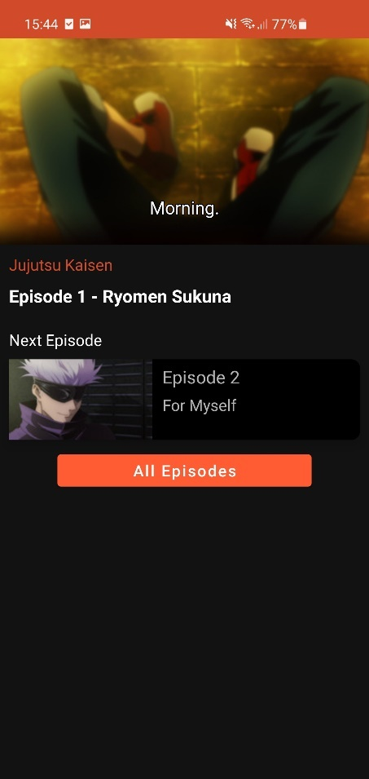 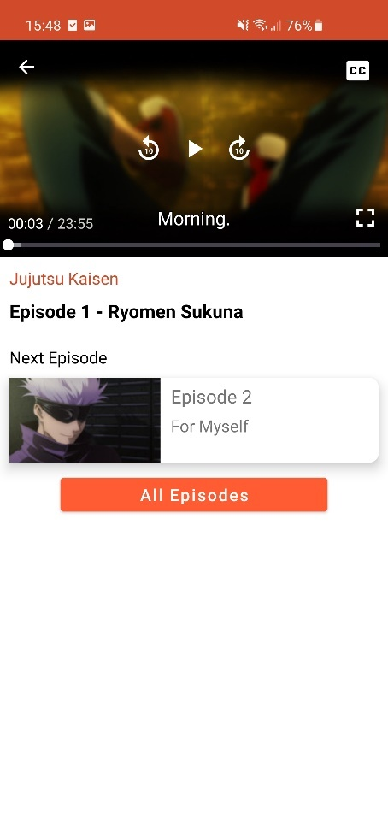

**Figura 5.6.26 – Episódio Light (Episode Player)**

**Figura 5.6.25 – Episódio Dark (Episode Player)**

* 1. **Subtitle Chooser**

Ao pressionar no botão das legendas que se encontra no menu do vídeo, o utilizador é levado para esta página, onde pode escolher outra língua ou desativar as legendas. A legenda selecionada aparece com um contorno a laranja, ou se estiverem desativadas, o contorno aparece à volta da opção “*Off*”.

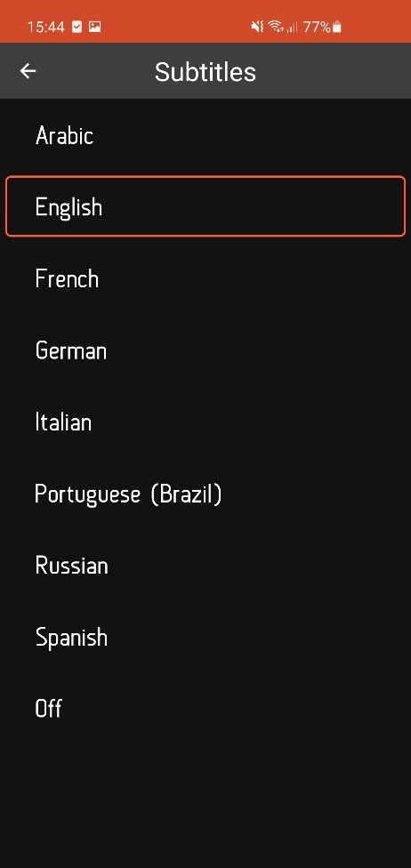 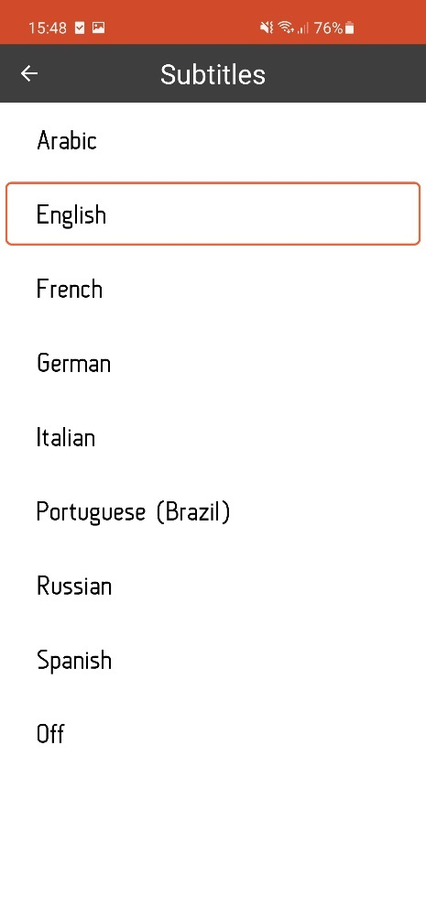

**Figura 5.6.28 – Legendas Light (Subtitle Chooser)**

**Figura 5.6.27 – Legendas Dark (Subtitle Chooser)**

**Condicionalismos**

No decorrer do desenvolvimento do projeto foram encontradas várias dificuldades que abrandaram significativamente a construção do mesmo. No entanto, apesar destes obstáculos, isso contribuiu para o desenvolvimento da capacidade de resolução de problemas.

Na aplicação *web*, as dificuldades encontradas foram de pequena escala, maioritariamente no desenho da página, já que alguns elementos não ficavam como desejado, pelo que não teve um grande impacto na produtividade. O mais difícil foi aprender a *framework* e linguagem de programação nova, que devido à sua simplicidade, não foi uma tarefa muito demorada.

Na aplicação *mobile* o mais difícil foi certamente fazer a página de reprodução do episódio. O *player* utilizado não tinha muita informação disponível na internet e sofreu muitas mudanças num curto espaço de tempo, o que significa que o que está disponível, para além da documentação, encontra-se demasiado desatualizado.

Foram ainda encontrados mais alguns problemas cuja resolução foi mais simples. Um deles era das imagens que, algumas vezes, não eram carregadas e a sua solução foi apenas trocar a *package* que carrega as imagens da “Picasso”, para a “Glide”. Outro dos problemas estava relacionado com o tema escuro, que era aplicado em algumas partes da *app* e noutras não. Acontece que nas atividades em que o tema não era aplicado, os métodos das RecyclerViews tinham como contexto getApplicationContext() que não aplica o tema e ao mudar para this, o problema foi resolvido.

**Conclusão**

Apesar de todas as dificuldades e obstáculos encontrados e de algumas funcionalidades terem ficado para trás, penso que tanto em termos de qualidade do produto final como em ganhos a nível pessoal e profissional foi positivo. No entanto há ainda muito que pode ser melhorado e implementado, até porque esta é uma aplicação que necessita de muita manutenção, uma vez que existe uma comunidade para ser moderada e saem episódios novos todos os dias.

À medida que a tecnologia se vai desenvolvendo cada vez mais as pessoas consomem e partilham conteúdo através de meios digitais. Como tal, seria uma mais valia implementar mais funcionalidade na parte de utilizador, uma vez que criar uma comunidade seria crucial para a popularidade da plataforma, já que neste momento, essa é uma parte fraca.

O maior objetivo da plataforma, proporcionar conteúdo de qualidade de forma acessível, foi atingido, já que com ela as pessoas facilmente podem ter acesso aos episódios de forma simples tanto no *site*, como na *app*.

O que tornou todo este desenvolvimento possível foi a grande motivação pelo projeto, uma vez que o tema é interessante e é algo que se pode vir a lançar futuramente. Houve uma grande falta de apoio, ou seja, estava completamente sozinho sem ter com quem partilhar pensamentos ou colocar duvidas, o provocou uma grande frustração. Foi graças a esta motivação e ao gosto pela área que me permitiu continuar a lutar pelos meus objetivos, sem nunca desistir.

**Bibliografia e Webgrafia**

**Template Principal:**

URL: <https://demo.harutheme.com/vidio/>

2018/06/24

**Template Administração:**

URL: <https://adminlte.io/>

2014

**Template Autenticação:**

ColorLib

URL: https://colorlib.com/wp/template/colorlib-regform-7/

2020

**Template Comentários:**

Erdemece, Bootstrap 3.3.0 Snippet

URL: https://bootsnipp.com/snippets/ZkexO

**Documentação Django:**

URL: https://docs.djangoproject.com/en/3.2/

2020

**Anexo A – Diagrama da Base de Dados**

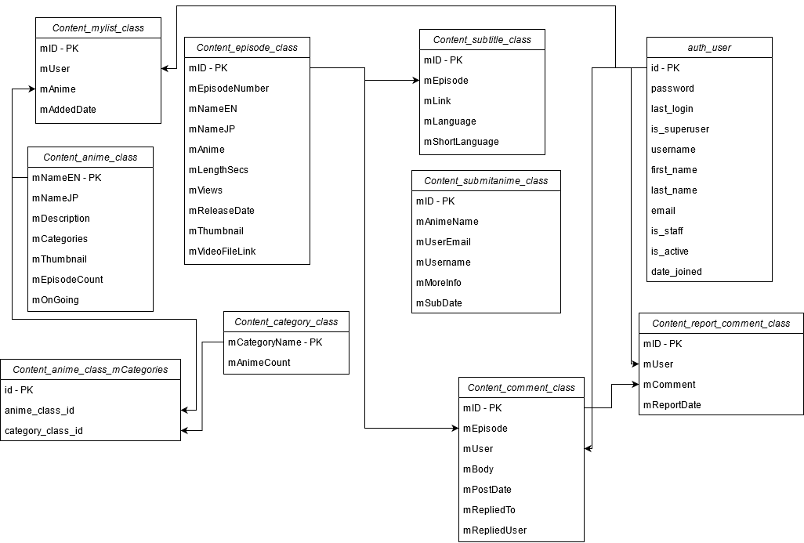

Note que há algumas tabelas específicas do *Django*, que se relacionam com a tabela “auth_user”, em falta.

**Anexo B – Tabelas da Base de Dados**

Content Anime Class – Animes:

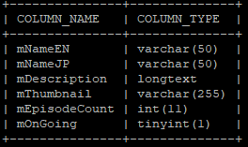

Content Anime Class mCategories – Tabela Intermedia entre animes e categorias:

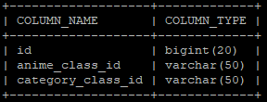

Content Category Class – Categorias:

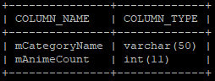

Content Comment Class – Comentários:

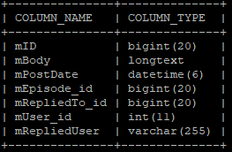

Content Episode Class – Episodios:

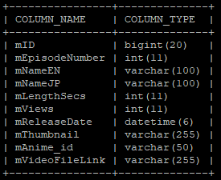

Content MyList Class – MyLists:

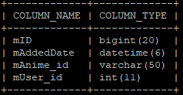

Content Report Comment Class – Comentários Reportados:

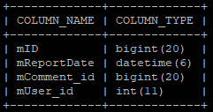

Content SubmitAnime Class – Submissões:

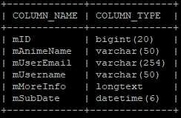

Content Subtitle Class – Legendas:

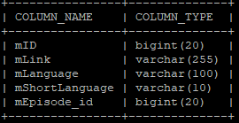

Auth Group – Grupos de utilizadores:

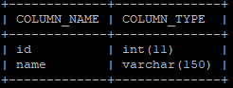

Auth Group Permissions – Permissões dos Grupos:

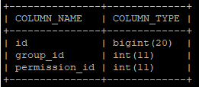

Auth Permission – Lista de permissões:

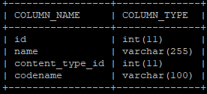

Auth User – Utilizadores:

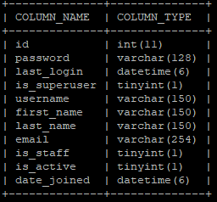

Auth User Groups – Grupos de utilizadores:

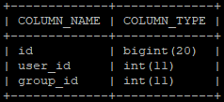

Auth User User Permissions – Permissões dos Utilizadores:

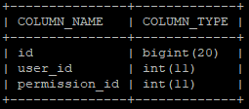

AuthToken Token – Tokens

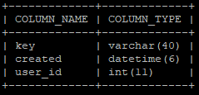

Django Admin Log:

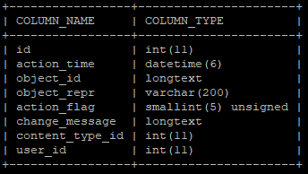

Django Content Type:

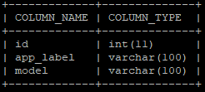

Django Migrations:

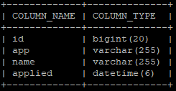

Django Session:

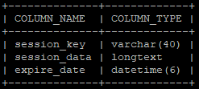

**Anexo C – settings.py**

"""

Django settings for AnimeWatcher project.

Generated by 'django-admin startproject' using Django 3.2.1.

For more information on this file, see

https://docs.djangoproject.com/en/3.2/topics/settings/

For the full list of settings and their values, see

https://docs.djangoproject.com/en/3.2/ref/settings/

"""

**import** os

**from** pathlib **import** Path

# Build paths inside the project like this: BASE_DIR / 'subdir'.

BASE_DIR **=** Path**(**__file__**).**resolve**().**parent**.**parent

# Quick-start development settings - unsuitable for production

# See https://docs.djangoproject.com/en/3.2/howto/deployment/checklist/

# SECURITY WARNING: keep the secret key used in production secret!

SECRET_KEY **=** 'django-insecure-*g22i9&=!er%9k17s3h7uvgy@b@%&04s!zit95#e6(05rs4@l5'

# SECURITY WARNING: don't run with debug turned on in production!

DEBUG **=** **True**

ALLOWED_HOSTS **=** **[**'*'**]**

# Application definition

INSTALLED_APPS **=** **[**

'django.contrib.admin'**,**

'django.contrib.auth'**,**

'django.contrib.contenttypes'**,**

'django.contrib.sessions'**,**

'django.contrib.messages'**,**

'django.contrib.staticfiles'**,**

# third party

'rest_framework'**,**

'rest_framework.authtoken'**,**

# own

'Authentication'**,**

'Content'**,**

'Admin'**,**

'Api'**,**

**]**

MIDDLEWARE **=** **[**

'django.middleware.security.SecurityMiddleware'**,**

'django.contrib.sessions.middleware.SessionMiddleware'**,**

'django.middleware.common.CommonMiddleware'**,**

'django.middleware.csrf.CsrfViewMiddleware'**,**

'django.contrib.auth.middleware.AuthenticationMiddleware'**,**

'django.contrib.messages.middleware.MessageMiddleware'**,**

'django.middleware.clickjacking.XFrameOptionsMiddleware'**,**

**]**

ROOT_URLCONF **=** 'AnimeWatcher.urls'

TEMPLATES **=** **[**

**{**

'BACKEND'**:** 'django.template.backends.django.DjangoTemplates'**,**

'DIRS'**:** **[**os**.**path**.**join**(**BASE_DIR**,** "templates"**)],**

'APP_DIRS'**:** **True,**

'OPTIONS'**:** **{**

'context_processors'**:** **[**

'django.template.context_processors.debug'**,**

'django.template.context_processors.request'**,**

'django.contrib.auth.context_processors.auth'**,**

'django.contrib.messages.context_processors.messages'**,**

**],**

**},**

**},**

**]**

WSGI_APPLICATION **=** 'AnimeWatcher.wsgi.application'

# Database

# https://docs.djangoproject.com/en/3.2/ref/settings/#databases

# Removido por questões de privacidade

DATABASES **=** **{**

'default'**:** **{**

'ENGINE'**:** 'django.db.backends.mysql'**,**

'NAME'**:** ''**,**

'HOST'**:** ''**,**

'PORT'**:** ''**,**

'USER'**:** ''**,**

'PASSWORD'**:** ''**,**

**}**

**}**

# Password validation

# https://docs.djangoproject.com/en/3.2/ref/settings/#auth-password-validators

AUTH_PASSWORD_VALIDATORS **=** **[**

**{**

'NAME'**:** 'django.contrib.auth.password_validation.UserAttributeSimilarityValidator'**,**

**},**

**{**

'NAME'**:** 'django.contrib.auth.password_validation.MinimumLengthValidator'**,**

**},**

**{**

'NAME'**:** 'django.contrib.auth.password_validation.CommonPasswordValidator'**,**

**},**

**{**

'NAME'**:** 'django.contrib.auth.password_validation.NumericPasswordValidator'**,**

**},**

**]**

# Internationalization

# https://docs.djangoproject.com/en/3.2/topics/i18n/

LANGUAGE_CODE **=** 'en-us'

TIME_ZONE **=** 'UTC'

USE_I18N **=** **True**

USE_L10N **=** **True**

USE_TZ **=** **True**

# Static files (CSS, JavaScript, Images)

# https://docs.djangoproject.com/en/3.2/howto/static-files/

STATIC_URL **=** '/static/'

MEDIA_URL **=** 'image/'

MEDIA_ROOT **=** os**.**path**.**join**(**BASE_DIR**,** 'static'**)**

STATICFILES_DIRS **=** **[**

os**.**path**.**join**(**BASE_DIR**,** 'static'**)**

**]**

# Default primary key field type

# https://docs.djangoproject.com/en/3.2/ref/settings/#default-auto-field

DEFAULT_AUTO_FIELD **=** 'django.db.models.BigAutoField'

# Email (removido por questões de privacidade)

EMAIL_HOST **=** ''

EMAIL_HOST_USER **=** ''

EMAIL_USE_TLS **=** **True**

DEFAULT_FROM_EMAIL **=** ''

EMAIL_PORT **=**

EMAIL_HOST_PASSWORD **=** ''

**Anexo D – urls.py**

"""AnimeWatcher URL Configuration

The `urlpatterns` list routes URLs to views. For more information please see:

https://docs.djangoproject.com/en/3.2/topics/http/urls/

Examples:

Function views

1. Add an import: from my_app import views

2. Add a URL to urlpatterns: path('', views.home, name='home')

Class-based views

1. Add an import: from other_app.views import Home

2. Add a URL to urlpatterns: path('', Home.as_view(), name='home')

Including another URLconf

1. Import the include() function: from django.urls import include, path

2. Add a URL to urlpatterns: path('blog/', include('blog.urls'))

"""

**from** django**.**urls **import** path

**from** Authentication**.**views **import** **\***

**from** Content**.**views **import** **\***

**from** Admin**.**views **import** **\***

**from** Api**.**views **import** **\***

urlpatterns **=** **[**

# Authentication

path**(**'login/'**,** login_view**,** name**=**'login'**),**

path**(**'register/'**,** register_view**,** name**=**'register'**),**

path**(**'logout/'**,** logout_view**,** name**=**'logout'**),**

path**(**'account-settings/'**,** account_settings_view**,** name**=**'account-settings'**),**

path**(**'account-settings/<token>/'**,** account_settings_token_view**,** name**=**'account-settings-token'**),**

path**(**'change-password/'**,** change_password_view**,** name**=**'change-password'**),**

path**(**'change-password/<token>/'**,** change_password_token_view**,** name**=**'change-password-token'**),**

path**(**'forgot-password/'**,** forgot_password_view**,** name**=**'forgot-password'**),**

path**(**'recover-password/<uidb64>/<token>/'**,** recover_password_view**,** name**=**'recover-password'**),**

path**(**'account-activation/<uidb64>/<token>/'**,** verification_view**,** name**=**'account-activation'**),**

# Content

path**(**''**,** home_view**,** name**=**'home'**),**

path**(**'about-us/'**,** about_us_view**,** name**=**'about-us'**),**

path**(**'disclaimer/'**,** disclaimer_view**,** name**=**'disclaimer'**),**

path**(**'privacy-policy/'**,** privacy_policy_view**,** name**=**'privacy-policy'**),**

path**(**'my-list/'**,** my_list_view**,** name**=**'my-list'**),**

path**(**'anime/'**,** anime_list_view**,** name**=**'anime-list'**),**

path**(**'anime/<str:AnimeID>/'**,** anime_view**,** name**=**'animes'**),**

path**(**'anime/<str:AnimeID>/<int:EpisodeID>/'**,** play_anime_view**,** name**=**'anime-player'**),**

path**(**'report-comment/<int:id>'**,** report_comment_view**,** name**=**'report-comment'**),**

path**(**'delete-comment/<int:id>'**,** delete_comment_view**,** name**=**'delete-comment'**),**

path**(**'submit-anime/'**,** submit_anime_view**,** name**=**'submit-anime'**),**

path**(**'category/<str:id>/'**,** category_view**,** name**=**'category_id'**),**

path**(**'category/'**,** category_list_view**,** name**=**'categories'**),**

# Admin

path**(**'admin/'**,** admin_home_view**,** name**=**'admin'**),**

path**(**'admin/user'**,** redirect_view**,** name**=**'admin-user'**),**

path**(**'admin/user/create'**,** admin_user_create_view**,** name**=**'admin-user-create'**),**

path**(**'admin/user/all'**,** admin_user_edit_view**,** name**=**'admin-user-all'**),**

path**(**'admin/user/edit/<str:username>'**,** admin_user_edit_username_view**,** name**=**'admin-user-edit-username'**),**

path**(**'admin/anime'**,** redirect_view**,** name**=**'admin-anime'**),**

path**(**'admin/anime/create'**,** admin_anime_create_view**,** name**=**'admin-anime-create'**),**

path**(**'admin/anime/all'**,** admin_anime_edit_view**,** name**=**'admin-anime-all'**),**

path**(**'admin/anime/edit/<str:id>'**,** admin_anime_edit_id_view**,** name**=**'admin-anime-edit-id'**),**

path**(**'admin/anime/mylist'**,** redirect_view**,** name**=**'admin-anime-mylist'**),**

path**(**'admin/anime/mylist/create'**,** admin_anime_list_create_view**,** name**=**'admin-anime-mylist-create'**),**

path**(**'admin/anime/mylist/all'**,** admin_anime_list_edit_view**,** name**=**'admin-anime-mylist-all'**),**

path**(**'admin/anime/mylist/edit/<int:id>'**,** admin_anime_list_edit_id_view**,** name**=**'admin-anime-mylist-edit-id'**),**

path**(**'admin/anime/submitted'**,** admin_anime_submitted_view**,** name**=**'admin-anime-submitted'**),**

path**(**'admin/category'**,** redirect_view**,** name**=**'admin-category'**),**

path**(**'admin/category/create'**,** admin_category_create_view**,** name**=**'admin-category-create'**),**

path**(**'admin/category/all'**,** admin_category_edit_view**,** name**=**'admin-category-all'**),**

path**(**'admin/category/edit/<str:id>'**,** admin_category_edit_id_view**,** name**=**'admin-category-edit-id'**),**

path**(**'admin/episode'**,** redirect_view**,** name**=**'admin-episode'**),**

path**(**'admin/episode/create'**,** admin_episode_create_view**,** name**=**'admin-episode-create'**),**

path**(**'admin/episode/all'**,** admin_episode_edit_view**,** name**=**'admin-episode-all'**),**

path**(**'admin/episode/edit/<int:id>'**,** admin_episode_edit_id_view**,** name**=**'admin-episode-edit-id'**),**

path**(**'admin/subtitle'**,** redirect_view**,** name**=**'admin-subtitle'**),**

path**(**'admin/subtitle/create'**,** admin_subtitle_create_view**,** name**=**'admin-subtitle-create'**),**

path**(**'admin/subtitle/all'**,** admin_subtitle_edit_view**,** name**=**'admin-subtitle-all'**),**

path**(**'admin/subtitle/edit/<int:id>'**,** admin_subtitle_edit_id_view**,** name**=**'admin-subtitle-edit-id'**),**

path**(**'admin/reported-comments'**,** admin_rep_comments_view**,** name**=**'admin-repcomments'**),**

# Api

path**(**'api/authenticate-user'**,** authenticate_user**,** name**=**'api-authenticate-user'**),**

path**(**'api/logout'**,** logout_user**,** name**=**'api-logout'**),**

path**(**'api/submit-anime'**,** submit_anime**,** name**=**'api-submit-anime'**),**

path**(**'api/get-all-anime'**,** get_all_anime**,** name**=**'api-get-all-anime'**),**

path**(**'api/get-mylist-anime'**,** get_mylist_anime**,** name**=**'api-get-mylist-anime'**),**

path**(**'api/get-search-anime'**,** get_search_anime**,** name**=**'api-get-search-anime'**),**

path**(**'api/get-string-categories'**,** get_string_cats**,** name**=**'api-get-string-categories'**),**

path**(**'api/get-category-anime'**,** get_category_anime**,** name**=**'api-get-category-anime'**),**

path**(**'api/get-episodes'**,** get_episodes**,** name**=**'api-get-episodes'**),**

path**(**'api/get-episodes-latest'**,** get_episodes_latest**,** name**=**'api-get-episodes-latest'**),**

path**(**'api/get-episodes-most-views'**,** get_episodes_most_views**,** name**=**'api-get-episodes-most-views'**),**

path**(**'api/get-episodes-random'**,** get_episodes_random**,** name**=**'api-get-episodes-random'**),**

path**(**'api/get-episode'**,** get_episode**,** name**=**'api-get-episode'**),**

path**(**'api/get-episode-next'**,** get_episode_next**,** name**=**'api-get-episode-next'**),**

path**(**'api/get-anime-thumbnail'**,** get_anime_thumbnail**,** name**=**'api-get-anime-thumbnail'**),**

path**(**'api/episode-add-view'**,** episode_add_view**,** name**=**'api-episode-add-view'**),**

path**(**'api/check-token'**,** check_token**,** name**=**'api-check-token'**),**

path**(**'api/get-episode-subtitles'**,** get_episode_subtitles**,** name**=**'api-get-episode-subtitles'**),**

path**(**'api/get-subtitle'**,** get_subtitle**,** name**=**'api-get-subtitle'**),**

path**(**'api/my-list-add'**,** add_mylist**,** name**=**'api-my-list-add'**),**

path**(**'api/my-list-remove'**,** remove_mylist**,** name**=**'api-my-list-remove'**),**

path**(**'api/my-list-check'**,** check_mylist**,** name**=**'api-my-list-check'**),**

**]**

**Anexo E – Content\views.py**

**import** datetime

**from** random **import** shuffle

**from** django**.**contrib**.**auth**.**decorators **import** login_required

**from** django**.**shortcuts **import** render**,** redirect

**from** django**.**contrib **import** messages

**from** **.**models **import** **\***

**def** home_view**(**request**):**

objs **=** Category_class**.**objects**.all()**

LatestEpisodeObjs **=** Episode_class**.**objects**.**order_by**(**'-mReleaseDate'**)**

MostViewsEpisodeObjs **=** Episode_class**.**objects**.**order_by**(**'-mViews'**)**

RandomEpisodeObjs **=** **list(**Episode_class**.**objects**.all())**

shuffle**(**RandomEpisodeObjs**)**

content **=** **{**

'request'**:** request**,**

'pageTitle'**:** 'Home'**,**

'objs'**:** objs**,**

'LatestEpisodeObjs'**:** LatestEpisodeObjs**,**

'MostViewsEpisodeObjs'**:** MostViewsEpisodeObjs**,**

'RandomEpisodeObjs'**:** RandomEpisodeObjs**,**

'qtdAnimeObjs'**:** Episode_class**.**objects**.**count**()**

**}**

**return** render**(**request**,** "content/index.html"**,** content**)**

**def** about_us_view**(**request**):**

content **=** **{**

'request'**:** request**,**

'pageTitle'**:** 'About us'

**}**

**return** render**(**request**,** "content/about-us.html"**,** content**)**

**def** disclaimer_view**(**request**):**

content **=** **{**

'request'**:** request**,**

'pageTitle'**:** 'Disclaimer'

**}**

**return** render**(**request**,** "content/disclaimer.html"**,** content**)**

**def** privacy_policy_view**(**request**):**

content **=** **{**

'request'**:** request**,**

'pageTitle'**:** 'Privacy Policy'

**}**

**return** render**(**request**,** "content/privacy-policy.html"**,** content**)**

**def** anime_list_view**(**request**):**

searchRes **=** request**.**GET**.**get**(**'s'**,** ''**)**

**if** searchRes**:**

objs **=** Anime_class**.**objects**.filter(**mNameEN__contains**=**searchRes**.**lower**()).**order_by**(**'mNameEN'**)**

qtdAnimes **=** objs**.**count**()**

**else:**

objs **=** Anime_class**.**objects**.**order_by**(**'mNameEN'**)**

qtdAnimes **=** Anime_class**.**objects**.**count**()**

EpisodeObjs **=** Episode_class**.**objects**.all()**

content **=** **{**

'request'**:** request**,**

'pageTitle'**:** 'Anime List'**,**

'objs'**:** objs**,**

'qtdAnimes'**:** qtdAnimes**,**

'EpisodeObjs'**:** EpisodeObjs

**}**

**return** render**(**request**,** "content/animes.html"**,** content**)**

**def** anime_view**(**request**,** AnimeID**):**

objAnime **=** Anime_class**.**objects**.**get**(**pk**=**AnimeID**)**

EpObjs **=** Episode_class**.**objects**.**order_by**(**'mEpisodeNumber'**)**

isInList **=** **False**

# Check if the anime is already added to the list

objs **=** MyList_class**.**objects**.all()**

**for** obj **in** objs**:**

**if** obj**.**mAnime **==** objAnime **and** obj**.**mUser **==** request**.**user**:**

isInList **=** **True**

**break**

**if** request**.**method **==** 'POST'**:**

**if** **not** request**.**user**.**is_authenticated**:**

**return** redirect**(**'login'**)**

**else:**

**if** **not** isInList**:**

myListObj **=** MyList_class**(**mAnime**=**objAnime**,** mUser**=**request**.**user**,** mAddedDate**=**datetime**.**date**.**today**())**

myListObj**.**save**()**

messages**.**success**(**request**,** 'Anime added to your list successfully!'**)**

**return** redirect**(**'/anime/' **+** AnimeID**)**

**else:**

obj**.**delete**()**

messages**.**success**(**request**,** 'Anime removed from your list successfully!'**)**

isInList **=** **False**

content **=** **{**

'request'**:** request**,**

'pageTitle'**:** objAnime**.**mNameEN**,**

'objAnime'**:** objAnime**,**

'EpObjs'**:** EpObjs**,**

'isInList'**:** isInList**,**

**}**

**return** render**(**request**,** "content/anime.html"**,** content**)**

**def** play_anime_view**(**request**,** AnimeID**,** EpisodeID**):**

objAnime **=** Anime_class**.**objects**.**get**(**pk**=**AnimeID**)**

objEpisode **=** Episode_class**.**objects**.**get**(**pk**=**EpisodeID**)**

objsSubtitle **=** Subtitle_class**.**objects**.all()**

objsEpisode **=** Episode_class**.**objects**.**order_by**(**'mEpisodeNumber'**)**

commentObjs **=** Comment_class**.**objects**.filter(**mEpisode**=**objEpisode**).**order_by**(**'mPostDate'**)**

# Add a view to the anime

objEpisode**.**mViews **=** objEpisode**.**mViews **+** 1

objEpisode**.**save**()**

# Get previous and next episode

prevEp **=** ''

nextEp **=** ''

episodes **=** Episode_class**.**objects**.all()**

**for** obj **in** episodes**:**

**if** obj**.**mAnime **==** objAnime **and** obj**.**mEpisodeNumber **==** objEpisode**.**mEpisodeNumber **+** 1**:**

nextEp **=** obj

**elif** obj**.**mAnime **==** objAnime **and** obj**.**mEpisodeNumber **==** objEpisode**.**mEpisodeNumber **-** 1**:**

prevEp **=** obj

test **=** ''

**if** request**.**method **==** 'POST'**:**

**if** request**.**user**.**is_authenticated**:**

**if** request**.**POST**.**get**(**'post'**)** **==** 'new'**:**

commentText **=** request**.**POST**.**get**(**'commentText'**)**

**if** commentText**:**

newComment **=** Comment_class**(**mEpisode**=**objEpisode**,** mUser**=**request**.**user**,** mBody**=**commentText**)**

newComment**.**save**()**

**elif** request**.**POST**.**get**(**'post'**)** **is** **not** **None:**

postReplied **=** request**.**POST**.**get**(**'post'**)**

commentText **=** request**.**POST**.**get**(**'commentText'**)**

postReplied **=** postReplied**.**split**(**","**)**

**if** commentText**:**

comment **=** Comment_class**(**mEpisode**=**objEpisode**,** mUser**=**request**.**user**,** mBody**=**commentText**,** mRepliedTo**=**Comment_class**.**objects**.**get**(**pk**=**postReplied**[**0**]),** mRepliedUser**=**'@' **+** postReplied**[**1**])**

comment**.**save**()**

**else:**

**return** redirect**(**'login'**)**

content **=** **{**

'request'**:** request**,**

'pageTitle'**:** objAnime**.**mNameEN **+** ' Episode ' **+** **str(**objEpisode**.**mEpisodeNumber**),**

'objAnime'**:** objAnime**,**

'objEpisode'**:** objEpisode**,**

'objsSubtitle'**:** objsSubtitle**,**

'prevEp'**:** prevEp**,**

'nextEp'**:** nextEp**,**

'commentObjs'**:** commentObjs**,**

'objsEpisode'**:** objsEpisode

**}**

**return** render**(**request**,** "content/anime-player.html"**,** content**)**

@login_required**(**login_url**=**'login'**)**

**def** report_comment_view**(**request**,** **id):**

comment **=** Comment_class**.**objects**.**get**(**pk**=id)**

report **=** Report_Comment_Class**(**mUser**=**request**.**user**,** mComment**=**comment**)**

report**.**save**()**

**return** redirect**(**'/anime/' **+** comment**.**mEpisode**.**mAnime**.**mNameEN **+** '/' **+** **str(**comment**.**mEpisode**.**mID**))**

@login_required**(**login_url**=**'login'**)**

**def** delete_comment_view**(**request**,** **id):**

comment **=** Comment_class**.**objects**.**get**(**pk**=id)**

animeName **=** comment**.**mEpisode**.**mAnime**.**mNameEN

episodeID **=** **str(**comment**.**mEpisode**.**mID**)**

comment**.**delete**()**

**return** redirect**(**'/anime/' **+** animeName **+** '/' **+** episodeID**)**

@login_required**(**login_url**=**'login'**)**

**def** my_list_view**(**request**):**

myListObjs **=** MyList_class**.**objects**.**order_by**(**'mAddedDate'**)**

myListCount **=** MyList_class**.**objects**.filter(**mUser**=**request**.**user**).**count**()**

# get anime count

qtdAnime **=** 0

**for** obj **in** myListObjs**:**

**if** obj**.**mUser **==** request**.**user**:**

qtdAnime **=** qtdAnime **+** 1

content **=** **{**

'request'**:** request**,**

'pageTitle'**:** 'My List'**,**

'myListObjs'**:** myListObjs**,**

'qtdAnimes'**:** qtdAnime**,**

'myListCount'**:** myListCount

**}**

**return** render**(**request**,** "content/my-list.html"**,** content**)**

**def** submit_anime_view**(**request**):**

**if** request**.**method **==** 'POST'**:**

username **=** request**.**POST**.**get**(**'username'**)**

email **=** request**.**POST**.**get**(**'email'**)**

anime **=** request**.**POST**.**get**(**'anime'**)**

description **=** request**.**POST**.**get**(**'description'**)**

**if** username **and** email **and** anime**:**

obj **=** SubmitAnime_class**(**mAnimeName**=**anime**,** mUserEmail**=**email**,** mUsername**=**username**,** mMoreInfo**=**description**,** mSubDate**=**datetime**.**datetime**.**now**())**

obj**.**save**()**

messages**.**success**(**request**,** 'Your request was submitted successfully!'**)**

**else:**

messages**.**error**(**request**,** 'Please fill in all the mandatory fields!'**,** extra_tags**=**'error'**)**

content **=** **{**

'request'**:** request**,**

'pageTitle'**:** 'Submit Anime'

**}**

**return** render**(**request**,** "content/submit-anime.html"**,** content**)**

**def** category_list_view**(**request**):**

objs **=** Category_class**.**objects**.all()**

anime_objs **=** Anime_class**.**objects**.all()**

qtdCat **=** Category_class**.**objects**.**count**()**

content **=** **{**

'objs'**:** objs**,**

'request'**:** request**,**

'pageTitle'**:** 'Categories'**,**

'qtdCat'**:** qtdCat**,**

'anime_objs'**:** anime_objs

**}**

**return** render**(**request**,** "content/categories.html"**,** content**)**

**def** category_view**(**request**,** **id):**

CategoryObj **=** Category_class**.**objects**.**get**(**mCategoryName**=id)**

AnimeObjs **=** Anime_class**.**objects**.**order_by**(**'mNameEN'**)**

test **=** ''

# find anime count with that category

qtdAnimes **=** 0

**for** AnimeObj **in** AnimeObjs**:**

**for** CatObj **in** AnimeObj**.**mCategories**.all():**

**if** CatObj**.**mCategoryName **==** CategoryObj**.**mCategoryName**:**

qtdAnimes **=** qtdAnimes **+** 1

**break**

content **=** **{**

'CategoryObj'**:** CategoryObj**,**

'AnimeObjs'**:** AnimeObjs**,**

'request'**:** request**,**

'pageTitle'**:** **id,**

'qtdAnimes'**:** qtdAnimes**,**

**}**

**return** render**(**request**,** 'content/category.html'**,** content**)**

**Anexo F – Content\models.py**

**from** django**.**db **import** models

**from** django**.**conf **import** settings

# Create your models here.

**class** **Anime_class(**models**.**Model**):**

mNameEN **=** models**.**CharField**(**primary_key**=True,** max_length**=**50**,** unique**=True,** null**=False)**

mNameJP **=** models**.**CharField**(**null**=True,** max_length**=**50**)**

mDescription **=** models**.**TextField**(**null**=False)**

mCategories **=** models**.**ManyToManyField**(**'Category_class'**)**

mThumbnail **=** models**.**CharField**(**null**=True,** max_length**=**255**)**

mEpisodeCount **=** models**.**IntegerField**(**null**=False,** default**=**0**)**

mOnGoing **=** models**.**BooleanField**(**default**=False)**

**class** **Episode_class(**models**.**Model**):**

mID **=** models**.**BigAutoField**(**primary_key**=True)**

mEpisodeNumber **=** models**.**IntegerField**(**null**=False)**

mNameEN **=** models**.**CharField**(**null**=False,** max_length**=**100**)**

mNameJP **=** models**.**CharField**(**null**=True,** max_length**=**100**)**

mAnime **=** models**.**ForeignKey**(**Anime_class**,** on_delete**=**models**.**CASCADE**,** null**=False)**

mLengthSecs **=** models**.**IntegerField**(**null**=False)**

mViews **=** models**.**IntegerField**(**null**=False)**

mReleaseDate **=** models**.**DateTimeField**(**null**=False)**

mThumbnail **=** models**.**CharField**(**null**=True,** max_length**=**255**)**

mVideoFileLink **=** models**.**CharField**(**null**=True,** max_length**=**255**)**

**class** **Subtitle_class(**models**.**Model**):**

mID **=** models**.**BigAutoField**(**primary_key**=True)**

mEpisode **=** models**.**ForeignKey**(**Episode_class**,** on_delete**=**models**.**CASCADE**,** null**=False)**

mLink **=** models**.**CharField**(**null**=False,** max_length**=**255**)**

mLanguage **=** models**.**CharField**(**null**=False,** max_length**=**100**)**

mShortLanguage **=** models**.**CharField**(**null**=False,** max_length**=**10**)**

**class** **Category_class(**models**.**Model**):**

mCategoryName **=** models**.**CharField**(**primary_key**=True,** null**=False,** max_length**=**50**,** unique**=True)**

mAnimeCount **=** models**.**IntegerField**(**null**=False,** default**=**0**)**

**class** **SubmitAnime_class(**models**.**Model**):**

mID **=** models**.**BigAutoField**(**primary_key**=True)**

mAnimeName **=** models**.**CharField**(**null**=False,** max_length**=**50**)**

mUserEmail **=** models**.**EmailField**(**null**=False)**

mUsername **=** models**.**CharField**(**null**=False,** max_length**=**50**)**

mMoreInfo **=** models**.**TextField**(**null**=True)**

mSubDate **=** models**.**DateTimeField**(**null**=True)**

**class** **MyList_class(**models**.**Model**):**

mID **=** models**.**BigAutoField**(**primary_key**=True)**

mUser **=** models**.**ForeignKey**(**settings**.**AUTH_USER_MODEL**,** on_delete**=**models**.**CASCADE**,** null**=False)**

mAnime **=** models**.**ForeignKey**(**Anime_class**,** on_delete**=**models**.**CASCADE**,** null**=False)**

mAddedDate **=** models**.**DateTimeField**(**null**=False)**

**class** **Comment_class(**models**.**Model**):**

mID **=** models**.**BigAutoField**(**primary_key**=True)**

mEpisode **=** models**.**ForeignKey**(**Episode_class**,** on_delete**=**models**.**CASCADE**,** null**=False)**

mUser **=** models**.**ForeignKey**(**settings**.**AUTH_USER_MODEL**,** on_delete**=**models**.**CASCADE**,** null**=False)**

mBody **=** models**.**TextField**(**null**=False)**

mPostDate **=** models**.**DateTimeField**(**auto_now_add**=True)**

mRepliedTo **=** models**.**ForeignKey**(**'self'**,** on_delete**=**models**.**CASCADE**,** null**=True)**

mRepliedUser **=** models**.**CharField**(**max_length**=**255**,** null**=True)**

**class** **Report_Comment_Class(**models**.**Model**):**

mID **=** models**.**BigAutoField**(**primary_key**=True)**

mUser **=** models**.**ForeignKey**(**settings**.**AUTH_USER_MODEL**,** on_delete**=**models**.**CASCADE**,** null**=False)**

mComment **=** models**.**ForeignKey**(**Comment_class**,** on_delete**=**models**.**CASCADE**,** null**=False)**

mReportDate **=** models**.**DateTimeField**(**auto_now_add**=True)**

**Anexo G – templatetags\sectodur.py**

# Import template library

**from** django **import** template

# Set register

register **=** template**.**Library**()**

# Register filter

@register**.filter**

**def** sectodur**(**value**,** arg**=**''**):**

"""

#######################################################

# #

# Seconds-to-Duration Template Tag #

# Dan Ward 2009 (http://d-w.me) #

# #

#######################################################

Usage: {{ VALUE|sectodur[:"long"] }}

NOTE: Please read up 'Custom template tags and filters'

if you are unsure as to how the template tag is

implemented in your project.

"""

# Place seconds in to integer

secs **=** **int(**value**)**

# If seconds are greater than 0

**if** secs **>** 0**:**

# Import math library

**import** math

# Place durations of given units in to variables

daySecs **=** 86400

hourSecs **=** 3600

minSecs **=** 60

# If short string is enabled

**if** arg **==** 'long'**:**

# Set short names

dayUnitName **=** ' day'

hourUnitName **=** ' hr'

minUnitName **=** ' min'

secUnitName **=** ' sec'

# Set short duration unit splitters

lastDurSplitter **=** ' '

nextDurSplitter **=** lastDurSplitter

# If short string is not provided or any other value

**else:**

# Set long names

dayUnitName **=** ':'

hourUnitName **=** ':'

minUnitName **=** ':'

secUnitName **=** ''

# Set long duration unit splitters

lastDurSplitter **=** ''

nextDurSplitter **=** ', '

# Create string to hold output

durationString **=** ''

# Calculate number of days from seconds

days **=** **int(**math**.**floor**(**secs **/** **int(**daySecs**)))**

# Subtract days from seconds

secs **=** secs **-** **(**days **\*** **int(**daySecs**))**

# Calculate number of hours from seconds (minus number of days)

hours **=** **int(**math**.**floor**(**secs **/** **int(**hourSecs**)))**

# Subtract hours from seconds

secs **=** secs **-** **(**hours **\*** **int(**hourSecs**))**

# Calculate number of minutes from seconds (minus number of days and hours)

minutes **=** **int(**math**.**floor**(**secs **/** **int(**minSecs**)))**

# Subtract days from seconds

secs **=** secs **-** **(**minutes **\*** **int(**minSecs**))**

# Calculate number of seconds (minus days, hours and minutes)

seconds **=** secs

# If number of days is greater than 0

**if** days **>** 0 **and** arg **==** 'long'**:**

# Add multiple days to duration string

durationString **+=** ' ' **+** **str(**days**)** **+** dayUnitName **+** **(**days **>** 1 **and** 's' **or** ''**)**

**elif** days **>** 0**:**

# Add multiple days to duration string

durationString **+=** '' **+** **str(**days**)** **+** dayUnitName **+** **(**days **>** 1 **and** '' **or** ''**)**

hourSplitter **=** ''

# Determine if next string is to be shown

**if** hours **>** 0**:**

# If there are no more units after this

**if** minutes **<=** 0 **and** seconds **<=** 0**:**

# Set hour splitter to last

hourSplitter **=** lastDurSplitter

# If there are unit after this

**else:**

# Set hour splitter to next

hourSplitter **=** **(len(**durationString**)** **>** 0 **and** nextDurSplitter **or** ''**)**

# If number of hours is greater than 0

**if** hours **>** 0 **and** arg **==** 'long'**:**

# Add multiple days to duration string

durationString **+=** hourSplitter **+** ' ' **+** **str(**hours**)** **+** hourUnitName **+** **(**hours **>** 1 **and** 's' **or** ''**)**

**elif** hours **>** 0**:**

# Add multiple days to duration string

durationString **+=** hourSplitter **+** '' **+** **str(**hours**)** **+** hourUnitName **+** **(**hours **>** 1 **and** '' **or** ''**)**

# Determine if next string is to be shown

**if** minutes **>=** 0**:**

# Set minute splitter to next

minSplitter **=** **(len(**durationString**)** **>** 0 **and** nextDurSplitter **or** ''**)**

# If number of minutes is greater than 0

**if** minutes **>** 0 **and** arg **==** 'long'**:**

# Add multiple days to duration string

durationString **+=** minSplitter **+** ' ' **+** **str(**minutes**)** **+** minUnitName **+** **(**minutes **>** 1 **and** 's' **or** ''**)**

**elif** minutes **>** 0**:**

**if** minutes **>** 10**:**

# Add multiple days to duration string

durationString **+=** minSplitter **+** '' **+** **str(**minutes**)** **+** minUnitName **+** **(**minutes **>** 1 **and** '' **or** ''**)**

**else:**

# Add multiple days to duration string

durationString **+=** minSplitter **+** '' **+** '0' **+** **str(**minutes**)** **+** minUnitName **+** **(**minutes **>** 1 **and** '' **or** ''**)**

**elif** minutes **==** 0**:**

durationString **+=** minSplitter **+** '' **+** **str(**minutes**)** **+** '0' **+** minUnitName **+** **(**minutes **>** 1 **and** '' **or** ''**)**

# Determine if next string is last

**if** seconds **>=** 0**:**

# Set second splitter

secSplitter **=** **(len(**durationString**)** **>** 0 **and** lastDurSplitter **or** ''**)**

# If number of seconds is greater than 0

**if** seconds **>** 0 **and** arg **==** 'long'**:**

# Add multiple days to duration string

durationString **+=** secSplitter **+** ' ' **+** **str(**seconds**)** **+** secUnitName **+** **(**seconds **>** 1 **and** 's' **or** ''**)**

**elif** seconds **>** 0**:**

**if** seconds **>** 10**:**

# Add multiple days to duration string

durationString **+=** secSplitter **+** '' **+** **str(**seconds**)** **+** secUnitName **+** **(**seconds **>** 1 **and** '' **or** ''**)**

**else:**

# Add multiple days to duration string

durationString **+=** secSplitter **+** '' **+** '0' **+** **str(**seconds**)** **+** secUnitName **+** **(**seconds **>** 1 **and** '' **or** ''**)**

**elif** seconds **==** 0**:**

durationString **+=** secSplitter **+** '' **+** **str(**seconds**)** **+** secUnitName **+** **(**seconds **>** 1 **and** '' **or** ''**)** **+** '0'

# Return duration string

**return** durationString**.**strip**()**

# If seconds are not greater than 0

**else:**

# Provide 'No duration' message

**return** 'No duration'

**Anexo H – Authentication\views.py**

**import** django**.**views**.**defaults

**from** django**.**conf **import** settings

**from** django**.**http **import** HttpResponseNotFound

**from** django**.**shortcuts **import** render**,** redirect

**from** django**.**contrib **import** messages

**from** django**.**contrib**.**auth **import** authenticate**,** login**,** logout

**from** django**.**contrib**.**auth**.**decorators **import** login_required

**from** django**.**contrib**.**auth**.**models **import** User

**from** django**.**core**.**mail **import** EmailMessage

**from** django**.**template**.**loader **import** render_to_string

**from** django**.**urls **import** reverse

**from** django**.**utils**.**encoding **import** force_bytes**,** force_text**,** DjangoUnicodeDecodeError

**from** django**.**utils**.**html **import** strip_tags

**from** django**.**utils**.**http **import** urlsafe_base64_encode**,** urlsafe_base64_decode

**from** django**.**contrib**.**sites**.**shortcuts **import** get_current_site

**from** django**.**contrib**.**auth**.**tokens **import** PasswordResetTokenGenerator

**from** **.**forms **import** ChangePasswordForm**,** ChangeAccountSettingsForm

**from** **.**utils **import** token_generator**,** hasNumbers

**from** rest_framework**.**authtoken**.**models **import** Token

**import** threading

# Methods

**class** **EmailThread(**threading**.**Thread**):**

# Constructor

**def** __init__**(**self**,** email_message**):**

self**.**email_message **=** email_message

threading**.**Thread**.**__init__**(**self**)**

**def** run**(**self**):**

self**.**email_message**.**send**()**

**def** login_view**(**request**):**

**if** request**.**user**.**is_authenticated**:**

**return** redirect**(**'home'**)**

**else:**

**if** request**.**method **==** 'POST'**:**

username **=** request**.**POST**.**get**(**'username'**)**

password **=** request**.**POST**.**get**(**'password'**)**

user **=** authenticate**(**request**,** username**=**username**,** password**=**password**)**

**if** user **is** **not** **None:**

login**(**request**,** user**)**

**return** redirect**(**'home'**)**

**else:**

messages**.**error**(**request**,** 'Your username or password is incorrect.'**,** extra_tags**=**'error'**)**

**return** render**(**request**,** "authentication/login.html"**,** **{})**

**def** logout_view**(**request**):**

logout**(**request**)**

**return** redirect**(**'login'**)**

**def** register_view**(**request**):**

**if** request**.**user**.**is_authenticated**:**

**return** redirect**(**'home'**)**

**else:**

**if** request**.**method **==** 'POST'**:**

termsConditions **=** request**.**POST**.**get**(**'terms'**)**

form_username **=** request**.**POST**.**get**(**'username'**)**

form_email **=** request**.**POST**.**get**(**'email'**)**

form_pass1 **=** request**.**POST**.**get**(**'password1'**)**

form_pass2 **=** request**.**POST**.**get**(**'password2'**)**

**if** form_username **and** form_email **and** form_pass1 **and** form_pass2**:**

**if** form_pass2 **==** form_pass1**:**

contains_letters **=** form_pass1**.**lower**()**

**if** **len(**form_pass1**)** **>=** 8 **and** hasNumbers**(**form_pass1**)** **and** contains_letters**.**islower**():**

# Check if the email and username are already in use

userObjs **=** User**.**objects**.all()**

EmailInUse **=** **False**

UserInUse **=** **False**

**for** obj **in** userObjs**:**

**if** obj**.**email **==** form_email**:**

EmailInUse **=** **True**

**if** obj**.**username **==** form_username**:**

UserInUse **=** **True**

**if** **not** EmailInUse**:**

**if** **not** UserInUse**:**

**if** termsConditions**:**

user **=** User**.**objects**.**create_user**(**form_username**,** form_email**,** form_pass1**)**

user**.**is_active **=** **False** # This is because the user has to confirm their email

user**.**save**()**

# Send a confirmation email to the user

domain **=** get_current_site**(**request**).**domain

uidb64 **=** urlsafe_base64_encode**(**force_bytes**(**user**.**pk**))**

link **=** reverse**(**'account-activation'**,**

kwargs**={**'uidb64'**:** uidb64**,** 'token'**:** token_generator**.**make_token**(**user**)})**

activate_url **=** request**.**scheme **+** '://' **+** domain **+** link

email_subject **=** 'Please activate your account!'

message **=** render_to_string**(**'authentication/email-activate-account.html'**,**

**{**

'user'**:** user**,**

'protocol'**:** request**.**scheme **+** '://'**,**

'domain'**:** get_current_site**(**request**).**domain**,**

'uid'**:** urlsafe_base64_encode**(**

force_bytes**(**user**.**pk**)),**

'token'**:** token_generator**.**make_token**(**user**)**

**})**

email **=** EmailMessage**(**

email_subject**,**

message**,**

settings**.**EMAIL_HOST_USER**,**

**[**form_email**]**

**)**

email**.**content_subtype **=** 'html'

EmailThread**(**email**).**start**()**

messages**.**success**(**request**,** 'Account created successfully!'**)**

messages**.**success**(**request**,** 'Please check your email address to activate it.'**)**

**else:**

messages**.**error**(**request**,** 'You must agree to the terms and conditions!'**,**

extra_tags**=**'error'**)**

**else:**

messages**.**error**(**request**,** 'That username is already in use!'**,** extra_tags**=**'error'**)**

**else:**

messages**.**error**(**request**,** 'That email is already in use!'**,** extra_tags**=**'error'**)**

**else:**

messages**.**error**(**request**,**

'Your password must be more than 8 characters long and contain letters and at least one number!'**,**

extra_tags**=**'error'**)**

**else:**

messages**.**error**(**request**,** 'Passwords don\'t match!!'**,** extra_tags**=**'error'**)**

**else:**

messages**.**error**(**request**,** 'Please fill all the mandatory fields!'**,** extra_tags**=**'error'**)**

context **=** **{}**

**return** render**(**request**,** "authentication/register.html"**,** context**)**

**def** verification_view**(**request**,** uidb64**,** token**):**

**try:**

**id** **=** force_text**(**urlsafe_base64_decode**(**uidb64**))**

user **=** User**.**objects**.**get**(**pk**=id)**

# Check if the token hasnt been used before

**if** **not** token_generator**.**check_token**(**user**,** token**):**

messages**.**error**(**request**,** 'Your account activation token is no longer valid!'**,** extra_tags**=**'error'**)**

**return** redirect**(**'login'**)**

**if** user**.**is_active**:**

**return** redirect**(**'login'**)**

user**.**is_active **=** **True**

user**.**save**()**

messages**.**success**(**request**,** 'Account activated successfully!'**)**

**return** redirect**(**'login'**)**

**except** DjangoUnicodeDecodeError **as** ee**:**

messages**.**error**(**request**,** 'Something went wrong setting your new password.'**,** extra_tags**=**'error'**)**

**return** redirect**(**'login'**)**

**def** forgot_password_view**(**request**):**

**if** request**.**user**.**is_authenticated**:**

**return** redirect**(**'home'**)**

**else:**

**if** request**.**method **==** 'POST'**:**

form_email **=** request**.**POST**.**get**(**'email'**)**

**if** form_email**:**

# Check if there is a user with that email

user **=** User**.**objects**.filter(**email**=**form_email**)**

**if** user**.**exists**():**

email_subject **=** 'Reset your Password'

message **=** render_to_string**(**'authentication/email-forgot-password.html'**,**

**{**

'protocol'**:** request**.**scheme **+** '://'**,**

'domain'**:** get_current_site**(**request**).**domain**,**

'uid'**:** urlsafe_base64_encode**(**force_bytes**(**user**[**0**].**pk**)),**

'token'**:** PasswordResetTokenGenerator**().**make_token**(**user**[**0**])**

**})**

message_text **=** strip_tags**(**message**)**

email **=** EmailMessage**(**

email_subject**,**

message**,**

settings**.**EMAIL_HOST_USER**,**

**[**form_email**],**

**)**

email**.**content_subtype **=** 'html'

EmailThread**(**email**).**start**()**

messages**.**success**(**request**,** 'We have sent you an email with instructions on how to reset your password!'**)**

**else:**

messages**.**error**(**request**,** 'Please insert an email address!'**,** extra_tags**=**'error'**)**

context **=** **{}**

**return** render**(**request**,** "authentication/forgot-password.html"**,** context**)**

**def** recover_password_view**(**request**,** uidb64**,** token**):**

**if** request**.**user**.**is_authenticated**:**

**return** redirect**(**'home'**)**

**else:**

**try:**

user_id **=** force_text**(**urlsafe_base64_decode**(**uidb64**))**

user **=** User**.**objects**.**get**(**pk**=**user_id**)**

**if** **not** PasswordResetTokenGenerator**().**check_token**(**user**,** token**):**

messages**.**error**(**request**,** 'Password reset link is invalid, please request another one.'**,**

extra_tags**=**'error'**)**

**return** redirect**(**'forgot-password'**)**

**if** request**.**method **==** 'POST'**:**

form_pass1 **=** request**.**POST**.**get**(**'password1'**)**

form_pass2 **=** request**.**POST**.**get**(**'password2'**)**

**if** form_pass1 **and** form_pass2**:**

**if** form_pass2 **==** form_pass1**:**

contains_letters **=** form_pass1**.**lower**()**

**if** **len(**form_pass1**)** **>=** 8 **and** hasNumbers**(**form_pass1**)** **and** contains_letters**.**islower**():**

user**.**set_password**(**form_pass1**)**

user**.**save**()**

messages**.**success**(**request**,** 'Password set successfully!'**)**

**return** redirect**(**'login'**)**

**else:**

messages**.**error**(**request**,**

'Your password must be more than 8 characters long and contain letters and at least one number!'**,**

extra_tags**=**'error'**)**

**else:**

messages**.**error**(**request**,** 'Passwords don\'t match!'**,** extra_tags**=**'error'**)**

**else:**

messages**.**error**(**request**,** 'Please fill all the mandatory fields!'**,** extra_tags**=**'error'**)**

context **=** **{}**

**return** render**(**request**,** "authentication/recover-password.html"**,** context**)**

**except** DjangoUnicodeDecodeError **as** i**:**

messages**.**error**(**request**,** 'Something went wrong setting your new password.'**,** extra_tags**=**'error'**)**

@login_required**(**login_url**=**'login'**)**

**def** change_password_view**(**request**):**

form **=** ChangePasswordForm**(None)**

**if** request**.**method **==** 'POST'**:**

form **=** ChangePasswordForm**(**request**.**user**,** request**.**POST**)**

**if** form**.**is_valid**():**

form**.**save**()**

messages**.**success**(**request**,** 'Password updated successfully!'**)**

context **=** **{**

'form'**:** form**,**

'username'**:** request**.**user**.**username**,**

**}**

**return** render**(**request**,** "authentication/change-password.html"**,** context**)**

**def** change_password_token_view**(**request**,** token**):**

form **=** ChangePasswordForm**(None)**

**print(**token**)**

**try:**

tokenObj **=** Token**.**objects**.**get**(**key**=**token**)**

**if** tokenObj **is** **not** **None:**

user **=** User**.**objects**.**get**(**pk**=**tokenObj**.**user_id**)**

**if** user **is** **not** **None** **and** user**.**is_active**:**

**if** request**.**method **==** 'POST'**:**

form **=** ChangePasswordForm**(**user**,** request**.**POST**)**

**if** form**.**is_valid**():**

form**.**save**()**

messages**.**success**(**request**,** 'Password updated successfully!'**)**

context **=** **{**

'form'**:** form**,**

'username'**:** user**.**username**,**

**}**

**return** render**(**request**,** "authentication/change-password.html"**,** context**)**

**else:**

django**.**views**.**defaults**.**page_not_found**()**

**else:**

django**.**views**.**defaults**.**page_not_found**()**

**except** Token**.**DoesNotExist**:**

django**.**views**.**defaults**.**page_not_found**()**

@login_required**(**login_url**=**'login'**)**

**def** account_settings_view**(**request**):**

**if** request**.**method **==** 'POST'**:**

form **=** ChangeAccountSettingsForm**(**request**.**POST**,** instance**=**request**.**user**)**

**if** form**.**is_valid**():**

form**.**save**()**

messages**.**success**(**request**,** 'Settings applied successfully!'**)**

**else:**

form **=** ChangeAccountSettingsForm**(**instance**=**request**.**user**)**

context **=** **{**

'form'**:** form**,**

'username_value'**:** request**.**user**.**username**,**

'email_value'**:** request**.**user**.**email**,**

**}**

**return** render**(**request**,** "authentication/account-settings.html"**,** context**)**

**def** account_settings_token_view**(**request**,** token**):**

**try:**

tokenObj **=** Token**.**objects**.**get**(**key**=**token**)**

**if** tokenObj **is** **not** **None:**

user **=** User**.**objects**.**get**(**pk**=**tokenObj**.**user_id**)**

**if** user **is** **not** **None:**

form **=** ChangeAccountSettingsForm**(**instance**=**user**)**

**if** request**.**method **==** 'POST'**:**

form **=** ChangeAccountSettingsForm**(**request**.**POST**,** instance**=**user**)**

**if** form**.**is_valid**():**

form**.**save**()**

messages**.**success**(**request**,** 'Settings applied successfully!'**)**

context **=** **{**

'form'**:** form**,**

'username_value'**:** user**.**username**,**

'email_value'**:** user**.**email**,**

**}**

**return** render**(**request**,** "authentication/account-settings.html"**,** context**)**

**else:**

django**.**views**.**defaults**.**page_not_found**()**

**else:**

django**.**views**.**defaults**.**page_not_found**()**

**except** Token**.**DoesNotExist**:**

django**.**views**.**defaults**.**page_not_found**()**

**Anexo I – Authentication\forms.py**

**from** django**.**contrib**.**auth**.**forms **import** PasswordChangeForm**,** UserChangeForm

**from** django**.**contrib**.**auth**.**models **import** User

**class** **ChangePasswordForm(**PasswordChangeForm**):**

**class** **Meta:**

model **=** User

fields **=** **[**'old_password'**,** 'new_password1'**,** 'new_password2'**]**

**class** **ChangeAccountSettingsForm(**UserChangeForm**):**

**def** __init__**(**self**,** **\***args**,** **\*\***kwargs**):**

**super(**ChangeAccountSettingsForm**,** self**).**__init__**(\***args**,** **\*\***kwargs**)**

**del** self**.**fields**[**'password'**]**

**class** **Meta:**

model **=** User

fields **=** **[**'username'**,** 'first_name'**,** 'last_name'**,** 'email'**]**

**Anexo J – Admin\views.py**

**import** datetime

**from** django**.**contrib**.**admin**.**views**.**decorators **import** staff_member_required

**from** django**.**contrib**.**auth **import** logout

**from** django**.**shortcuts **import** render**,** redirect

**from** django**.**contrib**.**auth**.**models **import** User

**from** django**.**contrib **import** messages

**from** Content**.**models **import** **\***

# Create your views here.

@staff_member_required

**def** admin_home_view**(**request**):**

userCount **=** User**.**objects**.**count**()**

episodeCount **=** Episode_class**.**objects**.**count**()**

animeCount **=** Anime_class**.**objects**.**count**()**

commentsCount **=** Comment_class**.**objects**.**count**()**

content **=** **{**

'PageTitle'**:** 'Dashboard'**,**

'userCount'**:** userCount**,**

'episodeCount'**:** episodeCount**,**

'animeCount'**:** animeCount**,**

'commentsCount'**:** commentsCount**,**

**}**

**return** render**(**request**,** "admin/index.html"**,** content**)**

@staff_member_required

**def** redirect_view**(**request**):**

**return** redirect**(**'admin'**)**

@staff_member_required

**def** admin_user_create_view**(**request**):**

**if** request**.**method **==** 'POST'**:**

first_name **=** request**.**POST**.**get**(**'first_name'**)**

last_name **=** request**.**POST**.**get**(**'last_name'**)**

username **=** request**.**POST**.**get**(**'username'**)**

email **=** request**.**POST**.**get**(**'email'**)**

password1 **=** request**.**POST**.**get**(**'password1'**)**

password2 **=** request**.**POST**.**get**(**'password2'**)**

chkAdmin **=** request**.**POST**.**get**(**'adminCheck'**)**

**if** email **and** password1 **and** password2**:**

**if** password2 **==** password1**:**

# Check if the email is already in use

userObjs **=** User**.**objects**.all()**

InUse **=** **False**

**for** obj **in** userObjs**:**

**if** obj**.**email **==** email**:**

InUse **=** **True**

**if** **not** InUse**:**

user **=** User**.**objects**.**create_user**(**username**,** email**,** password1**)**

**if** first_name**:**

user**.**first_name **=** first_name

**if** last_name**:**

user**.**last_name **=** last_name

**if** chkAdmin**:**

user**.**is_staff **=** **True**

user**.**is_admin **=** **True**

user**.**is_superuser **=** **True**

user**.**save**()**

messages**.**success**(**request**,** 'User created successfully!'**)**

**else:**

messages**.**error**(**request**,** 'That email is already in use!'**,** extra_tags**=**'error'**)**

**else:**

messages**.**error**(**request**,** 'Passwords don\'t match!'**,** extra_tags**=**'error'**)**

**else:**

messages**.**error**(**request**,** 'Please fill all the mandatory fields!'**,** extra_tags**=**'error'**)**

content **=** **{**

'PageTitle'**:** 'Create User'

**}**

**return** render**(**request**,** "admin/create-user.html"**,** content**)**

@staff_member_required

**def** admin_user_edit_view**(**request**):**

searchRes **=** request**.**GET**.**get**(**'s'**,** ''**)**

**if** searchRes**:**

userObjs **=** User**.**objects**.filter(**username__contains**=**searchRes**).**order_by**(**'username'**)**

**else:**

userObjs **=** User**.**objects**.**order_by**(**'username'**)**

content **=** **{**

'PageTitle'**:** 'All Users'**,**

'userObjs'**:** userObjs**,**

**}**

**return** render**(**request**,** "admin/edit-user.html"**,** content**)**

@staff_member_required

**def** admin_user_edit_username_view**(**request**,** username**):**

userObj **=** ''

userObjs **=** User**.**objects**.filter(**username**=**username**)**

# Convert objs into obj

**for** obj **in** userObjs**:**

userObj **=** obj

**if** request**.**method **==** 'POST'**:**

**if** request**.**POST**.**get**(**"save"**):**

first_name **=** request**.**POST**.**get**(**"first_name"**)**

last_name **=** request**.**POST**.**get**(**"last_name"**)**

form_username **=** request**.**POST**.**get**(**"username"**)**

email **=** request**.**POST**.**get**(**"email"**)**

password1 **=** request**.**POST**.**get**(**"password1"**)**

password2 **=** request**.**POST**.**get**(**"password2"**)**

chkAdmin **=** request**.**POST**.**get**(**'adminCheck'**)**

**if** form_username **and** email**:**

userObj**.**username **=** form_username

userObj**.**email **=** email

**if** first_name**:**

userObj**.**first_name **=** first_name

**if** last_name**:**

userObj**.**last_name **=** last_name

passChange **=** **False**

**if** password1 **or** password2**:**

**if** password2 **==** password1**:**

userObj**.**set_password**(**password1**)**

passChange **=** **True**

**else:**

messages**.**error**(**request**,** 'Passwords don\'t match!'**,** extra_tags**=**'error'**)**

**if** chkAdmin**:**

userObj**.**is_staff **=** **True**

userObj**.**is_admin **=** **True**

userObj**.**is_superuser **=** **True**

**if** request**.**user **==** userObj **and** passChange**:**

logout**(**request**)**

userObj**.**save**()**

messages**.**success**(**request**,** 'Account settings saved successfully!'**)**

**return** redirect**(**'login'**)**

**else:**

userObj**.**save**()**

messages**.**success**(**request**,** 'Account settings saved successfully!'**)**

**else:**

messages**.**error**(**request**,** 'Please fill all the mandatory fields!'**,** extra_tags**=**'error'**)**

**elif** request**.**POST**.**get**(**"delete"**):**

**if** request**.**user **==** userObj**:**

logout**(**request**)**

userObj**.**delete**()**

messages**.**success**(**request**,** 'User deleted successfully!'**)**

**return** redirect**(**'login'**)**

**else:**

userObj**.**delete**()**

**return** redirect**(**'admin-user-all'**)**

content **=** **{**

'PageTitle'**:** 'Edit - ' **+** username**,**

'userObj'**:** userObj**,**

**}**

**return** render**(**request**,** "admin/user.html"**,** content**)**

@staff_member_required

**def** admin_anime_create_view**(**request**):**

catObjs **=** Category_class**.**objects**.**order_by**(**'mCategoryName'**)**

**if** request**.**method **==** 'POST'**:**

nameEN **=** request**.**POST**.**get**(**'nameEn'**)**

nameJP **=** request**.**POST**.**get**(**'nameJP'**)**

Desc **=** request**.**POST**.**get**(**'description'**)**

Cats **=** request**.**POST**.**getlist**(**'categories'**)**

onGoing **=** request**.**POST**.**get**(**'onGoing'**)**

thumbnail **=** request**.**POST**.**get**(**'thumbnail'**)**

**if** nameEN **and** Desc **and** Cats **and** thumbnail**:**

anime **=** Anime_class**(**mNameEN**=**nameEN**.**lower**(),** mDescription**=**Desc**,**

mThumbnail**=**thumbnail**,** mEpisodeCount**=**0**)**

**if** onGoing**:**

anime**.**mOnGoing **=** **True**

**else:**

anime**.**mOnGoing **=** **False**

**if** nameJP**:**

anime**.**mNameJP **=** nameJP

anime**.**save**()**

# Increment category count and add it to the anime

**for** cat **in** Cats**:**

category **=** Category_class**.**objects**.**get**(**mCategoryName**=**cat**)**

category**.**mAnimeCount **=** category**.**mAnimeCount **+** 1

category**.**save**()**

anime**.**mCategories**.**add**(**category**)**

messages**.**success**(**request**,** 'Anime added successfully!'**)**

**else:**

messages**.**error**(**request**,** 'Please fill all the mandatory fields!'**,** extra_tags**=**'error'**)**

content **=** **{**

'PageTitle'**:** 'Add Anime'**,**

'catObjs'**:** catObjs**,**

**}**

**return** render**(**request**,** "admin/add-anime.html"**,** content**)**

@staff_member_required

**def** admin_anime_edit_view**(**request**):**

searchRes **=** request**.**GET**.**get**(**'s'**,** ''**)**

**if** searchRes**:**

animeObjs **=** Anime_class**.**objects**.filter(**mNameEN__contains**=**searchRes**.**lower**()).**order_by**(**'mNameEN'**)**

**else:**

animeObjs **=** Anime_class**.**objects**.**order_by**(**'mNameEN'**)**

content **=** **{**

'PageTitle'**:** 'All Animes'**,**

'animeObjs'**:** animeObjs

**}**

**return** render**(**request**,** "admin/edit-anime.html"**,** content**)**

@staff_member_required

**def** admin_anime_edit_id_view**(**request**,** **id):**

animeObj **=** Anime_class**.**objects**.**get**(**pk**=id)**

catObjs **=** Category_class**.**objects**.**order_by**(**'mCategoryName'**)**

animeCatObjs **=** animeObj**.**mCategories**.**order_by**(**'mCategoryName'**)**

**if** request**.**method **==** 'POST'**:**

**if** request**.**POST**.**get**(**"save"**):**

nameJP **=** request**.**POST**.**get**(**'nameJP'**)**

Desc **=** request**.**POST**.**get**(**'description'**)**

Cats **=** request**.**POST**.**getlist**(**'categories'**)**

onGoing **=** request**.**POST**.**get**(**'onGoing'**)**

thumbnail **=** request**.**POST**.**get**(**'thumbnail'**)**

**if** Desc **and** Cats**:**

# Decrement all the categories

**for** delCat **in** animeObj**.**mCategories**.all():**

delCat**.**mAnimeCount **=** delCat**.**mAnimeCount **-** 1

delCat**.**save**()**

# Remove all the categories from the object

animeObj**.**mCategories**.**clear**()**

**if** nameJP**:**

animeObj**.**mNameJP **=** nameJP

animeObj**.**mDescription **=** Desc

**if** onGoing**:**

animeObj**.**mOnGoing **=** **True**

**else:**

animeObj**.**mOnGoing **=** **False**

animeObj**.**mThumbnail **=** thumbnail

animeObj**.**save**()**

**for** cat **in** Cats**:**

category **=** Category_class**.**objects**.**get**(**mCategoryName**=**cat**)**

category**.**mAnimeCount **=** category**.**mAnimeCount **+** 1

category**.**save**()**

animeObj**.**mCategories**.**add**(**category**)**

messages**.**success**(**request**,** 'Anime edited successfully!'**)**

**else:**

messages**.**error**(**request**,** 'Please fill all the mandatory fields!'**,** extra_tags**=**'error'**)**

**elif** request**.**POST**.**get**(**"delete"**):**

# decrement anime from counter

**for** catobj **in** animeObj**.**mCategories**.all():**

catobj**.**mAnimeCount **=** catobj**.**mAnimeCount **-** 1

catobj**.**save**()**

animeObj**.**delete**()**

**return** redirect**(**'admin-anime-all'**)**

content **=** **{**

'PageTitle'**:** 'Edit Anime - ' **+** **id,**

'catObjs'**:** catObjs**,**

'animeObj'**:** animeObj**,**

'animeCatObjs'**:** animeCatObjs

**}**

**return** render**(**request**,** "admin/anime.html"**,** content**)**

@staff_member_required

**def** admin_anime_list_create_view**(**request**):**

userObjs **=** User**.**objects**.**order_by**(**'username'**)**

animeObjs **=** Anime_class**.**objects**.**order_by**(**'mNameEN'**)**

**if** request**.**method **==** 'POST'**:**

user **=** request**.**POST**.**get**(**'user'**)**

anime **=** request**.**POST**.**get**(**'anime'**)**

userObjs **=** User**.**objects**.filter(**username**=**user**)**

# Convert objs into obj

userObj **=** ''

**for** obj **in** userObjs**:**

userObj **=** obj

# check if this anime is already added to the user's list

mylistObjs **=** MyList_class**.**objects**.all()**

repeated **=** **False**

**for** obj **in** mylistObjs**:**

**if** obj**.**mUser **==** userObj **and** obj**.**mAnime **==** Anime_class**.**objects**.**get**(**pk**=**anime**):**

repeated **=** **True**

**break**

**if** **not** repeated**:**

mylist **=** MyList_class**(**mUser**=**userObj**,** mAnime**=**Anime_class**.**objects**.**get**(**pk**=**anime**),** mAddedDate**=**datetime**.**datetime**.**now**())**

mylist**.**save**()**

messages**.**success**(**request**,** 'Anime successfully added to ' **+** user **+** '\'s list!'**)**

**else:**

messages**.**error**(**request**,** 'This user already has this anime added to the list!'**,** extra_tags**=**'error'**)**

content **=** **{**

'animeObjs'**:** animeObjs**,**

'userObjs'**:** userObjs**,**

'PageTitle'**:** 'Add List Item'**,**

**}**

**return** render**(**request**,** "admin/add-mylist.html"**,** content**)**

@staff_member_required

**def** admin_anime_list_edit_view**(**request**):**

searchRes **=** request**.**GET**.**get**(**'s'**,** ''**)**

**if** searchRes**:**

**if** "@" **in** searchRes**:**

mylistObjs **=** MyList_class**.**objects**.filter(**mUser__email__contains**=**searchRes**.**lower**()).**order_by**(**'mID'**)**

**else:**

mylistObjs **=** MyList_class**.**objects**.filter(**mUser__username__contains**=**searchRes**.**lower**()).**order_by**(**'mID'**)**

**else:**

mylistObjs **=** MyList_class**.**objects**.**order_by**(**'mID'**)**

content **=** **{**

'PageTitle'**:** 'All MyLists'**,**

'mylistObjs'**:** mylistObjs

**}**

**return** render**(**request**,** "admin/edit-mylist.html"**,** content**)**

@staff_member_required

**def** admin_anime_list_edit_id_view**(**request**,** **id):**

mylistObj **=** MyList_class**.**objects**.**get**(**pk**=id)**

userObjs **=** User**.**objects**.**order_by**(**'username'**)**

animeObjs **=** Anime_class**.**objects**.**order_by**(**'mNameEN'**)**

**if** request**.**method **==** 'POST'**:**

**if** request**.**POST**.**get**(**"save"**):**

user **=** request**.**POST**.**get**(**'user'**)**

anime **=** request**.**POST**.**get**(**'anime'**)**

userObjs **=** User**.**objects**.filter(**username**=**user**)**

# Convert objs into obj

userObj **=** ''

**for** obj **in** userObjs**:**

userObj **=** obj

# check if this anime is already added to the user's list

mylistObjs **=** MyList_class**.**objects**.all()**

repeated **=** **False**

**for** obj **in** mylistObjs**:**

**if** obj**.**mUser **==** userObj **and** obj**.**mAnime **==** Anime_class**.**objects**.**get**(**pk**=**anime**):**

repeated **=** **True**

**break**

**if** **not** repeated**:**

mylistObj**.**mUser **=** userObj

mylistObj**.**mAnime **=** Anime_class**.**objects**.**get**(**pk**=**anime**)**

mylistObj**.**save**()**

messages**.**success**(**request**,** 'Item edited successfully!'**)**

**else:**

messages**.**error**(**request**,** 'This user already has this anime added to the list!'**,** extra_tags**=**'error'**)**

**elif** request**.**POST**.**get**(**"delete"**):**

mylistObj**.**delete**()**

**return** redirect**(**'admin-anime-list-all'**)**

content **=** **{**

'PageTitle'**:** 'Edit List Item'**,**

'mylistObj'**:** mylistObj**,**

'userObjs'**:** userObjs**,**

'animeObjs'**:** animeObjs

**}**

**return** render**(**request**,** "admin/mylist.html"**,** content**)**

@staff_member_required

**def** admin_anime_submitted_view**(**request**):**

searchRes **=** request**.**GET**.**get**(**'s'**,** ''**)**

**if** searchRes**:**

submittedObjs **=** SubmitAnime_class**.**objects**.filter(**mUsername__contains**=**searchRes**).**order_by**(**'-mSubDate'**)**

**else:**

submittedObjs **=** SubmitAnime_class**.**objects**.**order_by**(**'-mSubDate'**)**

**if** request**.**method **==** 'POST'**:**

delItems **=** request**.**POST**.**getlist**(**'delete'**)**

**for** item **in** delItems**:**

**if** item **!=** 'delete'**:**

tempItem **=** SubmitAnime_class**.**objects**.**get**(**pk**=int(**item**))**

tempItem**.**delete**()**

content **=** **{**

'PageTitle'**:** 'Submitted Animes'**,**

'submittedObjs'**:** submittedObjs**,**

**}**

**return** render**(**request**,** "admin/submited-animes.html"**,** content**)**

@staff_member_required

**def** admin_category_create_view**(**request**):**

**if** request**.**method **==** 'POST'**:**

catName **=** request**.**POST**.**get**(**'catName'**)**

**if** catName**:**

category **=** Category_class**(**mCategoryName**=**catName**.**lower**(),** mAnimeCount**=**0**)**

category**.**save**()**

messages**.**success**(**request**,** 'Category added successfully!!'**)**

**else:**

messages**.**error**(**request**,** 'Please fill all the mandatory fields!'**,** extra_tags**=**'error'**)**

content **=** **{**

'PageTitle'**:** 'Add Category'**,**

**}**

**return** render**(**request**,** "admin/add-category.html"**,** content**)**

@staff_member_required

**def** admin_category_edit_view**(**request**):**

searchRes **=** request**.**GET**.**get**(**'s'**,** ''**)**

**if** searchRes**:**

catObjs **=** Category_class**.**objects**.filter(**mCategoryName__contains**=**searchRes**.**lower**()).**order_by**(**'mCategoryName'**)**

**else:**

catObjs **=** Category_class**.**objects**.**order_by**(**'mCategoryName'**)**

content **=** **{**

'PageTitle'**:** 'All Categories'**,**

'catObjs'**:** catObjs

**}**

**return** render**(**request**,** "admin/edit-category.html"**,** content**)**

@staff_member_required

**def** admin_category_edit_id_view**(**request**,** **id):**

catObj **=** Category_class**.**objects**.**get**(**pk**=id)**

**if** request**.**method **==** 'POST'**:**

**if** request**.**POST**.**get**(**"save"**):**

desc **=** request**.**POST**.**get**(**'description'**)**

thumbnail **=** request**.**POST**.**get**(**'thumbnail'**)**

**if** desc**:**

catObj**.**mDescription **=** desc

**if** thumbnail**:**

catObj**.**mPicture **=** thumbnail

catObj**.**save**()**

messages**.**success**(**request**,** 'Category edited successfully!'**)**

**elif** request**.**POST**.**get**(**"delete"**):**

catObj**.**delete**()**

**return** redirect**(**'admin-category-all'**)**

content **=** **{**

'PageTitle'**:** 'Delete Category - ' **+** **id,**

'catObj'**:** catObj**,**

**}**

**return** render**(**request**,** "admin/category.html"**,** content**)**

@staff_member_required

**def** admin_episode_create_view**(**request**):**

animeObjs **=** Anime_class**.**objects**.**order_by**(**'mNameEN'**)**

**if** request**.**method **==** 'POST'**:**

nameEN **=** request**.**POST**.**get**(**'nameEn'**)**

nameJP **=** request**.**POST**.**get**(**'nameJP'**)**

length **=** request**.**POST**.**get**(**'length'**)**

epi **=** request**.**POST**.**get**(**'epi'**)**

reldate **=** request**.**POST**.**get**(**'reldate'**)**

reltime **=** request**.**POST**.**get**(**'reltime'**)**

videoFile **=** request**.**POST**.**get**(**'videoFile'**)**

anime **=** request**.**POST**.**get**(**'anime'**)**

selfHosted **=** request**.**POST**.**get**(**'selfHosted'**)**

thumbnail **=** request**.**POST**.**get**(**'thumbnail'**)**

**if** nameEN **and** length **and** epi **and** reldate **and** videoFile **and** anime**:**

episode **=** Episode_class**(**mEpisodeNumber**=**epi**,** mNameEN**=**nameEN**.**lower**(),** mViews**=**0**,**

mThumbnail**=**thumbnail**,** mVideoFileLink**=**videoFile**)**

# add episode to count

anime **=** Anime_class**.**objects**.**get**(**pk**=**anime**)**

anime**.**mEpisodeCount **=** anime**.**mEpisodeCount **+** 1

anime**.**save**()**

episode**.**mAnime **=** anime

**if** nameJP**:**

episode**.**mNameJP **=** nameJP

# Split Date

sepDate **=** reldate**.**split**(**"-"**)**

**if** reltime**:**

# Split Time

sepTime **=** reltime**.**split**(**":"**)**

episode**.**mReleaseDate **=** datetime**.**datetime**(int(**sepDate**[**0**]),** **int(**sepDate**[**1**]),** **int(**sepDate**[**2**]),**

**int(**sepTime**[**0**]),** **int(**sepTime**[**1**]))**

**else:**

episode**.**mReleaseDate **=** datetime**.**datetime**(int(**sepDate**[**0**]),** **int(**sepDate**[**1**]),** **int(**sepDate**[**2**]),** 0**,** 0**)**

# split length

sepLength **=** length**.**split**(**":"**)**

secsH **=** **int(**sepLength**[**0**])** **\*** 3600

secsM **=** **int(**sepLength**[**1**])** **\*** 60

total **=** secsH **+** secsM **+** **int(**sepLength**[**2**])**

episode**.**mLengthSecs **=** total

episode**.**save**()**

messages**.**success**(**request**,** 'Episode added successfully!'**)**

**else:**

messages**.**error**(**request**,** 'Please fill all the mandatory fields!'**,** extra_tags**=**'error'**)**

content **=** **{**

'PageTitle'**:** 'Add Episode'**,**

'animeObjs'**:** animeObjs**,**

**}**

**return** render**(**request**,** "admin/add-episode.html"**,** content**)**

@staff_member_required

**def** admin_episode_edit_view**(**request**):**

searchRes **=** request**.**GET**.**get**(**'s'**,** ''**)**

**if** searchRes**:**

epObjs **=** Episode_class**.**objects**.filter(**mNameEN__contains**=**searchRes**.**lower**()).**order_by**(**'mID'**)**

**else:**

epObjs **=** Episode_class**.**objects**.**order_by**(**'mID'**)**

content **=** **{**

'PageTitle'**:** 'All Episodes'**,**

'epObjs'**:** epObjs

**}**

**return** render**(**request**,** "admin/edit-episode.html"**,** content**)**

@staff_member_required

**def** admin_episode_edit_id_view**(**request**,** **id):**

episodeObj **=** Episode_class**.**objects**.**get**(**pk**=id)**

animeObjs **=** Anime_class**.**objects**.**order_by**(**'mNameEN'**)**

# Separate release date and time

relDate **=** episodeObj**.**mReleaseDate**.**strftime**(**"%Y"**)** **+** '-' **+** episodeObj**.**mReleaseDate**.**strftime**(**

"%m"**)** **+** '-' **+** episodeObj**.**mReleaseDate**.**strftime**(**"%d"**)**

relTime **=** episodeObj**.**mReleaseDate**.**strftime**(**"%H:%M"**)**

# convert length from secs to hh:mm:ss

length **=** **str(**datetime**.**timedelta**(**seconds**=**episodeObj**.**mLengthSecs**))**

**if** request**.**method **==** 'POST'**:**

**if** request**.**POST**.**get**(**"save"**):**

nameEn **=** request**.**POST**.**get**(**'nameEn'**)**

nameJp **=** request**.**POST**.**get**(**'nameJP'**)**

form_length **=** request**.**POST**.**get**(**'length'**)**

epi **=** request**.**POST**.**get**(**'epi'**)**

form_reldate **=** request**.**POST**.**get**(**'reldate'**)**

form_reltime **=** request**.**POST**.**get**(**'reltime'**)**

videoFile **=** request**.**POST**.**get**(**'videoFile'**)**

anime **=** request**.**POST**.**get**(**'anime'**)**

selfHosted **=** request**.**POST**.**get**(**'selfHosted'**)**

thumbnail **=** request**.**POST**.**get**(**'thumbnail'**)**

**if** nameEn **and** form_length **and** epi **and** form_reldate **and** videoFile **and** anime **and** thumbnail**:**

episodeObj**.**mEpisodeNumber **=** epi

episodeObj**.**mNameEN **=** nameEn

**if** nameJp**:**

episodeObj**.**mNameJP **=** nameJp

**else:**

episodeObj**.**mNameJP **=** **None**

# decrement old anime, increment new and add it

oldAnime **=** episodeObj**.**mAnime

oldAnime**.**mEpisodeCount **=** oldAnime**.**mEpisodeCount **-** 1

oldAnime**.**save**()**

newAnime **=** Anime_class**.**objects**.**get**(**pk**=**anime**)**

newAnime**.**mEpisodeCount **=** newAnime**.**mEpisodeCount **+** 1

newAnime**.**save**()**

episodeObj**.**mAnime **=** newAnime

# Split Date

sepDate **=** form_reldate**.**split**(**"-"**)**

**if** form_reltime**:**

# Split Time

sepTime **=** form_reltime**.**split**(**":"**)**

episodeObj**.**mReleaseDate **=** datetime**.**datetime**(int(**sepDate**[**0**]),** **int(**sepDate**[**1**]),** **int(**sepDate**[**2**]),**

**int(**sepTime**[**0**]),** **int(**sepTime**[**1**]))**

**else:**

episodeObj**.**mReleaseDate **=** datetime**.**datetime**(int(**sepDate**[**0**]),** **int(**sepDate**[**1**]),** **int(**sepDate**[**2**]),** 0**,** 0**)**

# split length

sepLength **=** form_length**.**split**(**":"**)**

secsH **=** **int(**sepLength**[**0**])** **\*** 3600

secsM **=** **int(**sepLength**[**1**])** **\*** 60

total **=** secsH **+** secsM **+** **int(**sepLength**[**2**])**

episodeObj**.**mLengthSecs **=** total

episodeObj**.**mThumbnail **=** thumbnail

episodeObj**.**mVideoFileLink **=** videoFile

episodeObj**.**save**()**

messages**.**success**(**request**,** 'Episode edited successfully!'**)**

**return** redirect**(**'/admin/episode/edit/' **+** **str(id))**

**else:**

messages**.**error**(**request**,** 'Please fill all the mandatory fields!'**,** extra_tags**=**'error'**)**

**elif** request**.**POST**.**get**(**"delete"**):**

# decrement episode counter

animeDel **=** episodeObj**.**mAnime

animeDel**.**mEpisodeCount **=** animeDel**.**mEpisodeCount **-** 1

animeDel**.**save**()**

episodeObj**.**delete**()**

**return** redirect**(**'admin-episode-all'**)**

content **=** **{**

'PageTitle'**:** 'Edit Episode - ' **+** **str(id),**

'animeObjs'**:** animeObjs**,**

'episodeObj'**:** episodeObj**,**

'relDate'**:** relDate**,**

'relTime'**:** relTime**,**

'length'**:** length**,**

**}**

**return** render**(**request**,** "admin/episode.html"**,** content**)**

@staff_member_required

**def** admin_subtitle_create_view**(**request**):**

episodeObjs **=** Episode_class**.**objects**.**order_by**(**'mID'**)**

**if** request**.**method **==** 'POST'**:**

lang **=** request**.**POST**.**get**(**'lang'**)**

langCode **=** request**.**POST**.**get**(**'langCode'**)**

subtitle **=** request**.**POST**.**get**(**'subtitle'**)**

epi **=** request**.**POST**.**get**(**'epi'**)**

**if** lang **and** langCode **and** subtitle**:**

episode **=** epi**.**split**(**" - "**)**

subtitle **=** Subtitle_class**(**mEpisode**=**Episode_class**.**objects**.**get**(**pk**=**episode**[**0**]),**

mLink**=**subtitle**,** mLanguage**=**lang**,** mShortLanguage**=**langCode**)**

subtitle**.**save**()**

messages**.**success**(**request**,** 'Subtitle successfully added!'**)**

**else:**

messages**.**error**(**request**,** 'Please fill all the mandatory fields!'**,** extra_tags**=**'error'**)**

content **=** **{**

'PageTitle'**:** 'Add Subtitle'**,**

'episodeObjs'**:** episodeObjs

**}**

**return** render**(**request**,** "admin/add-subtitle.html"**,** content**)**

@staff_member_required

**def** admin_subtitle_edit_view**(**request**):**

searchRes **=** request**.**GET**.**get**(**'s'**,** ''**)**

**if** searchRes**:**

subtObjs **=** Subtitle_class**.**objects**.filter(**mEpisode__mNameEN__contains**=**searchRes**.**lower**()).**order_by**(**'mID'**)**

**else:**

subtObjs **=** Subtitle_class**.**objects**.**order_by**(**'mID'**)**

content **=** **{**

'PageTitle'**:** 'All Subtitles'**,**

'subtObjs'**:** subtObjs

**}**

**return** render**(**request**,** "admin/edit-subtitle.html"**,** content**)**

@staff_member_required

**def** admin_subtitle_edit_id_view**(**request**,** **id):**

episodeObjs **=** Episode_class**.**objects**.**order_by**(**'mID'**)**

subtObj **=** Subtitle_class**.**objects**.**get**(**pk**=id)**

**if** request**.**method **==** 'POST'**:**

**if** request**.**POST**.**get**(**"save"**):**

lang **=** request**.**POST**.**get**(**'lang'**)**

langCode **=** request**.**POST**.**get**(**'langCode'**)**

subtitle **=** request**.**POST**.**get**(**'subtitle'**)**

epi **=** request**.**POST**.**get**(**'epi'**)**

**if** lang **and** langCode **and** subtitle**:**

subtObj**.**mLanguage **=** lang

subtObj**.**mShortLanguage **=** langCode

subtObj**.**mLink **=** subtitle

subtObj**.**mEpisode **=** Episode_class**.**objects**.**get**(**pk**=**epi**)**

subtObj**.**save**()**

messages**.**success**(**request**,** 'Subtitle edited successfully!'**)**

**else:**

messages**.**error**(**request**,** 'Please fill all the mandatory fields!'**,** extra_tags**=**'error'**)**

**elif** request**.**POST**.**get**(**"delete"**):**

subtObj**.**delete**()**

**return** redirect**(**'admin-subtitle-all'**)**

content **=** **{**

'PageTitle'**:** 'Edit Subtitle'**,**

'subtObj'**:** subtObj**,**

'episodeObjs'**:** episodeObjs

**}**

**return** render**(**request**,** "admin/subtitle.html"**,** content**)**

@staff_member_required

**def** admin_rep_comments_view**(**request**):**

searchRes **=** request**.**GET**.**get**(**'s'**,** ''**)**

**if** searchRes**:**

repCommentsObjs **=** Report_Comment_Class**.**objects**.filter(**mUser__contains**=**searchRes**).**order_by**(**'-mReportDate'**)**

**else:**

repCommentsObjs **=** Report_Comment_Class**.**objects**.**order_by**(**'-mReportDate'**)**

**if** request**.**method **==** 'POST'**:**

**if** request**.**POST**.**get**(**'deleteRep'**):**

delItems **=** request**.**POST**.**getlist**(**'delete'**)**

**for** item **in** delItems**:**

**if** item **!=** 'delete'**:**

tempItem **=** Report_Comment_Class**.**objects**.**get**(**pk**=int(**item**))**

tempItem**.**delete**()**

**elif** request**.**POST**.**get**(**'deleteCom'**):**

delItems **=** request**.**POST**.**getlist**(**'delete'**)**

**for** item **in** delItems**:**

**if** item **!=** 'delete'**:**

tempItem **=** Report_Comment_Class**.**objects**.**get**(**pk**=int(**item**))**

tempComment **=** tempItem**.**mComment

tempComment**.**delete**()**

content **=** **{**

'PageTitle'**:** 'Reported Comments'**,**

'repCommentsObjs'**:** repCommentsObjs**,**

**}**

**return** render**(**request**,** "admin/reported-comments.html"**,** content**)**

**Anexo K – Api\views.py**

**import** datetime

**from** random **import** shuffle

**from** django**.**contrib**.**auth **import** authenticate

**from** Content**.**models **import** **\***

**from** **.**serializers **import** **\***

**from** rest_framework**.**response **import** Response

**from** rest_framework **import** status

**from** rest_framework**.**decorators **import** api_view

**from** rest_framework**.**authtoken**.**models **import** Token

# Create your views here.

@api_view**([**'POST'**])**

**def** authenticate_user**(**request**):**

**if** request**.**method **==** 'POST'**:**

data **=** request**.**data

**print(**data**)**

user **=** authenticate**(**username**=**data**[**'username'**],** password**=**data**[**'password'**])**

**if** user **is** **not** **None:**

**if** user**.**is_active**:**

# Check if there is a token for this user

**try:**

tokenObj **=** Token**.**objects**.**get**(**user_id**=**user**.**pk**)**

**if** tokenObj **is** **not** **None:**

token_key **=** tokenObj**.**key

**else:**

token **=** Token**.**objects**.**create**(**user**=**user**)**

token_key **=** token**.**key

**except** **Exception:**

token **=** Token**.**objects**.**create**(**user**=**user**)**

token_key **=** token**.**key

# Update last login

user**.**last_login **=** datetime**.**datetime**.**now**()**

user**.**save**()**

response_data **=** **{**

'Status'**:** 'Authenticated'**,**

'Token'**:** token_key**,**

'id'**:** user**.id,**

'username'**:** user**.**username**,**

'email'**:** user**.**email**,**

'password'**:** user**.**password**,**

'first_name'**:** user**.**first_name**,**

'last_name'**:** user**.**last_name**,**

'is_superuser'**:** user**.**is_superuser**,**

'is_staff'**:** user**.**is_staff**,**

'is_active'**:** user**.**is_active**,**

'last_login'**:** user**.**last_login**,**

'date_joined'**:** user**.**date_joined

**}**

**return** Response**(**response_data**)**

**else:**

response_data **=** **{**

'Status'**:** 'error'**,**

'Error'**:** 'Your account is not active!'

**}**

**return** Response**(**response_data**)**

**else:**

response_data **=** **{**

'Status'**:** 'error'**,**

'Error'**:** 'Invalid username or password!'

**}**

**return** Response**(**response_data**)**

@api_view**([**'POST'**])**

**def** check_token**(**request**):**

**if** request**.**method **==** 'POST'**:**

data **=** request**.**data

**try:**

token **=** Token**.**objects**.**get**(**key**=**data**[**'Token'**])**

**if** token **is** **not** **None:**

response_data **=** **{**

'Status'**:** 'Success'

**}**

**return** Response**(**response_data**)**

**else:**

response_data **=** **{**

'Status'**:** 'error'**,**

'Error'**:** 'Invalid Token'

**}**

**return** Response**(**response_data**,** status**=**404**)**

**except** **Exception:**

response_data **=** **{**

'Status'**:** 'error'**,**

'Error'**:** 'Invalid Token'

**}**

**return** Response**(**response_data**,** status**=**404**)**

@api_view**([**'POST'**])**

**def** logout_user**(**request**):**

**if** request**.**method **==** 'POST'**:**

data **=** request**.**data

**try:**

token **=** Token**.**objects**.**get**(**key**=**data**[**'Token'**])**

user **=** User**.**objects**.**get**(**pk**=**token**.**user_id**)**

**if** user **is** **not** **None:**

token**.**delete**()**

response_data **=** **{**

'Status'**:** 'Success'

**}**

**return** Response**(**response_data**)**

**else:**

response_data **=** **{**

'Status'**:** 'error'**,**

'Error'**:** 'User non existent'

**}**

**return** Response**(**response_data**)**

**except** Token**.**doesNotExist**:**

response_data **=** **{**

'Status'**:** 'error'**,**

'Error'**:** 'Invalid Token'

**}**

**return** Response**(**response_data**)**

@api_view**([**'POST'**])**

**def** submit_anime**(**request**):**

**if** request**.**method **==** 'POST'**:**

serializer **=** SubmitAnimeSerializer**(**data**=**request**.**data**)**

**if** serializer**.**is_valid**():**

serializer**.**save**()**

response_data **=** **{**

'Status'**:** 'Success'

**}**

**return** Response**(**response_data**,** status**=**status**.**HTTP_201_CREATED**)**

**else:**

response_data **=** **{**

'Status'**:** 'error'**,**

'Error'**:** 'Data is Invalid'

**}**

**return** Response**(**response_data**)**

@api_view**([**'GET'**])**

**def** get_all_anime**(**request**):**

**if** request**.**method **==** 'GET'**:**

animeObjs **=** Anime_class**.**objects**.**order_by**(**'mNameEN'**)**

serializer **=** AnimeSerializer**(**animeObjs**,** many**=True)**

**return** Response**(**serializer**.**data**)**

@api_view**([**'POST'**])**

**def** get_search_anime**(**request**):**

**if** request**.**method **==** 'POST'**:**

data **=** request**.**data

**print(**data**)**

**if** data**[**"Keywords"**]:**

animeObjs **=** Anime_class**.**objects**.filter(**mNameEN__contains**=**data**[**"Keywords"**].**lower**()).**order_by**(**'mNameEN'**)**

**if** animeObjs**.**count**()** **>** 0**:**

serializer **=** AnimeSerializer**(**animeObjs**,** many**=True)**

**return** Response**(**serializer**.**data**)**

**else:**

response_data **=** **{**

'Status'**:** 'error'**,**

'Error'**:** 'No items to show'

**}**

**return** Response**(**response_data**,** status**=**404**)**

**else:**

response_data **=** **{**

'Status'**:** 'error'**,**

'Error'**:** 'Invalid Post Data'

**}**

**return** Response**(**response_data**,** status**=**404**)**

@api_view**([**'POST'**])**

**def** get_mylist_anime**(**request**):**

**if** request**.**method **==** 'POST'**:**

data **=** request**.**data

**try:**

**print(**request**.**data**)**

token **=** Token**.**objects**.**get**(**pk**=**data**[**'Token'**])**

user **=** User**.**objects**.**get**(**pk**=**token**.**user_id**)**

**if** user **is** **not** **None:**

mylistObjs **=** MyList_class**.**objects**.filter(**mUser**=**user**).**order_by**(**'-mAddedDate'**)**

**if** mylistObjs**.**count**()** **>** 0**:**

animes **=** **[]**

**for** mylist **in** mylistObjs**:**

animes**.**append**(**Anime_class**.**objects**.**get**(**pk**=**mylist**.**mAnime**.**mNameEN**))**

serializer **=** AnimeSerializer**(**animes**,** many**=True)**

**return** Response**(**serializer**.**data**)**

**else:**

response_data **=** **{**

'Status'**:** 'error'**,**

'Error'**:** 'No items to show'

**}**

**return** Response**(**response_data**,** status**=**404**)**

**else:**

response_data **=** **{**

'Status'**:** 'error'**,**

'Error'**:** 'Invalid Token'

**}**

**return** Response**(**response_data**,** status**=**500**)**

**except** Token**.**doesNotExist**:**

response_data **=** **{**

'Status'**:** 'error'**,**

'Error'**:** 'Invalid Token'

**}**

**return** Response**(**response_data**,** status**=**500**)**

@api_view**([**'POST'**])**

**def** add_mylist**(**request**):**

**if** request**.**method **==** 'POST'**:**

data **=** request**.**data

**try:**

token **=** Token**.**objects**.**get**(**pk**=**data**[**'Token'**])**

user **=** User**.**objects**.**get**(**pk**=**token**.**user_id**)**

**if** token **is** **not** **None** **and** user **is** **not** **None:**

**if** data**[**'mNameEN'**]:**

anime **=** Anime_class**.**objects**.**get**(**mNameEN**=**data**[**'mNameEN'**])**

**if** anime **is** **not** **None:**

mylist **=** MyList_class**(**mAnime**=**anime**,** mUser**=**user**,** mAddedDate**=**datetime**.**date**.**today**())**

mylist**.**save**()**

response_data **=** **{**

'Status'**:** 'Success'

**}**

**return** Response**(**response_data**)**

**else:**

response_data **=** **{**

'Status'**:** 'error'**,**

'Error'**:** 'Invalid Anime'

**}**

**return** Response**(**response_data**,** status**=**500**)**

**else:**

response_data **=** **{**

'Status'**:** 'error'**,**

'Error'**:** 'Invalid Post Data'

**}**

**return** Response**(**response_data**,** status**=**500**)**

**else:**

response_data **=** **{**

'Status'**:** 'error'**,**

'Error'**:** 'Invalid Token'

**}**

**return** Response**(**response_data**,** status**=**500**)**

**except** **Exception:**

response_data **=** **{**

'Status'**:** 'error'**,**

'Error'**:** 'Exception has occurred'

**}**

**return** Response**(**response_data**,** status**=**500**)**

@api_view**([**'POST'**])**

**def** remove_mylist**(**request**):**

**if** request**.**method **==** 'POST'**:**

data **=** request**.**data

**try:**

token **=** Token**.**objects**.**get**(**pk**=**data**[**'Token'**])**

user **=** User**.**objects**.**get**(**pk**=**token**.**user_id**)**

**if** token **is** **not** **None** **and** user **is** **not** **None:**

**if** data**[**'mNameEN'**]:**

anime **=** Anime_class**.**objects**.**get**(**mNameEN**=**data**[**'mNameEN'**])**

**if** anime **is** **not** **None:**

MyList_class**.**objects**.filter(**mUser**=**user**).filter(**mAnime**=**anime**).**delete**()**

response_data **=** **{**

'Status'**:** 'Success'

**}**

**return** Response**(**response_data**)**

**else:**

response_data **=** **{**

'Status'**:** 'error'**,**

'Error'**:** 'Invalid Anime'

**}**

**return** Response**(**response_data**,** status**=**500**)**

**else:**

response_data **=** **{**

'Status'**:** 'error'**,**

'Error'**:** 'Invalid Post Data'

**}**

**return** Response**(**response_data**,** status**=**500**)**

**else:**

response_data **=** **{**

'Status'**:** 'error'**,**

'Error'**:** 'Invalid Token'

**}**

**return** Response**(**response_data**,** status**=**500**)**

**except** **Exception:**

response_data **=** **{**

'Status'**:** 'error'**,**

'Error'**:** 'Exception has occurred'

**}**

**return** Response**(**response_data**,** status**=**500**)**

@api_view**([**'POST'**])**

**def** check_mylist**(**request**):**

**if** request**.**method **==** 'POST'**:**

data **=** request**.**data

**try:**

token **=** Token**.**objects**.**get**(**pk**=**data**[**'Token'**])**

user **=** User**.**objects**.**get**(**pk**=**token**.**user_id**)**

**if** token **is** **not** **None** **and** user **is** **not** **None:**

**if** data**[**'mNameEN'**]:**

anime **=** Anime_class**.**objects**.**get**(**mNameEN**=**data**[**'mNameEN'**])**

**if** anime **is** **not** **None:**

**if** MyList_class**.**objects**.filter(**mUser**=**user**).filter(**mAnime**=**anime**).**count**()** **>** 0**:**

response_data **=** **{**

'Added'**:** **True**

**}**

**else:**

response_data **=** **{**

'Added'**:** **False**

**}**

**return** Response**(**response_data**)**

**else:**

response_data **=** **{**

'Status'**:** 'error'**,**

'Error'**:** 'Invalid Anime'

**}**

**return** Response**(**response_data**,** status**=**500**)**

**else:**

response_data **=** **{**

'Status'**:** 'error'**,**

'Error'**:** 'Invalid Post Data'

**}**

**return** Response**(**response_data**,** status**=**500**)**

**else:**

response_data **=** **{**

'Status'**:** 'error'**,**

'Error'**:** 'Invalid Token'

**}**

**return** Response**(**response_data**,** status**=**500**)**

**except** **Exception:**

response_data **=** **{**

'Status'**:** 'error'**,**

'Error'**:** 'Exception has occurred'

**}**

**return** Response**(**response_data**,** status**=**500**)**

@api_view**([**'GET'**])**

**def** get_string_cats**(**request**):**

**if** request**.**method **==** 'GET'**:**

catObjs **=** Category_class**.**objects**.**order_by**(**'mCategoryName'**)**

serializer **=** CategoryNameSerializer**(**catObjs**,** many**=True)**

**return** Response**(**serializer**.**data**)**

@api_view**([**'POST'**])**

**def** get_category_anime**(**request**):**

**if** request**.**method **==** 'POST'**:**

data **=** request**.**data

**if** data**[**"mCategoryName"**]:**

animeObjs **=** Anime_class**.**objects**.filter(**

mCategories__mCategoryName__contains**=**data**[**"mCategoryName"**].**lower**()).**order_by**(**'mNameEN'**)**

**if** animeObjs**.**count**()** **>** 0**:**

serializer **=** AnimeSerializer**(**animeObjs**,** many**=True)**

**return** Response**(**serializer**.**data**)**

**else:**

response_data **=** **{**

'Status'**:** 'error'**,**

'Error'**:** 'No items to show'

**}**

**return** Response**(**response_data**,** status**=**404**)**

**else:**

response_data **=** **{**

'Status'**:** 'error'**,**

'Error'**:** 'Invalid Post Data'

**}**

**return** Response**(**response_data**,** status**=**404**)**

@api_view**([**'POST'**])**

**def** get_episodes**(**request**):**

**if** request**.**method **==** 'POST'**:**

data **=** request**.**data

**print(**data**)**

**if** data**[**'mNameEN'**]:**

anime **=** Anime_class**.**objects**.**get**(**mNameEN**=**data**[**"mNameEN"**].**lower**())**

episodeObjs **=** Episode_class**.**objects**.filter(**mAnime**=**anime**).**order_by**(**'mEpisodeNumber'**)**

**if** episodeObjs**.**count**()** **>** 0**:**

serializer **=** EpisodeSerializer**(**episodeObjs**,** many**=True)**

**return** Response**(**serializer**.**data**)**

**else:**

response_data **=** **{**

'Status'**:** 'error'**,**

'Error'**:** 'No items to show'

**}**

**return** Response**(**response_data**,** status**=**404**)**

**else:**

response_data **=** **{**

'Status'**:** 'error'**,**

'Error'**:** 'Invalid Post Data'

**}**

**return** Response**(**response_data**,** status**=**404**)**

@api_view**([**'GET'**])**

**def** get_episodes_latest**(**request**):**

**if** request**.**method **==** 'GET'**:**

episodeObjs **=** Episode_class**.**objects**.**order_by**(**'-mReleaseDate'**)[:**30**]**

**if** episodeObjs**.**count**()** **>** 0**:**

serializer **=** EpisodeSerializer**(**episodeObjs**,** many**=True)**

**return** Response**(**serializer**.**data**)**

**else:**

response_data **=** **{**

'Status'**:** 'error'**,**

'Error'**:** 'No items to show'

**}**

**return** Response**(**response_data**,** status**=**404**)**

@api_view**([**'GET'**])**

**def** get_episodes_most_views**(**request**):**

**if** request**.**method **==** 'GET'**:**

episodeObjs **=** Episode_class**.**objects**.**order_by**(**'-mViews'**)[:**30**]**

**if** episodeObjs**.**count**()** **>** 0**:**

serializer **=** EpisodeSerializer**(**episodeObjs**,** many**=True)**

**return** Response**(**serializer**.**data**)**

**else:**

response_data **=** **{**

'Status'**:** 'error'**,**

'Error'**:** 'No items to show'

**}**

**return** Response**(**response_data**,** status**=**404**)**

@api_view**([**'GET'**])**

**def** get_episodes_random**(**request**):**

**if** request**.**method **==** 'GET'**:**

EpisodeObjs **=** Episode_class**.**objects**.all()[:**30**]**

RandomEpisodeObjs **=** **list(**EpisodeObjs**)**

shuffle**(**RandomEpisodeObjs**)**

**if** EpisodeObjs**.**count**()** **>** 0**:**

serializer **=** EpisodeSerializer**(**RandomEpisodeObjs**,** many**=True)**

**return** Response**(**serializer**.**data**)**

**else:**

response_data **=** **{**

'Status'**:** 'error'**,**

'Error'**:** 'No items to show'

**}**

**return** Response**(**response_data**,** status**=**404**)**

@api_view**([**'POST'**])**

**def** get_episode**(**request**):**

**if** request**.**method **==** 'POST'**:**

data **=** request**.**data

**print(**data**)**

**if** data**[**"mID"**]:**

episodeObj **=** Episode_class**.**objects**.**get**(**mID**=**data**[**"mID"**])**

**if** episodeObj **is** **not** **None:**

serializer **=** EpisodeSerializer**(**episodeObj**)**

**return** Response**(**serializer**.**data**)**

**else:**

response_data **=** **{**

'Status'**:** 'error'**,**

'Error'**:** 'No items to show'

**}**

**return** Response**(**response_data**,** status**=**404**)**

**else:**

response_data **=** **{**

'Status'**:** 'error'**,**

'Error'**:** 'Invalid Post Data'

**}**

**return** Response**(**response_data**,** status**=**404**)**

@api_view**([**'POST'**])**

**def** get_episode_next**(**request**):**

**if** request**.**method **==** 'POST'**:**

data **=** request**.**data

**print(**data**)**

**if** data**[**"mID"**]:**

episodeObj **=** Episode_class**.**objects**.**get**(**mID**=**data**[**"mID"**])**

**if** episodeObj **is** **not** **None:**

eps **=** Episode_class**.**objects**.filter(**mAnime__mNameEN__contains**=**episodeObj**.**mAnime**.**mNameEN**).filter(**

mEpisodeNumber__contains**=**episodeObj**.**mEpisodeNumber **+** 1**).**order_by**(**'mID'**)**

**if** eps**.**count**()** **>** 0**:**

serializer **=** EpisodeSerializer**(**eps**[**0**])**

**return** Response**(**serializer**.**data**)**

**else:**

response_data **=** **{**

'Status'**:** 'error'**,**

'Error'**:** 'No next EP'

**}**

**return** Response**(**response_data**,** status**=**404**)**

**else:**

response_data **=** **{**

'Status'**:** 'error'**,**

'Error'**:** 'Post episode does not exist'

**}**

**return** Response**(**response_data**,** status**=**404**)**

**else:**

response_data **=** **{**

'Status'**:** 'error'**,**

'Error'**:** 'Invalid Post Data'

**}**

**return** Response**(**response_data**,** status**=**404**)**

@api_view**([**'POST'**])**

**def** get_anime_thumbnail**(**request**):**

**if** request**.**method **==** 'POST'**:**

data **=** request**.**data

**if** data**[**"mNameEN"**]:**

animeObj **=** Anime_class**.**objects**.**get**(**mNameEN**=**data**[**"mNameEN"**])**

**if** animeObj **is** **not** **None:**

response_data **=** **{**

'mThumbnail'**:** animeObj**.**mThumbnail

**}**

**return** Response**(**response_data**)**

**else:**

response_data **=** **{**

'Status'**:** 'error'**,**

'Error'**:** 'No items to show'

**}**

**return** Response**(**response_data**,** status**=**404**)**

**else:**

response_data **=** **{**

'Status'**:** 'error'**,**

'Error'**:** 'Invalid Post Data'

**}**

**return** Response**(**response_data**,** status**=**404**)**

@api_view**([**'POST'**])**

**def** episode_add_view**(**request**):**

**if** request**.**method **==** 'POST'**:**

data **=** request**.**data

**if** data**[**"mID"**]:**

episode **=** Episode_class**.**objects**.**get**(**pk**=**data**[**"mID"**])**

**if** episode **is** **not** **None:**

episode**.**mViews **=** episode**.**mViews **+** 1

episode**.**save**()**

response_data **=** **{**

'Status'**:** 'Success'

**}**

**return** Response**(**response_data**)**

**else:**

response_data **=** **{**

'Status'**:** 'error'**,**

'Error'**:** 'Invalid Post Data'

**}**

**return** Response**(**response_data**)**

**else:**

response_data **=** **{**

'Status'**:** 'error'**,**

'Error'**:** 'Invalid Post Data'

**}**

**return** Response**(**response_data**,** status**=**404**)**

@api_view**([**'POST'**])**

**def** get_episode_subtitles**(**request**):**

**if** request**.**method **==** 'POST'**:**

data **=** request**.**data

**print(**data**)**

**if** data**[**"mID"**]:**

episode **=** Episode_class**.**objects**.**get**(**mID**=**data**[**"mID"**])**

**if** episode **is** **not** **None:**

subtitles **=** Subtitle_class**.**objects**.filter(**mEpisode**=**episode**).**order_by**(**"mLanguage"**)**

**if** subtitles**.**count**()** **>** 0**:**

serializer **=** SubtitleSerializer**(**subtitles**,** many**=True)**

**return** Response**(**serializer**.**data**)**

**else:**

response_data **=** **{**

'Status'**:** 'error'**,**

'Error'**:** 'No items to show'

**}**

**return** Response**(**response_data**,** status**=**404**)**

**else:**

response_data **=** **{**

'Status'**:** 'error'**,**

'Error'**:** 'Invalid Episode ID'

**}**

**return** Response**(**response_data**,** status**=**404**)**

**else:**

response_data **=** **{**

'Status'**:** 'error'**,**

'Error'**:** 'Invalid Post Data'

**}**

**return** Response**(**response_data**,** status**=**404**)**

@api_view**([**'POST'**])**

**def** get_subtitle**(**request**):**

**if** request**.**method **==** 'POST'**:**

data **=** request**.**data

**print(**data**)**

**if** data**[**"mID"**]:**

subtitle **=** Subtitle_class**.**objects**.**get**(**mID**=**data**[**"mID"**])**

**if** subtitle **is** **not** **None:**

serializer **=** SubtitleSerializer**(**subtitle**)**

**return** Response**(**serializer**.**data**)**

**else:**

response_data **=** **{**

'Status'**:** 'error'**,**

'Error'**:** 'No items to show'

**}**

**return** Response**(**response_data**,** status**=**404**)**

**else:**

response_data **=** **{**

'Status'**:** 'error'**,**

'Error'**:** 'Invalid Post Data'

**}**

**return** Response**(**response_data**,** status**=**404**)**

**Anexo L – Api\serializers.py**

**from** django**.**contrib**.**auth**.**models **import** User

**from** rest_framework **import** serializers

**from** Content**.**models **import** **\***

**class** **UserSerializer(**serializers**.**ModelSerializer**):**

**class** **Meta:**

model **=** User

fields **=** '__all__'

**class** **AnimeSerializer(**serializers**.**ModelSerializer**):**

**class** **Meta:**

model **=** Anime_class

fields **=** '__all__'

**class** **EpisodeSerializer(**serializers**.**ModelSerializer**):**

**class** **Meta:**

model **=** Episode_class

fields **=** '__all__'

**class** **CategorySerializer(**serializers**.**ModelSerializer**):**

**class** **Meta:**

model **=** Category_class

fields **=** '__all__'

**class** **SubtitleSerializer(**serializers**.**ModelSerializer**):**

**class** **Meta:**

model **=** Subtitle_class

fields **=** '__all__'

**class** **MyListSerializer(**serializers**.**ModelSerializer**):**

**class** **Meta:**

model **=** MyList_class

fields **=** '__all__'

**class** **SubmitAnimeSerializer(**serializers**.**ModelSerializer**):**

**class** **Meta:**

model **=** SubmitAnime_class

fields **=** '__all__'

**class** **CommentSerializer(**serializers**.**ModelSerializer**):**

**class** **Meta:**

model **=** Comment_class

fields **=** '__all__'

**class** **ReportCommentSerializer(**serializers**.**ModelSerializer**):**

**class** **Meta:**

model **=** Report_Comment_Class

fields **=** '__all__'

**class** **CategoryNameSerializer(**serializers**.**ModelSerializer**):**

**class** **Meta:**

model **=** Category_class

fields **=** **[**'mCategoryName'**]**

**Anexo M – admin\base.html**

**{% load static %}**

**<!**DOCTYPE html**>**

<html lang=**"en"**>

<head>

<meta charset=**"utf-8"**>

<meta name=**"viewport"** content=**"width=device-width, initial-scale=1"**>

<title>**AW Administration | {{ PageTitle|title }}**</title>

<link rel=**"icon"** href=**"{% static 'favicon.png' %}"** media=**"(prefers-color-scheme:no-preference)"**>

<link rel=**"icon"** href=**"{% static 'favicon_white.png' %}"** media=**"(prefers-color-scheme:dark)"**>

<link rel=**"icon"** href=**"{% static 'favicon_black.png' %}"** media=**"(prefers-color-scheme:light)"**>

<!-- Google Font: Source Sans Pro -->

<link rel=**"stylesheet"** href=**"https://fonts.googleapis.com/css?family=Source+Sans+Pro:300,400,400i,700&display=fallback"**>

<!-- Font Awesome Icons -->

<link rel=**"stylesheet"** href=**"{% static 'admin/plugins/fontawesome-free/css/all.min.css' %}"**>

<!-- IonIcons -->

<link rel=**"stylesheet"** href=**"https://code.ionicframework.com/ionicons/2.0.1/css/ionicons.min.css"**>

<!-- Theme style -->

<link rel=**"stylesheet"** href=**"{% static 'admin/dist/css/adminlte.min.css' %}"**>

<link rel=**'stylesheet'** id=**'haru-animate-css'** href=**'https://demo.harutheme.com/vidio/wp-content/themes/vidio/framework/core/megamenu/assets/css/animate.css?ver=5.5.4'** type=**'text/css'** media=**'all'** />

<link rel=**'stylesheet'** id=**'haru-theme-style-css'** href=**"{% static 'admin/profile.css' %}"** type=**'text/css'** media=**'all'** />

<link rel=**"stylesheet"** href=**"https://fonts.googleapis.com/css?family=Lato:100,300,400,700,900,100italic,300italic,400italic,700italic,900italic%7CMontserrat:100,200,300,400,500,600,700,800,900,100italic,200italic,300italic,400italic,500italic,600italic,700italic,800italic,900italic&#038;display=swap&#038;ver=1609252187"** media=**"print"** onload=**"this.media='all'"**>

<style>

**.sidebar-dark-primary .nav-sidebar > .nav-item > .nav-link.active, .sidebar-light-primary .nav-sidebar > .nav-item > .nav-link.active {**

**background-color: #ff5c33;**

**color: #fff;**

**}**

**a {**

**color: #ff5c33;**

**}**

**a:hover {**

**color: #d14b2a;**

**}**

**.form-control:focus {**

**border: 1px solid #ff5c33;**

**}**

**.btn-primary {**

**background-color: #ff5c33;**

**border-color: #ff5c33;**

**}**

**.btn-primary:hover {**

**background-color: #d14b2a;**

**border-color: #d14b2a;**

**}**

</style>

</head>

<!--

`body` tag options:

Apply one or more of the following classes to to the body tag

to get the desired effect

* sidebar-collapse

* sidebar-mini

-->

<body class=**"hold-transition sidebar-mini"**>

<div class=**"wrapper"**>

<!-- Navbar -->

<nav class=**"main-header navbar navbar-expand navbar-white navbar-light"**>

<!-- Left navbar links -->

<ul class=**"navbar-nav"**>

<li class=**"nav-item"**>

<a class=**"nav-link"** data-widget=**"pushmenu"** href=**"#"** role=**"button"**><i class=**"fas fa-bars"**></i></a>

</li>

<li class=**"nav-item d-none d-sm-inline-block"**>

<a href=**"{% url 'home' %}"** class=**"nav-link"**>**Home**</a>

</li>

</ul>

<!-- Right navbar links -->

<ul class=**"navbar-nav ml-auto"** style=**"margin-right: 20px;"**>

<li class=**"nav-item nav-link haru-menu menu_style_dropdown menu-item menu-item-type-custom menu-item-object-custom menu-item-has-children level-0 "** style=**"margin-right: 10px; list-style: none; padding-left: 5px;"**>

<a class=**"user-menu-login"** style=**"font-size: 16px; color: rgba(0,0,0,.5); cursor: pointer;"**>**{{ request.user.username }}**<i style=**"margin-left: 8px;"** class=**"fas fa-user"**></i></a>

<ul class=**"sub-menu animated menu_fadeInDown"** style=**""**>

**{% if request.user.is_superuser%}**

<li class=**"haru-menu menu_style_dropdown menu-item menu-item-type-post_type menu-item-object-page menu-item-home level-1 "**><a href=**"{% url 'admin' %}"**>**AW Admin**</a></li>

**{% endif %}**

<li id=**"menu-item-1243"** class=**"haru-menu menu_style_dropdown menu-item menu-item-type-post_type menu-item-object-page menu-item-home level-1 "**><a href=**"{% url 'account-settings' %}"**>**Account Settings**</a></li>

<li id=**"menu-item-1242"** class=**"haru-menu menu_style_dropdown menu-item menu-item-type-post_type menu-item-object-page current-menu-item page_item page-item-776 current_page_item level-1 "**><a href=**"{% url 'change-password' %}"**>**Change Password**</a></li>

<li id=**"menu-item-1241"** class=**"haru-menu menu_style_dropdown menu-item menu-item-type-post_type menu-item-object-page level-1 "**><a href=**"{% url 'logout' %}"**>**Logout**</a></li>

</ul>

</li>

<li class=**"nav-item"**>

<a class=**"nav-link"** data-widget=**"fullscreen"** style=**"cursor: pointer;"** role=**"button"**>

<i class=**"fas fa-expand-arrows-alt"**></i>

</a>

</li>

</ul>

</nav>

<!-- /.navbar -->

<!-- Main Sidebar Container -->

<aside class=**"main-sidebar sidebar-dark-primary elevation-4"**>

<!-- Brand Logo -->

<a href=**"{% url 'admin' %}"** class=**"brand-link"**>

<img src=**"{% static 'logo_only_white.png' %}"** alt=**"AdminLTE Logo"** class=**"brand-image "** style=**"opacity: .8"**>

<span class=**"brand-text font-weight-light"**>**AW Administration**</span>

</a>

<!-- Sidebar -->

<div class=**"sidebar"**>

<!-- Sidebar Menu -->

<nav class=**"mt-2"**>

<ul class=**"nav nav-pills nav-sidebar flex-column"** data-widget=**"treeview"** role=**"menu"** data-accordion=**"false"**>

<!-- Add icons to the links using the .nav-icon class

with font-awesome or any other icon font library -->

<li class=**"nav-item"**>

<a href=**"{% url 'admin' %}"** class=**"nav-link {% block active_dashboard %}{% endblock %}"**>

<i class=**"nav-icon fas fa-tachometer-alt"**></i>

<p>

**Dashboard**

</p>

</a>

</li>

<li class=**"nav-header"**>**Account Management**</li>

<li class=**"nav-item"**>

<a href=**"{% url 'admin-user-create' %}"** class=**"nav-link {% block create_user %} {% endblock %}"**>

<i class=**"nav-icon far fa-user"**></i>

<p>

**Create New User**

</p>

</a>

</li>

<li class=**"nav-item"**>

<a href=**"{% url 'admin-user-all' %}"** class=**"nav-link {% block edit_user %} {% endblock %}"**>

<i class=**"nav-icon far fa-user"**></i>

<p>

**View All Users**

</p>

</a>

</li>

<li class=**"nav-header"**>**Content Management**</li>

<li class=**"nav-item {% block open_anime %} {% endblock %}"**>

<a style=**"cursor: pointer;"** class=**"nav-link {% block anime %} {% endblock %}"**>

<i class=**"nav-icon fas fa-play"**></i>

<p>

**Animes**

<i class=**"right fas fa-angle-left"**></i>

</p>

</a>

<ul class=**"nav nav-treeview"**>

<li class=**"nav-item"**>

<a href=**"{% url 'admin-anime-create' %}"** class=**"nav-link {% block add_anime %} {% endblock %}"**>

<i class=**"far fa-plus-square nav-icon"**></i>

<p>**Add New Anime**</p>

</a>

</li>

<li class=**"nav-item"**>

<a href=**"{% url 'admin-anime-all' %}"** class=**"nav-link {% block edit_anime %} {% endblock %}"**>

<i class=**"far fa-edit nav-icon"**></i>

<p>**View All Animes**</p>

</a>

</li>

</ul>

</li>

<li class=**"nav-item {% block open_category %} {% endblock %}"**>

<a style=**"cursor: pointer;"** class=**"nav-link {% block category %} {% endblock %}"**>

<i class=**"nav-icon fas fa-th"**></i>

<p>

**Categories**

<i class=**"right fas fa-angle-left"**></i>

</p>

</a>

<ul class=**"nav nav-treeview"**>

<li class=**"nav-item"**>

<a href=**"{% url 'admin-category-create' %}"** class=**"nav-link {% block add_category %} {% endblock %}"**>

<i class=**"far fa-plus-square nav-icon"**></i>

<p>**Add New Category**</p>

</a>

</li>

<li class=**"nav-item"**>

<a href=**"{% url 'admin-category-all' %}"** class=**"nav-link {% block edit_category %} {% endblock %}"**>

<i class=**"far fa-edit nav-icon"**></i>

<p>**View All Categories**</p>

</a>

</li>

</ul>

</li>

<li class=**"nav-item {% block open_episode %} {% endblock %}"**>

<a style=**"cursor: pointer;"** class=**"nav-link {% block episode %} {% endblock %}"**>

<i class=**"nav-icon fas fa-play"**></i>

<p>

**Episodes**

<i class=**"right fas fa-angle-left"**></i>

</p>

</a>

<ul class=**"nav nav-treeview"**>

<li class=**"nav-item"**>

<a href=**"{% url 'admin-episode-create' %}"** class=**"nav-link {% block add_episode %} {% endblock %}"**>

<i class=**"far fa-plus-square nav-icon"**></i>

<p>**Add New Episode**</p>

</a>

</li>

<li class=**"nav-item"**>

<a href=**"{% url 'admin-episode-all' %}"** class=**"nav-link {% block edit_episode %} {% endblock %}"**>

<i class=**"far fa-edit nav-icon"**></i>

<p>**View All Episodes**</p>

</a>

</li>

</ul>

</li>

<li class=**"nav-item {% block open_subtitle %} {% endblock %}"**>

<a style=**"cursor: pointer;"** class=**"nav-link {% block subtitle %} {% endblock %}"**>

<i class=**"nav-icon fas fa-closed-captioning"**></i>

<p>

**Subtitles**

<i class=**"right fas fa-angle-left"**></i>

</p>

</a>

<ul class=**"nav nav-treeview"**>

<li class=**"nav-item"**>

<a href=**"{% url 'admin-subtitle-create' %}"** class=**"nav-link {% block add_subtitle %} {% endblock %}"**>

<i class=**"far fa-plus-square nav-icon"**></i>

<p>**Add New Subtitle**</p>

</a>

</li>

<li class=**"nav-item"**>

<a href=**"{% url 'admin-subtitle-all' %}"** class=**"nav-link {% block edit_subtitle %} {% endblock %}"**>

<i class=**"far fa-edit nav-icon"**></i>

<p>**View All Subtitles**</p>

</a>

</li>

</ul>

</li>

<li class=**"nav-header"**>**Others**</li>

<li class=**"nav-item {% block open_mylist %} {% endblock %}"**>

<a style=**"cursor: pointer;"** class=**"nav-link {% block mylist %} {% endblock %}"**>

<i class=**"nav-icon fas fa-users"**></i>

<p>

**User's My Lists**

<i class=**"right fas fa-angle-left"**></i>

</p>

</a>

<ul class=**"nav nav-treeview"**>

<li class=**"nav-item"**>

<a href=**"{% url 'admin-anime-mylist-create' %}"** class=**"nav-link {% block add_mylist %} {% endblock %}"**>

<i class=**"far fa-plus-square nav-icon"**></i>

<p>**Add Item to My List**</p>

</a>

</li>

<li class=**"nav-item"**>

<a href=**"{% url 'admin-anime-mylist-all' %}"** class=**"nav-link {% block edit_mylist %} {% endblock %}"**>

<i class=**"far fa-edit nav-icon"**></i>

<p>**View All MyList Items**</p>

</a>

</li>

</ul>

</li>

<li class=**"nav-item"**>

<a href=**"{% url 'admin-anime-submitted' %}"** class=**"nav-link {% block subanimes %} {% endblock %}"**>

<i class=**"nav-icon far fa-list-alt"**></i>

<p>

**Submitted Animes**

</p>

</a>

</li>

<li class=**"nav-item"**>

<a href=**"{% url 'admin-repcomments' %}"** class=**"nav-link {% block repcomments %} {% endblock %}"**>

<i class=**"nav-icon far fa-list-alt"**></i>

<p>

**Reported Comments**

</p>

</a>

</li>

</ul>

</nav>

<!-- /.sidebar-menu -->

</div>

<!-- /.sidebar -->

</aside>

<!-- Content Wrapper. Contains page content -->

<div class=**"content-wrapper"**>

**{% block content_main %}**

**{% endblock %}**

<!-- /.content -->

</div>

<!-- /.content-wrapper -->

<!-- Main Footer -->

<footer class=**"main-footer"**>

<strong>**Design Copyright** &copy; **2014-2021** <a href=**"https://adminlte.io"**>**AdminLTE.io**</a>**.**</strong>

**All rights reserved.**

<div class=**"float-right d-none d-sm-inline-block"**>

<b>**Version**</b> **3.1.0**

</div>

</footer>

</div>

<!-- ./wrapper -->

<!-- REQUIRED SCRIPTS -->

<!-- jQuery -->

<script src=**"{% static 'admin/plugins/jquery/jquery.min.js' %}"**></script>

<!-- Bootstrap -->

<script src=**"{% static 'admin/plugins/bootstrap/js/bootstrap.bundle.min.js' %}"**></script>

<!-- AdminLTE -->

<script src=**"{% static 'admin/dist/js/adminlte.js' %}"**></script>

<!-- OPTIONAL SCRIPTS -->

<script src=**"{% static 'admin/plugins/chart.js/Chart.min.js' %}"**></script>

<!-- AdminLTE for demo purposes -->

<script src=**"{% static 'admin/dist/js/demo.js' %}"**></script>

<!-- AdminLTE dashboard demo (This is only for demo purposes) -->

<script src=**"{% static 'admin/dist/js/pages/dashboard3.js' %}"**></script>

<script src=**"{% static 'admin/plugins/bs-custom-file-input/bs-custom-file-input.min.js' %}"**></script>

<script>

**$(document).ready(function() {**

**if (!window.matchMedia)**

**return;**

**var current = $('head > link[rel="icon"][media]');**

**$.each(current, function(i, icon) {**

**var match = window.matchMedia(icon.media);**

**function swap() {**

**if (match.matches) {**

**current.remove();**

**current = $(icon).appendTo('head');**

**}**

**}**

**match.addListener(swap);**

**swap();**

**});**

**});**

</script>

**{% block content_script %}**

**{% endblock %}**

</body>

</html>

**Anexo N – admin\add-anime.html**

**{% extends 'admin/base.html' %}**

**{% block anime %}**

**active**

**{% endblock %}**

**{% block add_anime %}**

**active**

**{% endblock %}**

**{% block open_anime %}**

**menu-open**

**{% endblock %}**

**{% block content_main %}**

<!-- Content Header (Page header) -->

<section class=**"content-header"**>

<div class=**"container-fluid"**>

<div class=**"row mb-2"**>

<div class=**"col-sm-6"**>

<h1>**Add New Anime**</h1>

</div>

<div class=**"col-sm-6"**>

<ol class=**"breadcrumb float-sm-right"**>

<li class=**"breadcrumb-item"**><a href=**"{% url 'admin' %}"**>**Dashboard**</a></li>

<li class=**"breadcrumb-item"**>**Anime**</li>

<li class=**"breadcrumb-item active"**>**Add**</li>

</ol>

</div>

</div>

</div><!-- /.container-fluid -->

</section>

<!-- Main content -->

<section class=**"content"**>

<div class=**"container-fluid"**>

<div class=**"row"**>

<!-- left column -->

<div class=**"col-md-6"** style=**"flex: 0 0 100%; max-width: 100%;"**>

<!-- general form elements -->

<div class=**"card card-primary"**>

<!-- /.card-header -->

<!-- form start -->

<form method=**"post"** enctype=**"multipart/form-data"**>**{% csrf_token %}**

<div class=**"card-body"**>

<div class=**"row"**>

<div class=**"col-sm-6"**>

<div class=**"form-group"**>

<label>**Name in English**<b style=**"color: red;"**>**\***</b></label>

<input type=**"text"** class=**"form-control"** placeholder=**"Name in English"** name=**"nameEn"** required>

</div>

</div>

<div class=**"col-sm-6"**>

<div class=**"form-group"**>

<label>**Name in Japanese**</label>

<input type=**"text"** class=**"form-control"** placeholder=**"Name in Japanese"** name=**"nameJP"**>

</div>

</div>

</div>

<div class=**"form-group"**>

<label for=**"description"**>**Description**<b style=**"color: red;"**>**\***</b></label>

<textarea name=**"description"** id=**"description"** style=**"resize: none;"** cols=**"40"** rows=**"5"** class=**"form-control"** aria-invalid=**"false"** placeholder=**"Description"** required></textarea>

</div>

<div class=**"form-group"**>

<label>**Thumbnail**<b style=**"color: red;"**>**\***</b></label>

<input type=**"text"** class=**"form-control"** placeholder=**"https://host.com/image.png"** name=**"thumbnail"** required>

</div>

<div class=**"form-group"** style=**"margin-top: 16px;"**>

<label>**Categories**<b style=**"color: red;"**>**\***</b></label>

<select multiple class=**"custom-select"** name=**"categories"** required>

**{% for catObj in catObjs %}**

<option>**{{ catObj.mCategoryName }}**</option>

**{% endfor %}**

</select>

</div>

<div class=**"form-check"**>

<input type=**"checkbox"** class=**"form-check-input"** id=**"onGoing"** name=**"onGoing"**>

<label class=**"form-check-label"** for=**"onGoing"**>**On Going**</label>

</div>

**{% for message in messages %}**

**{% if message.extra_tags == 'error' %}**

<p style=**"color: red; margin-top: 10px;"**>**{{message}}**</p>

**{% else %}**

<p style=**"color: green; margin-top: 10px;"**>**{{message}}**</p>

**{% endif %}**

**{% endfor %}**

</div>

<!-- /.card-body -->

<div class=**"card-footer"** style=**"margin-top: 25px;"**>

<button type=**"submit"** class=**"btn btn-primary"**>**Submit**</button>

</div>

</form>

</div>

<!-- /.card -->

</div>

</div>

<!-- /.row -->

</div><!-- /.container-fluid -->

</section>

**{% endblock %}**

**{% block content_script %}**

<script>

$**(function () {**

**bsCustomFileInput.init();**

**});**

</script>

**{% endblock %}**

**Anexo O – admin\add-category.html**

**{% extends 'admin/base.html' %}**

**{% block category %}**

**active**

**{% endblock %}**

**{% block add_category %}**

**active**

**{% endblock %}**

**{% block open_category %}**

**menu-open**

**{% endblock %}**

**{% block content_main %}**

<!-- Content Header (Page header) -->

<section class=**"content-header"**>

<div class=**"container-fluid"**>

<div class=**"row mb-2"**>

<div class=**"col-sm-6"**>

<h1>**Add New Category**</h1>

</div>

<div class=**"col-sm-6"**>

<ol class=**"breadcrumb float-sm-right"**>

<li class=**"breadcrumb-item"**><a href=**"{% url 'admin' %}"**>**Dashboard**</a></li>

<li class=**"breadcrumb-item"**>**Categories**</li>

<li class=**"breadcrumb-item active"**>**Add**</li>

</ol>

</div>

</div>

</div><!-- /.container-fluid -->

</section>

<!-- Main content -->

<section class=**"content"**>

<div class=**"container-fluid"**>

<div class=**"row"**>

<!-- left column -->

<div class=**"col-md-6"** style=**"flex: 0 0 100%; max-width: 100%;"**>

<!-- general form elements -->

<div class=**"card card-primary"**>

<!-- /.card-header -->

<!-- form start -->

<form method=**"post"** enctype=**"multipart/form-data"**>**{% csrf_token %}**

<div class=**"card-body"**>

<div class=**"form-group"**>

<label>**Category Name**<b style=**"color: red;"**>**\***</b></label>

<input type=**"text"** name=**"catName"** class=**"form-control"** placeholder=**"Category Name"** required>

</div>

**{% for message in messages %}**

**{% if message.extra_tags == 'error' %}**

<p style=**"color: red; margin-top: 10px;"**>**{{message}}**</p>

**{% else %}**

<p style=**"color: green; margin-top: 10px;"**>**{{message}}**</p>

**{% endif %}**

**{% endfor %}**

</div>

<!-- /.card-body -->

<div class=**"card-footer"** style=**"margin-top: 10px;"**>

<button type=**"submit"** class=**"btn btn-primary"**>**Submit**</button>

</div>

</form>

</div>

<!-- /.card -->

</div>

</div>

<!-- /.row -->

</div><!-- /.container-fluid -->

</section>

**{% endblock %}**

**{% block content_script %}**

<script>

$**(function () {**

**bsCustomFileInput.init();**

**});**

</script>

**{% endblock %}**

**Anexo P – admin\add-episode.html**

**{% extends 'admin/base.html' %}**

**{% block episode %}**

**active**

**{% endblock %}**

**{% block add_episode %}**

**active**

**{% endblock %}**

**{% block open_episode %}**

**menu-open**

**{% endblock %}**

**{% block content_main %}**

<!-- Content Header (Page header) -->

<section class=**"content-header"**>

<div class=**"container-fluid"**>

<div class=**"row mb-2"**>

<div class=**"col-sm-6"**>

<h1>**Add New Episode**</h1>

</div>

<div class=**"col-sm-6"**>

<ol class=**"breadcrumb float-sm-right"**>

<li class=**"breadcrumb-item"**><a href=**"{% url 'admin' %}"**>**Dashboard**</a></li>

<li class=**"breadcrumb-item"**>**Episode**</li>

<li class=**"breadcrumb-item active"**>**Add**</li>

</ol>

</div>

</div>

</div><!-- /.container-fluid -->

</section>

<!-- Main content -->

<section class=**"content"**>

<div class=**"container-fluid"**>

<div class=**"row"**>

<!-- left column -->

<div class=**"col-md-6"** style=**"flex: 0 0 100%; max-width: 100%;"**>

<!-- general form elements -->

<div class=**"card card-primary"**>

<!-- /.card-header -->

<!-- form start -->

<form method=**"post"** enctype=**"multipart/form-data"**>**{% csrf_token %}**

<div class=**"card-body"**>

<div class=**"row"**>

<div class=**"col-sm-6"**>

<div class=**"form-group"**>

<label>**Name in English**<b style=**"color: red;"**>**\***</b></label>

<input type=**"text"** class=**"form-control"** placeholder=**"Name in English"** name=**"nameEn"** required>

</div>

</div>

<div class=**"col-sm-6"**>

<div class=**"form-group"**>

<label>**Name in Japanese**</label>

<input type=**"text"** class=**"form-control"** placeholder=**"Name in Japanese"** name=**"nameJP"**>

</div>

</div>

</div>

<div class=**"row"**>

<div class=**"col-sm-6"**>

<div class=**"form-group"**>

<label for=**"length"**>**Length**<b style=**"color: red;"**>**\***</b></label>

<input type=**"time"** id=**"length"** class=**"form-control"** step=**'1'** name=**"length"** min=**"00:00:00"** max=**"20:00:00"** required>

</div>

</div>

<div class=**"col-sm-6"**>

<div class=**"form-group"**>

<label for=**"epi"**>**Episode Number**<b style=**"color: red;"**>**\***</b></label>

<input type=**"number"** id=**"epi"** class=**"form-control"** step=**'1'** name=**"epi"** min=**"1"** max=**"999999"** required>

</div>

</div>

</div>

<div class=**"row"**>

<div class=**"col-sm-6"**>

<div class=**"form-group"**>

<label>**Release Date**<b style=**"color: red;"**>**\***</b></label>

<input type=**"date"** class=**"form-control"** id=**"reldate"** name=**"reldate"** min=**"1500-01-01"** required>

</div>

</div>

<div class=**"col-sm-6"**>

<div class=**"form-group"**>

<label>**Release Time**</label>

<input type=**"time"** id=**"reltime"** class=**"form-control"** name=**"reltime"** min=**"00:00"** max=**"23:00"**>

</div>

</div>

</div>

<div class=**"form-group"**>

<label>**Video File Link**<b style=**"color: red;"**>**\***</b></label>

<input type=**"text"** class=**"form-control"** name=**"videoFile"** placeholder=**"https://host.com/example.mp4"** required>

</div>

<div class=**"form-group"**>

<label>**Thumbnail**<b style=**"color: red;"**>**\***</b></label>

<input type=**"text"** class=**"form-control"** name=**"thumbnail"** placeholder=**"https://host.com/image.png"** required>

</div>

<div class=**"form-group"** style=**"margin-top: 16px;"**>

<label>**Anime**<b style=**"color: red;"**>**\***</b></label>

<select class=**"custom-select"** name=**"anime"** required>

**{% for animeObj in animeObjs %}**

<option value=**"{{animeObj.mNameEN}}"**>**{{animeObj.mNameEN|title}}**</option>

**{% endfor %}**

</select>

</div>

**{% for message in messages %}**

**{% if message.extra_tags == 'error' %}**

<p style=**"color: red; margin-top: 10px;"**>**{{message}}**</p>

**{% else %}**

<p style=**"color: green; margin-top: 10px;"**>**{{message}}**</p>

**{% endif %}**

**{% endfor %}**

</div>

<!-- /.card-body -->

<div class=**"card-footer"** style=**"margin-top: 25px;"**>

<button type=**"submit"** class=**"btn btn-primary"**>**Submit**</button>

</div>

</form>

</div>

<!-- /.card -->

</div>

</div>

<!-- /.row -->

</div><!-- /.container-fluid -->

</section>

**{% endblock %}**

**{% block content_script %}**

<script>

$**(function () {**

**bsCustomFileInput.init();**

**});**

</script>

**{% endblock %}**

**Anexo Q – admin\add-mylist.html**

**{% extends 'admin/base.html' %}**

**{% block mylist %}active{% endblock %}**

**{% block add_mylist %}active{% endblock %}**

**{% block open_mylist %}menu-open{% endblock %}**

**{% block content_main %}**

<!-- Content Header (Page header) -->

<section class=**"content-header"**>

<div class=**"container-fluid"**>

<div class=**"row mb-2"**>

<div class=**"col-sm-6"**>

<h1>**Add New Item to MyList**</h1>

</div>

<div class=**"col-sm-6"**>

<ol class=**"breadcrumb float-sm-right"**>

<li class=**"breadcrumb-item"**><a href=**"{% url 'admin' %}"**>**Dashboard**</a></li>

<li class=**"breadcrumb-item"**>**Anime**</li>

<li class=**"breadcrumb-item"**>**My List**</li>

<li class=**"breadcrumb-item active"**>**Add**</li>

</ol>

</div>

</div>

</div><!-- /.container-fluid -->

</section>

<!-- Main content -->

<section class=**"content"**>

<div class=**"container-fluid"**>

<div class=**"row"**>

<!-- left column -->

<div class=**"col-md-6"** style=**"flex: 0 0 100%; max-width: 100%;"**>

<!-- general form elements -->

<div class=**"card card-primary"**>

<!-- /.card-header -->

<!-- form start -->

<form method=**"post"** enctype=**"multipart/form-data"**>**{% csrf_token %}**

<div class=**"card-body"**>

<div class=**"form-group"** style=**"margin-top: 16px;"**>

<label>**User**<b style=**"color: red;"**>**\***</b></label>

<select class=**"custom-select"** name=**"user"** required>

**{% for userObj in userObjs %}**

<option>**{{ userObj.username }}**</option>

**{% endfor %}**

</select>

</div>

<div class=**"form-group"** style=**"margin-top: 16px;"**>

<label>**Anime**<b style=**"color: red;"**>**\***</b></label>

<select class=**"custom-select"** name=**"anime"** required>

**{% for animeObj in animeObjs %}**

<option value=**"{{ animeObj.mNameEN }}"**>**{{ animeObj.mNameEN|title }}**</option>

**{% endfor %}**

</select>

</div>

**{% for message in messages %}**

**{% if message.extra_tags == 'error' %}**

<p style=**"color: red; margin-top: 10px;"**>**{{message}}**</p>

**{% else %}**

<p style=**"color: green; margin-top: 10px;"**>**{{message}}**</p>

**{% endif %}**

**{% endfor %}**

</div>

<!-- /.card-body -->

<div class=**"card-footer"** style=**"margin-top: 25px;"**>

<button type=**"submit"** class=**"btn btn-primary"**>**Submit**</button>

</div>

</form>

</div>

<!-- /.card -->

</div>

</div>

<!-- /.row -->

</div><!-- /.container-fluid -->

</section>

**{% endblock %}**

**Anexo R – admin\add-subtitle.html**

**{%** extends 'admin/base.html' **%}**

**{%** block subtitle **%}**active**{%** endblock **%}**

**{%** block add_subtitle **%}**active**{%** endblock **%}**

**{%** block open_subtitle **%}**menu**-open{%** endblock **%}**

**{%** block content_main **%}**

**<!--** Content Header **(**Page header**)** **-->**

**<**section **class=**"content-header"**>**

**<**div **class=**"container-fluid"**>**

**<**div **class=**"row mb-2"**>**

**<**div **class=**"col-sm-6"**>**

**<**h1**>**Add New Subtitle**</**h1**>**

**</**div**>**

**<**div **class=**"col-sm-6"**>**

**<**ol **class=**"breadcrumb float-sm-right"**>**

**<**li **class=**"breadcrumb-item"**><**a href**=**"{% url 'admin' %}"**>**Dashboard**</**a**></**li**>**

**<**li **class=**"breadcrumb-item"**>**Subtitles**</**li**>**

**<**li **class=**"breadcrumb-item active"**>**Add**</**li**>**

**</**ol**>**

**</**div**>**

**</**div**>**

**</**div**><!--** **/.**container**-**fluid **-->**

**</**section**>**

**<!--** Main content **-->**

**<**section **class=**"content"**>**

**<**div **class=**"container-fluid"**>**

**<**div **class=**"row"**>**

**<!--** left column **-->**

**<**div **class=**"col-md-6" style**=**"flex: 0 0 100%; max-width: 100%;"**>**

**<!--** general form elements **-->**

**<**div **class=**"card card-primary"**>**

**<!--** **/.**card**-**header **-->**

**<!--** form start **-->**

**<**form method**=**"post" enctype**=**"multipart/form-data"**>{%** csrf_token **%}**

**<**div **class=**"card-body"**>**

**<**div **class=**"row"**>**

**<**div **class=**"col-sm-6"**>**

**<**div **class=**"form-group"**>**

**<**label**>**Language**<**b style**=**"color: red;"**>*</**b**></**label**>**

**<input** **type=**"text" **class=**"form-control" placeholder**=**"Language" name**=**"lang" required**>**

**</**div**>**

**</**div**>**

**<**div **class=**"col-sm-6"**>**

**<**div **class=**"form-group"**>**

**<**label**>**Language Code**<**b style**=**"color: red;"**>*</**b**></**label**>**

**<input** **type=**"text" **class=**"form-control" placeholder**=**"Language Code (en-US)" name**=**"langCode" required**>**

**</**div**>**

**</**div**>**

**</**div**>**

**<**div **class=**"form-group"**>**

**<**label**>**Subtitle File**<**b style**=**"color: red;"**>*</**b**></**label**>**

**<input** **type=**"text" **class=**"form-control" placeholder**=**"https://host.com/english.vtt" name**=**"subtitle" required**>**

**</**div**>**

**<**div **class=**"form-group" style**=**"margin-top: 16px;"**>**

**<**label**>**Episode**<**b style**=**"color: red;"**>*</**b**></**label**>**

**<**select **class=**"custom-select" name**=**"epi" required**>**

**{%** **for** episodeObj **in** episodeObjs **%}**

**<**option**>{{** episodeObj**.**mID **}}** **-** **{{** episodeObj**.**mAnime**.**mNameEN**|**title **}}** Episode **{{** episodeObj**.**mEpisodeNumber **}}:** **{{** episodeObj**.**mNameEN**|**title **}}</**option**>**

**{%** endfor **%}**

**</**select**>**

**</**div**>**

**{%** **for** message **in** messages **%}**

**{%** **if** message**.**extra_tags **==** 'error' **%}**

**<**p style**=**"color: red; margin-top: 10px;"**>{{**message**}}</**p**>**

**{%** **else** **%}**

**<**p style**=**"color: green; margin-top: 10px;"**>{{**message**}}</**p**>**

**{%** endif **%}**

**{%** endfor **%}**

**</**div**>**

**<!--** **/.**card**-**body **-->**

**<**div **class=**"card-footer" style**=**"margin-top: 25px;"**>**

**<**button **type=**"submit" **class=**"btn btn-primary"**>**Submit**</**button**>**

**</**div**>**

**</**form**>**

**</**div**>**

**<!--** **/.**card **-->**

**</**div**>**

**</**div**>**

**<!--** **/.**row **-->**

**</**div**><!--** **/.**container**-**fluid **-->**

**</**section**>**

**{%** endblock **%}**

**{%** block content_script **%}**

**<**script**>**

$**(**function **()** **{**

bsCustomFileInput**.**init**();**

**});**

**</**script**>**

**{%** endblock **%}**

**Anexo S – admin\anime.html**

**{% extends 'admin/base.html' %}**

**{% block anime %}active{% endblock %}**

**{% block edit_anime %}active{% endblock %}**

**{% block open_anime %}menu-open{% endblock %}**

**{% block content_main %}**

<!-- Content Header (Page header) -->

<section class=**"content-header"**>

<div class=**"container-fluid"**>

<div class=**"row mb-2"**>

<div class=**"col-sm-6"**>

<h1>**Add New Anime**</h1>

</div>

<div class=**"col-sm-6"**>

<ol class=**"breadcrumb float-sm-right"**>

<li class=**"breadcrumb-item"**><a href=**"{% url 'admin' %}"**>**Dashboard**</a></li>

<li class=**"breadcrumb-item"**>**Anime**</li>

<li class=**"breadcrumb-item"**><a href=**"{% url 'admin-anime-all' %}"**>**Edit**</a></li>

<li class=**"breadcrumb-item active"**>**{{ animeObj.mNameEN }}**</li>

</ol>

</div>

</div>

</div><!-- /.container-fluid -->

</section>

<!-- Main content -->

<section class=**"content"**>

<div class=**"container-fluid"**>

<div class=**"row"**>

<!-- left column -->

<div class=**"col-md-6"** style=**"flex: 0 0 100%; max-width: 100%;"**>

<!-- general form elements -->

<div class=**"card card-primary"**>

<!-- /.card-header -->

<!-- form start -->

<form method=**"post"** enctype=**"multipart/form-data"**>**{% csrf_token %}**

<div class=**"card-body"**>

<div class=**"row"**>

<div class=**"col-sm-6"**>

<div class=**"form-group"**>

<label>**Name in English**</label>

<input type=**"text"** class=**"form-control"** value=**"{{ animeObj.mNameEN }}"** placeholder=**"Name in English"** name=**"nameEn"** disabled>

</div>

</div>

<div class=**"col-sm-6"**>

<div class=**"form-group"**>

<label>**Name in Japanese**</label>

<input type=**"text"** class=**"form-control"** {% if animeObj.mNameJP %}value=**"{{ animeObj.mNameJP }}"**{% endif %} placeholder=**"Name in Japanese"** name=**"nameJP"**>

</div>

</div>

</div>

<div class=**"form-group"**>

<label for=**"description"**>**Description**<b style=**"color: red;"**>**\***</b></label>

<textarea name=**"description"** id=**"description"** style=**"resize: none;"** cols=**"40"** rows=**"5"** class=**"form-control"** aria-invalid=**"false"** placeholder=**"Description"** required>**{{ animeObj.mDescription }}**</textarea>

</div>

<div class=**"form-group"** style=**"margin-top: 14px;"**>

<label>**Thumbnail**<b style=**"color: red;"**>**\***</b></label>

<input type=**"text"** class=**"form-control"** value=**"{{ animeObj.mThumbnail }}"** name=**"thumbnail"** placeholder=**"https://host.com/image.png"** required>

</div>

<div class=**"form-group"** style=**"margin-top: 16px;"**>

<label>**Categories**<b style=**"color: red;"**>**\***</b></label>

<div class=**"selecCats"**>

<select multiple class=**"custom-select"** name=**"categories"** required>

**{% for catObj in catObjs %}**

<option value=**"{{ catObj.mCategoryName }}"**>**{{ catObj.mCategoryName }}**</option>

**{% endfor %}**

</select>

</div>

</div>

<div class=**"form-check"**>

<input type=**"checkbox"** class=**"form-check-input"** id=**"onGoing"** name=**"onGoing"** {% if animeObj.mOnGoing %}checked{% endif %}>

<label class=**"form-check-label"** for=**"onGoing"**>**On Going**</label>

</div>

**{% for message in messages %}**

**{% if message.extra_tags == 'error' %}**

<p style=**"color: red; margin-top: 10px;"**>**{{message}}**</p>

**{% else %}**

<p style=**"color: green; margin-top: 10px;"**>**{{message}}**</p>

**{% endif %}**

**{% endfor %}**

</div>

<!-- /.card-body -->

<div class=**"card-footer"** style=**"margin-top: 25px;"**>

<button type=**"submit"** name=**"save"** value=**"save"** class=**"btn btn-primary"** style=**"margin-right: 86%"**>**Save Anime**</button>

<button type=**"submit"** name=**"delete"** value=**"delete"** class=**"btn btn-primary"** style=**"background-color: #ff3333; border-color: #ff3333;"**>**Delete Anime**</button>

</div>

</form>

</div>

<!-- /.card -->

</div>

</div>

<!-- /.row -->

</div><!-- /.container-fluid -->

</section>

**{% endblock %}**

**{% block content_script %}**

<script>

**$(function () {**

**bsCustomFileInput.init();**

**});**

</script>

<script>

**{% for animeCatObj in animeCatObjs %}**

**$("div.selecCats select").val("{{ animeCatObj.mCategoryName}}").change();**

**{% endfor %}**

</script>

<script>

**document.getElementById("id_ThumbNail").required = false**

</script>

**{% endblock %}**

**Anexo T – admin\category.html**

**{% extends 'admin/base.html' %}**

**{% block category %}**

**active**

**{% endblock %}**

**{% block edit_category %}**

**active**

**{% endblock %}**

**{% block open_category %}**

**menu-open**

**{% endblock %}**

**{% block content_main %}**

<!-- Content Header (Page header) -->

<section class=**"content-header"**>

<div class=**"container-fluid"**>

<div class=**"row mb-2"**>

<div class=**"col-sm-6"**>

<h1>**Add New Category**</h1>

</div>

<div class=**"col-sm-6"**>

<ol class=**"breadcrumb float-sm-right"**>

<li class=**"breadcrumb-item"**><a href=**"{% url 'admin' %}"**>**Dashboard**</a></li>

<li class=**"breadcrumb-item"**><a href=**"{% url 'admin-category-all' %}"**>**Categories**</a></li>

<li class=**"breadcrumb-item"**>**Delete**</li>

<li class=**"breadcrumb-item active"**>**{{ catObj.mCategoryName }}**</li>

</ol>

</div>

</div>

</div><!-- /.container-fluid -->

</section>

<!-- Main content -->

<section class=**"content"**>

<div class=**"container-fluid"**>

<div class=**"row"**>

<!-- left column -->

<div class=**"col-md-6"** style=**"flex: 0 0 100%; max-width: 100%;"**>

<!-- general form elements -->

<div class=**"card card-primary"**>

<!-- /.card-header -->

<!-- form start -->

<form method=**"post"** enctype=**"multipart/form-data"**>**{% csrf_token %}**

<div class=**"card-body"**>

<div class=**"form-group"**>

<label>**Category Name**</label>

<input type=**"text"** value=**"{{ catObj.mCategoryName }}"** name=**"catName"** class=**"form-control"** placeholder=**"Category Name"** disabled>

</div>

**{% for message in messages %}**

**{% if message.extra_tags == 'error' %}**

<p style=**"color: red; margin-top: 10px;"**>**{{message}}**</p>

**{% else %}**

<p style=**"color: green; margin-top: 10px;"**>**{{message}}**</p>

**{% endif %}**

**{% endfor %}**

</div>

<!-- /.card-body -->

<div class=**"card-footer"** style=**"margin-top: 10px;"**>

<button type=**"submit"** name=**"delete"** value=**"delete"** class=**"btn btn-primary"** style=**"background-color: #ff3333; border-color: #ff3333;"**>**Delete Category**</button>

</div>

</form>

</div>

<!-- /.card -->

</div>

</div>

<!-- /.row -->

</div><!-- /.container-fluid -->

</section>

**{% endblock %}**

**{% block content_script %}**

<script>

**$(function () {**

**bsCustomFileInput.init();**

**});**

</script>

**{% endblock %}**

**Anexo U – admin\create-user.html**

**{% extends 'admin/base.html' %}**

**{% block create_user %}active{% endblock %}**

**{% block content_main %}**

<!-- Content Header (Page header) -->

<section class=**"content-header"**>

<div class=**"container-fluid"**>

<div class=**"row mb-2"**>

<div class=**"col-sm-6"**>

<h1>**Create New User**</h1>

</div>

<div class=**"col-sm-6"**>

<ol class=**"breadcrumb float-sm-right"**>

<li class=**"breadcrumb-item"**><a href=**"{% url 'admin' %}"**>**Dashboard**</a></li>

<li class=**"breadcrumb-item active"**>**Create New User**</li>

</ol>

</div>

</div>

</div><!-- /.container-fluid -->

</section>

<!-- Main content -->

<section class=**"content"**>

<div class=**"container-fluid"**>

<div class=**"row"**>

<!-- left column -->

<div class=**"col-md-6"** style=**"flex: 0 0 100%; max-width: 100%;"**>

<!-- general form elements -->

<div class=**"card card-primary"**>

<!-- /.card-header -->

<!-- form start -->

<form method=**"post"**>**{% csrf_token %}**

<div class=**"card-body"**>

<div class=**"row"**>

<div class=**"col-sm-6"**>

<div class=**"form-group"**>

<label>**First Name**</label>

<input type=**"text"** class=**"form-control"** placeholder=**"First Name"** name=**"first_name"**>

</div>

</div>

<div class=**"col-sm-6"**>

<div class=**"form-group"**>

<label>**Last Name**</label>

<input type=**"text"** class=**"form-control"** placeholder=**"Last Name"** name=**"last_name"**>

</div>

</div>

</div>

<div class=**"form-group"**>

<label for=**"username"**>**Username**<b style=**"color: red;"**>**\***</b></label>

<input type=**"text"** class=**"form-control"** id=**"username"** placeholder=**"Username"** name=**"username"**>

</div>

<div class=**"form-group"**>

<label for=**"exampleInputEmail1"**>**Email address**<b style=**"color: red;"**>**\***</b></label>

<input type=**"email"** class=**"form-control"** id=**"exampleInputEmail1"** placeholder=**"Enter email"** name=**"email"**>

</div>

<div class=**"form-group"**>

<label for=**"exampleInputPassword1"**>**Password**<b style=**"color: red;"**>**\***</b></label>

<input type=**"password"** class=**"form-control"** id=**"exampleInputPassword1"** placeholder=**"Password"** name=**"password1"**>

</div>

<div class=**"form-group"**>

<label for=**"exampleInputPassword1"**>**Repeat Password**<b style=**"color: red;"**>**\***</b></label>

<input type=**"password"** class=**"form-control"** id=**"exampleInputPassword2"** placeholder=**"Repeat Password"** name=**"password2"**>

</div>

<div class=**"form-check"**>

<input type=**"checkbox"** class=**"form-check-input"** id=**"adminCheck"** name=**"adminCheck"**>

<label class=**"form-check-label"** for=**"adminCheck"**>**Admin Account**</label>

</div>

**{% for message in messages %}**

**{% if message.extra_tags == 'error' %}**

<p style=**"color: red; margin-top: 10px;"**>**{{message}}**</p>

**{% else %}**

<p style=**"color: green; margin-top: 10px;"**>**{{message}}**</p>

**{% endif %}**

**{% endfor %}**

</div>

<!-- /.card-body -->

<div class=**"card-footer"** style=**"margin-top: 25px;"**>

<button type=**"submit"** class=**"btn btn-primary"**>**Submit**</button>

</div>

</form>

</div>

<!-- /.card -->

</div>

</div>

<!-- /.row -->

</div><!-- /.container-fluid -->

</section>

**{% endblock %}**

**Anexo V – admin\edit-anime.html**

**{% extends 'admin/base.html' %}**

**{% block anime %}active{% endblock %}**

**{% block edit_anime %}active{% endblock %}**

**{% block open_anime %}menu-open{% endblock %}**

**{% block content_main %}**

<!-- Content Header (Page header) -->

<section class=**"content-header"**>

<div class=**"container-fluid"**>

<div class=**"row mb-2"**>

<div class=**"col-sm-6"**>

<h1>**All Anime**</h1>

</div>

<div class=**"col-sm-6"**>

<ol class=**"breadcrumb float-sm-right"**>

<li class=**"breadcrumb-item"**><a href=**"{% url 'admin' %}"**>**Dashboard**</a></li>

<li class=**"breadcrumb-item"**>**Anime**</li>

<li class=**"breadcrumb-item active"**>**All**</li>

</ol>

</div>

</div>

</div><!-- /.container-fluid -->

</section>

<section class=**"content"**>

<div class=**"container-fluid"**>

<h2 class=**"text-center display-4"**>**Anime Search**</h2>

<div class=**"row"**>

<div class=**"col-md-8 offset-md-2"**>

<form role=**"search"** method=**"get"** action=**""**>

<div class=**"input-group"**>

<input type=**"search"** name=**"s"** class=**"form-control form-control-lg"** placeholder=**"Type the anime here"**>

<div class=**"input-group-append"**>

<button type=**"submit"** class=**"btn btn-lg btn-default"**>

<i class=**"fa fa-search"**></i>

</button>

</div>

</div>

</form>

</div>

</div>

</div>

</section>

<!-- Main content -->

<section class=**"content"** style=**"margin-top: 60px;"**>

<div class=**"container-fluid"**>

<div class=**"row"**>

<div class=**"col-12"**>

<div class=**"card"**>

<div class=**"card-body table-responsive p-0"**>

<table class=**"table table-hover text-nowrap"**>

<thead>

<tr>

<th>**Name EN**</th>

<th>**Name JP**</th>

<th>**On Going**</th>

<th>**Thumbnail**</th>

</tr>

</thead>

<tbody>

**{% for obj in animeObjs %}**

<tr class=**'clickable-row'** data-href=**'/admin/anime/edit/{{ obj.mNameEN }}'** style=**"cursor: pointer;"**>

<td>**{{ obj.mNameEN|title }}**</td>

<td>**{{ obj.mNameJP|title }}**</td>

**{% if obj.mOnGoing %}**

<td>**Yes**</td>

**{% else %}**

<td>**No**</td>

**{% endif %}**

<td>**{{ obj.mThumbnail }}**</td>

</tr>

**{% endfor %}**

</tbody>

</table>

</div>

<!-- /.card-body -->

</div>

<!-- /.card -->

</div>

</div>

<!-- /.row -->

</div><!-- /.container-fluid -->

</section>

**{% endblock %}**

**{% block content_script %}**

<script>

**jQuery(document).ready(function($) {**

**$(".clickable-row").click(function() {**

**window.location = $(this).data("href");**

**});**

**});**

</script>

**{% endblock %}**

**Anexo W – admin\edit-category.html**

**<!**DO{% extends 'admin/base.html' %}

{% block category %}active{% endblock %}

{% block edit_category %}active{% endblock %}

{% block open_category %}menu-open{% endblock %}

{% block content_main %}

<!-- Content Header (Page header) --**>**

<section class=**"content-header"**>

<div class=**"container-fluid"**>

<div class=**"row mb-2"**>

<div class=**"col-sm-6"**>

<h1>**All Category**</h1>

</div>

<div class=**"col-sm-6"**>

<ol class=**"breadcrumb float-sm-right"**>

<li class=**"breadcrumb-item"**><a href=**"{% url 'admin' %}"**>**Dashboard**</a></li>

<li class=**"breadcrumb-item"**>**Category**</li>

<li class=**"breadcrumb-item active"**>**All**</li>

</ol>

</div>

</div>

</div><!-- /.container-fluid -->

</section>

<section class=**"content"**>

<div class=**"container-fluid"**>

<h2 class=**"text-center display-4"**>**Category Search**</h2>

<div class=**"row"**>

<div class=**"col-md-8 offset-md-2"**>

<form role=**"search"** method=**"get"** action=**""**>

<div class=**"input-group"**>

<input type=**"search"** name=**"s"** class=**"form-control form-control-lg"** placeholder=**"Type the category name here"**>

<div class=**"input-group-append"**>

<button type=**"submit"** class=**"btn btn-lg btn-default"**>

<i class=**"fa fa-search"**></i>

</button>

</div>

</div>

</form>

</div>

</div>

</div>

</section>

<!-- Main content -->

<section class=**"content"** style=**"margin-top: 60px;"**>

<div class=**"container-fluid"**>

<div class=**"row"**>

<div class=**"col-12"**>

<div class=**"card"**>

<div class=**"card-body table-responsive p-0"**>

<table class=**"table table-hover text-nowrap"**>

<thead>

<tr>

<th>**Category Name**</th>

<th>**Anime Count**</th>

</tr>

</thead>

<tbody>

**{% for obj in catObjs %}**

<tr class=**'clickable-row'** data-href=**'/admin/category/edit/{{ obj.mCategoryName }}'** style=**"cursor: pointer;"**>

<td>**{{ obj.mCategoryName|title }}**</td>

<td>**{{ obj.mAnimeCount }}**</td>

</tr>

**{% endfor %}**

</tbody>

</table>

</div>

<!-- /.card-body -->

</div>

<!-- /.card -->

</div>

</div>

<!-- /.row -->

</div><!-- /.container-fluid -->

</section>

**{% endblock %}**

**{% block content_script %}**

<script>

**jQuery(document).ready(function($) {**

**$(".clickable-row").click(function() {**

**window.location = $(this).data("href");**

**});**

**});**

</script>

**{% endblock %}**

**Anexo X – admin\edit-episode.html**

**{% extends 'admin/base.html' %}**

**{% block episode %}active{% endblock %}**

**{% block edit_episode %}active{% endblock %}**

**{% block open_episode %}menu-open{% endblock %}**

**{% block content_main %}**

<!-- Content Header (Page header) -->

<section class=**"content-header"**>

<div class=**"container-fluid"**>

<div class=**"row mb-2"**>

<div class=**"col-sm-6"**>

<h1>**All Episode**</h1>

</div>

<div class=**"col-sm-6"**>

<ol class=**"breadcrumb float-sm-right"**>

<li class=**"breadcrumb-item"**><a href=**"{% url 'admin' %}"**>**Dashboard**</a></li>

<li class=**"breadcrumb-item"**>**Episode**</li>

<li class=**"breadcrumb-item active"**>**All**</li>

</ol>

</div>

</div>

</div><!-- /.container-fluid -->

</section>

<section class=**"content"**>

<div class=**"container-fluid"**>

<h2 class=**"text-center display-4"**>**Episode Search**</h2>

<div class=**"row"**>

<div class=**"col-md-8 offset-md-2"**>

<form role=**"search"** method=**"get"** action=**""**>

<div class=**"input-group"**>

<input type=**"search"** name=**"s"** class=**"form-control form-control-lg"** placeholder=**"Type the episode name here"**>

<div class=**"input-group-append"**>

<button type=**"submit"** class=**"btn btn-lg btn-default"**>

<i class=**"fa fa-search"**></i>

</button>

</div>

</div>

</form>

</div>

</div>

</div>

</section>

<!-- Main content -->

<section class=**"content"** style=**"margin-top: 60px;"**>

<div class=**"container-fluid"**>

<div class=**"row"**>

<div class=**"col-12"**>

<div class=**"card"**>

<div class=**"card-body table-responsive p-0"**>

<table class=**"table table-hover text-nowrap"**>

<thead>

<tr>

<th>**ID**</th>

<th>**Name EN**</th>

<th>**Anime**</th>

<th>**Episode Number**</th>

<th>**Release Date and Time**</th>

<th>**Self Hosted**</th>

</tr>

</thead>

<tbody>

**{% for obj in epObjs %}**

<tr class=**'clickable-row'** data-href=**'/admin/episode/edit/{{ obj.mID }}'** style=**"cursor: pointer;"**>

<td>**{{ obj.mID }}**</td>

<td>**{{ obj.mNameEN|title }}**</td>

<td>**{{ obj.mAnime.mNameEN|title }}**</td>

<td>**{{ obj.mEpisodeNumber }}**</td>

<td>**{{ obj.mReleaseDate }}**</td>

**{% if obj.mSelfHosted %}**

<td>**Yes**</td>

**{% else %}**

<td>**No**</td>

**{% endif %}**

</tr>

**{% endfor %}**

</tbody>

</table>

</div>

<!-- /.card-body -->

</div>

<!-- /.card -->

</div>

</div>

<!-- /.row -->

</div><!-- /.container-fluid -->

</section>

**{% endblock %}**

**{% block content_script %}**

<script>

**jQuery(document).ready(function($) {**

**$(".clickable-row").click(function() {**

**window.location = $(this).data("href");**

**});**

**});**

</script>

**{% endblock %}**

**Anexo Y – admin\edit-mylist.html**

**{% extends 'admin/base.html' %}**

**{% block mylist %}active{% endblock %}**

**{% block edit_mylist %}active{% endblock %}**

**{% block open_mylist %}menu-open{% endblock %}**

**{% block content_main %}**

<!-- Content Header (Page header) -->

<section class=**"content-header"**>

<div class=**"container-fluid"**>

<div class=**"row mb-2"**>

<div class=**"col-sm-6"**>

<h1>**All List Item**</h1>

</div>

<div class=**"col-sm-6"**>

<ol class=**"breadcrumb float-sm-right"**>

<li class=**"breadcrumb-item"**><a href=**"{% url 'admin' %}"**>**Dashboard**</a></li>

<li class=**"breadcrumb-item"**>**Anime**</li>

<li class=**"breadcrumb-item"**>**My List**</li>

<li class=**"breadcrumb-item active"**>**All**</li>

</ol>

</div>

</div>

</div><!-- /.container-fluid -->

</section>

<section class=**"content"**>

<div class=**"container-fluid"**>

<h2 class=**"text-center display-4"**>**List Item Search**</h2>

<div class=**"row"**>

<div class=**"col-md-8 offset-md-2"**>

<form role=**"search"** method=**"get"** action=**""**>

<div class=**"input-group"**>

<input type=**"search"** name=**"s"** class=**"form-control form-control-lg"** placeholder=**"Type a username or email here"**>

<div class=**"input-group-append"**>

<button type=**"submit"** class=**"btn btn-lg btn-default"**>

<i class=**"fa fa-search"**></i>

</button>

</div>

</div>

</form>

</div>

</div>

</div>

</section>

<!-- Main content -->

<section class=**"content"** style=**"margin-top: 60px;"**>

<div class=**"container-fluid"**>

<div class=**"row"**>

<div class=**"col-12"**>

<div class=**"card"**>

<div class=**"card-body table-responsive p-0"**>

<table class=**"table table-hover text-nowrap"**>

<thead>

<tr>

<th>**ID**</th>

<th>**User**</th>

<th>**Anime**</th>

<th>**Added Date**</th>

</tr>

</thead>

<tbody>

**{% for obj in mylistObjs %}**

<tr class=**'clickable-row'** data-href=**'/admin/anime/mylist/edit/{{ obj.mID }}'** style=**"cursor: pointer;"**>

<td>**{{ obj.mID }}**</td>

<td>**{{ obj.mUser.username }}**</td>

<td>**{{ obj.mAnime.mNameEN|title }}**</td>

<td>**{{ obj.mAddedDate }}**</td>

</tr>

**{% endfor %}**

</tbody>

</table>

</div>

<!-- /.card-body -->

</div>

<!-- /.card -->

</div>

</div>

<!-- /.row -->

</div><!-- /.container-fluid -->

</section>

**{% endblock %}**

**{% block content_script %}**

<script>

**jQuery(document).ready(function($) {**

**$(".clickable-row").click(function() {**

**window.location = $(this).data("href");**

**});**

**});**

</script>

**{% endblock %}**

**Anexo Z – admin\edit-subtitle.html**

**{% extends 'admin/base.html' %}**

**{% block subtitle %}active{% endblock %}**

**{% block edit_subtitle %}active{% endblock %}**

**{% block open_subtitle %}menu-open{% endblock %}**

**{% block content_main %}**

<!-- Content Header (Page header) -->

<section class=**"content-header"**>

<div class=**"container-fluid"**>

<div class=**"row mb-2"**>

<div class=**"col-sm-6"**>

<h1>**All Subtitle**</h1>

</div>

<div class=**"col-sm-6"**>

<ol class=**"breadcrumb float-sm-right"**>

<li class=**"breadcrumb-item"**><a href=**"{% url 'admin' %}"**>**Dashboard**</a></li>

<li class=**"breadcrumb-item"**>**Subtitle**</li>

<li class=**"breadcrumb-item active"**>**All**</li>

</ol>

</div>

</div>

</div><!-- /.container-fluid -->

</section>

<section class=**"content"**>

<div class=**"container-fluid"**>

<h2 class=**"text-center display-4"**>**Subtitle Search**</h2>

<div class=**"row"**>

<div class=**"col-md-8 offset-md-2"**>

<form role=**"search"** method=**"get"** action=**""**>

<div class=**"input-group"**>

<input type=**"search"** name=**"s"** class=**"form-control form-control-lg"** placeholder=**"Type the episode name here"**>

<div class=**"input-group-append"**>

<button type=**"submit"** class=**"btn btn-lg btn-default"**>

<i class=**"fa fa-search"**></i>

</button>

</div>

</div>

</form>

</div>

</div>

</div>

</section>

<!-- Main content -->

<section class=**"content"** style=**"margin-top: 60px;"**>

<div class=**"container-fluid"**>

<div class=**"row"**>

<div class=**"col-12"**>

<div class=**"card"**>

<div class=**"card-body table-responsive p-0"**>

<table class=**"table table-hover text-nowrap"**>

<thead>

<tr>

<th>**ID**</th>

<th>**Language**</th>

<th>**Episode**</th>

</tr>

</thead>

<tbody>

**{% for obj in subtObjs %}**

<tr class=**'clickable-row'** data-href=**'/admin/subtitle/edit/{{ obj.mID }}'** style=**"cursor: pointer;"**>

<td>**{{ obj.mID }}**</td>

<td>**{{ obj.mLanguage }}**</td>

<td>**{{ obj.mEpisode.mID }} - {{ obj.mEpisode.mAnime.mNameEN|title }} Episode {{ obj.mEpisode.mEpisodeNumber }}: {{ obj.mEpisode.mNameEN|title }}**</td>

</tr>

**{% endfor %}**

</tbody>

</table>

</div>

<!-- /.card-body -->

</div>

<!-- /.card -->

</div>

</div>

<!-- /.row -->

</div><!-- /.container-fluid -->

</section>

**{% endblock %}**

**{% block content_script %}**

<script>

**jQuery(document).ready(function($) {**

**$(".clickable-row").click(function() {**

**window.location = $(this).data("href");**

**});**

**});**

</script>

**{% endblock %}**

**Anexo A – admin\edit-user.html**

**{% extends 'admin/base.html' %}**

**{% block edit_user %}active{% endblock %}**

**{% block content_main %}**

<!-- Content Header (Page header) -->

<section class=**"content-header"**>

<div class=**"container-fluid"**>

<div class=**"row mb-2"**>

<div class=**"col-sm-6"**>

<h1>**All User**</h1>

</div>

<div class=**"col-sm-6"**>

<ol class=**"breadcrumb float-sm-right"**>

<li class=**"breadcrumb-item"**><a href=**"{% url 'admin' %}"**>**Dashboard**</a></li>

<li class=**"breadcrumb-item"**>**Users**</li>

<li class=**"breadcrumb-item active"**>**All**</li>

</ol>

</div>

</div>

</div><!-- /.container-fluid -->

</section>

<section class=**"content"**>

<div class=**"container-fluid"**>

<h2 class=**"text-center display-4"**>**User Search**</h2>

<div class=**"row"**>

<div class=**"col-md-8 offset-md-2"**>

<form role=**"search"** method=**"get"** action=**""**>

<div class=**"input-group"**>

<input type=**"search"** name=**"s"** class=**"form-control form-control-lg"** placeholder=**"Type the username here"**>

<div class=**"input-group-append"**>

<button type=**"submit"** class=**"btn btn-lg btn-default"**>

<i class=**"fa fa-search"**></i>

</button>

</div>

</div>

</form>

</div>

</div>

</div>

</section>

<!-- Main content -->

<section class=**"content"** style=**"margin-top: 60px;"**>

<div class=**"container-fluid"**>

<div class=**"row"**>

<div class=**"col-12"**>

<div class=**"card"**>

<div class=**"card-body table-responsive p-0"**>

<table class=**"table table-hover text-nowrap"**>

<thead>

<tr>

<th>**Username**</th>

<th>**Email**</th>

<th>**First Name**</th>

<th>**Last Name**</th>

<th>**Admin**</th>

</tr>

</thead>

<tbody>

**{% for obj in userObjs %}**

<tr class=**'clickable-row'** data-href=**'/admin/user/edit/{{ obj.username }}'** style=**"cursor: pointer;"**>

<td>**{{ obj.username }}**</td>

<td>**{{ obj.email }}**</td>

**{% if obj.first_name %}**

<td>**{{obj.first_name}}**</td>

**{% else %}**

<td>**-**</td>

**{% endif %}**

**{% if obj.last_name %}**

<td>**{{obj.last_name}}**</td>

**{% else %}**

<td>**-**</td>

**{% endif %}**

**{% if obj.is_superuser %}**

<td>**Yes**</td>

**{% else %}**

<td>**No**</td>

**{% endif %}**

</tr>

**{% endfor %}**

</tbody>

</table>

</div>

<!-- /.card-body -->

</div>

<!-- /.card -->

</div>

</div>

<!-- /.row -->

</div><!-- /.container-fluid -->

</section>

**{% endblock %}**

**{% block content_script %}**

<script>

**jQuery(document).ready(function($) {**

**$(".clickable-row").click(function() {**

**window.location = $(this).data("href");**

**});**

**});**

</script>

**{% endblock %}**

**Anexo B – admin\episode.html**

**{% extends 'admin/base.html' %}**

**{% block episode %}**

**active**

**{% endblock %}**

**{% block edit_episode %}**

**active**

**{% endblock %}**

**{% block open_episode %}**

**menu-open**

**{% endblock %}**

**{% block content_main %}**

<!-- Content Header (Page header) -->

<section class=**"content-header"**>

<div class=**"container-fluid"**>

<div class=**"row mb-2"**>

<div class=**"col-sm-6"**>

<h1>**Edit Episode {{ episodeObj.mID }}**</h1>

</div>

<div class=**"col-sm-6"**>

<ol class=**"breadcrumb float-sm-right"**>

<li class=**"breadcrumb-item"**><a href=**"{% url 'admin' %}"**>**Dashboard**</a></li>

<li class=**"breadcrumb-item"**><a href=**"{% url 'admin-episode-all' %}"**>**Episode**</a></li>

<li class=**"breadcrumb-item"**>**Edit**</li>

<li class=**"breadcrumb-item active"**>**{{ episodeObj.mID }}**</li>

</ol>

</div>

</div>

</div><!-- /.container-fluid -->

</section>

<!-- Main content -->

<section class=**"content"**>

<div class=**"container-fluid"**>

<div class=**"row"**>

<!-- left column -->

<div class=**"col-md-6"** style=**"flex: 0 0 100%; max-width: 100%;"**>

<!-- general form elements -->

<div class=**"card card-primary"**>

<!-- /.card-header -->

<!-- form start -->

<form method=**"post"** enctype=**"multipart/form-data"**>**{% csrf_token %}**

<div class=**"card-body"**>

<div class=**"row"**>

<div class=**"col-sm-6"**>

<div class=**"form-group"**>

<label>**Name in English**<b style=**"color: red;"**>**\***</b></label>

<input type=**"text"** class=**"form-control"** placeholder=**"Name in English"** value=**"{{ episodeObj.mNameEN }}"** name=**"nameEn"** required>

</div>

</div>

<div class=**"col-sm-6"**>

<div class=**"form-group"**>

<label>**Name in Japanese**</label>

<input type=**"text"** class=**"form-control"** placeholder=**"Name in Japanese"** {% if episodeObj.mNameJP %} value=**"{{ episodeObj.mNameJP }}"** {% endif %} name=**"nameJP"**>

</div>

</div>

</div>

<div class=**"row"**>

<div class=**"col-sm-6"**>

<div class=**"form-group"**>

<label for=**"length"**>**Length**<b style=**"color: red;"**>**\***</b></label>

<input type=**"time"** id=**"length"** class=**"form-control"** step=**'1'** name=**"length"** value=**"{% if episodeObj.mLengthSecs < 36000 %}0{% endif %}{{length}}"** min=**"00:00:00"** max=**"20:00:00"** required>

</div>

</div>

<div class=**"col-sm-6"**>

<div class=**"form-group"**>

<label for=**"epi"**>**Episode Number**<b style=**"color: red;"**>**\***</b></label>

<input type=**"number"** id=**"epi"** class=**"form-control"** step=**'1'** value=**"{{ episodeObj.mEpisodeNumber }}"** name=**"epi"** min=**"1"** max=**"999999"** required>

</div>

</div>

</div>

<div class=**"row"**>

<div class=**"col-sm-6"**>

<div class=**"form-group"**>

<label>**Release Date**<b style=**"color: red;"**>**\***</b></label>

<input type=**"date"** class=**"form-control"** id=**"reldate"** value=**"{{ relDate }}"** name=**"reldate"** min=**"1500-01-01"** required>

</div>

</div>

<div class=**"col-sm-6"**>

<div class=**"form-group"**>

<label>**Release Time**</label>

<input type=**"time"** id=**"reltime"** class=**"form-control"** name=**"reltime"** {% if relTime != **'00:00'** %}value=**"{{ relTime }}"**{% endif %} min=**"00:00"** max=**"23:00"**>

</div>

</div>

</div>

<div class=**"form-group"**>

<label>**Video File Link**<b style=**"color: red;"**>**\***</b></label>

<input type=**"text"** class=**"form-control"** name=**"videoFile"** value=**"{{ episodeObj.mVideoFileLink }}"** placeholder=**"https://host.com/example.mp4"** required>

</div>

<div class=**"form-group"** style=**"margin-top: 14px;"**>

<label>**Thumbnail**<b style=**"color: red;"**>**\***</b></label>

<input type=**"text"** class=**"form-control"** name=**"thumbnail"** value=**"{{ episodeObj.mThumbnail }}"** placeholder=**"https://host.com/image.png"** required>

</div>

<div class=**"form-group"** style=**"margin-top: 16px;"**>

<label>**Anime**<b style=**"color: red;"**>**\***</b></label>

<div class=**"selecCats"**>

<select class=**"custom-select"** name=**"anime"** required>

**{% for animeObj in animeObjs %}**

<option value=**"{{ animeObj.mNameEN }}"**>**{{ animeObj.mNameEN }}**</option>

**{% endfor %}**

</select>

</div>

</div>

**{% for message in messages %}**

**{% if message.extra_tags == 'error' %}**

<p style=**"color: red; margin-top: 10px;"**>**{{message}}**</p>

**{% else %}**

<p style=**"color: green; margin-top: 10px;"**>**{{message}}**</p>

**{% endif %}**

**{% endfor %}**

</div>

<!-- /.card-body -->

<div class=**"card-footer"** style=**"margin-top: 25px;"**>

<button type=**"submit"** name=**"save"** value=**"save"** class=**"btn btn-primary"** style=**"margin-right: 84.5%"**>**Save Episode**</button>

<button type=**"submit"** name=**"delete"** value=**"delete"** class=**"btn btn-primary"** style=**"background-color: #ff3333; border-color: #ff3333;"**>**Delete Episode**</button>

</div>

</form>

</div>

<!-- /.card -->

</div>

</div>

<!-- /.row -->

</div><!-- /.container-fluid -->

</section>

**{% endblock %}**

**{% block content_script %}**

<script>

**$(function () {**

**bsCustomFileInput.init();**

**});**

</script>

<script>

**$("div.selecCats select").val("{{ episodeObj.mAnime.mNameEN }}").change();**

</script>

<script>

**document.getElementById("id_ThumbNail").required = false**

</script>

**{% endblock %}**

**Anexo C – admin\index.html**

**{% extends 'admin/base.html' %}**

**{% block active_dashboard %}active{% endblock %}**

**{% block content_main %}**

<!-- Content Header (Page header) -->

<section class=**"content-header"**>

<div class=**"container-fluid"**>

<div class=**"row mb-2"**>

<div class=**"col-sm-6"**>

<h1>**Dashboard**</h1>

</div>

<div class=**"col-sm-6"**>

<ol class=**"breadcrumb float-sm-right"**>

<li class=**"breadcrumb-item"**><a href=**"{% url 'admin' %}"**>**Dashboard**</a></li>

</ol>

</div>

</div>

</div><!-- /.container-fluid -->

</section>

<!-- Main content -->

<section class=**"content"**>

<div class=**"container-fluid"**>

<div class=**"row"**>

<div class=**"col-12 col-sm-6 col-md-3"**>

<div class=**"info-box"**>

<span class=**"info-box-icon bg-info elevation-1"**><i class=**"fas fa-list-alt"**></i></span>

<div class=**"info-box-content"**>

<span class=**"info-box-text"**>**Comments Made**</span>

<span class=**"info-box-number"**>

**{{commentsCount}}**

</span>

</div>

<!-- /.info-box-content -->

</div>

<!-- /.info-box -->

</div>

<!-- /.col -->

<div class=**"col-12 col-sm-6 col-md-3"**>

<div class=**"info-box mb-3"**>

<span class=**"info-box-icon bg-danger elevation-1"**><i class=**"fas fa-play"**></i></span>

<div class=**"info-box-content"**>

<span class=**"info-box-text"**>**Episodes**</span>

<span class=**"info-box-number"**>**{{episodeCount}}**</span>

</div>

<!-- /.info-box-content -->

</div>

<!-- /.info-box -->

</div>

<!-- /.col -->

<!-- fix for small devices only -->

<div class=**"clearfix hidden-md-up"**></div>

<div class=**"col-12 col-sm-6 col-md-3"**>

<div class=**"info-box mb-3"**>

<span class=**"info-box-icon bg-success elevation-1"**><i class=**"fas fa-compact-disc"**></i></span>

<div class=**"info-box-content"**>

<span class=**"info-box-text"**>**Animes**</span>

<span class=**"info-box-number"**>**{{animeCount}}**</span>

</div>

<!-- /.info-box-content -->

</div>

<!-- /.info-box -->

</div>

<!-- /.col -->

<div class=**"col-12 col-sm-6 col-md-3"**>

<div class=**"info-box mb-3"**>

<span class=**"info-box-icon bg-warning elevation-1"**><i class=**"fas fa-users"**></i></span>

<div class=**"info-box-content"**>

<span class=**"info-box-text"**>**Users**</span>

<span class=**"info-box-number"**>**{{userCount}}**</span>

</div>

<!-- /.info-box-content -->

</div>

<!-- /.info-box -->

</div>

<!-- /.col -->

</div>

</div>

</section>

**{% endblock %}**

**{% block content_script %}**

<script>

**$(function () {**

**/* ChartJS**

**\* -------**

**\* Here we will create a few charts using ChartJS**

**\*/**

**//-------------**

**//- DONUT CHART -**

**//-------------**

**// Get context with jQuery - using jQuery's .get() method.**

**var donutChartCanvas = $('#donutChart').get(0).getContext('2d')**

**var donutData = {**

**labels: [**

**'Chrome',**

**'IE',**

**'FireFox',**

**'Safari',**

**'Opera',**

**'Navigator',**

**],**

**datasets: [**

**{**

**data: [700,500,400,600,300,100],**

**backgroundColor : ['#f56954', '#00a65a', '#f39c12', '#00c0ef', '#3c8dbc', '#d2d6de'],**

**}**

**]**

**}**

**var donutOptions = {**

**maintainAspectRatio : false,**

**responsive : true,**

**}**

**//Create pie or douhnut chart**

**// You can switch between pie and douhnut using the method below.**

**new Chart(donutChartCanvas, {**

**type: 'doughnut',**

**data: donutData,**

**options: donutOptions**

**})**

</script>

**{% endblock%}**

**Anexo D – admin\mylist.html**

**{% extends 'admin/base.html' %}**

**{% block mylist %}active{% endblock %}**

**{% block edit_mylist %}active{% endblock %}**

**{% block open_mylist %}menu-open{% endblock %}**

**{% block content_main %}**

<!-- Content Header (Page header) -->

<section class=**"content-header"**>

<div class=**"container-fluid"**>

<div class=**"row mb-2"**>

<div class=**"col-sm-6"**>

<h1>**Edit MyList Item {{ mylistObj.mID }}**</h1>

</div>

<div class=**"col-sm-6"**>

<ol class=**"breadcrumb float-sm-right"**>

<li class=**"breadcrumb-item"**><a href=**"{% url 'admin' %}"**>**Dashboard**</a></li>

<li class=**"breadcrumb-item"**>**Anime**</li>

<li class=**"breadcrumb-item"**><a href=**"{% url 'admin-anime-mylist-all' %}"**>**My List**</a></li>

<li class=**"breadcrumb-item"**>**Edit**</li>

<li class=**"breadcrumb-item active"**>**{{ mylistObj.mID }}**</li>

</ol>

</div>

</div>

</div><!-- /.container-fluid -->

</section>

<!-- Main content -->

<section class=**"content"**>

<div class=**"container-fluid"**>

<div class=**"row"**>

<!-- left column -->

<div class=**"col-md-6"** style=**"flex: 0 0 100%; max-width: 100%;"**>

<!-- general form elements -->

<div class=**"card card-primary"**>

<!-- /.card-header -->

<!-- form start -->

<form method=**"post"** enctype=**"multipart/form-data"**>**{% csrf_token %}**

<div class=**"card-body"**>

<div class=**"form-group"** style=**"margin-top: 16px;"**>

<label>**User**<b style=**"color: red;"**>**\***</b></label>

<div class=**"selecUser"**>

<select class=**"custom-select"** name=**"user"** required>

**{% for userObj in userObjs %}**

<option value=**"{{ userObj.username }}"**>**{{ userObj.username }}**</option>

**{% endfor %}**

</select>

</div>

</div>

<div class=**"form-group"** style=**"margin-top: 16px;"**>

<label>**Anime**<b style=**"color: red;"**>**\***</b></label>

<div class=**"selecAnime"**>

<select class=**"custom-select"** name=**"anime"** required>

**{% for animeObj in animeObjs %}**

<option value=**"{{ animeObj.mNameEN }}"**>**{{ animeObj.mNameEN|title }}**</option>

**{% endfor %}**

</select>

</div>

</div>

**{% for message in messages %}**

**{% if message.extra_tags == 'error' %}**

<p style=**"color: red; margin-top: 10px;"**>**{{message}}**</p>

**{% else %}**

<p style=**"color: green; margin-top: 10px;"**>**{{message}}**</p>

**{% endif %}**

**{% endfor %}**

</div>

<!-- /.card-body -->

<div class=**"card-footer"** style=**"margin-top: 25px;"**>

<button type=**"submit"** name=**"save"** value=**"save"** class=**"btn btn-primary"** style=**"margin-right: 87.5%"**>**Save Item**</button>

<button type=**"submit"** name=**"delete"** value=**"delete"** class=**"btn btn-primary"** style=**"background-color: #ff3333; border-color: #ff3333;"**>**Delete Item**</button>

</div>

</form>

</div>

<!-- /.card -->

</div>

</div>

<!-- /.row -->

</div><!-- /.container-fluid -->

</section>

**{% endblock %}**

**{% block content_script %}**

<script>

**$("div.selecAnime select").val("{{ mylistObj.mAnime.mNameEN }}").change();**

**$("div.selecUser select").val("{{ mylistObj.mUser.username }}").change();**

</script>

**{% endblock %}**

**Anexo E – admin\reported-comments.html**

**{% extends 'admin/base.html' %}**

**{% block repcomments %}active{% endblock %}**

**{% block content_main %}**

<!-- Content Header (Page header) -->

<section class=**"content-header"**>

<div class=**"container-fluid"**>

<div class=**"row mb-2"**>

<div class=**"col-sm-6"**>

<h1>**Anime Submissions**</h1>

</div>

<div class=**"col-sm-6"**>

<ol class=**"breadcrumb float-sm-right"**>

<li class=**"breadcrumb-item"**><a href=**"{% url 'admin' %}"**>**Dashboard**</a></li>

<li class=**"breadcrumb-item"**>**Anime**</li>

<li class=**"breadcrumb-item"**>**Submitted**</li>

</ol>

</div>

</div>

</div><!-- /.container-fluid -->

</section>

<section class=**"content"**>

<div class=**"container-fluid"**>

<h2 class=**"text-center display-4"**>**Submitted Animes Search**</h2>

<div class=**"row"**>

<div class=**"col-md-8 offset-md-2"**>

<form role=**"search"** method=**"get"** action=**""**>

<div class=**"input-group"**>

<input type=**"search"** name=**"s"** class=**"form-control form-control-lg"** placeholder=**"Type the username here"**>

<div class=**"input-group-append"**>

<button type=**"submit"** class=**"btn btn-lg btn-default"**>

<i class=**"fa fa-search"**></i>

</button>

</div>

</div>

</form>

</div>

</div>

</div>

</section>

<!-- Main content -->

<section class=**"content"** style=**"margin-top: 60px;"**>

<div class=**"container-fluid"**>

<form method=**"post"**>**{% csrf_token %}**

<div class=**"row"**>

<div class=**"col-12"**>

<button type=**"submit"** name=**"deleteCom"** value=**"delete"** class=**"btn btn-primary"** style=**"background-color: #ff3333; border-color: #ff3333; margin-bottom: 16px;"**>**Delete Comments**</button>

<button type=**"submit"** name=**"deleteRep"** value=**"delete"** class=**"btn btn-primary"** style=**"background-color: #ff3333; border-color: #ff3333; margin-bottom: 16px;"**>**Delete Reports**</button>

<div class=**"card"**>

<div class=**"card-body table-responsive p-0"**>

<table class=**"table table-hover text-nowrap"**>

<thead>

<tr>

<th></th>

<th>**ID**</th>

<th>**Reported By**</th>

<th>**Report Date**</th>

<th>**Comment Author**</th>

<th>**Episode**</th>

<th>**Comment Text**</th>

</tr>

</thead>

<tbody>

**{% for obj in repCommentsObjs %}**

<tr>

<td style=**"text-align: center;"**><input type=**"checkbox"** class=**"form-check-input"** name=**"delete"** value=**"{{ obj.mID }}"**></td>

<td>**{{ obj.mID }}**</td>

<td>**{{ obj.mUser.username }}**</td>

<td>**{{ obj.mReportDate }}**</td>

<td>**{{ obj.mComment.mUser.username }}**</td>

<td>**{{ obj.mComment.mEpisode.mAnime.mNameEN }} Episode {{ obj.mComment.mEpisode.mEpisodeNumber }}**</td>

<td>**{{ obj.mComment.mBody }}**</td>

</tr>

**{% endfor %}**

</tbody>

</table>

</div>

<!-- /.card-body -->

</div>

<!-- /.card -->

</div>

</div>

</form>

<!-- /.row -->

</div><!-- /.container-fluid -->

</section>

**{% endblock %}**

**Anexo F – admin\submited-animes.html**

**{% extends 'admin/base.html' %}**

**{% block subanimes %}active{% endblock %}**

**{% block content_main %}**

<!-- Content Header (Page header) -->

<section class=**"content-header"**>

<div class=**"container-fluid"**>

<div class=**"row mb-2"**>

<div class=**"col-sm-6"**>

<h1>**Anime Submissions**</h1>

</div>

<div class=**"col-sm-6"**>

<ol class=**"breadcrumb float-sm-right"**>

<li class=**"breadcrumb-item"**><a href=**"{% url 'admin' %}"**>**Dashboard**</a></li>

<li class=**"breadcrumb-item"**>**Anime**</li>

<li class=**"breadcrumb-item"**>**Submitted**</li>

</ol>

</div>

</div>

</div><!-- /.container-fluid -->

</section>

<section class=**"content"**>

<div class=**"container-fluid"**>

<h2 class=**"text-center display-4"**>**Submitted Animes Search**</h2>

<div class=**"row"**>

<div class=**"col-md-8 offset-md-2"**>

<form role=**"search"** method=**"get"** action=**""**>

<div class=**"input-group"**>

<input type=**"search"** name=**"s"** class=**"form-control form-control-lg"** placeholder=**"Type the username here"**>

<div class=**"input-group-append"**>

<button type=**"submit"** class=**"btn btn-lg btn-default"**>

<i class=**"fa fa-search"**></i>

</button>

</div>

</div>

</form>

</div>

</div>

</div>

</section>

<!-- Main content -->

<section class=**"content"** style=**"margin-top: 60px;"**>

<div class=**"container-fluid"**>

<form method=**"post"**>**{% csrf_token %}**

<div class=**"row"**>

<div class=**"col-12"**>

<button type=**"submit"** name=**"delete"** value=**"delete"** class=**"btn btn-primary"** style=**"background-color: #ff3333; border-color: #ff3333; margin-bottom: 16px;"**>**Delete Items**</button>

<div class=**"card"**>

<div class=**"card-body table-responsive p-0"**>

<table class=**"table table-hover text-nowrap"**>

<thead>

<tr>

<th></th>

<th>**ID**</th>

<th>**User**</th>

<th>**Anime**</th>

<th>**Submission Date**</th>

<th>**More Info**</th>

</tr>

</thead>

<tbody>

**{% for obj in submittedObjs %}**

<tr>

<td style=**"text-align: center;"**><input type=**"checkbox"** class=**"form-check-input"** name=**"delete"** value=**"{{ obj.mID }}"**></td>

<td>**{{ obj.mID }}**</td>

<td>**{{ obj.mUsername }}**</td>

<td>**{{ obj.mAnimeName|title }}**</td>

<td>**{{ obj.mSubDate }}**</td>

<td>**{{ obj.mMoreInfo }}**</td>

</tr>

**{% endfor %}**

</tbody>

</table>

</div>

<!-- /.card-body -->

</div>

<!-- /.card -->

</div>

</div>

</form>

<!-- /.row -->

</div><!-- /.container-fluid -->

</section>

**{% endblock %}**

**Anexo G – admin\subtitle.html**

**{% extends 'admin/base.html' %}**

**{% block subtitle %}active{% endblock %}**

**{% block edit_subtitle %}active{% endblock %}**

**{% block open_subtitle %}menu-open{% endblock %}**

**{% block content_main %}**

<!-- Content Header (Page header) -->

<section class=**"content-header"**>

<div class=**"container-fluid"**>

<div class=**"row mb-2"**>

<div class=**"col-sm-6"**>

<h1>**Edit Subtitle {{ subtObj.mID }}**</h1>

</div>

<div class=**"col-sm-6"**>

<ol class=**"breadcrumb float-sm-right"**>

<li class=**"breadcrumb-item"**><a href=**"{% url 'admin' %}"**>**Dashboard**</a></li>

<li class=**"breadcrumb-item"**><a href=**"{% url 'admin-subtitle-all' %}"**>**Subtitles**</a></li>

<li class=**"breadcrumb-item"**>**Edit**</li>

<li class=**"breadcrumb-item active"**>**{{ subtObj.mID }}**</li>

</ol>

</div>

</div>

</div><!-- /.container-fluid -->

</section>

<!-- Main content -->

<section class=**"content"**>

<div class=**"container-fluid"**>

<div class=**"row"**>

<!-- left column -->

<div class=**"col-md-6"** style=**"flex: 0 0 100%; max-width: 100%;"**>

<!-- general form elements -->

<div class=**"card card-primary"**>

<!-- /.card-header -->

<!-- form start -->

<form method=**"post"** enctype=**"multipart/form-data"**>**{% csrf_token %}**

<div class=**"card-body"**>

<div class=**"row"**>

<div class=**"col-sm-6"**>

<div class=**"form-group"**>

<label>**Language**<b style=**"color: red;"**>**\***</b></label>

<input type=**"text"** class=**"form-control"** value=**"{{ subtObj.mLanguage }}"** placeholder=**"Language"** name=**"lang"** required>

</div>

</div>

<div class=**"col-sm-6"**>

<div class=**"form-group"**>

<label>**Language Code**<b style=**"color: red;"**>**\***</b></label>

<input type=**"text"** class=**"form-control"** value=**"{{ subtObj.mShortLanguage }}"** placeholder=**"Language Code (en-US)"** name=**"langCode"** required>

</div>

</div>

</div>

<div class=**"form-group"**>

<label>**Subtitle File**<b style=**"color: red;"**>**\***</b></label>

<input type=**"text"** class=**"form-control"** placeholder=**"https://host.com/english.vtt"** value=**"{{ subtObj.mLink }}"** name=**"subtitle"** required>

</div>

<div class=**"form-group"** style=**"margin-top: 16px;"**>

<div class=**"selecCats"**>

<label>**Episode**<b style=**"color: red;"**>**\***</b></label>

<select class=**"custom-select"** name=**"epi"** required>

**{% for episodeObj in episodeObjs %}**

<option value=**"{{ episodeObj.mID }}"**>**{{ episodeObj.mID }} - {{ episodeObj.mAnime.mNameEN|title }} Episode {{ episodeObj.mEpisodeNumber }}: {{ episodeObj.mNameEN|title }}**</option>

**{% endfor %}**

</select>

</div>

</div>

**{% for message in messages %}**

**{% if message.extra_tags == 'error' %}**

<p style=**"color: red; margin-top: 10px;"**>**{{message}}**</p>

**{% else %}**

<p style=**"color: green; margin-top: 10px;"**>**{{message}}**</p>

**{% endif %}**

**{% endfor %}**

</div>

<!-- /.card-body -->

<div class=**"card-footer"** style=**"margin-top: 25px;"**>

<button type=**"submit"** name=**"save"** value=**"save"** class=**"btn btn-primary"** style=**"margin-right: 84.5%"**>**Save Subtitle**</button>

<button type=**"submit"** name=**"delete"** value=**"delete"** class=**"btn btn-primary"** style=**"background-color: #ff3333; border-color: #ff3333;"**>**Delete Subtitle**</button>

</div>

</form>

</div>

<!-- /.card -->

</div>

</div>

<!-- /.row -->

</div><!-- /.container-fluid -->

</section>

**{% endblock %}**

**{% block content_script %}**

<script>

**$(function () {**

**bsCustomFileInput.init();**

**});**

</script>

<script>

**$("div.selecCats select").val("{{ subtObj.mEpisode.mID }}").change();**

</script>

<script>

**document.getElementById("id_Subtitle").required = false**

</script>

**{% endblock %}**

**Anexo H – admin\user.html**

**{% extends 'admin/base.html' %}**

**{% block edit_user %}active{% endblock %}**

**{% block content_main %}**

<section class=**"content-header"**>

<div class=**"container-fluid"**>

<div class=**"row mb-2"**>

<div class=**"col-sm-6"**>

<h1>**Edit User: {{ userObj.username }}**</h1>

</div>

<div class=**"col-sm-6"**>

<ol class=**"breadcrumb float-sm-right"**>

<li class=**"breadcrumb-item"**><a href=**"{% url 'admin' %}"**>**Dashboard**</a></li>

<li class=**"breadcrumb-item"**><a href=**"{% url 'admin-user-all' %}"**>**Users**</a></li>

<li class=**"breadcrumb-item"**>**Edit**</li>

<li class=**"breadcrumb-item active"**>**{{ userObj.username }}**</li>

</ol>

</div>

</div>

</div><!-- /.container-fluid -->

</section>

<!-- Main content -->

<section class=**"content"**>

<div class=**"container-fluid"**>

<div class=**"row"**>

<!-- left column -->

<div class=**"col-md-6"** style=**"flex: 0 0 100%; max-width: 100%;"**>

<!-- general form elements -->

<div class=**"card card-primary"**>

<!-- /.card-header -->

<!-- form start -->

<form method=**"post"**>**{% csrf_token %}**

<div class=**"card-body"**>

<div class=**"row"**>

<div class=**"col-sm-6"**>

<div class=**"form-group"**>

<label>**First Name**</label>

**{% if userObj.first_name %}**

<input type=**"text"** class=**"form-control"** value=**"{{ userObj.first_name }}"** placeholder=**"First Name"** name=**"first_name"**>

**{% else %}**

<input type=**"text"** class=**"form-control"** placeholder=**"First Name"** name=**"first_name"**>

**{% endif %}**

</div>

</div>

<div class=**"col-sm-6"**>

<div class=**"form-group"**>

<label>**Last Name**</label>

**{% if userObj.last_name %}**

<input type=**"text"** class=**"form-control"** value=**"{{ userObj.last_name }}"** placeholder=**"Last Name"** name=**"last_name"**>

**{% else %}**

<input type=**"text"** class=**"form-control"** placeholder=**"Last Name"** name=**"last_name"**>

**{% endif %}**

</div>

</div>

</div>

<div class=**"form-group"**>

<label for=**"username"**>**Username**<b style=**"color: red;"**>**\***</b></label>

<input type=**"text"** class=**"form-control"** id=**"username"** value=**"{{ userObj.username }}"** placeholder=**"Username"** name=**"username"**>

</div>

<div class=**"form-group"**>

<label for=**"exampleInputEmail1"**>**Email address**<b style=**"color: red;"**>**\***</b></label>

<input type=**"email"** class=**"form-control"** id=**"exampleInputEmail1"** value=**"{{ userObj.email }}"** placeholder=**"Enter email"** name=**"email"**>

</div>

<div class=**"form-group"**>

<label for=**"exampleInputPassword1"**>**New Password**</label>

<input type=**"password"** class=**"form-control"** id=**"exampleInputPassword1"** placeholder=**"New Password"** name=**"password1"**>

</div>

<div class=**"form-group"**>

<label for=**"exampleInputPassword1"**>**Repeat New Password**</label>

<input type=**"password"** class=**"form-control"** id=**"exampleInputPassword2"** placeholder=**"Repeat New Password"** name=**"password2"**>

</div>

<div class=**"form-check"**>

**{% if userObj.is_superuser %}**

<input type=**"checkbox"** class=**"form-check-input"** id=**"adminCheck1"** name=**"adminCheck"** checked>

<label class=**"form-check-label"** for=**"adminCheck1"**>**Admin Account**</label>

**{% else %}**

<input type=**"checkbox"** class=**"form-check-input"** id=**"adminCheck2"** name=**"adminCheck"**>

<label class=**"form-check-label"** for=**"adminCheck2"**>**Admin Account**</label>

**{% endif %}**

</div>

**{% for message in messages %}**

**{% if message.extra_tags == 'error' %}**

<p style=**"color: red; margin-top: 10px;"**>**{{message}}**</p>

**{% else %}**

<p style=**"color: green; margin-top: 10px;"**>**{{message}}**</p>

**{% endif %}**

**{% endfor %}**

</div>

<!-- /.card-body -->

<div class=**"card-footer"** style=**"margin-top: 25px;"**>

<button type=**"submit"** name=**"save"** value=**"save"** class=**"btn btn-primary"** style=**"margin-right: 84.5%"**>**Save Settings**</button>

<button type=**"submit"** name=**"delete"** value=**"delete"** class=**"btn btn-primary"** style=**"background-color: #ff3333; border-color: #ff3333;"**>**Delete Account**</button>

</div>

</form>

</div>

<!-- /.card -->

</div>

</div>

<!-- /.row -->

</div><!-- /.container-fluid -->

</section>

**{% endblock %}**

**Anexo I – authetication\account-settings.html**

**{% load static %}**

**<!**DOCTYPE html**>**

<html lang=**"en"**>

<head>

<meta charset=**"UTF-8"**>

<meta name=**"viewport"** content=**"width=device-width, initial-scale=1.0"**>

<meta http-equiv=**"X-UA-Compatible"** content=**"ie=edge"**>

<title>**Anime Watcher - Account Settings**</title>

<link rel=**"icon"** href=**"{% static 'favicon.png' %}"** media=**"(prefers-color-scheme:no-preference)"**>

<link rel=**"icon"** href=**"{% static 'favicon_white.png' %}"** media=**"(prefers-color-scheme:dark)"**>

<link rel=**"icon"** href=**"{% static 'favicon_black.png' %}"** media=**"(prefers-color-scheme:light)"**>

<!-- Font Icon -->

<link rel=**"stylesheet"** href=**"{% static 'authentication/fonts/material-icon/css/material-design-iconic-font.min.css' %}"**>

<!-- Main css -->

<link rel=**"stylesheet"** href=**"{% static 'authentication/css/style.css' %}"**>

<style>

**.form-submit:hover{**

**background: #d14b2a**

**}**

**.form-submit {**

**background: #ff5c33;**

**}**

**.signup-form {**

**margin-left: 0;**

**margin-right: 0;**

**padding-left: 0;**

**}**

**.signin-image {**

**margin-left: 0;**

**margin-right: 0;**

**margin-top: 10px;**

**}**

</style>

</head>

<body background=**"{% static 'authentication/images/mangaAccount.jpg' %}"** style=**"background-position: center;"**>

<div class=**"main"**>

<!-- Sign up form -->

<section class=**"signup"**>

<div class=**"container"** style=**"width: 100%;"**>

<div class=**"signup-content"**>

<div class=**"signin-image"** style=**"display: inline-block; *display: inline; vertical-align: top;"**>

<figure><img src=**"{% static 'authentication/images/animeAccount2.png' %}"** alt=**"sing up image"**></figure>

</div>

<div class=**"signup-form"** style=**"display: inline-block; *display: inline; vertical-align: top; max-width: 1250px; margin: auto;"**>

<h2 class=**"form-title"**>**Account Settings**</h2>

<form method=**"POST"** class=**"register-form"** id=**"register-form"**>**{% csrf_token %}**

<div class=**"form-group"**>

<label><i class=**"zmdi zmdi-account material-icons-name"** style=**"margin-left: 3px;"**></i></label>

**{{ form.username }}**

</div>

<div class=**"form-group"**>

<label><i class=**"zmdi zmdi-face"** style=**"margin-left: 3px;"**></i></label>

**{{ form.first_name }}**

</div>

<div class=**"form-group"**>

<label><i class=**"zmdi zmdi-face"** style=**"margin-left: 3px;"**></i></label>

**{{ form.last_name }}**

</div>

<div class=**"form-group"**>

<label><i class=**"zmdi zmdi-email"** style=**"margin-left: 3px;"**></i></label>

**{{ form.email }}**

</div>

<div class=**"form-group form-button"**>

<input type=**"submit"** name=**"signup"** id=**"signup"** class=**"form-submit"** value=**"Apply"**/>

</div>

**{% for obj in form.username.errors %}**

<p style=**"color: #ff3333;"**>**{{obj}}**</p>

**{% endfor %}**

**{% for obj in form.first_name.errors %}**

<p style=**"color: #ff3333;"**>**{{obj}}**</p>

**{% endfor %}**

**{% for obj in form.last_name.errors %}**

<p style=**"color: #ff3333;"**>**{{obj}}**</p>

**{% endfor %}**

**{% for obj in form.email.errors %}**

<p style=**"color: #ff3333;"**>**{{obj}}**</p>

**{% endfor %}**

**{% for message in messages %}**

**{% if message.extra_tags == 'error' %}**

<p style=**"color: #ff3333;"**>**{{message}}**</p>

**{% else %}**

<p style=**"color: #6fdc6f;"**>**{{message}}**</p>

**{% endif %}**

**{% endfor %}**

</form>

</div>

<div class=**"signin-image"** style=**"display: inline-block; *display: inline; vertical-align: top;"**>

<figure><img src=**"{% static 'authentication/images/animeAccount1.png' %}"** alt=**"sing up image"**></figure>

</div>

</div>

</div>

</section>

</div>

<!-- JS -->

<script src=**"{% static 'authentication/vendor/jquery/jquery.min.js' %}"**></script>

<script src=**"{% static 'authentication/js/main.js' %}"**></script>

<script type=**"text/javascript"** >

**$(document).ready(function(){**

**$("#id_username").attr('placeholder', 'Username');**

**$("#id_username").val("{{ username_value }}");**

**$("#id_first_name").attr('placeholder', 'First Name');**

**$("#id_last_name").attr('placeholder', 'Last Name');**

**$("#id_email").attr('placeholder', 'Email');**

**$("#id_email").val("{{ email_value }}");**

**});**

</script>

<script>

**$(document).ready(function() {**

**if (!window.matchMedia)**

**return;**

**var current = $('head > link[rel="icon"][media]');**

**$.each(current, function(i, icon) {**

**var match = window.matchMedia(icon.media);**

**function swap() {**

**if (match.matches) {**

**current.remove();**

**current = $(icon).appendTo('head');**

**}**

**}**

**match.addListener(swap);**

**swap();**

**});**

**});**

</script>

</body><!-- This templates was made by Colorlib (https://colorlib.com) -->

</html>

**Anexo J – authetication\change-password.html**

**{% load static %}**

**<!**DOCTYPE html**>**

<html lang=**"en"**>

<head>

<meta charset=**"UTF-8"**>

<meta name=**"viewport"** content=**"width=device-width, initial-scale=1.0"**>

<meta http-equiv=**"X-UA-Compatible"** content=**"ie=edge"**>

<title>**Anime Watcher - Change Password**</title>

<link rel=**"icon"** href=**"{% static 'favicon.png' %}"** media=**"(prefers-color-scheme:no-preference)"**>

<link rel=**"icon"** href=**"{% static 'favicon_white.png' %}"** media=**"(prefers-color-scheme:dark)"**>

<link rel=**"icon"** href=**"{% static 'favicon_black.png' %}"** media=**"(prefers-color-scheme:light)"**>

<!-- Font Icon -->

<link rel=**"stylesheet"** href=**"{% static 'authentication/fonts/material-icon/css/material-design-iconic-font.min.css' %}"**>

<!-- Main css -->

<link rel=**"stylesheet"** href=**"{% static 'authentication/css/style.css' %}"**>

<style>

**.form-submit:hover{**

**background: #d14b2a**

**}**

**.form-submit {**

**background: #ff5c33;**

**}**

</style>

</head>

<body background=**"{% static 'authentication/images/mangaChangePassword.jpg' %}"** style=**"background-position: center;"**>

<div class=**"main"**>

<!-- Sign up form -->

<section class=**"signup"**>

<div class=**"container"** style=**"background: #585858"**>

<div class=**"signup-content"**>

<div class=**"signup-form"** style=**"margin: auto;"**>

<h2 class=**"form-title"**>**Change Password**</h2>

<form method=**"POST"** class=**"register-form"** id=**"register-form"**>**{% csrf_token %}**

<div class=**"form-group"**>

<label><i class=**"zmdi zmdi-account material-icons-name"** style=**"color: black; margin-right: 18px; margin-left: 3px;"**></i></label>

<input type=**"text"** value=**"{{ username }}"** disabled>

</div>

<div class=**"form-group"**>

<label><i class=**"zmdi zmdi-lock"** style=**"margin-left: 3px;"**></i></label>

**{{ form.old_password }}**

</div>

<div class=**"form-group"**>

<label><i class=**"zmdi zmdi-lock-outline"** style=**"margin-left: 3px;"**></i></label>

**{{ form.new_password1 }}**

</div>

<div class=**"form-group"**>

<label><i class=**"zmdi zmdi-lock-outline"** style=**"margin-left: 3px;"**></i></label>

**{{ form.new_password2 }}**

</div>

<div class=**"form-group form-button"**>

<input type=**"submit"** name=**"signup"** id=**"signup"** class=**"form-submit"** value=**"Change Password"**/>

</div>

**{% for obj in form.old_password.errors %}**

<p style=**"color: #ff3333;"**>**{{obj}}**</p>

**{% endfor %}**

**{% for obj1 in form.new_password1.errors %}**

<p style=**"color: #ff3333;"**>**{{obj1}}**</p>

**{% endfor %}**

**{% for obj2 in form.new_password2.errors %}**

<p style=**"color: #ff3333;"**>**{{obj2}}**</p>

**{% endfor %}**

**{% for message in messages %}**

**{% if message.extra_tags == 'error' %}**

<p style=**"color: #ff3333;"**>**{{message}}**</p>

**{% else %}**

<p style=**"color: #6fdc6f;"**>**{{message}}**</p>

**{% endif %}**

**{% endfor %}**

</form>

</div>

</div>

</div>

</section>

</div>

<!-- JS -->

<script src=**"{% static 'authentication/vendor/jquery/jquery.min.js' %}"**></script>

<script src=**"{% static 'authentication/js/main.js' %}"**></script>

<script type=**"text/javascript"** >

**$(document).ready(function(){**

**$("#id_old_password").attr('placeholder', 'Old Password');**

**$("#id_new_password1").attr('placeholder', 'New Password');**

**$("#id_new_password2").attr('placeholder', 'Repeat New Password');**

**});**

</script>

<script>

**$(document).ready(function() {**

**if (!window.matchMedia)**

**return;**

**var current = $('head > link[rel="icon"][media]');**

**$.each(current, function(i, icon) {**

**var match = window.matchMedia(icon.media);**

**function swap() {**

**if (match.matches) {**

**current.remove();**

**current = $(icon).appendTo('head');**

**}**

**}**

**match.addListener(swap);**

**swap();**

**});**

**});**

</script>

</body><!-- This templates was made by Colorlib (https://colorlib.com) -->

</html>

**Anexo K – authetication\email-activate-account.html**

**<!**doctype html**>**

<html lang=**"en-US"**>

<head>

<meta content=**"text/html; charset=utf-8"** http-equiv=**"Content-Type"** />

<title>**Reset your Password**</title>

<meta name=**"description"** content=**"Activate your account"**>

<style type=**"text/css"**>

**a:hover {text-decoration: underline !important;}**

</style>

</head>

<body marginheight=**"0"** topmargin=**"0"** marginwidth=**"0"** style=**"margin: 0px; background-color: #f2f3f8;"** leftmargin=**"0"**>

<!--100% body table-->

<table cellspacing=**"0"** border=**"0"** cellpadding=**"0"** width=**"100%"** bgcolor=**"#f2f3f8"**

style=**"@import url(https://fonts.googleapis.com/css?family=Rubik:300,400,500,700|Open+Sans:300,400,600,700); font-family: 'Open Sans', sans-serif;"**>

<tr>

<td>

<table style=**"background-color: #f2f3f8; max-width:670px; margin:0 auto;"** width=**"100%"** border=**"0"**

align=**"center"** cellpadding=**"0"** cellspacing=**"0"**>

<tr>

<td style=**"height:80px;"**>&nbsp;</td>

</tr>

<tr>

<td style=**"text-align:center;"**>

<a href=**"{{ protocol }}{{ domain }}"** title=**"logo"** target=**"_blank"**>

<img src=**"https://www.dropbox.com/s/4petcletiut098q/logo_final_black.png?raw=1"** title=**"logo"** alt=**"logo"** style=**"max-width: 35%;"**>

</a>

</td>

</tr>

<tr>

<td style=**"height:20px;"**>&nbsp;</td>

</tr>

<tr>

<td>

<table width=**"95%"** border=**"0"** align=**"center"** cellpadding=**"0"** cellspacing=**"0"**

style=**"max-width:670px;background:#fff; border-radius:3px; text-align:center;-webkit-box-shadow:0 6px 18px 0 rgba(0,0,0,.06);-moz-box-shadow:0 6px 18px 0 rgba(0,0,0,.06);box-shadow:0 6px 18px 0 rgba(0,0,0,.06);"**>

<tr>

<td style=**"height:40px;"**>&nbsp;</td>

</tr>

<tr>

<td style=**"padding:0 35px;"**>

<h1 style=**"color:#1e1e2d; font-weight:500; margin:0;font-size:32px;font-family:'Rubik',sans-serif;"**>**Activate your account**</h1>

<span

style=**"display:inline-block; vertical-align:middle; margin:29px 0 26px; border-bottom:1px solid #cecece; width:100px;"**></span>

<p style=**"color:#455056; font-size:15px;line-height:24px; margin:0;"**>

**Hello {{ user.username }}, to activate your account and start using our platform, please press the button bellow. This will take you to a form where you can then login!**

</p>

<a href=**"{{ protocol }}{{ domain }}{% url 'account-activation' uidb64=uid token=token %}"**

style=**"background:#ff5c33;text-decoration:none !important; font-weight:500; margin-top:35px; color:#fff;text-transform:uppercase; font-size:14px;padding:10px 24px;display:inline-block;border-radius:50px;"**>**Activate**

**Account**</a>

</td>

</tr>

<tr>

<td style=**"height:40px;"**>&nbsp;</td>

</tr>

</table>

</td>

<tr>

<td style=**"height:20px;"**>&nbsp;</td>

</tr>

<tr>

<td style=**"height:80px;"**>&nbsp;</td>

</tr>

</table>

</td>

</tr>

</table>

<!--/100% body table-->

</body>

</html>

**Anexo L – authetication\email-forgot-password.html**

**<!**doctype html**>**

<html lang=**"en-US"**>

<head>

<meta content=**"text/html; charset=utf-8"** http-equiv=**"Content-Type"** />

<title>**Reset your Password**</title>

<meta name=**"description"** content=**"Reset Password Email Template."**>

<style type=**"text/css"**>

**a:hover {text-decoration: underline !important;}**

</style>

</head>

<body marginheight=**"0"** topmargin=**"0"** marginwidth=**"0"** style=**"margin: 0px; background-color: #f2f3f8;"** leftmargin=**"0"**>

<!--100% body table-->

<table cellspacing=**"0"** border=**"0"** cellpadding=**"0"** width=**"100%"** bgcolor=**"#f2f3f8"**

style=**"@import url(https://fonts.googleapis.com/css?family=Rubik:300,400,500,700|Open+Sans:300,400,600,700); font-family: 'Open Sans', sans-serif;"**>

<tr>

<td>

<table style=**"background-color: #f2f3f8; max-width:670px; margin:0 auto;"** width=**"100%"** border=**"0"**

align=**"center"** cellpadding=**"0"** cellspacing=**"0"**>

<tr>

<td style=**"height:80px;"**>&nbsp;</td>

</tr>

<tr>

<td style=**"text-align:center;"**>

<a href=**"{{ protocol }}{{ domain }}"** title=**"logo"** target=**"_blank"**>

<img src=**"https://www.dropbox.com/s/4petcletiut098q/logo_final_black.png?raw=1"** title=**"logo"** alt=**"logo"** style=**"max-width: 35%;"**>

</a>

</td>

</tr>

<tr>

<td style=**"height:20px;"**>&nbsp;</td>

</tr>

<tr>

<td>

<table width=**"95%"** border=**"0"** align=**"center"** cellpadding=**"0"** cellspacing=**"0"**

style=**"max-width:670px;background:#fff; border-radius:3px; text-align:center;-webkit-box-shadow:0 6px 18px 0 rgba(0,0,0,.06);-moz-box-shadow:0 6px 18px 0 rgba(0,0,0,.06);box-shadow:0 6px 18px 0 rgba(0,0,0,.06);"**>

<tr>

<td style=**"height:40px;"**>&nbsp;</td>

</tr>

<tr>

<td style=**"padding:0 35px;"**>

<h1 style=**"color:#1e1e2d; font-weight:500; margin:0;font-size:32px;font-family:'Rubik',sans-serif;"**>**Password Reset Request**</h1>

<span

style=**"display:inline-block; vertical-align:middle; margin:29px 0 26px; border-bottom:1px solid #cecece; width:100px;"**></span>

<p style=**"color:#455056; font-size:15px;line-height:24px; margin:0;"**>

**Hello there. To reset your password, please press the button bellow, this will take you to a page where you will be able to insert a new one. If you didn't make this request, don't panic! Your account is safe, simply ignore this email.**

</p>

<a href=**"{{ protocol }}{{ domain }}{% url 'recover-password' uidb64=uid token=token %}"**

style=**"background:#ff5c33;text-decoration:none !important; font-weight:500; margin-top:35px; color:#fff;text-transform:uppercase; font-size:14px;padding:10px 24px;display:inline-block;border-radius:50px;"**>**Reset**

**Password**</a>

</td>

</tr>

<tr>

<td style=**"height:40px;"**>&nbsp;</td>

</tr>

</table>

</td>

<tr>

<td style=**"height:20px;"**>&nbsp;</td>

</tr>

<tr>

<td style=**"height:80px;"**>&nbsp;</td>

</tr>

</table>

</td>

</tr>

</table>

<!--/100% body table-->

</body>

</html>

**Anexo M – authetication\forgot-password.html**

**{% load static %}**

**<!**DOCTYPE html**>**

<html lang=**"en"**>

<head>

<meta charset=**"utf-8"**>

<meta name=**"viewport"** content=**"width=device-width, initial-scale=1"**>

<title>**Anime Watcher - Forgot Password**</title>

<link rel=**"icon"** href=**"{% static 'favicon.png' %}"** media=**"(prefers-color-scheme:no-preference)"**>

<link rel=**"icon"** href=**"{% static 'favicon_white.png' %}"** media=**"(prefers-color-scheme:dark)"**>

<link rel=**"icon"** href=**"{% static 'favicon_black.png' %}"** media=**"(prefers-color-scheme:light)"**>

<!-- Google Font: Source Sans Pro -->

<link rel=**"stylesheet"** href=**"https://fonts.googleapis.com/css?family=Source+Sans+Pro:300,400,400i,700&display=fallback"**>

<!-- Font Awesome -->

<link rel=**"stylesheet"** href=**"{% static 'admin/plugins/fontawesome-free/css/all.min.css' %}"**>

<!-- icheck bootstrap -->

<link rel=**"stylesheet"** href=**"{% static 'admin/plugins/icheck-bootstrap/icheck-bootstrap.min.css' %}"**>

<!-- Theme style -->

<link rel=**"stylesheet"** href=**"{% static 'admin/dist/css/adminlte.min.css' %}"**>

<style>

**.btn-primary{**

**background-color: #ff5c33;**

**border-color: #ff5c33;**

**}**

**.btn-primary:hover{**

**background-color: #d14b2a;**

**border-color: #d14b2a;**

**}**

**.btn-primary:focus{**

**background-color: #d14b2a;**

**border-color: #d14b2a;**

**}**

**a{**

**color: #ff5c33;**

**}**

**a:hover{**

**color: #d14b2a;**

**}**

**.card-primary.card-outline{**

**border-top: 3px solid #ff5c33;**

**}**

</style>

</head>

<body class=**"hold-transition login-page"**>

<div class=**"login-box"**>

<div class=**"card card-outline card-primary"**>

<div class=**"card-header text-center"**>

<a href=**"{% url 'home' %}"** class=**"h1"**><img src=**"{% static 'logoTrim.png' %}"** style=**"max-width: 50%;"**></a>

</div>

<div class=**"card-body"**>

<p class=**"login-box-msg"**>**Forgot your password? To create a new one, insert your email bellow!**</p>

<form method=**"post"**>**{% csrf_token %}**

<div class=**"input-group mb-3"**>

<input type=**"email"** name=**"email"** class=**"form-control"** placeholder=**"Email"**>

<div class=**"input-group-append"**>

<div class=**"input-group-text"**>

<span class=**"fas fa-envelope"**></span>

</div>

</div>

</div>

<div class=**"row"**>

<div class=**"col-12"**>

<button type=**"submit"** class=**"btn btn-primary btn-block"**>**Request new password**</button>

</div>

<!-- /.col -->

</div>

</form>

<p class=**"mt-3 mb-1"**>

<a href=**"{% url 'login' %}"**>**Login**</a>

</p>

**{% for message in messages %}**

**{% if message.extra_tags == 'error' %}**

<p style=**"color: red; margin-top: 16px;"**>**{{message}}**</p>

**{% else %}**

<p style=**"color: green; margin-top: 16px;"**>**{{message}}**</p>

**{% endif %}**

**{% endfor %}**

</div>

<!-- /.login-card-body -->

</div>

</div>

<!-- /.login-box -->

<!-- jQuery -->

<script src=**"{% static 'admin/plugins/jquery/jquery.min.js' %}"**></script>

<!-- Bootstrap 4 -->

<script src=**"{% static 'admin/plugins/bootstrap/js/bootstrap.bundle.min.js' %}"**></script>

<!-- AdminLTE App -->

<script src=**"{% static 'admin/dist/js/adminlte.min.js' %}"**></script>

<script>

**$(document).ready(function() {**

**if (!window.matchMedia)**

**return;**

**var current = $('head > link[rel="icon"][media]');**

**$.each(current, function(i, icon) {**

**var match = window.matchMedia(icon.media);**

**function swap() {**

**if (match.matches) {**

**current.remove();**

**current = $(icon).appendTo('head');**

**}**

**}**

**match.addListener(swap);**

**swap();**

**});**

**});**

</script>

</body>

</html>

**Anexo N – authetication\login.html**

**{% load static %}**

**<!**DOCTYPE html**>**

<html lang=**"en"**>

<head>

<meta charset=**"UTF-8"**>

<meta name=**"viewport"** content=**"width=device-width, initial-scale=1.0"**>

<meta http-equiv=**"X-UA-Compatible"** content=**"ie=edge"**>

<title>**Anime Watcher - Login**</title>

<link rel=**"icon"** href=**"{% static 'favicon.png' %}"** media=**"(prefers-color-scheme:no-preference)"**>

<link rel=**"icon"** href=**"{% static 'favicon_white.png' %}"** media=**"(prefers-color-scheme:dark)"**>

<link rel=**"icon"** href=**"{% static 'favicon_black.png' %}"** media=**"(prefers-color-scheme:light)"**>

<!-- Font Icon -->

<link rel=**"stylesheet"** href=**"{% static 'authentication/fonts/material-icon/css/material-design-iconic-font.min.css' %}"**>

<!-- Main css -->

<link rel=**"stylesheet"** href=**"{% static 'authentication/css/style.css' %}"**>

<style>

**.form-submit:hover{**

**background: #d14b2a**

**}**

</style>

</head>

<body background=**"{% static 'authentication/images/mangaLogin.jpg' %}"**>

<div class=**"main"**>

<!-- Sing in Form -->

<section class=**"sign-in"**>

<div class=**"container"**>

<div class=**"signin-content"**>

<div class=**"signin-image"**>

<figure><img src=**"{% static 'authentication/images/animeLogin.png' %}"** alt=**"sing up image"**></figure>

<a href=**"{% url 'register' %}"** class=**"signup-image-link"**>**Create an account**</a>

</div>

<div class=**"signin-form"**>

<h2 class=**"form-title"**>**Sign in**</h2>

<form method=**"POST"** class=**"register-form"** id=**"login-form"**>**{% csrf_token %}**

<div class=**"form-group"**>

<label for=**"username"**><i class=**"zmdi zmdi-account material-icons-name"** style=**"margin-left: 3px;"**></i></label>

<input type=**"text"** name=**"username"** id=**"username"** placeholder=**"Username"**/>

</div>

<div class=**"form-group"**>

<label for=**"password"**><i class=**"zmdi zmdi-lock"** style=**"margin-left: 3px;"**></i></label>

<input type=**"password"** name=**"password"** id=**"password"** placeholder=**"Password"**/>

</div>

<a href=**"{% url 'forgot-password' %}"** class=**"signup-image-link"** style=**"text-align: left;"**>**Forgot password?**</a>

<div class=**"form-group form-button"** style=**"margin-top: 16px;"**>

<input type=**"submit"** name=**"signin"** id=**"signin"** class=**"form-submit"** value=**"Log in"**/>

</div>

</form>

<div class=**"social-login"**>

**{{ form.errors }}**

**{% for message in messages %}**

**{% if message.extra_tags == 'error' %}**

<p style=**"color: #ff3333;"**>**{{message}}**</p>

**{% else %}**

<p style=**"color: #6fdc6f;"**>**{{message}}**</p>

**{% endif %}**

**{% endfor %}**

</div>

</div>

</div>

</div>

</section>

</div>

<!-- JS -->

<script src=**"{% static 'authentication/vendor/jquery/jquery.min.js' %}"**></script>

<script src=**"{% static 'authentication/js/main.js' %}"**></script>

<script>

**$(document).ready(function() {**

**if (!window.matchMedia)**

**return;**

**var current = $('head > link[rel="icon"][media]');**

**$.each(current, function(i, icon) {**

**var match = window.matchMedia(icon.media);**

**function swap() {**

**if (match.matches) {**

**current.remove();**

**current = $(icon).appendTo('head');**

**}**

**}**

**match.addListener(swap);**

**swap();**

**});**

**});**

</script>

</body>

</html>

**Anexo O – authetication\recover-password.html**

**{% load static %}**

**<!**DOCTYPE html**>**

<html lang=**"en"**>

<head>

<meta charset=**"utf-8"**>

<meta name=**"viewport"** content=**"width=device-width, initial-scale=1"**>

<title>**Anime Watcher - Recover Password**</title>

<link rel=**"icon"** href=**"{% static 'favicon.png' %}"** media=**"(prefers-color-scheme:no-preference)"**>

<link rel=**"icon"** href=**"{% static 'favicon_white.png' %}"** media=**"(prefers-color-scheme:dark)"**>

<link rel=**"icon"** href=**"{% static 'favicon_black.png' %}"** media=**"(prefers-color-scheme:light)"**>

<!-- Google Font: Source Sans Pro -->

<link rel=**"stylesheet"** href=**"https://fonts.googleapis.com/css?family=Source+Sans+Pro:300,400,400i,700&display=fallback"**>

<!-- Font Awesome -->

<link rel=**"stylesheet"** href=**"{% static 'admin/plugins/fontawesome-free/css/all.min.css' %}"**>

<!-- icheck bootstrap -->

<link rel=**"stylesheet"** href=**"{% static 'admin/plugins/icheck-bootstrap/icheck-bootstrap.min.css' %}"**>

<!-- Theme style -->

<link rel=**"stylesheet"** href=**"{% static 'admin/dist/css/adminlte.min.css' %}"**>

<style>

**.btn-primary{**

**background-color: #ff5c33;**

**border-color: #ff5c33;**

**}**

**.btn-primary:hover{**

**background-color: #d14b2a;**

**border-color: #d14b2a;**

**}**

**.btn-primary:focus{**

**background-color: #d14b2a;**

**border-color: #d14b2a;**

**}**

**a{**

**color: #ff5c33;**

**}**

**a:hover{**

**color: #d14b2a;**

**}**

**.card-primary.card-outline{**

**border-top: 3px solid #ff5c33;**

**}**

</style>

</head>

<body class=**"hold-transition login-page"**>

<div class=**"login-box"**>

<div class=**"card card-outline card-primary"**>

<div class=**"card-header text-center"**>

<a href=**"{% url 'home' %}"** class=**"h1"**><img src=**"{% static 'logoTrim.png' %}"** style=**"max-width: 50%;"**></a>

</div>

<div class=**"card-body"**>

<p class=**"login-box-msg"**>**Now that we confirmed your identity, the only thing left is to type in your new password!**</p>

<form method=**"post"**>**{% csrf_token %}**

<div class=**"input-group mb-3"**>

<input type=**"password"** name=**"password1"** class=**"form-control"** placeholder=**"Password*"**>

<div class=**"input-group-append"**>

<div class=**"input-group-text"**>

<span class=**"fas fa-lock"**></span>

</div>

</div>

</div>

<div class=**"input-group mb-3"**>

<input type=**"password"** name=**"password2"** class=**"form-control"** placeholder=**"Confirm Password*"**>

<div class=**"input-group-append"**>

<div class=**"input-group-text"**>

<span class=**"fas fa-lock"**></span>

</div>

</div>

</div>

<div class=**"row"**>

<div class=**"col-12"**>

<button type=**"submit"** class=**"btn btn-primary btn-block"**>**Change password**</button>

</div>

<!-- /.col -->

</div>

</form>

<p class=**"mt-3 mb-1"**>

<a href=**"{% url 'login' %}"**>**Login**</a>

</p>

**{% for message in messages %}**

**{% if message.extra_tags == 'error' %}**

<p style=**"color: red; margin-top: 16px;"**>**{{message}}**</p>

**{% else %}**

<p style=**"color: green; margin-top: 16px;"**>**{{message}}**</p>

**{% endif %}**

**{% endfor %}**

</div>

<!-- /.login-card-body -->

</div>

</div>

<!-- /.login-box -->

<!-- jQuery -->

<script src=**"{% static 'admin/plugins/jquery/jquery.min.js' %}"**></script>

<!-- Bootstrap 4 -->

<script src=**"{% static 'admin/plugins/bootstrap/js/bootstrap.bundle.min.js' %}"**></script>

<!-- AdminLTE App -->

<script src=**"{% static 'admin/dist/js/adminlte.min.js' %}"**></script>

<script>

**$(document).ready(function() {**

**if (!window.matchMedia)**

**return;**

**var current = $('head > link[rel="icon"][media]');**

**$.each(current, function(i, icon) {**

**var match = window.matchMedia(icon.media);**

**function swap() {**

**if (match.matches) {**

**current.remove();**

**current = $(icon).appendTo('head');**

**}**

**}**

**match.addListener(swap);**

**swap();**

**});**

**});**

</script>

</body>

</html>

**Anexo P – authetication\register.html**

**{% load static %}**

**<!**DOCTYPE html**>**

<html lang=**"en"**>

<head>

<meta charset=**"UTF-8"**>

<meta name=**"viewport"** content=**"width=device-width, initial-scale=1.0"**>

<meta http-equiv=**"X-UA-Compatible"** content=**"ie=edge"**>

<title>**Anime Watcher - Register**</title>

<link rel=**"icon"** href=**"{% static 'favicon.png' %}"** media=**"(prefers-color-scheme:no-preference)"**>

<link rel=**"icon"** href=**"{% static 'favicon_white.png' %}"** media=**"(prefers-color-scheme:dark)"**>

<link rel=**"icon"** href=**"{% static 'favicon_black.png' %}"** media=**"(prefers-color-scheme:light)"**>

<!-- Font Icon -->

<link rel=**"stylesheet"** href=**"{% static 'authentication/fonts/material-icon/css/material-design-iconic-font.min.css' %}"**>

<!-- Main css -->

<link rel=**"stylesheet"** href=**"{% static 'authentication/css/style.css' %}"**>

<style>

**.form-submit:hover{**

**background: #d14b2a**

**}**

</style>

</head>

<body background=**"{% static 'authentication/images/mangaRegister.png' %}"**>

<div class=**"main"**>

<!-- Sign up form -->

<section class=**"signup"**>

<div class=**"container"**>

<div class=**"signup-content"**>

<div class=**"signup-form"**>

<h2 class=**"form-title"**>**Sign up**</h2>

<form method=**"POST"** class=**"register-form"** id=**"register-form"**>**{% csrf_token %}**

<div class=**"form-group"**>

<label><i class=**"zmdi zmdi-account material-icons-name"** style=**"margin-left: 3px;"**></i></label>

<input id=**"id_username"** type=**"text"** name=**"username"** maxlength=**"150"** autofocus required placeholder=**"Username"**>

</div>

<div class=**"form-group"**>

<label><i class=**"zmdi zmdi-email"** style=**"margin-left: 3px;"**></i></label>

<input id=**"id_email"** type=**"email"** name=**"email"** maxlength=**"254"** placeholder=**"Email Address"**>

</div>

<div class=**"form-group"**>

<label><i class=**"zmdi zmdi-lock"** style=**"margin-left: 3px;"**></i></label>

<input id=**"id_password1"** type=**"password"** name=**"password1"** autocomplete=**"new-password"** placeholder=**"Password"** required>

</div>

<div class=**"form-group"**>

<label><i class=**"zmdi zmdi-lock-outline"** style=**"margin-left: 3px;"**></i></label>

<input id=**"id_password2"** type=**"password"** name=**"password2"** autocomplete=**"new-password"** placeholder=**"Repeat Password"** required>

</div>

<div class=**"form-group"**>

<input type=**"checkbox"** name=**"terms"** id=**"terms"** class=**"agree-term"** />

<label for=**"terms"** class=**"label-agree-term"** style=**"color: white;"**><span><span></span></span>**I agree all statements in** <a href=**"{% url 'privacy-policy' %}"** class=**"term-service"** style=**"color: white;"**>**Terms of service**</a></label>

</div>

<div class=**"form-group form-button"**>

<input type=**"submit"** name=**"signup"** id=**"signup"** class=**"form-submit"** value=**"Register"**/>

</div>

**{{ form.errors }}**

**{% for message in messages %}**

**{% if message.extra_tags == 'error' %}**

<p style=**"color: #ff3333;"**>**{{message}}**</p>

**{% else %}**

<p style=**"color: #6fdc6f;"**>**{{message}}**</p>

**{% endif %}**

**{% endfor %}**

</form>

</div>

<div class=**"signup-image"**>

<figure><img src=**"{% static 'authentication/images/animeRegister.png' %}"** alt=**"sing up image"**></figure>

<a href=**"{% url 'login' %}"** class=**"signup-image-link"**>**I am already member**</a>

</div>

</div>

</div>

</section>

</div>

<!-- JS -->

<script src=**"{% static 'authentication/vendor/jquery/jquery.min.js' %}"**></script>

<script src=**"{% static 'authentication/js/main.js' %}"**></script>

<script>

**$(document).ready(function() {**

**if (!window.matchMedia)**

**return;**

**var current = $('head > link[rel="icon"][media]');**

**$.each(current, function(i, icon) {**

**var match = window.matchMedia(icon.media);**

**function swap() {**

**if (match.matches) {**

**current.remove();**

**current = $(icon).appendTo('head');**

**}**

**}**

**match.addListener(swap);**

**swap();**

**});**

**});**

</script>

</body><!-- This templates was made by Colorlib (https://colorlib.com) -->

</html>

**Anexo Q – content\base.html**

**{% load static %}**

**<!**DOCTYPE html**>**

<!-- Open HTML -->

<html lang=**"en-US"**>

<!-- Open Head -->

<head>

<meta charset=**"UTF-8"**>

<meta name=**"viewport"** content=**"width=device-width, initial-scale=1"**>

<link rel=**"profile"** href=**"//gmpg.org/xfn/11"**>

<script>**document.documentElement.className = document.documentElement.className + ' yes-js js_active js'**</script>

<title>**Anime Watcher - {{ pageTitle|title }}**</title>

<link rel=**"icon"** href=**"{% static 'favicon.png' %}"** media=**"(prefers-color-scheme:no-preference)"**>

<link rel=**"icon"** href=**"{% static 'favicon_white.png' %}"** media=**"(prefers-color-scheme:dark)"**>

<link rel=**"icon"** href=**"{% static 'favicon_black.png' %}"** media=**"(prefers-color-scheme:light)"**>

<link rel=**'dns-prefetch'** href=**'//fonts.googleapis.com'** />

<link rel=**'dns-prefetch'** href=**'//s.w.org'** />

<link rel=**'preconnect'** href=**'https://fonts.gstatic.com'** crossorigin />

<link rel=**"alternate"** type=**"application/rss+xml"** title=**"Vidio - Multipurpose Video Manager WordPress theme &raquo; Feed"** href=**"https://demo.harutheme.com/vidio/feed/"** />

<link rel=**"alternate"** type=**"application/rss+xml"** title=**"Vidio - Multipurpose Video Manager WordPress theme &raquo; Comments Feed"** href=**"https://demo.harutheme.com/vidio/comments/feed/"** />

<script type=**"text/javascript"**>

**window._wpemojiSettings = {"baseUrl":"https:\/\/s.w.org\/images\/core\/emoji\/13.0.0\/72x72\/","ext":".png","svgUrl":"https:\/\/s.w.org\/images\/core\/emoji\/13.0.0\/svg\/","svgExt":".svg","source":{"concatemoji":"https:\/\/demo.harutheme.com\/vidio\/wp-includes\/js\/wp-emoji-release.min.js?ver=5.5.4"}};**

**!function(e,a,t){var n,r,o,i=a.createElement("canvas"),p=i.getContext&&i.getContext("2d");function s(e,t){var a=String.fromCharCode;p.clearRect(0,0,i.width,i.height),p.fillText(a.apply(this,e),0,0);e=i.toDataURL();return p.clearRect(0,0,i.width,i.height),p.fillText(a.apply(this,t),0,0),e===i.toDataURL()}function c(e){var t=a.createElement("script");t.src=e,t.defer=t.type="text/javascript",a.getElementsByTagName("head")[0].appendChild(t)}for(o=Array("flag","emoji"),t.supports={everything:!0,everythingExceptFlag:!0},r=0;r<o.length;r++)t.supports[o[r]]=function(e){if(!p||!p.fillText)return!1;switch(p.textBaseline="top",p.font="600 32px Arial",e){case"flag":return s([127987,65039,8205,9895,65039],[127987,65039,8203,9895,65039])?!1:!s([55356,56826,55356,56819],[55356,56826,8203,55356,56819])&&!s([55356,57332,56128,56423,56128,56418,56128,56421,56128,56430,56128,56423,56128,56447],[55356,57332,8203,56128,56423,8203,56128,56418,8203,56128,56421,8203,56128,56430,8203,56128,56423,8203,56128,56447]);case"emoji":return!s([55357,56424,8205,55356,57212],[55357,56424,8203,55356,57212])}return!1}(o[r]),t.supports.everything=t.supports.everything&&t.supports[o[r]],"flag"!==o[r]&&(t.supports.everythingExceptFlag=t.supports.everythingExceptFlag&&t.supports[o[r]]);t.supports.everythingExceptFlag=t.supports.everythingExceptFlag&&!t.supports.flag,t.DOMReady=!1,t.readyCallback=function(){t.DOMReady=!0},t.supports.everything||(n=function(){t.readyCallback()},a.addEventListener?(a.addEventListener("DOMContentLoaded",n,!1),e.addEventListener("load",n,!1)):(e.attachEvent("onload",n),a.attachEvent("onreadystatechange",function(){"complete"===a.readyState&&t.readyCallback()})),(n=t.source||{}).concatemoji?c(n.concatemoji):n.wpemoji&&n.twemoji&&(c(n.twemoji),c(n.wpemoji)))}(window,document,window._wpemojiSettings);**

</script>

<style type=**"text/css"**>

**img.wp-smiley,**

**img.emoji {**

**display: inline !important;**

**border: none !important;**

**box-shadow: none !important;**

**height: 1em !important;**

**width: 1em !important;**

**margin: 0 .07em !important;**

**vertical-align: -0.1em !important;**

**background: none !important;**

**padding: 0 !important;**

**}**

</style>

<link rel=**'stylesheet'** id=**'fontawesome-all-css'** href=**'https://demo.harutheme.com/vidio/wp-content/plugins/haru-vidi/assets/libraries/fontawesome/css/all.min.css?ver=5.5.4'** type=**'text/css'** media=**'all'** />

<link rel=**'stylesheet'** id=**'fontawesome-shims-css'** href=**'https://demo.harutheme.com/vidio/wp-content/plugins/haru-vidi/assets/libraries/fontawesome/css/v4-shims.min.css?ver=5.5.4'** type=**'text/css'** media=**'all'** />

<link rel=**'stylesheet'** id=**'animate-css'** href=**'https://demo.harutheme.com/vidio/wp-content/plugins/haru-vidi/assets/libraries/animate/animate.min.css?ver=5.5.4'** type=**'text/css'** media=**'all'** />

<link rel=**'stylesheet'** id=**'mediaelement-css'** href=**'https://demo.harutheme.com/vidio/wp-content/plugins/haru-vidi/assets/libraries/mediaelement/mediaelementplayer.css?ver=5.5.4'** type=**'text/css'** media=**'all'** />

<link rel=**'stylesheet'** id=**'magnific-popup-css'** href=**'https://demo.harutheme.com/vidio/wp-content/plugins/haru-vidi/assets/libraries/magnificPopup/magnific-popup.css?ver=5.5.4'** type=**'text/css'** media=**'all'** />

<link rel=**'stylesheet'** id=**'haru-vidi-css'** href=**"{% static 'content/css/haru/style.css' %}"** type=**'text/css'** media=**'all'** />

<link rel=**'stylesheet'** id=**'wp-block-library-css'** href=**'https://demo.harutheme.com/vidio/wp-includes/css/dist/block-library/style.min.css?ver=5.5.4'** type=**'text/css'** media=**'all'** />

<link rel=**'stylesheet'** id=**'bp-member-block-css'** href=**'https://demo.harutheme.com/vidio/wp-content/plugins/buddypress/bp-members/css/blocks/member.min.css?ver=7.1.0'** type=**'text/css'** media=**'all'** />

<link rel=**'stylesheet'** id=**'bp-members-block-css'** href=**'https://demo.harutheme.com/vidio/wp-content/plugins/buddypress/bp-members/css/blocks/members.min.css?ver=7.1.0'** type=**'text/css'** media=**'all'** />

<link rel=**'stylesheet'** id=**'bp-group-block-css'** href=**'https://demo.harutheme.com/vidio/wp-content/plugins/buddypress/bp-groups/css/blocks/group.min.css?ver=7.1.0'** type=**'text/css'** media=**'all'** />

<link rel=**'stylesheet'** id=**'bp-groups-block-css'** href=**'https://demo.harutheme.com/vidio/wp-content/plugins/buddypress/bp-groups/css/blocks/groups.min.css?ver=7.1.0'** type=**'text/css'** media=**'all'** />

<link rel=**'stylesheet'** id=**'wc-block-vendors-style-css'** href=**'https://demo.harutheme.com/vidio/wp-content/plugins/woocommerce/packages/woocommerce-blocks/build/vendors-style.css?ver=4.0.0'** type=**'text/css'** media=**'all'** />

<link rel=**'stylesheet'** id=**'wc-block-style-css'** href=**'https://demo.harutheme.com/vidio/wp-content/plugins/woocommerce/packages/woocommerce-blocks/build/style.css?ver=4.0.0'** type=**'text/css'** media=**'all'** />

<link rel=**'stylesheet'** id=**'jquery-selectBox-css'** href=**'https://demo.harutheme.com/vidio/wp-content/plugins/yith-woocommerce-wishlist/assets/css/jquery.selectBox.css?ver=1.2.0'** type=**'text/css'** media=**'all'** />

<link rel=**'stylesheet'** id=**'yith-wcwl-font-awesome-css'** href=**'https://demo.harutheme.com/vidio/wp-content/plugins/yith-woocommerce-wishlist/assets/css/font-awesome.css?ver=4.7.0'** type=**'text/css'** media=**'all'** />

<link rel=**'stylesheet'** id=**'yith-wcwl-main-css'** href=**'https://demo.harutheme.com/vidio/wp-content/plugins/yith-woocommerce-wishlist/assets/css/style.css?ver=3.0.18'** type=**'text/css'** media=**'all'** />

<link rel=**'stylesheet'** id=**'contact-form-7-css'** href=**'https://demo.harutheme.com/vidio/wp-content/plugins/contact-form-7/includes/css/styles.css?ver=5.3.2'** type=**'text/css'** media=**'all'** />

<link rel=**'stylesheet'** id=**'pmpro_frontend-css'** href=**'https://demo.harutheme.com/vidio/wp-content/plugins/paid-memberships-pro/css/frontend.css?ver=2.5.4'** type=**'text/css'** media=**'screen'** />

<link rel=**'stylesheet'** id=**'pmpro_print-css'** href=**'https://demo.harutheme.com/vidio/wp-content/plugins/paid-memberships-pro/css/print.css?ver=2.5.4'** type=**'text/css'** media=**'print'** />

<link rel=**'stylesheet'** id=**'dashicons-css'** href=**'https://demo.harutheme.com/vidio/wp-includes/css/dashicons.min.css?ver=5.5.4'** type=**'text/css'** media=**'all'** />

<style id=**'dashicons-inline-css'** type=**'text/css'**>

**[data-font="Dashicons"]:before {**

**font-family: 'Dashicons' !important;**

**content: attr(data-icon) !important;**

**speak: none !important;**

**font-weight: normal !important;**

**font-variant: normal !important;**

**text-transform: none !important;**

**line-height: 1 !important;**

**font-style: normal !important;**

**-webkit-font-smoothing: antialiased !important;**

**-moz-osx-font-smoothing: grayscale !important;**

**}**

</style>

<link rel=**'stylesheet'** id=**'post-views-counter-frontend-css'** href=**'https://demo.harutheme.com/vidio/wp-content/plugins/post-views-counter/css/frontend.css?ver=1.3.3'** type=**'text/css'** media=**'all'** />

<link rel=**'stylesheet'** id=**'woocommerce-layout-css'** href=**'https://demo.harutheme.com/vidio/wp-content/plugins/woocommerce/assets/css/woocommerce-layout.css?ver=5.0.0'** type=**'text/css'** media=**'all'** />

<link rel=**'stylesheet'** id=**'woocommerce-smallscreen-css'** href=**'https://demo.harutheme.com/vidio/wp-content/plugins/woocommerce/assets/css/woocommerce-smallscreen.css?ver=5.0.0'** type=**'text/css'** media=**'only screen and (max-width: 768px)'** />

<link rel=**'stylesheet'** id=**'woocommerce-general-css'** href=**'https://demo.harutheme.com/vidio/wp-content/plugins/woocommerce/assets/css/woocommerce.css?ver=5.0.0'** type=**'text/css'** media=**'all'** />

<style id=**'woocommerce-inline-inline-css'** type=**'text/css'**>

**.woocommerce form .form-row .required {**

**visibility: visible;**

**}**

</style>

<link rel=**'stylesheet'** id=**'yz-opensans-css'** href=**'https://fonts.googleapis.com/css?family=Open+Sans%3A400%2C600&#038;ver=2.6.2'** type=**'text/css'** media=**'all'** />

<link rel=**'stylesheet'** id=**'youzer-css'** href=**'https://demo.harutheme.com/vidio/wp-content/plugins/youzer/includes/public/assets/css/youzer.min.css?ver=2.6.2'** type=**'text/css'** media=**'all'** />

<link rel=**'stylesheet'** id=**'yz-headers-css'** href=**'https://demo.harutheme.com/vidio/wp-content/plugins/youzer/includes/public/assets/css/yz-headers.min.css?ver=2.6.2'** type=**'text/css'** media=**'all'** />

<link rel=**'stylesheet'** id=**'yz-scheme-css'** href=**'https://demo.harutheme.com/vidio/wp-content/plugins/youzer/includes/public/assets/css/schemes/yz-blue-scheme.min.css?ver=2.6.2'** type=**'text/css'** media=**'all'** />

<link rel=**'stylesheet'** id=**'yz-social-css'** href=**'https://demo.harutheme.com/vidio/wp-content/plugins/youzer/includes/public/assets/css/yz-social.min.css?ver=2.6.2'** type=**'text/css'** media=**'all'** />

<link rel=**'stylesheet'** id=**'yz-icons-css'** href=**'https://demo.harutheme.com/vidio/wp-content/plugins/youzer/includes/admin/assets/css/all.min.css?ver=2.6.2'** type=**'text/css'** media=**'all'** />

<link rel=**'stylesheet'** id=**'yz-mycred-css'** href=**'https://demo.harutheme.com/vidio/wp-content/plugins/youzer/includes/public/assets/css/yz-mycred.min.css?ver=2.6.2'** type=**'text/css'** media=**'all'** />

<link rel=**'stylesheet'** id=**'jquery-colorbox-css'** href=**'https://demo.harutheme.com/vidio/wp-content/plugins/yith-woocommerce-compare/assets/css/colorbox.css?ver=5.5.4'** type=**'text/css'** media=**'all'** />

<link rel=**'stylesheet'** id=**'woocommerce_prettyPhoto_css-css'** href=**'//demo.harutheme.com/vidio/wp-content/plugins/woocommerce/assets/css/prettyPhoto.css?ver=5.5.4'** type=**'text/css'** media=**'all'** />

<link rel=**'stylesheet'** id=**'bootstrap-css'** href=**'https://demo.harutheme.com/vidio/wp-content/themes/vidio/assets/libraries/bootstrap/css/bootstrap.min.css?ver=5.5.4'** type=**'text/css'** media=**'all'** />

<link rel=**'stylesheet'** id=**'font-awesome-all-css'** href=**'https://demo.harutheme.com/vidio/wp-content/themes/vidio/assets/libraries/font-awesome/css/all.min.css?ver=5.5.4'** type=**'text/css'** media=**'all'** />

<link rel=**'stylesheet'** id=**'font-awesome-shims-css'** href=**'https://demo.harutheme.com/vidio/wp-content/themes/vidio/assets/libraries/font-awesome/css/v4-shims.min.css?ver=5.5.4'** type=**'text/css'** media=**'all'** />

<link rel=**'stylesheet'** id=**'font-awesome-animation-css'** href=**'https://demo.harutheme.com/vidio/wp-content/themes/vidio/assets/libraries/font-awesome/css/font-awesome-animation.min.css?ver=5.5.4'** type=**'text/css'** media=**'all'** />

<link rel=**'stylesheet'** id=**'jplayer-css'** href=**'https://demo.harutheme.com/vidio/wp-content/themes/vidio/assets/libraries/jPlayer/skin/haru/skin.css?ver=5.5.4'** type=**'text/css'** media=**'all'** />

<link rel=**'stylesheet'** id=**'owl-carousel-css'** href=**'https://demo.harutheme.com/vidio/wp-content/themes/vidio/assets/libraries/owl-carousel/assets/owl.carousel.min.css?ver=5.5.4'** type=**'text/css'** media=**'all'** />

<link rel=**'stylesheet'** id=**'slick-css'** href=**'https://demo.harutheme.com/vidio/wp-content/themes/vidio/assets/libraries/slick/slick.css?ver=5.5.4'** type=**'text/css'** media=**'all'** />

<link rel=**'stylesheet'** id=**'prettyPhoto-css'** href=**'https://demo.harutheme.com/vidio/wp-content/themes/vidio/assets/libraries/prettyPhoto/css/prettyPhoto.min.css?ver=5.5.4'** type=**'text/css'** media=**'all'** />

<link rel=**'stylesheet'** id=**'haru-animate-css'** href=**'https://demo.harutheme.com/vidio/wp-content/themes/vidio/framework/core/megamenu/assets/css/animate.css?ver=5.5.4'** type=**'text/css'** media=**'all'** />

<link rel=**'stylesheet'** id=**'haru-vc-customize-css'** href=**'https://demo.harutheme.com/vidio/wp-content/themes/vidio/assets/css/vc-customize.css?ver=5.5.4'** type=**'text/css'** media=**'all'** />

<link rel=**'stylesheet'** id=**'haru-theme-style-css'** href=**"{% static 'content/css/style.css' %}"** type=**'text/css'** media=**'all'** />

<link rel=**'stylesheet'** id=**'mycred-front-css'** href=**'https://demo.harutheme.com/vidio/wp-content/plugins/mycred/assets/css/mycred-front.css?ver=2.0.2'** type=**'text/css'** media=**'all'** />

<link rel=**'stylesheet'** id=**'logy-style-css'** href=**'https://demo.harutheme.com/vidio/wp-content/plugins/youzer/includes/logy/includes/public/assets/css/logy.min.css?ver=2.6.2'** type=**'text/css'** media=**'all'** />

<link rel=**'stylesheet'** id=**'logy-customStyle-css'** href=**'https://demo.harutheme.com/vidio/wp-content/plugins/youzer/includes/admin/assets/css/custom-script.css?ver=5.5.4'** type=**'text/css'** media=**'all'** />

<link rel=**'stylesheet'** id=**'js_composer_front-css'** href=**'https://demo.harutheme.com/vidio/wp-content/plugins/js_composer/assets/css/js_composer.min.css?ver=6.5.0'** type=**'text/css'** media=**'all'** />

<link rel=**"preload"** as=**"style"** href=**"https://fonts.googleapis.com/css?family=Lato:100,300,400,700,900,100italic,300italic,400italic,700italic,900italic%7CMontserrat:100,200,300,400,500,600,700,800,900,100italic,200italic,300italic,400italic,500italic,600italic,700italic,800italic,900italic&#038;display=swap&#038;ver=1609252187"** />

<link rel=**"stylesheet"** href=**"https://fonts.googleapis.com/css?family=Lato:100,300,400,700,900,100italic,300italic,400italic,700italic,900italic%7CMontserrat:100,200,300,400,500,600,700,800,900,100italic,200italic,300italic,400italic,500italic,600italic,700italic,800italic,900italic&#038;display=swap&#038;ver=1609252187"** media=**"print"** onload=**"this.media='all'"**>

<noscript><link rel=**"stylesheet"** href=**"https://fonts.googleapis.com/css?family=Lato:100,300,400,700,900,100italic,300italic,400italic,700italic,900italic%7CMontserrat:100,200,300,400,500,600,700,800,900,100italic,200italic,300italic,400italic,500italic,600italic,700italic,800italic,900italic&#038;display=swap&#038;ver=1609252187"** /></noscript>

<script type=**"text/template"** id=**"tmpl-unavailable-variation-template"**>

**<p>Sorry, this product is unavailable. Please choose a different combination.**</p>

</script>

<script type=**'text/javascript'** src=**'https://demo.harutheme.com/vidio/wp-includes/js/jquery/jquery.js?ver=1.12.4-wp'** id=**'jquery-core-js'**></script>

<script type=**'text/javascript'** id=**'bp-confirm-js-extra'**>

**/* <![CDATA[ */**

**var BP_Confirm = {"are_you_sure":"Are you sure?"};**

**/* ]]> */**

</script>

<script type=**'text/javascript'** src=**'https://demo.harutheme.com/vidio/wp-content/plugins/buddypress/bp-core/js/confirm.min.js?ver=7.1.0'** id=**'bp-confirm-js'**></script>

<script type=**'text/javascript'** src=**'https://demo.harutheme.com/vidio/wp-content/plugins/buddypress/bp-core/js/widget-members.min.js?ver=7.1.0'** id=**'bp-widget-members-js'**></script>

<script type=**'text/javascript'** src=**'https://demo.harutheme.com/vidio/wp-content/plugins/buddypress/bp-core/js/jquery-query.min.js?ver=7.1.0'** id=**'bp-jquery-query-js'**></script>

<script type=**'text/javascript'** src=**'https://demo.harutheme.com/vidio/wp-content/plugins/buddypress/bp-core/js/vendor/jquery-cookie.min.js?ver=7.1.0'** id=**'bp-jquery-cookie-js'**></script>

<script type=**'text/javascript'** src=**'https://demo.harutheme.com/vidio/wp-content/plugins/buddypress/bp-core/js/vendor/jquery-scroll-to.min.js?ver=7.1.0'** id=**'bp-jquery-scroll-to-js'**></script>

<script type=**'text/javascript'** id=**'bp-legacy-js-js-extra'**>

**/* <![CDATA[ */**

**var BP_DTheme = {"accepted":"Accepted","close":"Close","comments":"comments","leave_group_confirm":"Are you sure you want to leave this group?","mark_as_fav":"Like","my_favs":"My Favorites","rejected":"Rejected","remove_fav":"Unlike","show_all":"Show all","show_all_comments":"Show all comments for this thread","show_x_comments":"Show all comments (%d)","unsaved_changes":"Your profile has unsaved changes. If you leave the page, the changes will be lost.","view":"View","store_filter_settings":""};**

**/* ]]> */**

</script>

<script type=**'text/javascript'** src=**'https://demo.harutheme.com/vidio/wp-content/plugins/youzer/includes/public/assets/js/buddypress.min.js?ver=7.1.0'** id=**'bp-legacy-js-js'**></script>

<script type=**'text/javascript'** src=**'https://demo.harutheme.com/vidio/wp-content/plugins/buddypress/bp-groups/js/widget-groups.min.js?ver=7.1.0'** id=**'groups_widget_groups_list-js-js'**></script>

<script type=**'text/javascript'** src=**'https://demo.harutheme.com/vidio/wp-content/plugins/woocommerce/assets/js/jquery-blockui/jquery.blockUI.min.js?ver=2.70'** id=**'jquery-blockui-js'**></script>

<script type=**'text/javascript'** id=**'wc-add-to-cart-js-extra'**>

**/* <![CDATA[ */**

**var wc_add_to_cart_params = {"ajax_url":"\/vidio\/wp-admin\/admin-ajax.php","wc_ajax_url":"\/vidio\/?wc-ajax=%%endpoint%%","i18n_view_cart":"View cart","cart_url":"https:\/\/demo.harutheme.com\/vidio\/cart\/","is_cart":"","cart_redirect_after_add":"no"};**

**/* ]]> */**

</script>

<script type=**'text/javascript'** src=**'https://demo.harutheme.com/vidio/wp-content/plugins/woocommerce/assets/js/frontend/add-to-cart.min.js?ver=5.0.0'** id=**'wc-add-to-cart-js'**></script>

<script type=**'text/javascript'** src=**'https://demo.harutheme.com/vidio/wp-content/plugins/js_composer/assets/js/vendors/woocommerce-add-to-cart.js?ver=6.5.0'** id=**'vc_woocommerce-add-to-cart-js-js'**></script>

<link rel=**"https://api.w.org/"** href=**"https://demo.harutheme.com/vidio/wp-json/"** />

<link rel=**"alternate"** type=**"application/json"** href=**"https://demo.harutheme.com/vidio/wp-json/wp/v2/pages/776"** />

<link rel=**"EditURI"** type=**"application/rsd+xml"** title=**"RSD"** href=**"https://demo.harutheme.com/vidio/xmlrpc.php?rsd"** />

<link rel=**"wlwmanifest"** type=**"application/wlwmanifest+xml"** href=**"https://demo.harutheme.com/vidio/wp-includes/wlwmanifest.xml"** />

<meta name=**"generator"** content=**"WordPress 5.5.4"** />

<meta name=**"generator"** content=**"WooCommerce 5.0.0"** />

<link rel=**"canonical"** href=**"https://demo.harutheme.com/vidio/home-2/"** />

<link rel=**'shortlink'** href=**'https://demo.harutheme.com/vidio/?p=776'** />

<link rel=**"alternate"** type=**"application/json+oembed"** href=**"https://demo.harutheme.com/vidio/wp-json/oembed/1.0/embed?url=https%3A%2F%2Fdemo.harutheme.com%2Fvidio%2Fhome-2%2F"** />

<link rel=**"alternate"** type=**"text/xml+oembed"** href=**"https://demo.harutheme.com/vidio/wp-json/oembed/1.0/embed?url=https%3A%2F%2Fdemo.harutheme.com%2Fvidio%2Fhome-2%2F&#038;format=xml"** />

<meta name=**"framework"** content=**"Redux 4.1.24"** />

<script type=**"text/javascript"**>**var ajaxurl = 'https://demo.harutheme.com/vidio/wp-admin/admin-ajax.php';**</script>

<style type=**"text/css"** data-type=**"vc_shortcodes-custom-css"**>

**.vc_custom_1588822220987 {**

**padding-right: 3% !important;**

**padding-left: 3% !important;**

**background-color: #3e3e3e !important;**

**}**

**.vc_custom_1588823344939 {**

**padding-top: 1% !important;**

**padding-bottom: 3% !important;**

**}**

**.vc_custom_1594781268997 {**

**margin-top: 15px !important;**

**}**

**.vc_custom_1594781291249 {**

**margin-top: 15px !important;**

**}**

**.vc_custom_1588664682869 {**

**margin-bottom: 20px !important;**

**}**

**.vc_custom_1587009996890 {**

**margin-bottom: 20px !important;**

**}**

**.vc_custom_1588603970358 {**

**margin-bottom: 25px !important;**

**}**

**.vc_custom_1604162226354 {**

**margin-bottom: 25px !important;**

**}**

</style>

<noscript>

<style>

**.woocommerce-product-gallery {**

**opacity: 1 !important;**

**}**

</style>

</noscript>

<meta name=**"generator"** content=**"Powered by WPBakery Page Builder - drag and drop page builder for WordPress."** />

<style id=**"haru_vidio_options-dynamic-css"** title=**"dynamic-css"** class=**"redux-options-output"**>

**body {**

**background-repeat: no-repeat;**

**background-attachment: fixed;**

**background-position: center center;**

**background-size: cover;**

**}**

**body {**

**font-family: Lato;**

**font-weight: 400;**

**font-style: normal;**

**font-size: 14px;**

**font-display: swap;**

**}**

**h1 {**

**font-family: Montserrat;**

**font-weight: 500;**

**font-style: normal;**

**font-size: 36px;**

**font-display: swap;**

**}**

**h2 {**

**font-family: Montserrat;**

**font-weight: 500;**

**font-style: normal;**

**font-size: 28px;**

**font-display: swap;**

**}**

**h3 {**

**font-family: Montserrat;**

**font-weight: 500;**

**font-style: normal;**

**font-size: 24px;**

**font-display: swap;**

**}**

**h4 {**

**font-family: Montserrat;**

**font-weight: 700;**

**font-style: normal;**

**font-size: 21px;**

**font-display: swap;**

**}**

**h5 {**

**font-family: Montserrat;**

**font-weight: 500;**

**font-style: normal;**

**font-size: 18px;**

**font-display: swap;**

**}**

**h6 {**

**font-family: Montserrat;**

**font-weight: 500;**

**font-style: normal;**

**font-size: 14px;**

**font-display: swap;**

**}**

**.navbar .navbar-nav a {**

**font-family: Montserrat;**

**font-weight: 500;**

**font-size: 14px;**

**font-display: swap;**

**}**

**.page-title-inner h1 {**

**font-family: Montserrat;**

**font-weight: 500;**

**font-style: normal;**

**font-size: 36px;**

**font-display: swap;**

**}**

**.page-title-inner .page-sub-title {**

**font-family: Montserrat;**

**font-weight: 400;**

**font-style: italic;**

**font-size: 14px;**

**font-display: swap;**

**}**

</style>

<style type=**"text/css"** data-type=**"vc_shortcodes-custom-css"**>

**.vc_custom_1588824552404 {**

**margin-top: 30px !important;**

**}**

**.vc_custom_1588824702762 {**

**margin-bottom: 30px !important;**

**}**

**.vc_custom_1588822627346 {**

**margin-top: 10px !important;**

**margin-bottom: 10px !important;**

**}**

**.vc_custom_1588823218491 {**

**margin-bottom: 15px !important;**

**}**

**.vc_custom_1594776290288 {**

**margin-bottom: 10px !important;**

**}**

**.vc_custom_1593659586302 {**

**margin-bottom: 30px !important;**

**}**

</style>

<style>

**.watcher-user{**

**color: #fff;**

**}**

**.watcher-icon{**

**background-color: #fff;**

**}**

**header.haru-mobile-header .haru-mobile-header-wrap .haru-mobile-header-container {**

**background-color: #3e3e3e;**

**}**

**.toggle-icon-wrap .toggle-icon > span {**

**background: none repeat scroll 0 0 #fff;**

**}**

**.toggle-icon-wrap .toggle-icon:after, .toggle-icon-wrap .toggle-icon:before {**

**background: none repeat scroll 0 0 #fff;**

**}**

**.haru-icon {**

**background-color: #fff;**

**}**

**header.haru-mobile-header .haru-mobile-header-wrap .haru-mobile-header-container .haru-mobile-header-nav .mobile-menu-header {**

**background-color: #3e3e3e;**

**}**

</style>

**{% block content_style%}**

**{% endblock %}**

<noscript>

<style>

**.wpb_animate_when_almost_visible {**

**opacity: 1;**

**}**

</style>

</noscript>

</head>

<!-- Close Head -->

<body class=**"bp-legacy page-template-default page page-id-776 theme-vidio pmpro-body-has-access woocommerce-no-js yz-blue-scheme not-logged-in layout-wide wpb-js-composer js-comp-ver-6.5.0 vc_responsive no-js"**>

<!-- Display newsletter popup -->

<!-- Open haru main -->

<div id=**"haru-main"**>

<header id=**"haru-mobile-header"** class=**"haru-mobile-header header-mobile-3 header-mobile-sticky"**>

<div class=**"haru-mobile-header-wrap menu-mobile-fly"**>

<div class=**"container haru-mobile-header-container"**>

<div class=**"haru-mobile-header-inner"**>

<div class=**"toggle-icon-wrap toggle-mobile-menu"** data-ref=**"haru-nav-mobile-menu"** data-drop-type=**"fly"**>

<div class=**"toggle-icon"**><span></span></div>

</div>

<!-- Header mobile customize -->

<div class=**"header-elements"** style=**"font-size: inherit;"**>

<div class=**"header-elements-item"**>

<div class=**"video-search-shortcode style-button "**>

<a href=**"javascript:;"** class=**"video-search-button"** data-effect=**"search-zoom-in"**><i class=**"haru-icon haru-search"**></i></a>

<div id=**"video-search-popup-0"** class=**"video-search-popup white-popup mfp-hide mfp-with-anim"**>

<form role=**"search"** method=**"get"** class=**"haru-video-search search-form"** action=**"{% url 'anime-list' %}"**>

<label for=**"haru-video-search-field-0"**>

<span class=**"screen-reader-text"**>**Search for:**</span>

<input type=**"search"** id=**"haru-video-search-field-0"** class=**"search-field"** placeholder=**"Search videos&hellip;"** value=**""** name=**"s"** />

</label>

<button type=**"submit"** class=**"search-submit"** value=**"Search"**>

<span>**Search**</span>

</button>

</form>

</div>

</div>

</div>

**{% if request.user.is_authenticated %}**

<div class=**"header-elements-item"**>

<div class=**"user-menu-shortcode default "**>

<div class=**"user-account-wrap"**>

<div class=**"user-account-content logged-out"**>

<li class=**"haru-menu menu_style_dropdown menu-item menu-item-type-custom menu-item-object-custom menu-item-has-children level-0 "** style=**"list-style: none; padding-left: 5px;"**>

<a class=**"user-menu-login watcher-user"** style=**"font-size: 16px; cursor: pointer;"**>**{{ request.user.username }}**<i style=**"margin-left: 8px;"** class=**"haru-icon watcher-icon haru-user"**></i></a>

<ul class=**"sub-menu animated menu_fadeInDown"** style=**""**>

**{% if request.user.is_superuser%}**

<li class=**"haru-menu menu_style_dropdown menu-item menu-item-type-post_type menu-item-object-page menu-item-home level-1 "**><a href=**"{% url 'admin' %}"**>**AW Admin**</a></li>

**{% endif %}**

<li id=**"menu-item-1243"** class=**"haru-menu menu_style_dropdown menu-item menu-item-type-post_type menu-item-object-page menu-item-home level-1 "**><a href=**"{% url 'account-settings' %}"**>**Account Settings**</a></li>

<li id=**"menu-item-1242"** class=**"haru-menu menu_style_dropdown menu-item menu-item-type-post_type menu-item-object-page current-menu-item page_item page-item-776 current_page_item level-1 "**><a href=**"{% url 'change-password' %}"**>**Change Password**</a></li>

<li id=**"menu-item-1241"** class=**"haru-menu menu_style_dropdown menu-item menu-item-type-post_type menu-item-object-page level-1 "**><a href=**"{% url 'logout' %}"**>**Logout**</a></li>

</ul>

</li>

</div>

</div>

</div>

</div>

**{% else %}**

<div class=**"header-elements-item"**>

<div class=**"user-menu-shortcode default "**>

<div class=**"user-account-wrap"**>

<div class=**"user-account-content logged-out"**>

<a href=**"{% url 'login' %}"** class=**"user-menu-login"**><i style=**"margin-left: 8px;"** class=**"haru-icon watcher-icon haru-user"**></i></a>

</div>

</div>

</div>

</div>

**{% endif %}**

</div>

<!-- End Header mobile customize -->

<div class=**"header-logo-mobile"**>

<a href=**"{% url 'home' %}"** class=**"logo-mobile-default"** title=**"Anime Watcher"**>

<img src=**"{% static 'logoWhite.png' %}"** alt=**"Anime Watcher"** />

</a>

<a href=**"{% url 'home' %}"** class=**"logo-mobile-retina"** title=**"Anime Watcher"**>

<img src=**"{% static 'logoWhite.png' %}"** alt=**"Anime Watcher"** />

</a>

</div>

</div>

<div id=**"haru-nav-mobile-menu"** class=**"haru-mobile-header-nav menu-mobile-fly"**>

<div class=**"mobile-menu-header"**>**Menu**<span class=**"mobile-menu-close"**></span></div>

<ul id=**"menu-mobile-menu"** class=**"haru-nav-mobile-menu"**>

<li id=**"menu-item-mobile-626"** class=**"haru-menu menu_style_dropdown menu-item menu-item-type-post_type menu-item-object-page level-0 "**>

<a href=**"{% url 'home' %}"**>**Home**</a>

</li>

**{% if request.user.is_superuser %}**

<li id=**"menu-item-mobile-626"** class=**"haru-menu menu_style_dropdown menu-item menu-item-type-post_type menu-item-object-page level-0 "**>

<a href=**"{% url 'admin' %}"**>**AW Admin**</a>

</li>

**{% endif %}**

<li id=**"menu-item-mobile-626"** class=**"haru-menu menu_style_dropdown menu-item menu-item-type-post_type menu-item-object-page level-0 "**>

<a href=**"{% url 'anime-list' %}"**>**Anime List**</a>

</li>

<li id=**"menu-item-mobile-626"** class=**"haru-menu menu_style_dropdown menu-item menu-item-type-post_type menu-item-object-page level-0 "**>

<a href=**"{% url 'categories' %}"**>**Categories**</a>

</li>

<li id=**"menu-item-mobile-626"** class=**"haru-menu menu_style_dropdown menu-item menu-item-type-post_type menu-item-object-page level-0 "**>

<a href=**"{% url 'my-list' %}"**>**My List**</a>

</li>

<li id=**"menu-item-mobile-2423"** class=**"haru-menu menu_style_dropdown menu-item menu-item-type-custom menu-item-object-custom menu-item-has-children level-0 "**>

<a style=**"cursor: pointer;"** >**Pages**</a><b class=**"menu-caret"**></b>

<ul class=**"sub-menu"** style=**""**>

<li id=**"menu-item-mobile-2428"** class=**"haru-menu menu_style_dropdown menu-item menu-item-type-post_type menu-item-object-page level-1 "**>

<a href=**"{% url 'submit-anime' %}"**>**Submit Anime**</a>

</li>

<li id=**"menu-item-mobile-2430"** class=**"haru-menu menu_style_dropdown menu-item menu-item-type-post_type menu-item-object-page level-1 "**>

<a href=**"{% url 'about-us' %}"**>**About Us**</a>

</li>

</ul>

</li>

</ul>

</div>

<div class=**"haru-mobile-menu-overlay"**></div>

</div>

</div>

</header>

<header id=**"haru-header"** class=**"haru-main-header header-2 header-sticky sticky_light"**>

<div class=**"haru-header-nav-wrap"**>

<div class=**"row header-nav-above d-flex justify-content-between"**>

<div class=**"col-lg-2 col-md-2 header-left header-elements align-self-center"**>

<div class=**"header-elements header-elements-left"**>

<ul class=**"header-elements-item header-social-network-wrap"**>

</ul>

</div>

</div>

<div class=**"col-lg-8 col-md-8 header-center d-flex align-self-center align-items-center"**>

<!-- Menu Left -->

<div class=**"menu-left header-navigation navbar navbar-toggleable-md"** role=**"navigation"**>

<div id=**"left-menu-primary"** class=**"menu-wrap"**>

<ul id=**"left-menu"** class=**"haru-main-menu nav-collapse navbar-nav nav-separate"**>

<li id=**"menu-item-1244"** class=**"haru-menu menu_style_dropdown menu-item menu-item-type-post_type menu-item-object-page menu-item-home current-menu-ancestor current-menu-parent current_page_parent current_page_ancestor menu-item-has-children level-0 "**>

<a href=**"{% url 'anime-list' %}"**>**Anime List**</a><b class=**"menu-caret"**></b>

</li>

<li id=**"menu-item-1245"** class=**"haru-menu haru_megamenu menu_style_column mega-col-columns-4 mega-fullwidth menu-item menu-item-type-custom menu-item-object-custom menu-item-has-children level-0 "**>

<a href=**"{% url 'categories' %}"**>**Categories**</a><b class=**"menu-caret"**></b>

</li>

</ul>

</div>

</div>

<!-- Logo -->

<div class=**"header-logo-wrap"**>

<div class=**"header-logo has-logo-sticky"**>

<a href=**"{% url 'home' %}"** class=**"logo-default"** title=**"Anime Watcher"**>

<img src=**"{% static 'logoWhite.png' %}"** alt=**"Anime Watcher"** style=**"max-height: 52px"** />

</a>

<a href=**"{% url 'home' %}"** class=**"logo-black"** title=**"Anime Watcher"**>

<img src=**"{% static 'logoWhite.png' %}"** alt=**"Anime Watcher"** style=**"max-height: 52px"** />

</a>

<a href=**"{% url 'home' %}"** class=**"logo-retina"** title=**"Anime Watcher"**>

<img src=**"{% static 'logoWhite.png' %}"** alt=**"Anime Watcher"** style=**"max-height: 52px"** />

</a>

<a href=**"{% url 'home' %}"** class=**"logo-black-retina"** title=**"Anime Watcher"**>

<img src=**"{% static 'logoWhite.png' %}"** alt=**"Anime Watcher"** style=**"max-height: 52px"** />

</a>

<a href=**"{% url 'home' %}"** class=**"logo-sticky"** title=**"Anime Watcher"**>

<img src=**"{% static 'logoWhite.png' %}"** alt=**"Anime Watcher"** style=**"max-height: 52px"** />

</a>

<a href=**"{% url 'home' %}"** class=**"logo-sticky-retina"** title=**"Anime Watcher"**>

<img src=**"{% static 'logoWhite.png' %}"** alt=**"Anime Watcher"** style=**"max-height: 52px"** />

</a>

</div>

</div>

<!-- Right Menu -->

<div class=**"menu-right header-navigation navbar navbar-toggleable-md"** role=**"navigation"**>

<div id=**"right-menu-primary"** class=**"menu-wrap"**>

<ul id=**"right-menu"** class=**"haru-main-menu nav-collapse navbar-nav nav-separate"**>

<li id=**"menu-item-2523"** class=**"haru-menu haru_megamenu menu_style_tab mega-col-columns-2 mega-fullwidth menu-item menu-item-type-custom menu-item-object-custom menu-item-has-children level-0 "**>

<a href=**"{% url 'my-list' %}"**>**My List**</a><b class=**"menu-caret"**></b>

</li>

<li id=**"menu-item-1251"** class=**"haru-menu menu_style_dropdown menu-item menu-item-type-custom menu-item-object-custom menu-item-has-children level-0 "**>

<a href=**"#"**>**Pages**</a><b class=**"menu-caret"**></b>

<ul class=**"sub-menu animated menu_fadeInDown"** style=**""**>

<li id=**"menu-item-1250"** class=**"haru-menu menu_style_dropdown menu-item menu-item-type-custom menu-item-object-custom menu-item-has-children level-1 "**>

<a href=**"{% url 'submit-anime' %}"**>**Submit Anime**</a>

</li>

<li id=**"menu-item-1256"** class=**"haru-menu menu_style_dropdown menu-item menu-item-type-post_type menu-item-object-page menu-item-has-children level-1 "**>

<a href=**"{% url 'about-us' %}"**>**About Us**</a>

</li>

</ul>

</li>

</ul>

<div class=**"header-elements-item"** style=**"width: 300px; margin-left: 12%; position: relative; margin-top: 0; margin-right: 0; margin-bottom: 0; position: absolute; top: 50%; -ms-transform: translateY(-50%); transform: translateY(-50%);"**>

<div class=**"video-search-shortcode style-button "**>

<form role=**"search"** method=**"get"** class=**"haru-video-search search-form"** action=**"{% url 'anime-list' %}"**>

<label for=**"haru-video-search-field-1"** style=**"background-color: #fff"**>

<input type=**"search"** id=**"haru-video-search-field-1"** class=**"search-field"** placeholder=**"Search Anime&hellip;"** value=**""** name=**"s"** />

</label>

<button type=**"submit"** class=**"search-submit"** value=**"Search"**>

<span>**Search**</span>

</button>

</form>

</div>

</div>

</div>

</div>

</div>

<div class=**"col-lg-2 col-md-2 header-right header-elements align-self-center"**>

<div class=**"header-elements header-elements-right"**>

**{% if request.user.is_authenticated %}**

<div class=**"header-elements-item"**>

<div class=**"user-menu-shortcode default "**>

<div class=**"user-account-wrap"**>

<div class=**"user-account-content logged-out"**>

<li class=**"haru-menu menu_style_dropdown menu-item menu-item-type-custom menu-item-object-custom menu-item-has-children level-0 "** style=**"list-style: none; padding-left: 5px;"**>

<a href=**"{% url 'account-settings' %}"** class=**"user-menu-login watcher-user"** style=**"font-size: 16px;"**>**{{ request.user.username }}**<i style=**"margin-left: 8px;"** class=**"haru-icon watcher-icon haru-user"**></i></a>

<ul class=**"sub-menu animated menu_fadeInDown"** style=**""**>

**{% if request.user.is_superuser %}**

<li class=**"haru-menu menu_style_dropdown menu-item menu-item-type-post_type menu-item-object-page menu-item-home level-1 "**><a href=**"{% url 'admin' %}"**>**AW Admin**</a></li>

**{% endif %}**

<li id=**"menu-item-1243"** class=**"haru-menu menu_style_dropdown menu-item menu-item-type-post_type menu-item-object-page menu-item-home level-1 "**><a href=**"{% url 'account-settings' %}"**>**Account Settings**</a></li>

<li id=**"menu-item-1242"** class=**"haru-menu menu_style_dropdown menu-item menu-item-type-post_type menu-item-object-page current-menu-item page_item page-item-776 current_page_item level-1 "**><a href=**"{% url 'change-password' %}"**>**Change Password**</a></li>

<li id=**"menu-item-1241"** class=**"haru-menu menu_style_dropdown menu-item menu-item-type-post_type menu-item-object-page level-1 "**><a href=**"{% url 'logout' %}"**>**Logout**</a></li>

</ul>

</li>

</div>

</div>

</div>

</div>

**{% else %}**

<div class=**"header-elements-item"**>

<div class=**"user-menu-shortcode default "**>

<div class=**"user-account-wrap"**>

<div class=**"user-account-content logged-out"**>

<a href=**"{% url 'login' %}"** class=**"user-menu-login"**><i style=**"margin-left: 8px;"** class=**"haru-icon watcher-icon haru-user"**></i></a>

</div>

</div>

</div>

</div>

**{% endif %}**

<div class=**"header-elements-item"**>

</div>

</div>

</div>

</div>

</div>

</header><!-- Open HARU Content Main -->

<div id=**"haru-content-main"** class=**"clearfix"**>

<main class=**"haru-page"**>

<div class=**"page-content col-md-12 col-sm-12 col-xs-12"**>

<div class=**"page-wrapper"**>

<div class=**"page-inner clearfix"**>

<div id=**"post-776"** class=**"post-776 page type-page status-publish hentry pmpro-has-access clearfix"**>

<div class=**"entry-content"**>

<div data-vc-full-width=**"true"** data-vc-full-width-init=**"false"** data-vc-stretch-content=**"true"** class=**"vc_row wpb_row vc_row-fluid sticky-sidebar vc_custom_1588824552404"**>

<!-- Entire page -->

**{% block content_entire %}**

**{% endblock %}**

<div class=**"haru-col-sm-4 wpb_column vc_column_container vc_col-sm-3"** id=**"sticky-sidebar"**>

<div class=**"vc_column-inner"**>

<div class=**"wpb_wrapper"**>

<!-- Left side of the page -->

**{% block content_left %}**

**{% endblock %}**

</div>

</div>

</div>

<div class=**"haru-col-sm-8 wpb_column vc_column_container vc_col-sm-9"**>

<div class=**"vc_column-inner"**>

<div class=**"wpb_wrapper"**>

<div class=**"vc_row wpb_row vc_inner vc_row-fluid"**>

<div class=**"wpb_column vc_column_container vc_col-sm-12"**>

<div class=**"vc_column-inner"**>

<div class=**"wpb_wrapper"**>

<div class=**"wpb_text_column wpb_content_element vc_custom_1594776290288"**>

<div class=**"wpb_wrapper"**>

<!-- Right side of the page -->

**{% block content_right %}**

**{% endblock %}**

</div>

</div>

</div>

</div>

</div>

</div>

</div>

</div>

</div>

</div>

<div class=**"vc_row-full-width vc_clearfix"**>

</div>

</div>

</div>

</div>

</div>

</div>

</main>

</div>

<!-- Close HARU Content Main -->

<footer id=**"haru-footer-main"** class=**"footer-2"**>

<div class=**"container clearfix"**>

<div data-vc-full-width=**"true"** data-vc-full-width-init=**"false"** data-vc-stretch-content=**"true"** class=**"vc_row wpb_row vc_row-fluid vc_custom_1588822220987 vc_row-has-fill"**>

<div class=**"wpb_column vc_column_container vc_col-sm-12"**>

<div class=**"vc_column-inner"** style=**"padding-top: 5px;"**>

<div class=**"wpb_wrapper"**>

<div class=**"vc_row wpb_row vc_inner vc_row-fluid vc_custom_1588823344939"** style=**"padding-bottom: 2% !important;"**>

<div class=**"haru-col-sm-6 wpb_column vc_column_container vc_col-sm-4"**>

<div class=**"vc_column-inner"**>

<div class=**"wpb_wrapper"**>

<div class=**"wpb_single_image wpb_content_element vc_align_left vc_custom_1594781268997 footer-logo"**>

<figure class=**"wpb_wrapper vc_figure"**>

<div class=**"vc_single_image-wrapper vc_box_border_grey"**><img style=**"max-height:72px;"** src=**"{% static 'logoWhite.png '%}"** class=**"vc_single_image-img attachment-full"** alt=**""** loading=**"lazy"** /></div>

</figure>

</div>

<div class=**"wpb_single_image wpb_content_element vc_align_left vc_custom_1594781291249 footer-logo-retina"**>

<figure class=**"wpb_wrapper vc_figure"**>

<div class=**"vc_single_image-wrapper vc_box_border_grey"**><img style=**"max-height:72px;"** src=**"{% static 'logoWhite.png '%}"** class=**"vc_single_image-img attachment-full"** alt=**""** loading=**"lazy"** /></div>

</figure>

</div>

<div class=**"wpb_text_column wpb_content_element vc_custom_1588664682869 cl-secondary"**>

<div class=**"wpb_wrapper"**>

<p style=**"color: #fff"**>**Watch your favourite Anime shows with good video quality, add Anime series to your list or even comment on the episodes you watch!**</p>

</div>

</div>

</div>

</div>

</div>

<div class=**"haru-col-sm-6 wpb_column vc_column_container vc_col-sm-2"**>

<div class=**"vc_column-inner"**>

<div class=**"wpb_wrapper"**>

<h2 style=**"text-align: left"** class=**"vc_custom_heading footer_style_4"**>**Quick Links**</h2><div class=**" "**>

<div class=**"footer-link-shortcode-wrap style_2 "**>

<div class=**"footer-link-content"**>

<ul class=**"link-list"**>

<li>

<a href=**"{% url 'about-us' %}"** target=**"_self"**>**About Us**</a>

</li>

<li>

<a href=**"{% url 'privacy-policy' %}"** target=**"_self"**>**Privacy Policy**</a>

</li>

<li>

<a href=**"{% url 'disclaimer' %}"** target=**"_self"**>**Disclaimer**</a>

</li>

</ul>

</div>

</div>

</div>

</div>

</div>

</div>

</div>

<div class=**"vc_row wpb_row vc_inner vc_row-fluid"**>

<div class=**"wpb_column vc_column_container vc_col-sm-12"**>

<div class=**"vc_column-inner"**>

<div class=**"wpb_wrapper"**>

<div class=**"vc_separator wpb_content_element vc_separator_align_center vc_sep_width_100 vc_sep_pos_align_center vc_separator_no_text vc_custom_1588603970358 vc_custom_1588603970358"**>

<span class=**"vc_sep_holder vc_sep_holder_l"**><span style=**"border-color:#787878;"** class=**"vc_sep_line"**></span></span><span class=**"vc_sep_holder vc_sep_holder_r"**><span style=**"border-color:#433246;"** class=**"vc_sep_line"**></span></span>

</div>

</div>

</div>

</div>

</div>

<div class=**"vc_row wpb_row vc_inner vc_row-fluid"**>

<div class=**"wpb_column vc_column_container vc_col-sm-12"**>

<div class=**"vc_column-inner"**>

<div class=**"wpb_wrapper"**>

<div class=**"wpb_text_column wpb_content_element vc_custom_1604162226354 secondary-font cl-secondary"**>

<div class=**"wpb_wrapper"**>

<p style=**"text-align: center; color: #fff"**>**Copyrights and trademarks for the anime, and other promotional materials are held by their respective owners and their use is allowed under the fair use clause of the Copyright Law.**</p>

</div>

</div>

</div>

</div>

</div>

</div>

</div>

</div>

</div>

</div><div class=**"vc_row-full-width vc_clearfix"**></div>

</div>

</footer>

</div>

<!-- Close haru main -->

<a class=**"back-to-top"** href=**"javascript:;"**>

<i>**^**</i>

</a><div class=**"haru-ajax-overflow"**>

<div class=**"haru-ajax-loading"**>

<div class=**"loading-wrapper"**>

<div class=**"spinner"** id=**"spinner_one"**></div>

<div class=**"spinner"** id=**"spinner_two"**></div>

<div class=**"spinner"** id=**"spinner_three"**></div>

<div class=**"spinner"** id=**"spinner_four"**></div>

<div class=**"spinner"** id=**"spinner_five"**></div>

<div class=**"spinner"** id=**"spinner_six"**></div>

<div class=**"spinner"** id=**"spinner_seven"**></div>

<div class=**"spinner"** id=**"spinner_eight"**></div>

</div>

</div>

</div>

<div class=**"haru-lightbox-overlay"**></div>

<div class=**"haru-lightbox"**><div class=**"close-lightbox"**><i class=**"haru-icon haru-times"**></i></div></div>

<!-- Memberships powered by Paid Memberships Pro v2.5.4.

-->

<script type=**"text/html"** id=**"wpb-modifications"**>

</script>

<script type=**"text/javascript"**>

**(function () {**

**var c = document.body.className;**

**c = c.replace(/woocommerce-no-js/, 'woocommerce-js');**

**document.body.className = c;**

**})()**

</script>

<link rel=**'stylesheet'** id=**'vc_google_fonts_abril_fatfaceregular-css'** href=**'//fonts.googleapis.com/css?family=Abril+Fatface%3Aregular&#038;subset=latin&#038;ver=5.5.4'** type=**'text/css'** media=**'all'** />

<script type=**'text/javascript'** src=**'https://demo.harutheme.com/vidio/wp-content/plugins/haru-vidi/assets/libraries/screenfull/screenfull.js?ver=5.5.4'** id=**'screenfull-js'**></script>

<script type=**'text/javascript'** src=**'https://demo.harutheme.com/vidio/wp-content/plugins/haru-vidi/assets/libraries/cookie/js-cookie.min.js?ver=5.5.4'** id=**'js-cookie-js'**></script>

<script type=**'text/javascript'** src=**'https://demo.harutheme.com/vidio/wp-content/plugins/haru-vidi/assets/libraries/magnificPopup/jquery.magnific-popup.min.js?ver=5.5.4'** id=**'jquery-magnific-popup-js'**></script>

<script type=**'text/javascript'** src=**'https://demo.harutheme.com/vidio/wp-content/plugins/haru-vidi/assets/libraries/infinitescroll/jquery.infinitescroll.min.js?ver=5.5.4'** id=**'infinitescroll-js'**></script>

<script type=**'text/javascript'** id=**'haru-vidi-js-extra'**>

**/* <![CDATA[ */**

**var haru_vidi_ajax_url = "https:\/\/demo.harutheme.com\/vidio\/wp-admin\/admin-ajax.php?activate-multi=true";**

**var haru_vidi_plugin_url = "https:\/\/demo.harutheme.com\/vidio\/wp-content\/plugins\/haru-vidi\/";**

**/* ]]> */**

</script>

<script type=**'text/javascript'** src=**'https://demo.harutheme.com/vidio/wp-content/plugins/haru-vidi/assets/js/haru-vidi.js?ver=5.5.4'** id=**'haru-vidi-js'**></script>

<script type=**'text/javascript'** src=**'https://demo.harutheme.com/vidio/wp-content/plugins/yith-woocommerce-wishlist/assets/js/jquery.selectBox.min.js?ver=1.2.0'** id=**'jquery-selectBox-js'**></script>

<script type=**'text/javascript'** id=**'jquery-yith-wcwl-js-extra'**>

**/* <![CDATA[ */**

**var yith_wcwl_l10n = {"ajax_url":"\/vidio\/wp-admin\/admin-ajax.php","redirect_to_cart":"no","multi_wishlist":"","hide_add_button":"1","enable_ajax_loading":"","ajax_loader_url":"https:\/\/demo.harutheme.com\/vidio\/wp-content\/plugins\/yith-woocommerce-wishlist\/assets\/images\/ajax-loader-alt.svg","remove_from_wishlist_after_add_to_cart":"1","is_wishlist_responsive":"1","time_to_close_prettyphoto":"3000","fragments_index_glue":".","reload_on_found_variation":"1","labels":{"cookie_disabled":"We are sorry, but this feature is available only if cookies on your browser are enabled.","added_to_cart_message":"<div class=\"woocommerce-notices-wrapper\"><div class=\"woocommerce-message\" role=\"alert\">Product added to cart successfully<\/div><\/div>"},"actions":{"add_to_wishlist_action":"add_to_wishlist","remove_from_wishlist_action":"remove_from_wishlist","reload_wishlist_and_adding_elem_action":"reload_wishlist_and_adding_elem","load_mobile_action":"load_mobile","delete_item_action":"delete_item","save_title_action":"save_title","save_privacy_action":"save_privacy","load_fragments":"load_fragments"}};**

**/* ]]> */**

</script>

<script type=**'text/javascript'** src=**'https://demo.harutheme.com/vidio/wp-content/plugins/yith-woocommerce-wishlist/assets/js/jquery.yith-wcwl.js?ver=3.0.18'** id=**'jquery-yith-wcwl-js'**></script>

<script type=**'text/javascript'** src=**'https://demo.harutheme.com/vidio/wp-includes/js/comment-reply.min.js?ver=5.5.4'** id=**'comment-reply-js'**></script>

<script type=**'text/javascript'** id=**'contact-form-7-js-extra'**>

**/* <![CDATA[ */**

**var wpcf7 = {"apiSettings":{"root":"https:\/\/demo.harutheme.com\/vidio\/wp-json\/contact-form-7\/v1","namespace":"contact-form-7\/v1"}};**

**/* ]]> */**

</script>

<script type=**'text/javascript'** src=**'https://demo.harutheme.com/vidio/wp-content/plugins/contact-form-7/includes/js/scripts.js?ver=5.3.2'** id=**'contact-form-7-js'**></script>

<script type=**'text/javascript'** src=**'https://demo.harutheme.com/vidio/wp-content/plugins/woocommerce/assets/js/frontend/woocommerce.min.js?ver=5.0.0'** id=**'woocommerce-js'**></script>

<script type=**'text/javascript'** src=**'https://demo.harutheme.com/vidio/wp-content/plugins/woocommerce/assets/js/frontend/cart-fragments.min.js?ver=5.0.0'** id=**'wc-cart-fragments-js'**></script>

<script type=**'text/javascript'** src=**'https://demo.harutheme.com/vidio/wp-includes/js/dist/vendor/wp-polyfill.min.js?ver=7.4.4'** id=**'wp-polyfill-js'**></script>

<script type=**'text/javascript'** id=**'wp-polyfill-js-after'**>

**( 'fetch' in window ) || document.write( '<script src="https://demo.harutheme.com/vidio/wp-includes/js/dist/vendor/wp-polyfill-fetch.min.js?ver=3.0.0"></scr' + 'ipt>' );( document.contains ) || document.write( '<script src="https://demo.harutheme.com/vidio/wp-includes/js/dist/vendor/wp-polyfill-node-contains.min.js?ver=3.42.0"></scr' + 'ipt>' );( window.DOMRect ) || document.write( '<script src="https://demo.harutheme.com/vidio/wp-includes/js/dist/vendor/wp-polyfill-dom-rect.min.js?ver=3.42.0"></scr' + 'ipt>' );( window.URL && window.URL.prototype && window.URLSearchParams ) || document.write( '<script src="https://demo.harutheme.com/vidio/wp-includes/js/dist/vendor/wp-polyfill-url.min.js?ver=3.6.4"></scr' + 'ipt>' );( window.FormData && window.FormData.prototype.keys ) || document.write( '<script src="https://demo.harutheme.com/vidio/wp-includes/js/dist/vendor/wp-polyfill-formdata.min.js?ver=3.0.12"></scr' + 'ipt>' );( Element.prototype.matches && Element.prototype.closest ) || document.write( '<script src="https://demo.harutheme.com/vidio/wp-includes/js/dist/vendor/wp-polyfill-element-closest.min.js?ver=2.0.2"></scr' + 'ipt>' );**

</script>

<script type=**'text/javascript'** src=**'https://demo.harutheme.com/vidio/wp-includes/js/dist/i18n.min.js?ver=772b1b30d38ec9ba77ae8ae1a39b232a'** id=**'wp-i18n-js'**></script>

<script type=**'text/javascript'** id=**'youzer-js-extra'**>

**/* <![CDATA[ */**

**var Youzer = {"unknown_error":"An unknown error occurred. Please try again later.","slideshow_auto":"1","slides_height_type":"fixed","activity_autoloader":"on","authenticating":"Authenticating ...","security_nonce":"c0d9e69657","displayed_user_id":"0","ajax_url":"https:\/\/demo.harutheme.com\/vidio\/wp-admin\/admin-ajax.php","save_changes":"Save Changes","thanks":"OK! Thanks","confirm":"Confirm","cancel":"Cancel","menu_title":"Menu","gotit":"Got it!","done":"Done !","ops":"Oops !","slideshow_speed":"5","assets":"https:\/\/demo.harutheme.com\/vidio\/wp-content\/plugins\/youzer\/includes\/public\/assets\/","youzer_url":"https:\/\/demo.harutheme.com\/vidio\/wp-content\/plugins\/youzer\/","live_notifications":"on","notifications_interval":"30","timeout":"10","last_notification":"0","sound_file":"https:\/\/demo.harutheme.com\/vidio\/wp-content\/plugins\/youzer\/includes\/public\/assets\/notification_sound"};**

**/* ]]> */**

</script>

<script type=**'text/javascript'** src=**'https://demo.harutheme.com/vidio/wp-content/plugins/youzer/includes/public/assets/js/youzer.min.js?ver=2.6.2'** id=**'youzer-js'**></script>

<script type=**'text/javascript'** src=**'https://demo.harutheme.com/vidio/wp-includes/js/dist/hooks.min.js?ver=fd4cfce4ee6f38b4c8fb837fa537df14'** id=**'wp-hooks-js'**></script>

<script type=**'text/javascript'** src=**'https://demo.harutheme.com/vidio/wp-includes/js/heartbeat.min.js?ver=5.5.4'** id=**'heartbeat-js'**></script>

<script type=**'text/javascript'** src=**'https://demo.harutheme.com/vidio/wp-content/plugins/yith-woocommerce-compare/assets/js/woocompare.min.js?ver=2.4.5'** id=**'yith-woocompare-main-js'**></script>

<script type=**'text/javascript'** src=**'https://demo.harutheme.com/vidio/wp-content/plugins/yith-woocommerce-compare/assets/js/jquery.colorbox-min.js?ver=1.4.21'** id=**'jquery-colorbox-js'**></script>

<script type=**'text/javascript'** src=**'//demo.harutheme.com/vidio/wp-content/plugins/woocommerce/assets/js/prettyPhoto/jquery.prettyPhoto.min.js?ver=3.1.6'** id=**'prettyPhoto-js'**></script>

<script type=**'text/javascript'** src=**'https://demo.harutheme.com/vidio/wp-content/themes/vidio/assets/libraries/bootstrap/js/bootstrap.min.js?ver=5.5.4'** id=**'bootstrap-js'**></script>

<script type=**'text/javascript'** src=**'https://demo.harutheme.com/vidio/wp-content/themes/vidio/assets/libraries/jPlayer/jquery.jplayer.min.js?ver=5.5.4'** id=**'jquery-jplayer-js'**></script>

<script type=**'text/javascript'** src=**'https://demo.harutheme.com/vidio/wp-content/themes/vidio/assets/libraries/owl-carousel/owl.carousel.min.js?ver=5.5.4'** id=**'owl-carousel-js'**></script>

<script type=**'text/javascript'** src=**'https://demo.harutheme.com/vidio/wp-content/themes/vidio/assets/libraries/slick/slick.min.js?ver=5.5.4'** id=**'slick-js'**></script>

<script type=**'text/javascript'** src=**'https://demo.harutheme.com/vidio/wp-includes/js/imagesloaded.min.js?ver=4.1.4'** id=**'imagesloaded-js'**></script>

<script type=**'text/javascript'** src=**'https://demo.harutheme.com/vidio/wp-content/themes/vidio/assets/libraries/infinitescroll/jquery.infinitescroll.min.js?ver=5.5.4'** id=**'jquery-infinitescroll-js'**></script>

<script type=**'text/javascript'** src=**'https://demo.harutheme.com/vidio/wp-content/plugins/js_composer/assets/lib/bower/isotope/dist/isotope.pkgd.min.js?ver=6.5.0'** id=**'isotope-js'**></script>

<script type=**'text/javascript'** src=**'https://demo.harutheme.com/vidio/wp-content/themes/vidio/assets/libraries/stellar/jquery.stellar.min.js?ver=5.5.4'** id=**'jquery-stellar-js'**></script>

<script type=**'text/javascript'** src=**'https://demo.harutheme.com/vidio/wp-content/plugins/woocommerce/assets/js/jquery-cookie/jquery.cookie.min.js?ver=1.4.1'** id=**'jquery-cookie-js'**></script>

<script type=**'text/javascript'** src=**'https://demo.harutheme.com/vidio/wp-content/themes/vidio/framework/core/megamenu/assets/js/megamenu.js?ver=5.5.4'** id=**'haru-megamenu-js-js'**></script>

<script type=**'text/javascript'** src=**'https://demo.harutheme.com/vidio/wp-includes/js/underscore.min.js?ver=1.8.3'** id=**'underscore-js'**></script>

<script type=**'text/javascript'** src=**'https://demo.harutheme.com/vidio/wp-includes/js/wp-util.min.js?ver=5.5.4'** id=**'wp-util-js'**></script>

<script type=**'text/javascript'** src=**'https://demo.harutheme.com/vidio/wp-content/plugins/woocommerce/assets/js/frontend/add-to-cart-variation.min.js?ver=5.0.0'** id=**'wc-add-to-cart-variation-js'**></script>

<script type=**'text/javascript'** src=**'https://demo.harutheme.com/vidio/wp-content/themes/vidio/assets/libraries/sticky-sidebar/sticky-sidebar.min.js?ver=5.5.4'** id=**'sticky-sidebar-js'**></script>

<script type=**'text/javascript'** id=**'haru-theme-script-js-extra'**>

**/* <![CDATA[ */**

**var haru_framework_ajax_url = "https:\/\/demo.harutheme.com\/vidio\/wp-admin\/admin-ajax.php?activate-multi=true";**

**var searchUrl = "https:\/\/demo.harutheme.com\/vidio\/?s=";**

**var haru_framework_constant = {"product_compare":"Compare","product_viewcart":"View Cart"};**

**var haru_framework_theme_url = "https:\/\/demo.harutheme.com\/vidio\/wp-content\/themes\/vidio";**

**/* ]]> */**

</script>

<script type=**'text/javascript'** src=**'https://demo.harutheme.com/vidio/wp-content/themes/vidio/assets/js/haru-main.js?ver=5.5.4'** id=**'haru-theme-script-js'**></script>

<script type=**'text/javascript'** src=**'https://demo.harutheme.com/vidio/wp-content/themes/vidio/assets/js/haru-shop.js?ver=5.5.4'** id=**'haru-shop-js'**></script>

<script type=**'text/javascript'** src=**'https://demo.harutheme.com/vidio/wp-content/themes/vidio/assets/js/haru-shop-ajax.js?ver=5.5.4'** id=**'haru-shop-ajax-js'**></script>

<script type=**'text/javascript'** src=**'https://demo.harutheme.com/vidio/wp-content/themes/vidio/assets/js/haru-vidio.js?ver=5.5.4'** id=**'haru-vidio-script-js'**></script>

<script type=**'text/javascript'** src=**'https://demo.harutheme.com/vidio/wp-includes/js/wp-embed.min.js?ver=5.5.4'** id=**'wp-embed-js'**></script>

<script type=**'text/javascript'** src=**'https://demo.harutheme.com/vidio/wp-content/plugins/js_composer/assets/js/dist/js_composer_front.min.js?ver=6.5.0'** id=**'wpb_composer_front_js-js'**></script>

<script src=**"http://www.storiesinflight.com/js_videosub/includes/videosub-0.9.9.js"**></script>

**{% block content_scripts %}**

**{% endblock %}**

<script>

**$(document).ready(function() {**

**if (!window.matchMedia)**

**return;**

**var current = $('head > link[rel="icon"][media]');**

**$.each(current, function(i, icon) {**

**var match = window.matchMedia(icon.media);**

**function swap() {**

**if (match.matches) {**

**current.remove();**

**current = $(icon).appendTo('head');**

**}**

**}**

**match.addListener(swap);**

**swap();**

**});**

**});**

</script>

</body>

</html>

**Anexo R – content\about-us.html**

**{% extends 'content/base.html' %}**

**{% block content_entire %}**

<div class=**"haru-page-title-section"**>

<section class=**"haru-page-title-wrapper page-title-wrapper-bg"**>

<div class=**"container"**>

<div class=**"page-title-inner"**>

<div class=**"block-center-inner"**>

<h2>**About Us**</h2>

</div>

</div>

</div>

</section>

<div class=**"haru-breadcrumb-wrapper"**>

<div class=**"container"**>

</div>

</div>

</div>

<main class=**"haru-page"**>

<div class=**"container clearfix"**>

<div class=**"row clearfix"**>

<div class=**"page-content col-md-12 col-sm-12 col-xs-12"**>

<div class=**"page-wrapper"**>

<div class=**"page-inner clearfix"**>

<div id=**"post-1072"** class=**"post-1072 page type-page status-publish hentry pmpro-has-access clearfix"**>

<div class=**"entry-content"**>

<div class=**"vc_row wpb_row vc_row-fluid"**>

<div class=**"wpb_column vc_column_container vc_col-sm-1"**>

<div class=**"vc_column-inner"**>

<div class=**"wpb_wrapper"**></div>

</div>

</div>

<div class=**"wpb_column vc_column_container vc_col-sm-10"** style=**"margin-bottom: 32px;"**>

<div class=**"vc_column-inner"**>

<div class=**"wpb_wrapper"**>

<div class=**"vc_row wpb_row vc_inner vc_row-fluid"**><div class=**"wpb_column vc_column_container vc_col-sm-12"**><div class=**"vc_column-inner"**><div class=**"wpb_wrapper"**><h2 style=**"text-align: left"** class=**"vc_custom_heading vc_custom_1590637200886 heading_style_1"**><span>**Who we are**</span></h2></div></div></div></div><div class=**"vc_row wpb_row vc_inner vc_row-fluid"**>

<div class=**"wpb_column vc_column_container vc_col-sm-6"**>

<div class=**"vc_column-inner"**>

<div class=**"wpb_wrapper"**>

<div class=**"wpb_text_column wpb_content_element "**>

<div class=**"wpb_wrapper"**>

<p>**We are a group that enjoys anime and came together to build this platform. We've noticed that all the free anime stream platforms sometimes lack quality, have a slow video buffer, or are full of pop ups and annoying ads.**</p>

</div>

</div>

</div>

</div>

</div><div class=**"wpb_column vc_column_container vc_col-sm-6"**>

<div class=**"vc_column-inner"**>

<div class=**"wpb_wrapper"**>

<div class=**"wpb_text_column wpb_content_element "**>

<div class=**"wpb_wrapper"**>

<p>**So we decided to change that and implement a solution that provides a good watching experience, for free, with no annoying ads and good video quality.**</p>

</div>

</div>

</div>

</div>

</div>

</div><div class=**"vc_row wpb_row vc_inner vc_row-fluid vc_custom_1590638907708"**>

<div class=**"wpb_column vc_column_container vc_col-sm-12"**>

<div class=**"vc_column-inner"**>

<div class=**"wpb_wrapper"**>

<h2 style=**"text-align: left"** class=**"vc_custom_heading vc_custom_1590637398610 heading_style_4"**>**Why should you watch anime on our platform?**</h2>

<div class=**"wpb_text_column wpb_content_element "**>

<div class=**"wpb_wrapper"**>

<p>**Well, our website may not be perfect and have some flaws, or its missing some of your favourite series, but we are working every day to improve it and because we are providing it for free we really need YOU, the community, to grow. So if you start using our platform and recommend it to your friends and our users multiply, we will be able to provide a much better experience!**</p>

</div>

</div>

</div>

</div>

</div>

</div>

</div>

</div>

</div><div class=**"wpb_column vc_column_container vc_col-sm-1"**><div class=**"vc_column-inner"**><div class=**"wpb_wrapper"**></div></div></div>

</div>

</div>

</div>

</div>

</div>

</div>

</div>

</div>

</main>

**{% endblock %}**

**Anexo S – content\anime.html**

**{% extends 'content/base.html' %}**

**{% load static %}**

**{% block content_entire %}**

<div id=**"haru-content-main"** class=**"clearfix"**>

<div class=**"haru-single-channel haru-container"** style=**"max-width: 1400px; padding: 15px; border: 1px solid #000000; border-radius: 20px; background-color: #ffffff"**>

<!-- Left Side -->

<div class=**"single-content"** style=**"display: inline-block; float: left; max-width: 35%;"**>

<div class=**"single-channel__thumbnail"**>

<img src=**"{{objAnime.mThumbnail}}"** style=**"border-radius: 10px;"** width=**"400"** height=**"561"** alt=**"TV Show"**>

</div>

<div class=**"single-channel__meta-info"**>

<form method=**"post"**>**{% csrf_token %}**

<div class=**"single-channel__subscribe"**>

**{% if isInList %}**

<input type=**"submit"** class=**"button-background button-background--small"** style=**"margin-top: 32px; height: 34px; line-height: 32px;"** value=**"- Remove from my list"**>

**{% else %}**

<input type=**"submit"** class=**"button-background button-background--small"** style=**"margin-top: 32px; height: 34px; line-height: 32px;"** value=**"+ Add to my list"**>

**{% endif %}**

</div>

</form>

**{% for message in messages %}**

**{% if message.extra_tags == 'error' %}**

<p style=**"color: red;"**>**{{message}}**</p>

**{% else %}**

<p style=**"color: green;"**>**{{message}}**</p>

**{% endif %}**

**{% endfor %}**

</div>

</div>

<!---------------->

<!-- Right Side -->

<div style=**"display: inline-block; float: left; max-width: 65%;"**>

<h1 style=**"margin-left: 25px; margin-top: 3px; font-family: sans-serif;"**>**{{ objAnime.mNameEN|title }}**</h1>

**{% if objAnime.mNameJP %}**

<h2 style=**"margin-left: 35px; margin-top: 3px; font-family: sans-serif;"**>**{{ objAnime.mNameJP|title }}**</h2>

**{% endif %}**

<p style=**"margin-left: 35px; margin-top: 28px; font-size: 20px; margin-bottom: 0px; font-weight: bold;"**>**Description:**</p>

<p style=**"margin-left: 35px; margin-top: 0px; font-size: 16px; word-wrap: break-word;"**>**{{ objAnime.mDescription }}**</p>

<p style=**"margin-left: 35px; margin-top: 28px; margin-bottom: 0px; font-size: 20px;"**><b>**On Going:** </b>**{{ objAnime.mOnGoing }}**</p>

**{% for EpObj in EpObjs %}**

**{% if EpObj.mEpisodeNumber == 1 and EpObj.mAnime.mNameEN == objAnime.mNameEN %}**

<p style=**"margin-left: 35px; margin-top: 28px; margin-bottom: 0px; font-size: 20px;"**><b>**Launch Date:** </b> **{{ EpObj.mReleaseDate|date }}**</p>

**{% endif %}**

**{% endfor %}**

<p style=**"margin-left: 35px; margin-top: 28px; font-size: 20px; margin-bottom: 0px; font-weight: bold;"**>**Categories:**</p>

<p style=**"margin-left: 35px; margin-top: 0px; font-size: 16px; word-wrap: break-word;"**>

**{% for obj in objAnime.mCategories.all %}**

**{% if forloop.counter > 1 %}**

**•**

**{%endif%}**

<a href=**"/category/{{ obj.mCategoryName }}"**>**{{ obj.mCategoryName }}**</a>

**{% endfor %}**

</p>

</div>

<!---------------->

</div>

</div>

<div class=**"haru-archive-top"** style=**"max-width: 1400px; padding-right: 15px; padding-left: 0px; margin-right: auto; margin-left: auto;"**>

<div class=**"haru-archive-top-left"**>

<h6 class=**"archive-actor__title"**>

**Episodes**

</h6>

</div>

</div>

<div style=**"margin: auto; width: 75%; margin-bottom: 48px; max-width: 1400px;"**>

**{% for EpObj in EpObjs %}**

**{% if EpObj.mAnime.mNameEN == objAnime.mNameEN %}**

<article class=**"grid-item video-item video-281 harutheme travel vidio default"** style=**"max-width: 1400px; padding: 15px; border: 1px solid #000000; border-radius: 3px; background-color: #ffffff; height: 115px; margin-bottom: 20px;"**>

<a href=**"{{ request.path }}{{ EpObj.mID }}"**>

<!-- Left side -->

<div style=**"display: inline-block; float: left; width: 87%;"**>

<p style=**"margin-left: 16px; padding-bottom: 0px; margin-bottom: 0px; font-family: sans-serif; color: black; font-size: 25px;"**>**{{ objAnime.mNameEN|title }} Episode {{ EpObj.mEpisodeNumber }}**</p>

<p style=**"margin-left: 16px; font-size: 15px;"**>**{{ EpObj.mNameEN|title }}**</p>

</div>

<!--------------->

<!-- Right Side -->

<div style=**"display: inline-block; float: left; width: 13%;"**>

<span style=**"background-color: #ff5c33; padding: .2em .6em .3em; font-size: 85%; font-weight: 700; line-height: 1; color: #fff; text-align: center; border-radius: .25em;"**>**Launch Date: {{ EpObj.mReleaseDate|date }}**</span>

</div>

<!----------------->

</a>

</article>

**{% endif %}**

**{% endfor %}**

</div>

**{% endblock %}**

**Anexo T – content\anime-player.html**

**{% extends 'content/base.html' %}**

**{% load static %}**

**{% block content_entire %}**

<div id=**"haru-content-main"** class=**"clearfix"**>

<div class=**"haru-container"** style=**"display: inline-block; display: inline; border: 1.5px solid #000000; padding: 0px; border-radius: 10px;"**>

<div class=**"haru-single-channel haru-container"** style=**"max-width: 100%; margin-bottom: 20px; padding: 25px; border-bottom: 1px solid #000000; border-top: 1px solid #000000; background-color: #ffffff; padding-left: 5%; margin-right: 0px;"**>

<!-- Left Side -->

<img src=**"{{objAnime.mThumbnail}}"** style=**"width: 13%; display: inline-block; float: left; height: auto; border-radius: 10px;"** alt=**"TV Show"**>

<!---------------->

<!-- Right Side -->

<div style=**"display: inline-block; float: left;"**>

<h1 style=**"margin-left: 25px; margin-top: 3px; font-size: 30px; font-family: sans-serif;"**>**{{ objAnime.mNameEN|title }} Episode {{ objEpisode.mEpisodeNumber }}**</h1>

<h2 style=**"margin-left: 25px; margin-top: 3px; font-size: 22px; font-family: sans-serif;"**>**{{ objEpisode.mNameEN|title }}**</h2>

<p style=**"margin-left: 25px; margin-top: 24px; font-size: 16px; margin-bottom: 0px;"**><b>**Launch Date:** </b> **{{ objEpisode.mReleaseDate|date }}**</p>

<p style=**"margin-left: 25px; margin-top: 12px; font-size: 16px; margin-bottom: 0px; font-weight: bold;"**>**Categories:**</p>

<p style=**"margin-left: 25px; margin-top: 0px; font-size: 14px; word-wrap: break-word;"**>

**{% for obj in objAnime.mCategories.all %}**

**{% if forloop.counter > 1 %}**

**•**

**{%endif%}**

<a href=**"/category/{{ obj.mCategoryName }}"**>**{{ obj.mCategoryName }}**</a>

**{% endfor %}**

</div>

<!---------------->

</div>

<div class=**"haru-single-channel haru-container"** style=**"padding: 15px; margin-left: auto; margin-top: 38px; margin-bottom: 150px; max-width: 100%"**>

<div style=**"margin: auto; width: 1507px;"**>

<div style=**"display: inline-block; *display: inline; vertical-align: top;"**>

<div style=**"margin-bottom: 20px; height: 30px;"**>

**{% if objEpisode.mEpisodeNumber > 1 %}**

<div style=**"display: inline-block; *display: inline; vertical-align: top; margin-right: 40.5%;"**>

<a style=**"text-decoration: none; padding: 8px 16px; background-color: #ff5c33; color: white; border-radius: 5%;"** href=**"/anime/{{ objAnime.mNameEN }}/{{ prevEp.mID }}"**><</a>

</div>

**{% else %}**

<div style=**"display: inline-block; *display: inline; vertical-align: top; margin-right: 44.5%;"**>

</div>

**{% endif %}**

<div style=**"display: inline-block; *display: inline; vertical-align: top; margin-right: 40.5%;"**>

<a style=**"text-decoration: none; padding: 8px 16px; background-color: #ff5c33; color: white; border-radius: 5%;"** href=**"/anime/{{ objAnime.mNameEN }}"** >**All Episodes**</a>

</div>

<div style=**"display: inline-block; *display: inline; vertical-align: top; "**>

<a style=**"text-decoration: none; padding: 8px 16px; background-color: #ff5c33; color: white; border-radius: 5%;"** href=**"/anime/{{ objAnime.mNameEN }}/{{ nextEp.mID }}"**>**>**</a>

</div>

</div>

<video id=**"videoPlayer"** class=**"video-js vjs-theme-forest"** controls preload=**"auto"** width=**"1024"** height=**"576"** poster=**"{{ objEpisode.mThumbnail }}"** data-setup=**"{}"**>

<source src=**"{{ objEpisode.mVideoFileLink }}"** type=**"video/mp4"** />

<p class=**"vjs-no-js"**>

**To view this video please enable JavaScript, and consider upgrading to a**

**web browser that**

<a href=**"https://videojs.com/html5-video-support/"** target=**"_blank"**

>**supports HTML5 video**</a>

</p>

**{% for SubObj in objsSubtitle %}**

**{% if SubObj.mEpisode == objEpisode %}**

**{% if SubObj.mLanguage == 'English' %}**

<track src=**"{{ SubObj.mLink }}"** label=**"English"** kind=**"subtitles"** srclang=**"{{ SubObj.mShortLanguage }}"** default >

**{% else %}**

<track src=**"{{ SubObj.mLink }}"** label=**"{{ SubObj.mLanguage }}"** kind=**"subtitles"** srclang=**"{{ SubObj.mShortLanguage }}"**>

**{% endif %}**

**{% endif %}**

**{% endfor %}**

</video>

<script src=**"https://vjs.zencdn.net/7.11.4/video.min.js"**></script>

<script src=**"https://cdn.sc.gl/videojs-hotkeys/0.2/videojs.hotkeys.min.js"**></script>

<script src=**"{% static 'content/js/video-player.js' %}"** type=**"text/javascript"**></script>

</div>

<div style=**"display: inline-block; *display: inline; vertical-align: top; margin-left: 30px;"**>

<h1 style=**"margin-top: 0px; font-family: Montserrat; font-size: 26px; margin-bottom: 20px;"**>**Next Episodes:**</h1>

<div class=**"vertical-menu"** style=**"border-radius: 10px;"**>

**{% for ep in objsEpisode %}**

**{% if ep.mAnime == objAnime %}**

<a href=**"/anime/{{ ep.mAnime.mNameEN }}/{{ ep.mID }}"** {% if ep == objEpisode %}class=**"active"**{% endif %}>**Episode {{ ep.mEpisodeNumber }} - {{ ep.mNameEN }}**</a>

**{% endif %}**

**{% endfor %}**

</div>

</div>

<div class=**"container"** style=**"margin-left: 0; padding-left: 0;"**>

<div class=**"alert warning"**>

<span class=**"closebtn"**>&times;</span>

<strong>**Warning!**</strong> **There is a very high chance the comment section contains spoilers. Proceed at your own risk!**

</div>

<h2 style=**"margin-top: 150px;"**>**Comment Section:**</h2>

<div class=**"post-comments"**>

<form method=**"post"**>**{% csrf_token %}**

<div class=**"form-group"**>

<label for=**"comment"**>**Your Comment:**</label>

<textarea name=**"commentText"** class=**"form-control"** rows=**"3"** style=**"resize: none;"** required></textarea>

</div>

<button type=**"submit"** name=**"post"** value=**"new"** class=**"btn btn-default"**>**Send**</button>

</form>

<div class=**"comments-nav"**>

<ul class=**"nav nav-pills"**>

<li role=**"presentation"** class=**"dropdown"**>

<a class=**"dropdown-toggle"**>**There are {{ commentObjs.count }} comments**</a>

</li>

</ul>

</div>

<div class=**"row"**>

**{% for obj in commentObjs %}**

**{% if obj.mRepliedTo is None %}**

<div class=**"media"**>

<!-- first comment -->

<div class=**"media-heading"**>

<button class=**"btn btn-default btn-xs"** type=**"button"** data-toggle=**"collapse"** data-target=**"#collapse{{ obj.mID }}"** aria-expanded=**"false"** aria-controls=**"collapseExample"**><span class=**"glyphicon glyphicon-minus"** aria-hidden=**"true"**></span></button> **{{ obj.mUser.username }} {% if obj.mUser.is_staff %}**<span class=**"label label-info"**>**Admin**</span>**{% endif %}** <span class=**"label label-info"** style=**"background-color: #ff5c33;"**>**{{ obj.mPostDate }}**</span>

</div>

<div class=**"panel-collapse collapse in"** id=**"collapse{{ obj.mID }}"**>

<div class=**"media-body"**>

<p>**{{ obj.mBody }}**</p>

<div class=**"comment-meta"**>

**{% if request.user.is_staff or request.user == obj.mUser %}**

<span><a href=**"/delete-comment/{{ obj.mID }}"**>**delete**</a></span>

**{% endif %}**

**{% if request.user != obj.mUser %}**

<span><a href=**"/report-comment/{{ obj.mID }}"**>**report**</a></span>

**{% endif %}**

<span>

<a class=**""** role=**"button"** data-toggle=**"collapse"** href=**"#replyComment{{ obj.mID }}"** aria-expanded=**"false"** aria-controls=**"collapseExample"**>**reply**</a>

</span>

<div class=**"collapse"** id=**"replyComment{{ obj.mID }}"**>

<form method=**"post"**>**{% csrf_token %}**

<div class=**"form-group"**>

<label for=**"comment"**>**Your Comment**</label>

<textarea name=**"commentText"** class=**"form-control"** rows=**"3"** style=**"resize: none;"** required></textarea>

</div>

<button type=**"submit"** name=**"post"** value=**"{{ obj.mID }},{{ obj.mUser.username }}"** class=**"btn btn-default"**>**Send**</button>

</form>

</div>

</div>

<!-- comment-meta -->

**{% for replyObj in commentObjs %}**

**{% if replyObj.mRepliedTo is not None %}**

**{% if replyObj.mRepliedTo == obj %}**

<div class=**"media"**>

<!-- answer to the first comment -->

<div class=**"media-heading"**>

<button class=**"btn btn-default btn-collapse btn-xs"** type=**"button"** data-toggle=**"collapse"** data-target=**"#collapse{{ replyObj.mID }}"** aria-expanded=**"false"** aria-controls=**"collapseExample"**><span class=**"glyphicon glyphicon-minus"** aria-hidden=**"true"**></span></button> **{{ replyObj.mUser.username }} {% if replyObj.mUser.is_staff %}**<span class=**"label label-info"**>**Admin**</span>**{% endif %}** <span class=**"label label-info"** style=**"background-color: #ff5c33;"**>**{{ replyObj.mPostDate }}**</span>

</div>

<div class=**"panel-collapse collapse in"** id=**"collapse{{ replyObj.mID }}"**>

<div class=**"media-body"**>

<p><strong style=**"color: #ff5c33;"**>**{{ replyObj.mRepliedUser }}**</strong> **{{ replyObj.mBody }}**</p>

<div class=**"comment-meta"**>

**{% if request.user.is_staff or request.user == replyObj.mUser %}**

<span><a href=**"/delete-comment/{{ replyObj.mID }}"**>**delete**</a></span>

**{% endif %}**

**{% if request.user != replyObj.mUser %}**

<span><a href=**"/report-comment/{{ replyObj.mID }}"**>**report**</a></span>

**{% endif %}**

<span>

<a class=**""** role=**"button"** data-toggle=**"collapse"** href=**"#replyComment{{ replyObj.mID }}"** aria-expanded=**"false"** aria-controls=**"collapseExample"**>**reply**</a>

</span>

<div class=**"collapse"** id=**"replyComment{{ replyObj.mID }}"**>

<form method=**"post"**>**{% csrf_token %}**

<div class=**"form-group"**>

<label for=**"comment"**>**Your Comment**</label>

<textarea name=**"commentText"** class=**"form-control"** rows=**"3"** style=**"resize: none;"** required></textarea>

</div>

<button type=**"submit"** name=**"post"** value=**"{{ obj.mID }},{{ replyObj.mUser.username }}"** class=**"btn btn-default"**>**Send**</button>

</form>

</div>

</div>

<!-- comment-meta -->

</div>

</div>

<!-- comments -->

</div>

<!-- answer to the first comment -->

**{% endif %}**

**{% endif %}**

**{% endfor %}**

</div>

</div>

<!-- comments -->

</div>

**{% endif %}**

**{% endfor %}**

</div>

</div>

<!-- post-comments -->

</div>

</div>

</div>

</div>

</div>

**{% endblock %}**

**{% block content_style %}**

<!-- player-->

<link href=**"{% static 'content/css/video-js.css' %}"** rel=**"stylesheet"** />

<link href=**"{% static 'content/css/index.css' %}"** rel=**"stylesheet"**>

<style>

**.video-js .vjs-text-track-display > div > div > div{**

**font-size: 25px !important;**

**line-height:33px !important;**

**padding:5px !important;**

**background:transparent !important;**

**text-shadow: -1px -1px 0 #000, 1px -1px 0 #000, -1px 1px 0 #000, 1px 1px 0 #000;**

**display: inline-block !important;**

**}**

**.video-js .vjs-time-control {**

**display: block;**

**}**

**.video-js .vjs-remaining-time {**

**display: none;**

**}**

</style>

<!-- Episodes Menu -->

<style>

**.vertical-menu {**

**width: 450px;**

**height: 576px;**

**overflow-y: auto;**

**}**

**.vertical-menu a {**

**background-color: #eee;**

**color: black;**

**display: block;**

**padding: 12px;**

**text-decoration: none;**

**}**

**.vertical-menu a:hover {**

**background-color: #ccc;**

**}**

**.vertical-menu a.active {**

**background-color: #ff5c33;**

**color: white;**

**}**

</style>

<!-- Comment Section -->

<style>

**.post-comments {**

**padding-bottom: 9px;**

**margin: 5px 0 5px;**

**}**

**.comments-nav {**

**border-bottom: 1px solid #eee;**

**margin-bottom: 5px;**

**}**

**.post-comments .comment-meta {**

**border-bottom: 1px solid #eee;**

**margin-bottom: 5px;**

**}**

**.post-comments .media {**

**border-left: 1px solid #787878;**

**margin-bottom: 5px;**

**padding-left: 10px;**

**}**

**.post-comments .media-heading {**

**font-size: 12px;**

**color: grey;**

**}**

**.post-comments .comment-meta a {**

**font-size: 12px;**

**color: grey;**

**font-weight: bolder;**

**margin-right: 5px;**

**}**

</style>

<!-- Alert Message -->

<style>

**.alert {**

**font-size: 16px;**

**padding: 20px;**

**margin-top: 24px;**

**width: 1024px;**

**background-color: #f44336;**

**color: white;**

**opacity: 1;**

**transition: opacity 0.6s;**

**margin-bottom: 15px;**

**}**

**.alert.warning {background-color: #ff9800;}**

**.closebtn {**

**margin-left: 15px;**

**color: white;**

**font-weight: bold;**

**float: right;**

**font-size: 22px;**

**line-height: 20px;**

**cursor: pointer;**

**transition: 0.3s;**

**}**

**.closebtn:hover {**

**color: black;**

**}**

</style>

**{% endblock %}**

**{% block content_script %}**

<!-- Comment Section -->

<script>

**$('[data-toggle="collapse"]').on('click', function() {**

**var $this = $(this),**

**$parent = typeof $this.data('parent')!== 'undefined' ? $($this.data('parent')) : undefined;**

**if($parent === undefined) { /* Just toggle my */**

**$this.find('.glyphicon').toggleClass('glyphicon-plus glyphicon-minus');**

**return true;**

**}**

**/* Open element will be close if parent !== undefined */**

**var currentIcon = $this.find('.glyphicon');**

**currentIcon.toggleClass('glyphicon-plus glyphicon-minus');**

**$parent.find('.glyphicon').not(currentIcon).removeClass('glyphicon-minus').addClass('glyphicon-plus');**

**});**

</script>

<!-- Alert Message -->

<script>

**var close = document.getElementsByClassName("closebtn");**

**var i;**

**for (i = 0; i < close.length; i++) {**

**close[i].onclick = function(){**

**var div = this.parentElement;**

**div.style.opacity = "0";**

**setTimeout(function(){ div.style.display = "none"; }, 600);**

**}**

**}**

</script>

**{% endblock %}**

**Anexo U – content\animes.html**

**{% extends 'content/base.html' %}**

**{% block content_entire %}**

<div class=**"archive-content"**>

<div class=**"haru-archive-top"** style=**"margin-left: 16px; margin-right: 16px;"**>

<div class=**"haru-archive-top-left"**>

<h6 class=**"archive-channel__title"**>

**Has total** <span class=**"archive-channel__total-count"**>**{{ qtdAnimes }} animes**</span>

</h6>

</div>

</div>

<div class=**"archive-channel-list layout-wrap style-grid grid-columns grid-columns__4"** style=**"width: 80%; margin: auto; display: flex; justify-content: center;"**>

**{% for obj in objs %}**

<article class=**"grid-item channel-item default"** style=**"margin-bottom: 20px;"**>

<div class=**"channel-item__thumbnail"**>

<a href=**"{{ request.path }}{{obj.mNameEN}}"**>

<img style=**"max-width: 75%;"** width=**"1600"** height=**"900"** src=**"{{obj.mThumbnail}}"** class=**"attachment-post-thumbnail size-post-thumbnail wp-post-image"** alt=**""** loading=**"lazy"** srcset=**"{{obj.mThumbnail}} 1600w, {{obj.mThumbnail}} 300w, {{obj.mThumbnail}} 1024w, {{obj.mThumbnail}} 768w, {{obj.mThumbnail}} 1536w"** sizes=**"(max-width: 1600px) 100vw, 1600px"** />

</a>

<div class=**"channel-item__icon"**>

<a href=**"{{ request.path }}{{obj.mNameEN}}"** class=**"channel-player-direct"**></a>

</div>

</div>

<div class=**"channel-item__content" style="max-width:80%"**>

**{% if obj.mNameJP %}**

<h6 class=**"channel-item__title"**><a href=**"{{ request.path }}{{obj.mNameEN}}"**>**{{obj.mNameEN|title}} ({{obj.mNameJP|title}})**</a></h6>

**{% else %}**

<h6 class=**"channel-item__title"**><a href=**"{{ request.path }}{{obj.mNameEN}}"**>**{{obj.mNameEN|title}}**</a></h6>

**{% endif %}**

<div class=**"channel-item__meta"**>

**{% for cat in obj.mCategories.all|slice:":4" %}**

<div class=**"channel-item__author"**>

<i class=**"fa fa-user"**></i>

<a href=**"/category/{{ cat.mCategoryName }}"**>**{{ cat.mCategoryName|title }}**</a>

</div>

**{% if forloop.counter >= 4 %}**

<div class**="channel-item__author"**>

<i class**="fa fa-user"**></i>

<a>**...**</a>

</div>

**{% endif %}**

**{% endfor %}**

<div class=**"channel-item__videos-count"**>**{{ obj.mEpisodeCount }}**<span> **episodes**</span></div>

</div>

<div class=**"channel-item__desc"**>

**{{ obj.mDescription }}**

</div>

</div>

</article>

**{% endfor %}**

</div>

</div>

**{% endblock %}**

**Anexo V – content\categories.html**

**{% extends 'content/base.html' %}**

**{% load static %}**

**{% block content_entire %}**

<div class=**"haru-archive-top"** style=**"margin-left: 16px; margin-right: 16px;"**>

<div class=**"haru-archive-top-left"**>

<h6 class=**"archive-actor__title"**>

**Has total** <span class=**"archive-actor__total-count"**>**{{ qtdCat }} categories**</span>

</h6>

</div>

</div>

<div style=**"margin: auto; width: 75%; margin-bottom: 48px; display: grid; grid-template-columns: auto auto auto; padding: 10px; min-height: 500px;"**>

**{% for obj in objs %}**

<div style=**"padding: 10px; margin: 30px; font-size: 30px; text-align: center;"**>

<button type=**"button"** class=**"btn btn-block btn-default btn-lg"** style=**"padding: 20px;"** onclick=**"window.location.href='{{ obj.mCategoryName }}'"**>**{{ obj.mCategoryName|title }}**</button>

</div>

**{% endfor%}**

</div>

**{% endblock %}**

**Anexo W – content\category.html**

**{% extends 'content/base.html' %}**

**{% load static %}**

**{% block content_entire %}**

<div class=**"archive-content"**>

<div class=**"haru-archive-top"** style=**"margin-left: 16px; margin-right: 16px;"**>

<div class=**"haru-archive-top-left"**>

<h6 class=**"archive-channel__title"**>

**Has total** <span class=**"archive-channel__total-count"**>**{{ qtdAnimes }} animes**</span>

</h6>

</div>

</div>

<div class=**"archive-channel-list layout-wrap style-grid grid-columns grid-columns__4"** style**="width: 80%; margin: auto; display: flex; justify-content: center;"**>

**{% for AnimeObj in AnimeObjs %}**

**{% for CatObj in AnimeObj.mCategories.all%}**

**{% if CatObj.mCategoryName == CategoryObj.mCategoryName %}**

<article class=**"grid-item channel-item default"** style=**"margin: 10px; max-width: 70%"**>

<div class=**"channel-item__thumbnail"**>

<a href=**"/anime/{{AnimeObj.mNameEN}}"**>

<img style="max-width: 75%;" width=**"1600"** height=**"900"** src=**"{{AnimeObj.mThumbnail}}"** class=**"attachment-post-thumbnail size-post-thumbnail wp-post-image"** alt=**""** loading=**"lazy"** srcset=**"{{AnimeObj.mThumbnail}} 1600w, {{AnimeObj.mThumbnail}} 300w, {{AnimeObj.mThumbnail}} 1024w, {{AnimeObj.mThumbnail}} 768w, {{AnimeObj.mThumbnail}} 1536w"** sizes=**"(max-width: 1600px) 100vw, 1600px"** />

</a>

<div class=**"channel-item__icon"**>

<a href=**"/anime/{{AnimeObj.mNameEN}}"** class=**"channel-player-direct"**></a>

</div>

</div>

<div class=**"channel-item__content" style="max-width:80%"**>

**{% if AnimeObj.mNameJP %}**

<h6 class=**"channel-item__title"**><a href=**"/anime/{{AnimeObj.mNameEN}}"**>**{{AnimeObj.mNameEN|title}} ({{AnimeObj.mNameJP|title}})**</a></h6>

**{% else %}**

<h6 class=**"channel-item__title"**><a href=**"/anime/{{AnimeObj.mNameEN}}"**>**{{AnimeObj.mNameEN|title}}**</a></h6>

**{% endif %}**

<div class=**"channel-item__meta"**>

**{% for cat in AnimeObj.mCategories.all|slice:":4" %}**

<div class=**"channel-item__author"**>

<i class=**"fa fa-user"**></i>

<a href=**"/category/{{ cat.mCategoryName }}"**>**{{ cat.mCategoryName|title }}**</a>

</div>

**{% if forloop.counter >= 4 %}**

<div class**="channel-item__author"**>

<i class**="fa fa-user"**></i>

<a>**...**</a>

</div>

**{% endif %}**

**{% endfor %}**

<div class=**"channel-item__videos-count"**>**{{ AnimeObj.mEpisodeCount }}**<span> **episodes**</span></div>

</div>

<div class=**"channel-item__desc"**>

**{{ AnimeObj.mDescription }}**

</div>

</div>

</article>

**{% endif %}**

**{% endfor %}**

**{% endfor %}**

</div>

<div class=**"archive-pagination"**>

<nav id=**"infinite_scroll_button"** data-max-page=**"2"** data-msgText=**"Loading..."** data-finishedMsg=**"All items loaded."**>

<a href=**"https://demo.harutheme.com/vidio/channel/page/2/"**></a>

</nav>

<div id=**"infinite_scroll_loading"** class=**"align-center infinite-scroll-loading"**></div>

</div>

</div>

**{% endblock %}**

**Anexo X – content\disclaimer.html**

**{% extends 'content/base.html' %}**

**{% block content_entire %}**

<div class=**"haru-page-title-section"**>

<section class=**"haru-page-title-wrapper page-title-wrapper-bg"**>

<div class=**"container"**>

<div class=**"page-title-inner"**>

<div class=**"block-center-inner"**>

<h2>**Disclaimer**</h2>

</div>

</div>

</div>

</section>

<div class=**"haru-breadcrumb-wrapper"**>

<div class=**"container"**>

</div>

</div>

</div>

<main class=**"haru-page"**>

<div class=**"container clearfix"**>

<div class=**"row clearfix"**>

<div class=**"page-content col-md-12 col-sm-12 col-xs-12"**>

<div class=**"page-wrapper"**>

<div class=**"page-inner clearfix"**>

<div id=**"post-1072"** class=**"post-1072 page type-page status-publish hentry pmpro-has-access clearfix"**>

<div class=**"entry-content"**>

<div class=**"vc_row wpb_row vc_row-fluid"**>

<div class=**"wpb_column vc_column_container vc_col-sm-1"**>

<div class=**"vc_column-inner"**>

<div class=**"wpb_wrapper"**></div>

</div>

</div>

<div class=**"wpb_column vc_column_container vc_col-sm-10"** style=**"margin-bottom: 32px;"**>

<div class=**"vc_column-inner"**>

<div class=**"wpb_wrapper"**>

<div class=**"vc_row wpb_row vc_inner vc_row-fluid vc_custom_1590638907708"**>

<div class=**"wpb_column vc_column_container vc_col-sm-12"**>

<div class=**"vc_column-inner"**>

<div class=**"wpb_wrapper"**>

<div class=**"wpb_text_column wpb_content_element "**>

<div class=**"wpb_wrapper"**>

<p style=**"font-size: 18px;"**>**We do not claim to be the creator of any anime series. We had absolutely no part in any creation of any anime series, and are just dedicated fans of various anime series who have taken their time to create this website. None of the video content of this website is hosted on our servers or on servers of our staff, family members or otherwise related in any way whatsoever. Unless otherwise stated, all video content is uploaded by and hosted on the servers of third-parties, so called Video Sharing Websites, such as, but not limited to Veoh, YouTube, Dailymotion and Myspace Videos. In case of copyright infringement or any other issue, please directly contact the responsible parties. Anime Watcher is merely functioning as an index and database of anime content found publicly on the Internet, in principle conducting in the same way as Google. However, Anime Watcher strongly believes in the protection of intellectual property and would be willing to assist when possible and applicable. Users who upload to these websites agree not to upload illegal content when creating their user accounts. Anime Watcher does not accept responsibility for content hosted on third party websites, nor do we upload vidoes ourselves or encourage others to do so. The anime videos are streamed directly from the third-party video sharing services mentioned above. We are simply here to encourage the continuing popularity of Japanese Anime, and for many more viewers to watch it. All other trademarks, logos, and images are the property of their respective and rightful owners.** </p>

</div>

</div>

</div>

</div>

</div>

</div>

</div>

</div>

</div><div class=**"wpb_column vc_column_container vc_col-sm-1"**><div class=**"vc_column-inner"**><div class=**"wpb_wrapper"**></div></div></div>

</div>

</div>

</div>

</div>

</div>

</div>

</div>

</div>

</main>

**{% endblock %}**

**Anexo Y – content\index.html**

**{% extends 'content/base.html' %}**

**{% load sectodur %}**

**{% block content_left %}**

<div class=**"vc_row wpb_row vc_inner vc_row-fluid"**>

<div class=**"wpb_column vc_column_container vc_col-sm-12"**>

<div class=**"vc_column-inner"**>

<div class=**"wpb_wrapper"**>

<div class=**"wpb_text_column wpb_content_element "**>

<div class=**"wpb_wrapper"**>

<div class=**"video-list-category-shortcode 1 widget-video-categories default "** id=**"video-list-category-shortcode853127522"**>

<h6 class=**"video-list-category-title haru-shortcode-title"**>

<span>**Video Category**</span>

</h6>

<ul class=**"video-categories default"**>

**{% for obj in objs %}**

<li class=**"cat-item cat-item-61"**><a href=**"{{ request.path }}category/{{obj.mCategoryName}}"**>**{{obj.mCategoryName|title}}**</a><span class=**"count"**><span class=**"list-count"**>**{{obj.mAnimeCount}}**</span></span></li>

**{% endfor%}**

</ul>

</div>

</div>

</div>

</div>

</div>

</div>

</div>

<!-- Ads Banner

<div class="vc_row wpb_row vc_inner vc_row-fluid vc_custom_1588824702762">

<div class="wpb_column vc_column_container vc_col-sm-12">

<div class="vc_column-inner">

<div class="wpb_wrapper">

<div class=" ">

<div class="banner-shortcode-wrap style_1 ">

<div class="banner-content-wrap">

<img src="https://demo.harutheme.com/vidio/wp-content/uploads/2020/04/ads-11.jpg" alt="">

<div class="banner-content-inner">

<div class="banner-content">

</div>

</div>

</div>

</div>

</div>

</div>

</div>

</div>

</div> -->

**{% endblock%}**

**{% block content_right %}**

<div class=**"video-order-shortcode default style-sidebar"** id=**"video-order-shortcode114478513"** data-atts=**"{&quot;layout&quot;:&quot;default&quot;,&quot;columns&quot;:&quot;4&quot;,&quot;categories&quot;:&quot;&quot;,&quot;video_style&quot;:&quot;default&quot;,&quot;posts_per_page&quot;:&quot;8&quot;}"**>

<div id=**"myBtnContainer"**>

<ul class=**"video-filter clearfix"**>

<li class=**"tab-item new"**>

<h6 class=**"tab-item-heading"**>

<a class=**"filter-item filterbtn active"** style=**"cursor: pointer;"** onclick=**"filterSelection('latest')"** data-video_order=**"new"**>**Latest**</a>

</h6>

</li>

<li class=**"tab-item view"**>

<h6 class=**"tab-item-heading"**>

<a class=**"filter-item filterbtn "** style=**"cursor: pointer;"** onclick=**"filterSelection('mostviews')"** data-video_order=**"view"**>**Most Views**</a>

</h6>

</li>

<li class=**"tab-item random"**>

<h6 class=**"tab-item-heading"**>

<a class=**"filter-item filterbtn "** style=**"cursor: pointer;"** onclick=**"filterSelection('random')"** data-video_order=**"random"**>**Random**</a>

</h6>

</li>

</ul>

</div>

<div class=**"video-ajax-content default"** style=**"margin-top: 16px;"**>

<div class=**"ajax-loading-icon"**><div class=**"loading-bar"**></div></div>

<div class=**"video-order-content"**>

<div class=**"video-list grid-columns grid-columns__5 animated fadeIn haru-clear"**>

<!-- Latest Episodes -->

<div class=**"filterDiv latest"**>

**{% for LatestEpisodeObj in LatestEpisodeObjs%}**

<article class=**"grid-item video-item video-1019 vidio default"**>

<div class=**"video-item__thumbnail"**>

<a href=**"/anime/{{LatestEpisodeObj.mAnime.mNameEN}}/{{LatestEpisodeObj.mID}}"**>

<div class=**"video-thumbnail image default"** data-speed=**"1000"**>

<img src=**"{{LatestEpisodeObj.mThumbnail}}"** alt=**"{{LatestEpisodeObj.mNameEN}}"**>

</div>

</a>

<div class=**"video-item__icon"**>

<a href=**"/anime/{{LatestEpisodeObj.mAnime.mNameEN}}/{{LatestEpisodeObj.mID}}"** class=**"video-item-player-direct"**>

<i class=**"haru-icon haru-play"**></i>

</a>

</div>

<div class=**"video-item__duration"**>**{{ LatestEpisodeObj.mLengthSecs|sectodur:"short"}}**</div>

</div>

<div class=**"video-item__content"**>

<h6 class=**"video-item__title"**><a href=**"/anime/{{LatestEpisodeObj.mAnime.mNameEN}}/{{LatestEpisodeObj.mID}}"**>**{{LatestEpisodeObj.mAnime.mNameEN|title}} Episode {{LatestEpisodeObj.mEpisodeNumber}}**</a></h6>

<div class=**"video-item__meta"**>

**{% for LatestCatObj in LatestEpisodeObj.mAnime.mCategories.all %}**

<div class=**"video-item__author"**>

<i class=**"fa fa-user"**></i>

<a href=**"/category/{{ LatestCatObj.mCategoryName }}"**>**{{ LatestCatObj.mCategoryName|title }}**</a>

</div>

**{% endfor %}**

<div class=**"video-item__date"**><i class=**"fa fa-calendar"**></i>**{{LatestEpisodeObj.mReleaseDate|date}}**</div>

<div class=**"video-item__view"**>

<div class=**"post-views-count"**>

<span class=**"post-views-label"**>**views**</span>

<i class=**"fa fa-eye"**></i>

<span class=**"post-view-count"**>**{{LatestEpisodeObj.mViews}}**</span>

<span class=**"post-view-unit"**> **views**</span>

</div>

</div>

</div>

</div>

</article>

**{% endfor %}**

</div>

<!--------------------->

<!-- Most Views -->

<div class=**"filterDiv mostviews"**>

**{% for MostViewsEpisodeObj in MostViewsEpisodeObjs %}**

<article class=**"grid-item video-item video-1019 vidio default"**>

<div class=**"video-item__thumbnail"**>

<a href=**"/anime/{{MostViewsEpisodeObj.mAnime.mNameEN}}/{{MostViewsEpisodeObj.mID}}"**>

<div class=**"video-thumbnail image default"** data-speed=**"1000"**>

<img src=**"{{MostViewsEpisodeObj.mThumbnail}}"** alt=**"{{MostViewsEpisodeObj.mNameEN}}"**>

</div>

</a>

<div class=**"video-item__icon"**>

<a href=**"/anime/{{MostViewsEpisodeObj.mAnime.mNameEN}}/{{MostViewsEpisodeObj.mID}}"** class=**"video-item-player-direct"**>

<i class=**"haru-icon haru-play"**></i>

</a>

</div>

<div class=**"video-item__duration"**>**{{MostViewsEpisodeObj.mLengthSecs|sectodur:"short"}}**</div>

</div>

<div class=**"video-item__content"**>

<h6 class=**"video-item__title"**><a href=**"/anime/{{MostViewsEpisodeObj.mAnime.mNameEN}}/{{MostViewsEpisodeObj.mID}}"**>**{{MostViewsEpisodeObj.mAnime.mNameEN|title}} Episode {{MostViewsEpisodeObj.mEpisodeNumber}}**</a></h6>

<div class=**"video-item__meta"**>

**{% for MostViewsCatObj in MostViewsEpisodeObj.mAnime.mCategories.all %}**

<div class=**"video-item__author"**>

<i class=**"fa fa-user"**></i>

<a href=**"/category/{{ MostViewsCatObj.mCategoryName }}"**>**{{ MostViewsCatObj.mCategoryName|title }}**</a>

</div>

**{% endfor %}**

<div class=**"video-item__date"**><i class=**"fa fa-calendar"**></i>**{{MostViewsEpisodeObj.mReleaseDate|date}}**</div>

<div class=**"video-item__view"**>

<div class=**"post-views-count"**>

<span class=**"post-views-label"**>**views**</span>

<i class=**"fa fa-eye"**></i>

<span class=**"post-view-count"**>**{{MostViewsEpisodeObj.mViews}}**</span>

<span class=**"post-view-unit"**> **views**</span>

</div>

</div>

</div>

</div>

</article>

**{% endfor %}**

</div>

<!--------------->

<!-- Random -->

<div class=**"filterDiv random"**>

**{% for RandomEpisodeObj in RandomEpisodeObjs %}**

<article class=**"grid-item video-item video-1019 vidio default"**>

<div class=**"video-item__thumbnail"**>

<a href=**"/anime/{{RandomEpisodeObj.mAnime.mNameEN}}/{{RandomEpisodeObj.mID}}"**>

<div class=**"video-thumbnail image default"** data-speed=**"1000"**>

<img src=**"{{RandomEpisodeObj.mThumbnail}}"** alt=**"{{RandomEpisodeObj.mNameEN}}"**>

</div>

</a>

<div class=**"video-item__icon"**>

<a href=**"/anime/{{RandomEpisodeObj.mAnime.mNameEN}}/{{RandomEpisodeObj.mID}}"** class=**"video-item-player-direct"**>

<i class=**"haru-icon haru-play"**></i>

</a>

</div>

<div class=**"video-item__duration"**>**{{RandomEpisodeObj.mLengthSecs|sectodur:"short"}}**</div>

</div>

<div class=**"video-item__content"**>

<h6 class=**"video-item__title"**><a href=**"/anime/{{RandomEpisodeObj.mAnime.mNameEN}}/{{RandomEpisodeObj.mID}}"**>**{{RandomEpisodeObj.mAnime.mNameEN|title}} Episode {{RandomEpisodeObj.mEpisodeNumber}}**</a></h6>

<div class=**"video-item__meta"**>

**{% for RandomCatObj in RandomEpisodeObj.mAnime.mCategories.all %}**

<div class=**"video-item__author"**>

<i class=**"fa fa-user"**></i>

<a href=**"/category/{{ RandomCatObj.mCategoryName }}"**>**{{ RandomCatObj.mCategoryName|title }}**</a>

</div>

**{% endfor %}**

<div class=**"video-item__date"**><i class=**"fa fa-calendar"**></i>**{{RandomEpisodeObj.mReleaseDate|date}}**</div>

<div class=**"video-item__view"**>

<div class=**"post-views-count"**>

<span class=**"post-views-label"**>**views**</span>

<i class=**"fa fa-eye"**></i>

<span class=**"post-view-count"**>**{{RandomEpisodeObj.mViews}}**</span>

<span class=**"post-view-unit"**> **views**</span>

</div>

</div>

</div>

</div>

</article>

**{% endfor %}**

</div>

<!------------>

</div>

</div>

</div>

</div>

**{% endblock %}**

**{% block content_scripts %}**

<script>

**filterSelection("latest")**

**function filterSelection(c) {**

**var x, i;**

**x = document.getElementsByClassName("filterDiv");**

**if (c == "all") c = "";**

**for (i = 0; i < x.length; i++) {**

**w3RemoveClass(x[i], "show");**

**if (x[i].className.indexOf(c) > -1) w3AddClass(x[i], "show");**

**}**

**}**

**function w3AddClass(element, name) {**

**var i, arr1, arr2;**

**arr1 = element.className.split(" ");**

**arr2 = name.split(" ");**

**for (i = 0; i < arr2.length; i++) {**

**if (arr1.indexOf(arr2[i]) == -1) {element.className += " " + arr2[i];}**

**}**

**}**

**function w3RemoveClass(element, name) {**

**var i, arr1, arr2;**

**arr1 = element.className.split(" ");**

**arr2 = name.split(" ");**

**for (i = 0; i < arr2.length; i++) {**

**while (arr1.indexOf(arr2[i]) > -1) {**

**arr1.splice(arr1.indexOf(arr2[i]), 1);**

**}**

**}**

**element.className = arr1.join(" ");**

**}**

**// Add active class to the current button (highlight it)**

**var btnContainer = document.getElementById("myBtnContainer");**

**var btns = btnContainer.getElementsByClassName("filterbtn");**

**for (var i = 0; i < btns.length; i++) {**

**btns[i].addEventListener("click", function(){**

**var current = document.getElementsByClassName("active");**

**current[0].className = current[0].className.replace(" active", "");**

**this.className += " active";**

**});**

**}**

</script>

**{% endblock %}**

**{% block content_style %}**

<style>

**.filterDiv {**

**display: none;**

**}**

**.show {**

**display: block;**

**}**

**/* Style the buttons */**

**.filterbtn {**

**font-color: #ffffff;**

**}**

</style>

**{% endblock %}**

**Anexo Z – content\my-list.html**

**{% extends 'content/base.html' %}**

**{% block content_entire %}**

<div class=**"archive-content"**>

<div class=**"haru-archive-top"** style=**"margin-left: 16px; margin-right: 16px;"**>

<div class=**"haru-archive-top-left"**>

<h6 class=**"archive-channel__title"**>

**Has total** <span class=**"archive-channel__total-count"**>**{{ qtdAnimes }} animes**</span>

</h6>

</div>

</div>

**{% if myListCount > 0 %}**

<div class=**"archive-channel-list layout-wrap style-grid grid-columns grid-columns__4"** style=**"width: 80%; margin: auto; display: flex; justify-content: center;"**>

**{% for ListObj in myListObjs %}**

**{% if ListObj.mUser == request.user %}**

<article class=**"grid-item channel-item default"**>

<div class=**"channel-item__thumbnail"**>

<a href=**"/anime/{{ListObj.mAnime.mNameEN}}"**>

<img **style="max-width: 75%;"** style=**"max-width: 75%;"** width=**"1600"** height=**"900"** src=**"{{ListObj.mAnime.mThumbnail}}"** class=**"attachment-post-thumbnail size-post-thumbnail wp-post-image"** alt=**""** loading=**"lazy"** srcset=**"{{ListObj.mAnime.mThumbnail}} 1600w, {{AnimeObj.mThumbnail}} 300w, {{ListObj.mAnime.mThumbnail}} 1024w, {{ListObj.mAnime.mThumbnail}} 768w, {{ListObj.mAnime.mThumbnail}} 1536w"** sizes=**"(max-width: 1600px) 100vw, 1600px"** />

</a>

<div class=**"channel-item__icon"**>

<a href=**"/anime/{{ListObj.mAnime.mNameEN}}"** class=**"channel-player-direct"**></a>

</div>

</div>

<div class=**"channel-item__content"**>

**{% if AnimeObj.mNameJP %}**

<h6 class=**"channel-item__title"**><a href=**"/anime/{{ListObj.mAnime.mNameEN}}"**>**{{ListObj.mAnime.mNameEN|title}} ({{ListObj.mAnime.mNameJP|title}})**</a></h6>

**{% else %}**

<h6 class=**"channel-item__title"**><a href=**"/anime/{{ListObj.mAnime.mNameEN}}"**>**{{ListObj.mAnime.mNameEN|title}}**</a></h6>

**{% endif %}**

<div class=**"channel-item__meta"**>

**{% for cat in ListObj.mAnime.mCategories.all|slice:":4" %}**

<div class=**"channel-item__author"**>

<i class=**"fa fa-user"**></i>

<a href=**"/category/{{ cat.mCategoryName }}"**>**{{ cat.mCategoryName|title }}**</a>

</div>

**{% if forloop.counter >= 4 %}**

<div class**="channel-item__author"**>

<i class**="fa fa-user"**></i>

<a>**...**</a>

</div>

**{% endif %}**

**{% endfor %}**

<div class=**"channel-item__videos-count"**>**{{ ListObj.mAnime.mEpisodeCount }}**<span> **episodes**</span></div>

</div>

<div class=**"channel-item__desc"**>

**{{ ListObj.mAnime.mDescription }}**

</div>

</div>

</article>

**{% endif %}**

**{% endfor %}**

</div>

**{% else %}**

<div style=**"margin: auto; font-size: 18px; max-width: 50%; text-align: center; margin-top: 6%; margin-bottom: 20%"**>

<strong>**Looks like you dont have any animes added yet :/**</strong>

<p style=**"color: #ff5c33"**>**To add some, choose an anime and press the "Add to List" button!**</p>

</div>

**{% endif %}**

</div>

**{% endblock %}**

**Anexo A – content\privacy-policy.html**

**{% extends 'content/base.html' %}**

**{% block content_entire %}**

<div class=**"haru-page-title-section"**>

<section class=**"haru-page-title-wrapper page-title-wrapper-bg"**>

<div class=**"container"**>

<div class=**"page-title-inner"**>

<div class=**"block-center-inner"**>

<h2>**Privacy Policy**</h2>

</div>

</div>

</div>

</section>

<div class=**"haru-breadcrumb-wrapper"**>

<div class=**"container"**>

</div>

</div>

</div>

<main class=**"haru-page"**>

<div class=**"container clearfix"**>

<div class=**"row clearfix"**>

<div class=**"page-content col-md-12 col-sm-12 col-xs-12"**>

<div class=**"page-wrapper"**>

<div class=**"page-inner clearfix"**>

<div id=**"post-1072"** class=**"post-1072 page type-page status-publish hentry pmpro-has-access clearfix"**>

<div class=**"entry-content"**>

<div class=**"vc_row wpb_row vc_row-fluid"**>

<div class=**"wpb_column vc_column_container vc_col-sm-1"**>

<div class=**"vc_column-inner"**>

<div class=**"wpb_wrapper"**></div>

</div>

</div>

<div class=**"wpb_column vc_column_container vc_col-sm-10"** style=**"margin-bottom: 32px;"**>

<div class=**"vc_column-inner"**>

<div class=**"wpb_wrapper"**>

<div class=**"vc_row wpb_row vc_inner vc_row-fluid vc_custom_1590638907708"**>

<div class=**"wpb_column vc_column_container vc_col-sm-12"**>

<div class=**"vc_column-inner"**>

<div class=**"wpb_wrapper"**>

<h2 style=**"text-align: left"** class=**"vc_custom_heading vc_custom_1590637398610 heading_style_4"**>**Cookies** & **3rd Party Advertisements**</h2>

<div class=**"wpb_text_column wpb_content_element "**>

<div class=**"wpb_wrapper"**>

<p>**Google, as a third party vendor, uses cookies to serve ads on your site. Google's use of the DART cookie enables it to serve ads to your users based on their visit to your sites and other sites on the Internet. Users may opt out of the use of the DART cookie by visiting the** <a href=**"https://www.google.com/privacy_ads.html"**>**Google ad and content network privacy policy.**</a></p>

<p>**We allow third-party companies to serve ads and/or collect certain anonymous information when you visit our web site. These companies may use non-personally identifiable information (e.g., click stream information, browser type, time and date, subject of advertisements clicked or scrolled over) during your visits to this and other Web sites in order to provide advertisements about goods and services likely to be of greater interest to you. These companies typically use a cookie or third party web beacon to collect this information. To learn more about this behavioral advertising practice or to opt-out of this type of advertising, you can visit** <a href=**"http://www.networkadvertising.org/managing/opt_out.asp"**>**http://www.networkadvertising.org/managing/opt_out.asp**</a>**.**</p>

</div>

</div>

</div>

<div class=**"wpb_wrapper"**>

<h2 style=**"text-align: left"** class=**"vc_custom_heading vc_custom_1590637398610 heading_style_4"**>**Third Party Disclosure**</h2>

<div class=**"wpb_text_column wpb_content_element "**>

<div class=**"wpb_wrapper"**>

<p>**We do not sell, trade, or otherwise transfer to outside parties your personally identifiable information unless we provide you with advance notice. This does not include website hosting partners and other parties who assist us in operating our website, conducting our business, or servicing you, so long as those parties agree to keep this information confidential. We may also release your information when we believe release is appropriate to comply with the law, enforce our site policies, or protect ours or others' rights, property, or safety.**

**However, non-personally identifiable visitor information may be provided to other parties for marketing, advertising, or other uses.** </p>

</div>

</div>

</div>

</div>

</div>

</div>

</div>

</div>

</div><div class=**"wpb_column vc_column_container vc_col-sm-1"**><div class=**"vc_column-inner"**><div class=**"wpb_wrapper"**></div></div></div>

</div>

</div>

</div>

</div>

</div>

</div>

</div>

</div>

</main>

**{% endblock %}**

**Anexo B – content\submit-anime.html**

**{% extends 'content/base.html' %}**

**{% block content_entire %}**

<div class=**"vc_row wpb_row vc_inner vc_row-fluid"**>

<div class=**"wpb_column vc_column_container vc_col-sm-12"**>

<div class=**"vc_column-inner"**>

<div class=**"wpb_wrapper"**>

<h2 style=**"text-align: center"** class=**"vc_custom_heading heading_style_1"**><span>**Submit Anime**</span></h2>

<div class=**"wpb_text_column wpb_content_element vc_custom_1590639499362"**>

<div class=**"wpb_wrapper"**>

<p style=**"text-align: center; font-size: 18px;"**>**Is there an anime, episode or season that our platform doesn't have yet? Tell us by filling out the form bellow and maybe it will be added in the future!**</p>

</div>

</div>

</div>

</div>

</div>

</div>

<div class=**"vc_row wpb_row vc_inner vc_row-fluid"** style=**"margin: auto; max-width: 50%; margin-top: 3%; margin-bottom: 6%;"**>

<div class=**"wpb_column vc_column_container vc_col-sm-7"** style=**"width: 100%"**>

<div class=**"vc_column-inner"**>

<div class=**"wpb_wrapper"**>

<div class=**"screen-reader-response"**><p role=**"status"** aria-live=**"polite"** aria-atomic=**"true"**></p><ul></ul></div>

<form method=**"POST"** >**{% csrf_token %}**

<div class=**"contact-form"**>

**{% if request.user.is_authenticated %}**

<div class=**"contact-name"**>

<div><span class=**"wpcf7-form-control-wrap your-name"**><input type=**"text"** name=**"username"** value=**"{{ request.user.username }}"** size=**"40"** class=**"wpcf7-form-control wpcf7-text wpcf7-validates-as-required"** aria-required=**"true"** aria-invalid=**"false"** placeholder=**"Username *"** /></span></div>

</div>

<div class=**"contact-email"**>

<div><span class=**"wpcf7-form-control-wrap your-email"**><input type=**"email"** name=**"email"** value=**"{{ request.user.email }}"** size=**"40"** class=**"wpcf7-form-control wpcf7-text wpcf7-email wpcf7-validates-as-required wpcf7-validates-as-email"** aria-required=**"true"** aria-invalid=**"false"** placeholder=**"Email *"** /></span></div>

</div>

**{% else %}**

<div class=**"contact-name"**>

<div><span class=**"wpcf7-form-control-wrap your-name"**><input type=**"text"** name=**"username"** value=**""** size=**"40"** class=**"wpcf7-form-control wpcf7-text wpcf7-validates-as-required"** aria-required=**"true"** aria-invalid=**"false"** placeholder=**"Username *"** /></span></div>

</div>

<div class=**"contact-email"**>

<div><span class=**"wpcf7-form-control-wrap your-email"**><input type=**"email"** name=**"email"** value=**""** size=**"40"** class=**"wpcf7-form-control wpcf7-text wpcf7-email wpcf7-validates-as-required wpcf7-validates-as-email"** aria-required=**"true"** aria-invalid=**"false"** placeholder=**"Email *"** /></span></div>

</div>

**{% endif %}**

<div class=**"contact-subject"**>

<div><span class=**"wpcf7-form-control-wrap your-subject"**><input type=**"text"** name=**"anime"** value=**""** size=**"40"** class=**"wpcf7-form-control wpcf7-text"** aria-invalid=**"false"** placeholder=**"Anime/Episode name *"** /></span></div>

</div>

<div class=**"contact-message"**>

<div><span class=**"wpcf7-form-control-wrap your-message"**><textarea name=**"description"** style=**"resize: none;"** cols=**"40"** rows=**"5"** class=**"wpcf7-form-control wpcf7-textarea"** aria-invalid=**"false"** placeholder=**"Description"**></textarea></span></div>

</div>

<div class=**"contact-submit"**>

<input type=**"submit"** value=**"Submit"** class=**"wpcf7-form-control wpcf7-submit"** />

</div>

</div>

<div class=**"wpcf7-response-output"** aria-hidden=**"true"**></div>

</form>

**{% for message in messages %}**

**{% if message.extra_tags == 'error' %}**

<p style=**"color: red; margin-top: 16px;"**>**{{message}}**</p>

**{% else %}**

<p style=**"color: green; margin-top: 16px;"**>**{{message}}**</p>

**{% endif %}**

**{% endfor %}**

</div>

</div>

</div>

</div>

**{% endblock %}**

**Anexo C – account_settings.java**

package com**.**animewatcher**.**animewatcher**;**

**import** androidx**.**annotation**.**NonNull**;**

**import** androidx**.**annotation**.**Nullable**;**

**import** androidx**.**appcompat**.**app**.**AppCompatActivity**;**

**import** android**.**content**.**Context**;**

**import** android**.**content**.**Intent**;**

**import** android**.**content**.**SharedPreferences**;**

**import** android**.**net**.**Uri**;**

**import** android**.**os**.**Bundle**;**

**import** android**.**view**.**LayoutInflater**;**

**import** android**.**view**.**View**;**

**import** android**.**view**.**ViewGroup**;**

**import** android**.**widget**.**ArrayAdapter**;**

**import** android**.**widget**.**ImageView**;**

**import** android**.**widget**.**ListView**;**

**import** android**.**widget**.**RelativeLayout**;**

**import** android**.**widget**.**TextView**;**

**import** android**.**widget**.**Toast**;**

**import** com**.**android**.**volley**.**AuthFailureError**;**

**import** com**.**android**.**volley**.**Request**;**

**import** com**.**android**.**volley**.**RequestQueue**;**

**import** com**.**android**.**volley**.**Response**;**

**import** com**.**android**.**volley**.**VolleyError**;**

**import** com**.**android**.**volley**.**toolbox**.**StringRequest**;**

**import** com**.**android**.**volley**.**toolbox**.**Volley**;**

**import** org**.**json**.**JSONException**;**

**import** org**.**json**.**JSONObject**;**

**import** java**.**nio**.**charset**.**StandardCharsets**;**

public class account_settings **extends** AppCompatActivity **{**

private static final String PREF_NAME **=** "PreName"**;**

int PRIVATE_MODE **=** 0**;**

SharedPreferences pref**;**

RequestQueue requestQueue**;**

String URL**;**

TextView lbl_username**,** lbl_email**;**

RelativeLayout current_user**,** current_email**,** profile_settings**,** change_password**,** privacy_policy**,** disclaimer**,** logout**;**

ImageView img_search**;**

@Override

protected void onCreate**(**Bundle savedInstanceState**)** **{**

**super.**onCreate**(**savedInstanceState**);**

setContentView**(**R**.**layout**.**activity_account_settings**);**

lbl_username **=** findViewById**(**R**.**id**.**lbl_current_user_extra**);**

lbl_email **=** findViewById**(**R**.**id**.**lbl_current_email_extra**);**

current_user **=** findViewById**(**R**.**id**.**option_current_user**);**

current_email **=** findViewById**(**R**.**id**.**option_current_email**);**

profile_settings **=** findViewById**(**R**.**id**.**option_change_account**);**

change_password **=** findViewById**(**R**.**id**.**option_change_password**);**

privacy_policy **=** findViewById**(**R**.**id**.**option_privacy_policy**);**

disclaimer **=** findViewById**(**R**.**id**.**option_disclaimer**);**

logout **=** findViewById**(**R**.**id**.**option_logout**);**

img_search **=** findViewById**(**R**.**id**.**topnav_search**);**

//Get account info and set it to TextViews

pref **=** getApplicationContext**().**getSharedPreferences**(**PREF_NAME**,** PRIVATE_MODE**);**

lbl_username**.**setText**(**pref**.**getString**(**"username"**,** ""**));**

lbl_email**.**setText**(**pref**.**getString**(**"email"**,** ""**));**

//Listeners

profile_settings**.**setOnClickListener**(**

**new** View**.**OnClickListener**()** **{**

@Override

public void onClick**(**View v**)** **{**

pref **=** getApplicationContext**().**getSharedPreferences**(**PREF_NAME**,** PRIVATE_MODE**);**

String Token **=** pref**.**getString**(**"Token"**,** ""**);**

Intent privacy_policy **=** **new** Intent**(**Intent**.**ACTION_VIEW**,** Uri**.**parse**(**getString**(**R**.**string**.**website_link**)** **+** "account-settings/" **+** Token **+**"/"**));**

startActivity**(**privacy_policy**);**

**}**

**}**

**);**

change_password**.**setOnClickListener**(**

**new** View**.**OnClickListener**()** **{**

@Override

public void onClick**(**View v**)** **{**

pref **=** getApplicationContext**().**getSharedPreferences**(**PREF_NAME**,** PRIVATE_MODE**);**

String Token **=** pref**.**getString**(**"Token"**,** ""**);**

Intent privacy_policy **=** **new** Intent**(**Intent**.**ACTION_VIEW**,** Uri**.**parse**(**getString**(**R**.**string**.**website_link**)** **+** "change-password/" **+** Token **+**"/"**));**

startActivity**(**privacy_policy**);**

**}**

**}**

**);**

privacy_policy**.**setOnClickListener**(**

**new** View**.**OnClickListener**()** **{**

@Override

public void onClick**(**View v**)** **{**

Intent privacy_policy **=** **new** Intent**(**Intent**.**ACTION_VIEW**,** Uri**.**parse**(**getString**(**R**.**string**.**website_link**)** **+** "privacy-policy/"**));**

startActivity**(**privacy_policy**);**

**}**

**}**

**);**

disclaimer**.**setOnClickListener**(**

**new** View**.**OnClickListener**()** **{**

@Override

public void onClick**(**View v**)** **{**

Intent disclaimer **=** **new** Intent**(**Intent**.**ACTION_VIEW**,** Uri**.**parse**(**getString**(**R**.**string**.**website_link**)** **+** "disclaimer/"**));**

startActivity**(**disclaimer**);**

**}**

**}**

**);**

logout**.**setOnClickListener**(**

**new** View**.**OnClickListener**()** **{**

@Override

public void onClick**(**View v**)** **{**

SharedPreferences**.**Editor editor **=** pref**.**edit**();**

editor**.**clear**();**

editor**.**apply**();**

finish**();**

**}**

**}**

**);**

img_search**.**setOnClickListener**(**

**new** View**.**OnClickListener**()** **{**

@Override

public void onClick**(**View v**)** **{**

Intent i **=** **new** Intent**(**getApplicationContext**(),** anime_search**.**class**);**

startActivity**(**i**);**

**}**

**}**

**);**

**}**

**}**

**Anexo D – anime_category.java**

package com**.**animewatcher**.**animewatcher**;**

**import** androidx**.**appcompat**.**app**.**AppCompatActivity**;**

**import** androidx**.**recyclerview**.**widget**.**GridLayoutManager**;**

**import** androidx**.**recyclerview**.**widget**.**LinearLayoutManager**;**

**import** androidx**.**recyclerview**.**widget**.**RecyclerView**;**

**import** android**.**content**.**res**.**Configuration**;**

**import** android**.**os**.**Bundle**;**

**import** android**.**view**.**View**;**

**import** android**.**view**.**animation**.**AnimationUtils**;**

**import** android**.**widget**.**ImageView**;**

**import** android**.**widget**.**TextView**;**

**import** android**.**widget**.**Toast**;**

**import** com**.**android**.**volley**.**AuthFailureError**;**

**import** com**.**android**.**volley**.**NetworkResponse**;**

**import** com**.**android**.**volley**.**Request**;**

**import** com**.**android**.**volley**.**RequestQueue**;**

**import** com**.**android**.**volley**.**Response**;**

**import** com**.**android**.**volley**.**VolleyError**;**

**import** com**.**android**.**volley**.**toolbox**.**StringRequest**;**

**import** com**.**android**.**volley**.**toolbox**.**Volley**;**

**import** org**.**json**.**JSONArray**;**

**import** org**.**json**.**JSONException**;**

**import** org**.**json**.**JSONObject**;**

**import** java**.**nio**.**charset**.**StandardCharsets**;**

**import** java**.**util**.**ArrayList**;**

**import** java**.**util**.**List**;**

**import** java**.**util**.**Objects**;**

public class anime_category **extends** AppCompatActivity **{**

RequestQueue requestQueue**;**

String URL**;**

RecyclerView animeList**;**

RecycleAdapter adapter**;**

List**<**anime_class**>** animes**;**

String category**;**

TextView lbl_cat**,** lbl_error**;**

ImageView img_back**;**

@Override

protected void onCreate**(**Bundle savedInstanceState**)** **{**

**super.**onCreate**(**savedInstanceState**);**

setContentView**(**R**.**layout**.**activity_anime_category**);**

category **=** getIntent**().**getStringExtra**(**"Category"**);**

animes **=** **new** ArrayList**<>();**

animeList **=** findViewById**(**R**.**id**.**recycle_anime_category**);**

lbl_cat **=** findViewById**(**R**.**id**.**lbl_anime_category_title**);**

lbl_error **=** findViewById**(**R**.**id**.**lbl_error_anime_category**);**

img_back **=** findViewById**(**R**.**id**.**topnav_anime_category_back**);**

lbl_error**.**setVisibility**(**View**.**GONE**);**

lbl_cat**.**setText**(**capitalizeLetters**(**category**));**

img_back**.**setOnClickListener**(**

**new** View**.**OnClickListener**()** **{**

@Override

public void onClick**(**View v**)** **{**

v**.**startAnimation**(**AnimationUtils**.**loadAnimation**(**getApplicationContext**(),** R**.**anim**.**image_click**));**

finish**();**

**}**

**}**

**);**

URL **=** getText**(**R**.**string**.**website_link**)** **+** "api/get-category-anime"**;**

String data **=** "{"**+**

"\"mCategoryName\":" **+** "\"" **+** category **+** "\"" **+**

"}"**;**

Submit**(**data**);**

**}**

private void Submit**(**String data**)**

**{**

final String savedata **=** data**;**

requestQueue **=** Volley**.**newRequestQueue**(**Objects**.**requireNonNull**(**getApplicationContext**()));**

StringRequest stringRequest **=** **new** StringRequest**(**Request**.**Method**.**POST**,** URL**,** **new** Response**.**Listener**<**String**>()** **{**

@Override

public void onResponse**(**String response**)** **{**

**try** **{**

lbl_error**.**setVisibility**(**View**.**GONE**);**

JSONArray jsonArray **=** **new** JSONArray**(**response**);**

**for** **(**int i **=** 0**;** i **<** jsonArray**.**length**();** i**++)**

**{**

JSONObject anime **=** jsonArray**.**getJSONObject**(**i**);**

anime_class a **=** **new** anime_class**();**

a**.**setmNameEN**(**anime**.**getString**(**"mNameEN"**));**

a**.**setmNameJP**(**anime**.**getString**(**"mNameJP"**));**

a**.**setmDescription**(**anime**.**getString**(**"mDescription"**));**

a**.**setmThumbnail**(**anime**.**getString**(**"mThumbnail"**));**

a**.**setmEpisodeCount**(**anime**.**getInt**(**"mEpisodeCount"**));**

a**.**setmOnGoing**(**anime**.**getBoolean**(**"mOnGoing"**));**

//Add Categories

List**<**String**>** cats **=** **new** ArrayList**<>();**

JSONArray catArray **=** anime**.**getJSONArray**(**"mCategories"**);**

**for** **(**int i2 **=** 0**;** i2 **<** catArray**.**length**();** i2**++)**

**{**

cats**.**add**(**catArray**.**get**(**i2**).**toString**());**

**}**

a**.**setmCategories**(**cats**);**

animes**.**add**(**a**);**

**}**

**if** **(**getApplication**()!=null)** **{**

**if(**getApplicationContext**().**getResources**().**getConfiguration**().**orientation **==** Configuration**.**ORIENTATION_LANDSCAPE**){**

adapter **=** **new** RecycleAdapter**(**anime_category**.this,** animes**);**

GridLayoutManager gridLayoutManager **=** **new** GridLayoutManager**(**anime_category**.this,** 3**,** GridLayoutManager**.**VERTICAL**,** **false);**

animeList**.**setLayoutManager**(**gridLayoutManager**);**

animeList**.**setAdapter**(**adapter**);**

**}**

**else**

**{**

adapter **=** **new** RecycleAdapter**(**anime_category**.this,** animes**);**

GridLayoutManager gridLayoutManager **=** **new** GridLayoutManager**(**anime_category**.this,** 2**,** GridLayoutManager**.**VERTICAL**,** **false);**

animeList**.**setLayoutManager**(**gridLayoutManager**);**

animeList**.**setAdapter**(**adapter**);**

**}**

**}**

**}** **catch** **(**JSONException e**)** **{**

Toast**.**makeText**(**getApplicationContext**(),** R**.**string**.**login_communication_error**,** Toast**.**LENGTH_LONG**).**show**();**

e**.**printStackTrace**();**

**}**

**}**

**},** **new** Response**.**ErrorListener**()** **{**

@Override

public void onErrorResponse**(**VolleyError error**)** **{**

**if(**error**.**networkResponse**.**statusCode **==** 404**)**

**{**

lbl_error**.**setVisibility**(**View**.**VISIBLE**);**

**}**

error**.**printStackTrace**();**

**}**

**})** **{**

@Override

public String getBodyContentType**()** **{**

**return** "application/json; charset=utf-8"**;**

**}**

@Override

public byte**[]** getBody**()** **throws** AuthFailureError **{**

**return** savedata **==** **null** **?** **null** **:** savedata**.**getBytes**(**StandardCharsets**.**UTF_8**);**

**}**

**};**

requestQueue**.**add**(**stringRequest**);**

**}**

private String capitalizeLetters**(**String str**)**

**{**

String**[]** strArray **=** str**.**split**(**" "**);**

StringBuilder builder **=** **new** StringBuilder**();**

**for** **(**String s **:** strArray**)** **{**

String cap **=** s**.**substring**(**0**,** 1**).**toUpperCase**()** **+** s**.**substring**(**1**);**

builder**.**append**(**cap **+** " "**);**

**}**

**return** builder**.**toString**();**

**}**

**}**

**Anexo E – anime_class.java**

package com**.**animewatcher**.**animewatcher**;**

**import** java**.**util**.**ArrayList**;**

**import** java**.**util**.**List**;**

public class anime_class **{**

private String mNameEN**,** mNameJP**,** mDescription**,** mThumbnail**;**

private List**<**String**>** mCategories**;**

private int mEpisodeCount**;**

private boolean mOnGoing**;**

public anime_class**(**String mNameEN**,** String mNameJP**,** String mDescription**,** String mThumbnail**,** int mEpisodeCount**,** boolean mOnGoing**,** List**<**String**>** Categories**)** **{**

**this.**mNameEN **=** mNameEN**;**

**this.**mNameJP **=** mNameJP**;**

**this.**mDescription **=** mDescription**;**

**this.**mThumbnail **=** mThumbnail**;**

**this.**mEpisodeCount **=** mEpisodeCount**;**

**this.**mOnGoing **=** mOnGoing**;**

**this.**mCategories **=** Categories**;**

**}**

public anime_class**()** **{**

**this.**mNameEN **=** ""**;**

**this.**mNameJP **=** ""**;**

**this.**mDescription **=** ""**;**

**this.**mThumbnail **=** ""**;**

**this.**mEpisodeCount **=** **-**1**;**

**this.**mOnGoing **=** **false;**

**this.**mCategories **=** **new** ArrayList**<>();**

**}**

public List**<**String**>** getmCategories**()** **{**

**return** mCategories**;**

**}**

public void setmCategories**(**List**<**String**>** mCategories**)** **{**

**this.**mCategories **=** mCategories**;**

**}**

public String getmNameEN**()** **{**

**return** mNameEN**;**

**}**

public void setmNameEN**(**String mNameEN**)** **{**

**this.**mNameEN **=** mNameEN**;**

**}**

public String getmNameJP**()** **{**

**return** mNameJP**;**

**}**

public void setmNameJP**(**String mNameJP**)** **{**

**this.**mNameJP **=** mNameJP**;**

**}**

public String getmDescription**()** **{**

**return** mDescription**;**

**}**

public void setmDescription**(**String mDescription**)** **{**

**this.**mDescription **=** mDescription**;**

**}**

public String getmThumbnail**()** **{**

**return** mThumbnail**;**

**}**

public void setmThumbnail**(**String mThumbnail**)** **{**

**this.**mThumbnail **=** mThumbnail**;**

**}**

public int getmEpisodeCount**()** **{**

**return** mEpisodeCount**;**

**}**

public void setmEpisodeCount**(**int mEpisodeCount**)** **{**

**this.**mEpisodeCount **=** mEpisodeCount**;**

**}**

public boolean ismOnGoing**()** **{**

**return** mOnGoing**;**

**}**

public void setmOnGoing**(**boolean mOnGoing**)** **{**

**this.**mOnGoing **=** mOnGoing**;**

**}**

**}**

**Anexo F – anime_list.java**

package com**.**animewatcher**.**animewatcher**;**

**import** android**.**content**.**SharedPreferences**;**

**import** android**.**content**.**res**.**Configuration**;**

**import** android**.**os**.**Bundle**;**

**import** androidx**.**fragment**.**app**.**Fragment**;**

**import** androidx**.**lifecycle**.**ReportFragment**;**

**import** androidx**.**recyclerview**.**widget**.**GridLayoutManager**;**

**import** androidx**.**recyclerview**.**widget**.**RecyclerView**;**

**import** android**.**view**.**LayoutInflater**;**

**import** android**.**view**.**View**;**

**import** android**.**view**.**ViewGroup**;**

**import** android**.**widget**.**Toast**;**

**import** com**.**android**.**volley**.**AuthFailureError**;**

**import** com**.**android**.**volley**.**Request**;**

**import** com**.**android**.**volley**.**RequestQueue**;**

**import** com**.**android**.**volley**.**Response**;**

**import** com**.**android**.**volley**.**VolleyError**;**

**import** com**.**android**.**volley**.**toolbox**.**JsonObjectRequest**;**

**import** com**.**android**.**volley**.**toolbox**.**StringRequest**;**

**import** com**.**android**.**volley**.**toolbox**.**Volley**;**

**import** org**.**json**.**JSONArray**;**

**import** org**.**json**.**JSONException**;**

**import** org**.**json**.**JSONObject**;**

**import** java**.**nio**.**charset**.**StandardCharsets**;**

**import** java**.**util**.**ArrayList**;**

**import** java**.**util**.**List**;**

/**

* A simple {@link Fragment} subclass.

* Use the {@link anime_list#newInstance} factory method to

* create an instance of this fragment.

*/

public class anime_list **extends** Fragment **{**

// TODO: Rename parameter arguments, choose names that match

// the fragment initialization parameters, e.g. ARG_ITEM_NUMBER

private static final String ARG_PARAM1 **=** "param1"**;**

private static final String ARG_PARAM2 **=** "param2"**;**

// TODO: Rename and change types of parameters

private String mParam1**;**

private String mParam2**;**

public anime_list**()** **{**

// Required empty public constructor

**}**

/**

* Use this factory method to create a new instance of

* this fragment using the provided parameters.

*

* **@param** param1 Parameter 1.

* **@param** param2 Parameter 2.

* **@return** A new instance of fragment anime_list.

*/

// TODO: Rename and change types and number of parameters

public static anime_list newInstance**(**String param1**,** String param2**)** **{**

anime_list fragment **=** **new** anime_list**();**

Bundle args **=** **new** Bundle**();**

args**.**putString**(**ARG_PARAM1**,** param1**);**

args**.**putString**(**ARG_PARAM2**,** param2**);**

fragment**.**setArguments**(**args**);**

**return** fragment**;**

**}**

@Override

public void onCreate**(**Bundle savedInstanceState**)** **{**

**super.**onCreate**(**savedInstanceState**);**

**if** **(**getArguments**()** **!=** **null)** **{**

mParam1 **=** getArguments**().**getString**(**ARG_PARAM1**);**

mParam2 **=** getArguments**().**getString**(**ARG_PARAM2**);**

**}**

**}**

RequestQueue requestQueue**;**

String URL**;**

RecyclerView animeList**;**

RecycleAdapter adapter**;**

List**<**anime_class**>** animes**;**

@Override

public View onCreateView**(**LayoutInflater inflater**,** ViewGroup container**,**

Bundle savedInstanceState**)** **{**

View v **=** inflater**.**inflate**(**R**.**layout**.**fragment_anime_list**,** container**,** **false);**

animes **=** **new** ArrayList**<>();**

animeList **=** v**.**findViewById**(**R**.**id**.**recycle_anime_list**);**

//Get all the animes in the DB

URL **=** getText**(**R**.**string**.**website_link**)** **+** "api/get-all-anime"**;**

Submit**();**

// Inflate the layout for this fragment

**return** v**;**

**}**

private void Submit**()**

**{**

requestQueue **=** Volley**.**newRequestQueue**(**getActivity**());**

StringRequest stringRequest **=** **new** StringRequest**(**Request**.**Method**.**GET**,** URL**,** **new** Response**.**Listener**<**String**>()** **{**

@Override

public void onResponse**(**String response**)** **{**

**try** **{**

JSONArray jsonArray **=** **new** JSONArray**(**response**);**

**for** **(**int i **=** 0**;** i **<** jsonArray**.**length**();** i**++)**

**{**

JSONObject anime **=** jsonArray**.**getJSONObject**(**i**);**

anime_class a **=** **new** anime_class**();**

a**.**setmNameEN**(**anime**.**getString**(**"mNameEN"**));**

a**.**setmNameJP**(**anime**.**getString**(**"mNameJP"**));**

a**.**setmDescription**(**anime**.**getString**(**"mDescription"**));**

a**.**setmThumbnail**(**anime**.**getString**(**"mThumbnail"**));**

a**.**setmEpisodeCount**(**anime**.**getInt**(**"mEpisodeCount"**));**

a**.**setmOnGoing**(**anime**.**getBoolean**(**"mOnGoing"**));**

//Add Categories

List**<**String**>** cats **=** **new** ArrayList**<>();**

JSONArray catArray **=** anime**.**getJSONArray**(**"mCategories"**);**

**for** **(**int i2 **=** 0**;** i2 **<** catArray**.**length**();** i2**++)**

**{**

cats**.**add**(**catArray**.**get**(**i2**).**toString**());**

**}**

a**.**setmCategories**(**cats**);**

animes**.**add**(**a**);**

**}**

**if** **(**getActivity**()!=null)** **{**

**if(**getActivity**().**getResources**().**getConfiguration**().**orientation **==** Configuration**.**ORIENTATION_LANDSCAPE**){**

adapter **=** **new** RecycleAdapter**(**getActivity**(),** animes**);**

GridLayoutManager gridLayoutManager **=** **new** GridLayoutManager**(**getActivity**(),** 3**,** GridLayoutManager**.**VERTICAL**,** **false);**

animeList**.**setLayoutManager**(**gridLayoutManager**);**

animeList**.**setAdapter**(**adapter**);**

**}**

**else**

**{**

adapter **=** **new** RecycleAdapter**(**getActivity**(),** animes**);**

GridLayoutManager gridLayoutManager **=** **new** GridLayoutManager**(**getActivity**(),** 2**,** GridLayoutManager**.**VERTICAL**,** **false);**

animeList**.**setLayoutManager**(**gridLayoutManager**);**

animeList**.**setAdapter**(**adapter**);**

**}**

**}**

**}** **catch** **(**JSONException e**)** **{**

Toast**.**makeText**(**getContext**(),** R**.**string**.**login_communication_error**,** Toast**.**LENGTH_LONG**).**show**();**

e**.**printStackTrace**();**

**}**

**}**

**},** **new** Response**.**ErrorListener**()** **{**

@Override

public void onErrorResponse**(**VolleyError error**)** **{**

Toast**.**makeText**(**getActivity**(),** R**.**string**.**login_communication_error**,** Toast**.**LENGTH_SHORT**).**show**();**

error**.**printStackTrace**();**

**}**

**});**

requestQueue**.**add**(**stringRequest**);**

**}**

**}**

**Anexo G – anime_page.java**

package com**.**animewatcher**.**animewatcher**;**

**import** androidx**.**appcompat**.**app**.**AppCompatActivity**;**

**import** androidx**.**recyclerview**.**widget**.**GridLayoutManager**;**

**import** androidx**.**recyclerview**.**widget**.**LinearLayoutManager**;**

**import** androidx**.**recyclerview**.**widget**.**RecyclerView**;**

**import** android**.**content**.**Intent**;**

**import** android**.**content**.**SharedPreferences**;**

**import** android**.**os**.**Bundle**;**

**import** android**.**os**.**Handler**;**

**import** android**.**util**.**Log**;**

**import** android**.**util**.**TypedValue**;**

**import** android**.**view**.**View**;**

**import** android**.**widget**.**ImageView**;**

**import** android**.**widget**.**RelativeLayout**;**

**import** android**.**widget**.**TextView**;**

**import** android**.**widget**.**Toast**;**

**import** com**.**android**.**volley**.**AuthFailureError**;**

**import** com**.**android**.**volley**.**Request**;**

**import** com**.**android**.**volley**.**RequestQueue**;**

**import** com**.**android**.**volley**.**Response**;**

**import** com**.**android**.**volley**.**VolleyError**;**

**import** com**.**android**.**volley**.**toolbox**.**StringRequest**;**

**import** com**.**android**.**volley**.**toolbox**.**Volley**;**

**import** com**.**bumptech**.**glide**.**Glide**;**

**import** com**.**google**.**android**.**material**.**appbar**.**AppBarLayout**;**

**import** com**.**google**.**android**.**material**.**appbar**.**CollapsingToolbarLayout**;**

**import** org**.**json**.**JSONArray**;**

**import** org**.**json**.**JSONException**;**

**import** org**.**json**.**JSONObject**;**

**import** java**.**nio**.**charset**.**StandardCharsets**;**

**import** java**.**sql**.**Date**;**

**import** java**.**util**.**ArrayList**;**

**import** java**.**util**.**List**;**

**import** java**.**util**.**Objects**;**

public class anime_page **extends** AppCompatActivity **{**

private static final String PREF_NAME **=** "PreName"**;**

int PRIVATE_MODE **=** 0**;**

SharedPreferences pref**;**

RecyclerView rcv_**;**

EpisodeRecycleAdapter adapter**;**

List**<**episode_class**>** episodes**;**

String URL**;**

ImageView img_back**,** img_cover**;**

CollapsingToolbarLayout ctl_**;**

TextView gradient**;**

AppBarLayout appBarLayout**;**

RelativeLayout btn_add_mylist**;**

TextView lbl_add_mylist**;**

ImageView img_mylist**;**

Boolean added **=** **false,** clicked **=** **false;**

String AnimeName**,** AnimeCover**;**

@Override

protected void onCreate**(**Bundle savedInstanceState**)** **{**

**super.**onCreate**(**savedInstanceState**);**

setContentView**(**R**.**layout**.**activity_anime_page**);**

//Get intent info

AnimeName **=** getIntent**().**getStringExtra**(**"mNameEN"**);**

AnimeCover **=** getIntent**().**getStringExtra**(**"mThumbnail"**);**

img_back **=** findViewById**(**R**.**id**.**anime_page_back**);**

img_cover **=** findViewById**(**R**.**id**.**anime_page_cover**);**

btn_add_mylist **=** findViewById**(**R**.**id**.**btn_add_mylist**);**

lbl_add_mylist **=** findViewById**(**R**.**id**.**lbl_add_mylist**);**

img_mylist **=** findViewById**(**R**.**id**.**img_heart_mylist**);**

appBarLayout **=** findViewById**(**R**.**id**.**anime_page_appbar**);**

gradient **=** findViewById**(**R**.**id**.**lbl_anime_page_gradient**);**

ctl_ **=** findViewById**(**R**.**id**.**anime_page_collapsing_toolbar**);**

rcv_ **=** findViewById**(**R**.**id**.**anime_page_rcv**);**

episodes **=** **new** ArrayList**<>();**

//Set activity properties

Glide**.**with**(**getApplicationContext**()).**load**(**AnimeCover**).**into**(**img_cover**);**

ctl_**.**setTitle**(**capitalizeLetters**(**AnimeName**));**

img_back**.**setOnClickListener**(**

**new** View**.**OnClickListener**()** **{**

@Override

public void onClick**(**View v**)** **{**

finish**();**

**}**

**}**

**);**

appBarLayout**.**addOnOffsetChangedListener**(**

**new** AppBarLayout**.**OnOffsetChangedListener**()** **{**

@Override

public void onOffsetChanged**(**AppBarLayout appBarLayout**,** int verticalOffset**)** **{**

float percentage **=** **(**float**)** Math**.**abs**(**verticalOffset**)** **/** appBarLayout**.**getTotalScrollRange**();**

**if** **(**Math**.**abs**(**verticalOffset**)** **==** appBarLayout**.**getTotalScrollRange**())** **{**

// Collapsed

//Hide your TextView here

gradient**.**setVisibility**(**View**.**GONE**);**

**}** **else** **if** **(**verticalOffset **==** 0**)** **{**

//Expanded

//Show your TextView here

gradient**.**setVisibility**(**View**.**VISIBLE**);**

**}** **else** **{**

//In Between

gradient**.**setVisibility**(**View**.**VISIBLE**);**

gradient**.**animate**().**alpha**(**percentage**);**

**}**

**}**

**}**

**);**

//Check if Anime is in user's List

pref **=** getApplicationContext**().**getSharedPreferences**(**PREF_NAME**,** PRIVATE_MODE**);**

**if(**pref**.**getString**(**"Token"**,** **null)** **!=** **null)**

**{**

URL **=** getText**(**R**.**string**.**website_link**)** **+** "api/my-list-check"**;**

String data **=** "{"**+**

"\"Token\":" **+** "\"" **+** pref**.**getString**(**"Token"**,** **null)** **+** "\","**+**

"\"mNameEN\":" **+** "\"" **+** AnimeName **+** "\"" **+**

"}"**;**

CheckMyList**(**data**);**

**}**

URL **=** getText**(**R**.**string**.**website_link**)** **+** "api/get-episodes"**;**

String data **=** "{"**+**

"\"mNameEN\":" **+** "\"" **+** AnimeName **+** "\"" **+**

"}"**;**

Submit**(**data**);**

btn_add_mylist**.**setOnClickListener**(**

**new** View**.**OnClickListener**()** **{**

@Override

public void onClick**(**View v**)** **{**

**if(**pref**.**getString**(**"Token"**,** **null)** **!=** **null)** **{**

**if** **(!**clicked**)** **{**

String mylistData **=** "{" **+**

"\"Token\":" **+** "\"" **+** pref**.**getString**(**"Token"**,** **null)** **+** "\"," **+**

"\"mNameEN\":" **+** "\"" **+** AnimeName **+** "\"" **+**

"}"**;**

**if** **(!**added**)** **{**

URL **=** getText**(**R**.**string**.**website_link**)** **+** "api/my-list-add"**;**

AddMyList**(**mylistData**);**

**}** **else** **{**

URL **=** getText**(**R**.**string**.**website_link**)** **+** "api/my-list-remove"**;**

RemoveMyList**(**mylistData**);**

**}**

clicked **=** **true;**

btn_add_mylist**.**setForeground**(null);**

**new** Handler**().**postDelayed**(new** Runnable**()** **{**

@Override

public void run**()** **{**

clicked **=** **false;**

//Set relative layout clickable again

TypedValue outValue **=** **new** TypedValue**();**

getApplicationContext**().**getTheme**().**resolveAttribute**(**android**.**R**.**attr**.**selectableItemBackground**,** outValue**,** **true);**

btn_add_mylist**.**setForeground**(**getDrawable**(**outValue**.**resourceId**));**

**}**

**},** 750**);**

**}**

**}**

**else**

**{**

Toast**.**makeText**(**getApplicationContext**(),** R**.**string**.**anime_page_mylist_login_error**,** Toast**.**LENGTH_SHORT**).**show**();**

Intent i **=** **new** Intent**(**getApplicationContext**(),** login**.**class**);**

startActivity**(**i**);**

**}**

**}**

**}**

**);**

**}**

private void Submit**(**String data**)**

**{**

final String savedata**=** data**;**

RequestQueue requestQueue **=** Volley**.**newRequestQueue**(**Objects**.**requireNonNull**(**getApplicationContext**()));**

StringRequest stringRequest **=** **new** StringRequest**(**Request**.**Method**.**POST**,** URL**,** **new** Response**.**Listener**<**String**>()** **{**

@Override

public void onResponse**(**String response**)** **{**

**try** **{**

episodes**.**clear**();**

JSONArray jsonArray **=** **new** JSONArray**(**response**);**

**for** **(**int i **=** 0**;** i **<** jsonArray**.**length**();** i**++)**

**{**

JSONObject episode **=** jsonArray**.**getJSONObject**(**i**);**

episode_class e **=** **new** episode_class**();**

e**.**setmID**(**episode**.**getInt**(**"mID"**));**

e**.**setmEpisodeNumber**(**episode**.**getInt**(**"mEpisodeNumber"**));**

e**.**setmNameEN**(**episode**.**getString**(**"mNameEN"**));**

e**.**setmNameJP**(**episode**.**getString**(**"mNameJP"**));**

e**.**setmLengthSecs**(**episode**.**getInt**(**"mLengthSecs"**));**

e**.**setmViews**(**episode**.**getInt**(**"mViews"**));**

String dateTime**[]** **=** episode**.**getString**(**"mReleaseDate"**).**split**(**"T"**);**

e**.**setmReleaseDate**(**Date**.**valueOf**(**dateTime**[**0**]));**

e**.**setmThumbnail**(**episode**.**getString**(**"mThumbnail"**));**

e**.**setmVideoFileLink**(**episode**.**getString**(**"mVideoFileLink"**));**

e**.**setmAnime**(**episode**.**getString**(**"mAnime"**));**

episodes**.**add**(**e**);**

**}**

adapter **=** **new** EpisodeRecycleAdapter**(**getApplicationContext**(),** episodes**,** getText**(**R**.**string**.**lbl_title_episode**).**toString**());**

rcv_**.**setLayoutManager**(new** LinearLayoutManager**(**getApplicationContext**()));**

rcv_**.**setAdapter**(**adapter**);**

**}** **catch** **(**JSONException e**)** **{**

Toast**.**makeText**(**getApplicationContext**(),** R**.**string**.**login_communication_error**,** Toast**.**LENGTH_LONG**).**show**();**

e**.**printStackTrace**();**

**}**

**}**

**},** **new** Response**.**ErrorListener**()** **{**

@Override

public void onErrorResponse**(**VolleyError error**)** **{**

Toast**.**makeText**(**getApplicationContext**(),** R**.**string**.**login_communication_error**,** Toast**.**LENGTH_SHORT**).**show**();**

error**.**printStackTrace**();**

**}**

**})** **{**

@Override

public String getBodyContentType**()** **{**

**return** "application/json; charset=utf-8"**;**

**}**

@Override

public byte**[]** getBody**()** **throws** AuthFailureError **{**

**return** savedata **==** **null** **?** **null** **:** savedata**.**getBytes**(**StandardCharsets**.**UTF_8**);**

**}**

**};**

requestQueue**.**add**(**stringRequest**);**

**}**

private void AddMyList**(**String data**)**

**{**

final String savedata**=** data**;**

RequestQueue requestQueue **=** Volley**.**newRequestQueue**(**Objects**.**requireNonNull**(**getApplicationContext**()));**

StringRequest stringRequest **=** **new** StringRequest**(**Request**.**Method**.**POST**,** URL**,** **new** Response**.**Listener**<**String**>()** **{**

@Override

public void onResponse**(**String response**)** **{**

**try** **{**

JSONObject jsonObject **=** **new** JSONObject**(**response**);**

**if(**jsonObject**.**getString**(**"Status"**).**equals**(**"Success"**))**

**{**

Toast**.**makeText**(**getApplicationContext**(),** R**.**string**.**mylist_success_message**,** Toast**.**LENGTH_SHORT**).**show**();**

lbl_add_mylist**.**setText**(**getText**(**R**.**string**.**remove_from_list_text**));**

img_mylist**.**setImageDrawable**(**getDrawable**(**R**.**drawable**.**ic_baseline_favorite_24_filled**));**

added **=** **true;**

**}**

**else**

**{**

Toast**.**makeText**(**getApplicationContext**(),** R**.**string**.**login_communication_error**,** Toast**.**LENGTH_LONG**).**show**();**

**}**

**}** **catch** **(**JSONException e**)** **{**

Toast**.**makeText**(**getApplicationContext**(),** R**.**string**.**login_communication_error**,** Toast**.**LENGTH_LONG**).**show**();**

e**.**printStackTrace**();**

**}**

**}**

**},** **new** Response**.**ErrorListener**()** **{**

@Override

public void onErrorResponse**(**VolleyError error**)** **{**

Toast**.**makeText**(**getApplicationContext**(),** R**.**string**.**login_communication_error**,** Toast**.**LENGTH_SHORT**).**show**();**

error**.**printStackTrace**();**

**}**

**})** **{**

@Override

public String getBodyContentType**()** **{**

**return** "application/json; charset=utf-8"**;**

**}**

@Override

public byte**[]** getBody**()** **throws** AuthFailureError **{**

**return** savedata **==** **null** **?** **null** **:** savedata**.**getBytes**(**StandardCharsets**.**UTF_8**);**

**}**

**};**

requestQueue**.**add**(**stringRequest**);**

**}**

private void RemoveMyList**(**String data**)**

**{**

final String savedata**=** data**;**

RequestQueue requestQueue **=** Volley**.**newRequestQueue**(**Objects**.**requireNonNull**(**getApplicationContext**()));**

StringRequest stringRequest **=** **new** StringRequest**(**Request**.**Method**.**POST**,** URL**,** **new** Response**.**Listener**<**String**>()** **{**

@Override

public void onResponse**(**String response**)** **{**

**try** **{**

JSONObject jsonObject **=** **new** JSONObject**(**response**);**

**if(**jsonObject**.**getString**(**"Status"**).**equals**(**"Success"**))**

**{**

Toast**.**makeText**(**getApplicationContext**(),** R**.**string**.**mylist_remove_sucess_message**,** Toast**.**LENGTH_SHORT**).**show**();**

lbl_add_mylist**.**setText**(**getText**(**R**.**string**.**add_to_list_text**));**

img_mylist**.**setImageDrawable**(**getDrawable**(**R**.**drawable**.**ic_baseline_favorite_24_border**));**

added **=** **false;**

**}**

**else**

**{**

Toast**.**makeText**(**getApplicationContext**(),** R**.**string**.**login_communication_error**,** Toast**.**LENGTH_LONG**).**show**();**

**}**

**}** **catch** **(**JSONException e**)** **{**

Toast**.**makeText**(**getApplicationContext**(),** R**.**string**.**login_communication_error**,** Toast**.**LENGTH_LONG**).**show**();**

e**.**printStackTrace**();**

**}**

**}**

**},** **new** Response**.**ErrorListener**()** **{**

@Override

public void onErrorResponse**(**VolleyError error**)** **{**

Toast**.**makeText**(**getApplicationContext**(),** R**.**string**.**login_communication_error**,** Toast**.**LENGTH_SHORT**).**show**();**

error**.**printStackTrace**();**

**}**

**})** **{**

@Override

public String getBodyContentType**()** **{**

**return** "application/json; charset=utf-8"**;**

**}**

@Override

public byte**[]** getBody**()** **throws** AuthFailureError **{**

**return** savedata **==** **null** **?** **null** **:** savedata**.**getBytes**(**StandardCharsets**.**UTF_8**);**

**}**

**};**

requestQueue**.**add**(**stringRequest**);**

**}**

private void CheckMyList**(**String data**)**

**{**

final String savedata**=** data**;**

RequestQueue requestQueue **=** Volley**.**newRequestQueue**(**Objects**.**requireNonNull**(**getApplicationContext**()));**

StringRequest stringRequest **=** **new** StringRequest**(**Request**.**Method**.**POST**,** URL**,** **new** Response**.**Listener**<**String**>()** **{**

@Override

public void onResponse**(**String response**)** **{**

**try** **{**

JSONObject jsonObject **=** **new** JSONObject**(**response**);**

**if(**jsonObject**.**getBoolean**(**"Added"**))**

**{**

lbl_add_mylist**.**setText**(**getText**(**R**.**string**.**remove_from_list_text**));**

img_mylist**.**setImageDrawable**(**getDrawable**(**R**.**drawable**.**ic_baseline_favorite_24_filled**));**

added **=** **true;**

**}**

**else**

**{**

lbl_add_mylist**.**setText**(**getText**(**R**.**string**.**add_to_list_text**));**

img_mylist**.**setImageDrawable**(**getDrawable**(**R**.**drawable**.**ic_baseline_favorite_24_border**));**

added **=** **false;**

**}**

**}** **catch** **(**JSONException e**)** **{**

Toast**.**makeText**(**getApplicationContext**(),** R**.**string**.**login_communication_error**,** Toast**.**LENGTH_LONG**).**show**();**

e**.**printStackTrace**();**

**}**

**}**

**},** **new** Response**.**ErrorListener**()** **{**

@Override

public void onErrorResponse**(**VolleyError error**)** **{**

Toast**.**makeText**(**getApplicationContext**(),** R**.**string**.**login_communication_error**,** Toast**.**LENGTH_SHORT**).**show**();**

error**.**printStackTrace**();**

**}**

**})** **{**

@Override

public String getBodyContentType**()** **{**

**return** "application/json; charset=utf-8"**;**

**}**

@Override

public byte**[]** getBody**()** **throws** AuthFailureError **{**

**return** savedata **==** **null** **?** **null** **:** savedata**.**getBytes**(**StandardCharsets**.**UTF_8**);**

**}**

**};**

requestQueue**.**add**(**stringRequest**);**

**}**

private String capitalizeLetters**(**String str**)**

**{**

String**[]** strArray **=** str**.**split**(**" "**);**

StringBuilder builder **=** **new** StringBuilder**();**

**for** **(**String s **:** strArray**)** **{**

String cap **=** s**.**substring**(**0**,** 1**).**toUpperCase**()** **+** s**.**substring**(**1**);**

builder**.**append**(**cap **+** " "**);**

**}**

**return** builder**.**toString**();**

**}**

**}**

**Anexo H – anime_search.java**

package com**.**animewatcher**.**animewatcher**;**

**import** androidx**.**appcompat**.**app**.**AppCompatActivity**;**

**import** androidx**.**recyclerview**.**widget**.**GridLayoutManager**;**

**import** androidx**.**recyclerview**.**widget**.**LinearLayoutManager**;**

**import** androidx**.**recyclerview**.**widget**.**RecyclerView**;**

**import** android**.**content**.**Context**;**

**import** android**.**content**.**SharedPreferences**;**

**import** android**.**os**.**Bundle**;**

**import** android**.**text**.**Editable**;**

**import** android**.**text**.**TextWatcher**;**

**import** android**.**view**.**View**;**

**import** android**.**view**.**WindowManager**;**

**import** android**.**view**.**inputmethod**.**InputMethodManager**;**

**import** android**.**widget**.**EditText**;**

**import** android**.**widget**.**ImageView**;**

**import** android**.**widget**.**TextView**;**

**import** android**.**widget**.**Toast**;**

**import** com**.**android**.**volley**.**AuthFailureError**;**

**import** com**.**android**.**volley**.**Network**;**

**import** com**.**android**.**volley**.**NetworkResponse**;**

**import** com**.**android**.**volley**.**Request**;**

**import** com**.**android**.**volley**.**RequestQueue**;**

**import** com**.**android**.**volley**.**Response**;**

**import** com**.**android**.**volley**.**VolleyError**;**

**import** com**.**android**.**volley**.**toolbox**.**StringRequest**;**

**import** com**.**android**.**volley**.**toolbox**.**Volley**;**

**import** org**.**json**.**JSONArray**;**

**import** org**.**json**.**JSONException**;**

**import** org**.**json**.**JSONObject**;**

**import** java**.**nio**.**charset**.**StandardCharsets**;**

**import** java**.**util**.**ArrayList**;**

**import** java**.**util**.**List**;**

**import** java**.**util**.**Objects**;**

public class anime_search **extends** AppCompatActivity**{**

private static final String PREF_NAME **=** "PreName"**;**

int PRIVATE_MODE **=** 0**;**

SharedPreferences pref**;**

RequestQueue requestQueue**;**

String URL**;**

ImageView img_back**;**

EditText txt_search**;**

RecyclerView animeSearch**;**

SearchRecycleAdapter adapter**;**

List**<**anime_class**>** animes**;**

TextView lbl_error**;**

@Override

protected void onCreate**(**Bundle savedInstanceState**)** **{**

**super.**onCreate**(**savedInstanceState**);**

setContentView**(**R**.**layout**.**activity_anime_search**);**

img_back **=** findViewById**(**R**.**id**.**search_back**);**

txt_search **=** findViewById**(**R**.**id**.**txt_searchField**);**

lbl_error **=** findViewById**(**R**.**id**.**search_lbl_error**);**

animes **=** **new** ArrayList**<>();**

animeSearch **=** findViewById**(**R**.**id**.**rcv_search**);**

URL **=** getText**(**R**.**string**.**website_link**)** **+** "api/get-search-anime"**;**

//Set focus on search bar and open keyboard

txt_search**.**requestFocus**();**

InputMethodManager imm **=** **(**InputMethodManager**)** getSystemService**(**Context**.**INPUT_METHOD_SERVICE**);**

imm**.**showSoftInput**(**txt_search**,** InputMethodManager**.**SHOW_FORCED**);**

img_back**.**setOnClickListener**(**

**new** View**.**OnClickListener**()** **{**

@Override

public void onClick**(**View v**)** **{**

finish**();**

**}**

**}**

**);**

txt_search**.**addTextChangedListener**(new** TextWatcher**()** **{**

@Override

public void beforeTextChanged**(**CharSequence s**,** int start**,** int count**,** int after**)** **{**

**}**

@Override

public void onTextChanged**(**CharSequence s**,** int start**,** int before**,** int count**)** **{**

**}**

@Override

public void afterTextChanged**(**Editable s**)** **{**

**if(**txt_search**.**getText**().**toString**().**isEmpty**())**

lbl_error**.**setVisibility**(**View**.**INVISIBLE**);**

String data **=** "{"**+**

"\"Keywords\":" **+** "\"" **+** txt_search**.**getText**().**toString**()** **+** "\"" **+**

"}"**;**

Submit**(**data**);**

**}**

**});**

**}**

private void Submit**(**String data**)**

**{**

final String savedata**=** data**;**

requestQueue **=** Volley**.**newRequestQueue**(**Objects**.**requireNonNull**(**getApplicationContext**()));**

StringRequest stringRequest **=** **new** StringRequest**(**Request**.**Method**.**POST**,** URL**,** **new** Response**.**Listener**<**String**>()** **{**

@Override

public void onResponse**(**String response**)** **{**

**try** **{**

lbl_error**.**setVisibility**(**View**.**INVISIBLE**);**

animes**.**clear**();**

JSONArray jsonArray **=** **new** JSONArray**(**response**);**

**for** **(**int i **=** 0**;** i **<** jsonArray**.**length**();** i**++)**

**{**

JSONObject anime **=** jsonArray**.**getJSONObject**(**i**);**

anime_class a **=** **new** anime_class**();**

a**.**setmNameEN**(**anime**.**getString**(**"mNameEN"**));**

a**.**setmNameJP**(**anime**.**getString**(**"mNameJP"**));**

a**.**setmDescription**(**anime**.**getString**(**"mDescription"**));**

a**.**setmThumbnail**(**anime**.**getString**(**"mThumbnail"**));**

a**.**setmEpisodeCount**(**anime**.**getInt**(**"mEpisodeCount"**));**

a**.**setmOnGoing**(**anime**.**getBoolean**(**"mOnGoing"**));**

//Add Categories

List**<**String**>** cats **=** **new** ArrayList**<>();**

JSONArray catArray **=** anime**.**getJSONArray**(**"mCategories"**);**

**for** **(**int i2 **=** 0**;** i2 **<** catArray**.**length**();** i2**++)**

**{**

cats**.**add**(**catArray**.**get**(**i2**).**toString**());**

**}**

a**.**setmCategories**(**cats**);**

animes**.**add**(**a**);**

**}**

**if** **(**getApplication**()!=null)** **{**

adapter **=** **new** SearchRecycleAdapter**(**getApplicationContext**(),** animes**);**

animeSearch**.**setLayoutManager**(new** LinearLayoutManager**(**getApplicationContext**()));**

animeSearch**.**setAdapter**(**adapter**);**

**}**

**}** **catch** **(**JSONException e**)** **{**

Toast**.**makeText**(**getApplicationContext**(),** R**.**string**.**login_communication_error**,** Toast**.**LENGTH_LONG**).**show**();**

e**.**printStackTrace**();**

**}**

**}**

**},** **new** Response**.**ErrorListener**()** **{**

@Override

public void onErrorResponse**(**VolleyError error**)** **{**

**if(**error**.**networkResponse**.**statusCode **==** 404**)**

**{**

animes**.**clear**();**

adapter **=** **new** SearchRecycleAdapter**(**anime_search**.this,** animes**);**

animeSearch**.**setLayoutManager**(new** LinearLayoutManager**(**getApplicationContext**()));**

animeSearch**.**setAdapter**(**adapter**);**

lbl_error**.**setVisibility**(**View**.**VISIBLE**);**

**}**

**else**

Toast**.**makeText**(**getApplicationContext**(),** R**.**string**.**login_communication_error**,** Toast**.**LENGTH_SHORT**).**show**();**

error**.**printStackTrace**();**

**}**

**})** **{**

@Override

public String getBodyContentType**()** **{**

**return** "application/json; charset=utf-8"**;**

**}**

@Override

public byte**[]** getBody**()** **throws** AuthFailureError **{**

**return** savedata **==** **null** **?** **null** **:** savedata**.**getBytes**(**StandardCharsets**.**UTF_8**);**

**}**

**};**

requestQueue**.**add**(**stringRequest**);**

**}**

**}**

**Anexo I – categories.java**

package com**.**animewatcher**.**animewatcher**;**

**import** android**.**os**.**Bundle**;**

**import** androidx**.**fragment**.**app**.**Fragment**;**

**import** androidx**.**recyclerview**.**widget**.**GridLayoutManager**;**

**import** androidx**.**recyclerview**.**widget**.**LinearLayoutManager**;**

**import** androidx**.**recyclerview**.**widget**.**RecyclerView**;**

**import** android**.**view**.**LayoutInflater**;**

**import** android**.**view**.**View**;**

**import** android**.**view**.**ViewGroup**;**

**import** android**.**widget**.**Toast**;**

**import** com**.**android**.**volley**.**Request**;**

**import** com**.**android**.**volley**.**RequestQueue**;**

**import** com**.**android**.**volley**.**Response**;**

**import** com**.**android**.**volley**.**VolleyError**;**

**import** com**.**android**.**volley**.**toolbox**.**StringRequest**;**

**import** com**.**android**.**volley**.**toolbox**.**Volley**;**

**import** org**.**json**.**JSONArray**;**

**import** org**.**json**.**JSONException**;**

**import** org**.**json**.**JSONObject**;**

**import** java**.**util**.**ArrayList**;**

**import** java**.**util**.**List**;**

/**

* A simple {@link Fragment} subclass.

* Use the {@link categories#newInstance} factory method to

* create an instance of this fragment.

*/

public class categories **extends** Fragment **{**

// TODO: Rename parameter arguments, choose names that match

// the fragment initialization parameters, e.g. ARG_ITEM_NUMBER

private static final String ARG_PARAM1 **=** "param1"**;**

private static final String ARG_PARAM2 **=** "param2"**;**

// TODO: Rename and change types of parameters

private String mParam1**;**

private String mParam2**;**

public categories**()** **{**

// Required empty public constructor

**}**

/**

* Use this factory method to create a new instance of

* this fragment using the provided parameters.

*

* **@param** param1 Parameter 1.

* **@param** param2 Parameter 2.

* **@return** A new instance of fragment categories.

*/

// TODO: Rename and change types and number of parameters

public static categories newInstance**(**String param1**,** String param2**)** **{**

categories fragment **=** **new** categories**();**

Bundle args **=** **new** Bundle**();**

args**.**putString**(**ARG_PARAM1**,** param1**);**

args**.**putString**(**ARG_PARAM2**,** param2**);**

fragment**.**setArguments**(**args**);**

**return** fragment**;**

**}**

@Override

public void onCreate**(**Bundle savedInstanceState**)** **{**

**super.**onCreate**(**savedInstanceState**);**

**if** **(**getArguments**()** **!=** **null)** **{**

mParam1 **=** getArguments**().**getString**(**ARG_PARAM1**);**

mParam2 **=** getArguments**().**getString**(**ARG_PARAM2**);**

**}**

**}**

RequestQueue requestQueue**;**

String URL**;**

RecyclerView catList**;**

CategoriesMainRecycleAdapter adapter**;**

List**<**String**>** cats**;**

@Override

public View onCreateView**(**LayoutInflater inflater**,** ViewGroup container**,**

Bundle savedInstanceState**)** **{**

View v **=** inflater**.**inflate**(**R**.**layout**.**fragment_categories**,** container**,** **false);**

catList **=** v**.**findViewById**(**R**.**id**.**crv_main_categories**);**

cats **=** **new** ArrayList**<>();**

URL **=** getText**(**R**.**string**.**website_link**)** **+** "api/get-string-categories"**;**

Submit**();**

// Inflate the layout for this fragment

**return** v**;**

**}**

private void Submit**()**

**{**

requestQueue **=** Volley**.**newRequestQueue**(**getActivity**());**

StringRequest stringRequest **=** **new** StringRequest**(**Request**.**Method**.**GET**,** URL**,** **new** Response**.**Listener**<**String**>()** **{**

@Override

public void onResponse**(**String response**)** **{**

**try** **{**

JSONArray jsonArray **=** **new** JSONArray**(**response**);**

**for** **(**int i **=** 0**;** i **<** jsonArray**.**length**();** i**++)**

**{**

JSONObject cat **=** jsonArray**.**getJSONObject**(**i**);**

String a**;**

a **=** cat**.**getString**(**"mCategoryName"**);**

cats**.**add**(**a**);**

**}**

**if** **(**getActivity**()!=null)** **{**

adapter **=** **new** CategoriesMainRecycleAdapter**(**getActivity**(),** cats**,** **(**String**)** getText**(**R**.**string**.**website_link**));**

catList**.**setLayoutManager**(new** LinearLayoutManager**(**getActivity**()));**

catList**.**setAdapter**(**adapter**);**

**}**

**}** **catch** **(**JSONException e**)** **{**

Toast**.**makeText**(**getContext**(),** R**.**string**.**login_communication_error**,** Toast**.**LENGTH_LONG**).**show**();**

e**.**printStackTrace**();**

**}**

**}**

**},** **new** Response**.**ErrorListener**()** **{**

@Override

public void onErrorResponse**(**VolleyError error**)** **{**

Toast**.**makeText**(**getActivity**(),** R**.**string**.**login_communication_error**,** Toast**.**LENGTH_SHORT**).**show**();**

error**.**printStackTrace**();**

**}**

**});**

requestQueue**.**add**(**stringRequest**);**

**}**

**}**

**Anexo J – CategoriesMainRecycleAdapter.java**

package com**.**animewatcher**.**animewatcher**;**

**import** android**.**content**.**Context**;**

**import** android**.**content**.**Intent**;**

**import** android**.**view**.**LayoutInflater**;**

**import** android**.**view**.**View**;**

**import** android**.**view**.**ViewGroup**;**

**import** android**.**view**.**animation**.**AnimationUtils**;**

**import** android**.**widget**.**ImageView**;**

**import** android**.**widget**.**TextView**;**

**import** android**.**widget**.**Toast**;**

**import** androidx**.**annotation**.**NonNull**;**

**import** androidx**.**cardview**.**widget**.**CardView**;**

**import** androidx**.**recyclerview**.**widget**.**LinearLayoutManager**;**

**import** androidx**.**recyclerview**.**widget**.**RecyclerView**;**

**import** com**.**android**.**volley**.**AuthFailureError**;**

**import** com**.**android**.**volley**.**Request**;**

**import** com**.**android**.**volley**.**RequestQueue**;**

**import** com**.**android**.**volley**.**Response**;**

**import** com**.**android**.**volley**.**VolleyError**;**

**import** com**.**android**.**volley**.**toolbox**.**StringRequest**;**

**import** com**.**android**.**volley**.**toolbox**.**Volley**;**

**import** org**.**json**.**JSONArray**;**

**import** org**.**json**.**JSONException**;**

**import** org**.**json**.**JSONObject**;**

**import** java**.**nio**.**charset**.**StandardCharsets**;**

**import** java**.**util**.**ArrayList**;**

**import** java**.**util**.**List**;**

**import** java**.**util**.**Objects**;**

public class CategoriesMainRecycleAdapter **extends** RecyclerView**.**Adapter**<**CategoriesMainRecycleAdapter**.**ViewHolder**>** **{**

RecyclerView**.**RecycledViewPool catAnime **=** **new** RecyclerView**.**RecycledViewPool**();**

RequestQueue requestQueue**;**

String URL**,** domain**;**

List**<**String**>** mCats**;**

Context mContext**;**

LayoutInflater inflater**;**

public CategoriesMainRecycleAdapter**(**Context c**,** List**<**String**>** Cats**,** String Domain**)**

**{**

**this.**mCats **=** Cats**;**

**this.**inflater **=** LayoutInflater**.**from**(**c**);**

**this.**mContext **=** c**;**

**this.**domain **=** Domain**;**

**}**

@NonNull

@Override

public ViewHolder onCreateViewHolder**(**@NonNull ViewGroup parent**,** int viewType**)** **{**

View view **=** inflater**.**inflate**(**R**.**layout**.**categories_main_recycler_item**,** parent**,** **false);**

**return** **new** CategoriesMainRecycleAdapter**.**ViewHolder**(**view**);**

**}**

@Override

public void onBindViewHolder**(**@NonNull ViewHolder holder**,** int position**)** **{**

holder**.**title**.**setText**(**capitalizeLetters**(**mCats**.**get**(**position**)));**

holder**.**viewAll**.**setImageResource**(**R**.**drawable**.**ic_baseline_arrow_forward_24_black**);**

holder**.**lbl_error**.**setText**(**R**.**string**.**no_anime_with_category_error**);**

holder**.**lbl_error**.**setVisibility**(**View**.**INVISIBLE**);**

holder**.**viewAll**.**setOnClickListener**(**

**new** View**.**OnClickListener**()** **{**

@Override

public void onClick**(**View v**)** **{**

v**.**startAnimation**(**AnimationUtils**.**loadAnimation**(**mContext**,** R**.**anim**.**image_click**));**

Intent i **=** **new** Intent**(**mContext**,** anime_category**.**class**);**

i**.**putExtra**(**"Category"**,** mCats**.**get**(**position**));**

mContext**.**startActivity**(**i**);**

**}**

**}**

**);**

//Start the other recycler views

URL **=** domain **+** "api/get-category-anime"**;**

String data **=** "{"**+**

"\"mCategoryName\":" **+** "\"" **+** mCats**.**get**(**position**)** **+** "\"" **+**

"}"**;**

Submit**(**data**,** holder**);**

**}**

private void Submit**(**String data**,** ViewHolder holder**)**

**{**

final String savedata**=** data**;**

requestQueue **=** Volley**.**newRequestQueue**(**Objects**.**requireNonNull**(**mContext**));**

StringRequest stringRequest **=** **new** StringRequest**(**Request**.**Method**.**POST**,** URL**,** **new** Response**.**Listener**<**String**>()** **{**

@Override

public void onResponse**(**String response**)** **{**

**try** **{**

holder**.**lbl_error**.**setVisibility**(**View**.**INVISIBLE**);**

List**<**anime_class**>** animes **=** **new** ArrayList**<>();**

JSONArray jsonArray **=** **new** JSONArray**(**response**);**

**for** **(**int i **=** 0**;** i **<** jsonArray**.**length**();** i**++)**

**{**

JSONObject anime **=** jsonArray**.**getJSONObject**(**i**);**

anime_class a **=** **new** anime_class**();**

a**.**setmNameEN**(**anime**.**getString**(**"mNameEN"**));**

a**.**setmNameJP**(**anime**.**getString**(**"mNameJP"**));**

a**.**setmDescription**(**anime**.**getString**(**"mDescription"**));**

a**.**setmThumbnail**(**anime**.**getString**(**"mThumbnail"**));**

a**.**setmEpisodeCount**(**anime**.**getInt**(**"mEpisodeCount"**));**

a**.**setmOnGoing**(**anime**.**getBoolean**(**"mOnGoing"**));**

//Add Categories

List**<**String**>** cats **=** **new** ArrayList**<>();**

JSONArray catArray **=** anime**.**getJSONArray**(**"mCategories"**);**

**for** **(**int i2 **=** 0**;** i2 **<** catArray**.**length**();** i2**++)**

**{**

cats**.**add**(**catArray**.**get**(**i2**).**toString**());**

**}**

a**.**setmCategories**(**cats**);**

animes**.**add**(**a**);**

**}**

**if** **(**mContext**!=null)** **{**

LinearLayoutManager linearLayoutManager **=** **new** LinearLayoutManager**(**

holder**.**rcv**.**getContext**(),**

LinearLayoutManager**.**HORIZONTAL**,**

**false**

**);**

linearLayoutManager**.**setInitialPrefetchItemCount**(**animes**.**size**());**

CategoriesSubRecycleAdapter adapter **=** **new** CategoriesSubRecycleAdapter**(**mContext**,** animes**);**

holder**.**rcv**.**setLayoutManager**(**linearLayoutManager**);**

holder**.**rcv**.**setAdapter**(**adapter**);**

holder**.**rcv**.**getRecycledViewPool**().**clear**();**

holder**.**rcv**.**setRecycledViewPool**(**catAnime**);**

holder**.**rcv**.**setNestedScrollingEnabled**(false);**

adapter**.**notifyDataSetChanged**();**

**}**

**}** **catch** **(**JSONException e**)** **{**

Toast**.**makeText**(**mContext**,** R**.**string**.**login_communication_error**,** Toast**.**LENGTH_LONG**).**show**();**

e**.**printStackTrace**();**

**}**

**}**

**},** **new** Response**.**ErrorListener**()** **{**

@Override

public void onErrorResponse**(**VolleyError error**)** **{**

**if(**error**.**networkResponse**.**statusCode **==** 404**)**

**{**

List**<**anime_class**>** animes **=** **new** ArrayList**<>();**

LinearLayoutManager linearLayoutManager **=** **new** LinearLayoutManager**(**

holder**.**rcv**.**getContext**(),**

LinearLayoutManager**.**HORIZONTAL**,**

**false**

**);**

linearLayoutManager**.**setInitialPrefetchItemCount**(**animes**.**size**());**

CategoriesSubRecycleAdapter adapter **=** **new** CategoriesSubRecycleAdapter**(**mContext**,** animes**);**

holder**.**rcv**.**setLayoutManager**(**linearLayoutManager**);**

holder**.**rcv**.**setAdapter**(**adapter**);**

holder**.**rcv**.**getRecycledViewPool**().**clear**();**

holder**.**rcv**.**setRecycledViewPool**(**catAnime**);**

holder**.**rcv**.**setNestedScrollingEnabled**(false);**

adapter**.**notifyDataSetChanged**();**

holder**.**lbl_error**.**setVisibility**(**View**.**VISIBLE**);**

**}**

**else**

Toast**.**makeText**(**mContext**,** R**.**string**.**login_communication_error**,** Toast**.**LENGTH_SHORT**).**show**();**

error**.**printStackTrace**();**

**}**

**})** **{**

@Override

public String getBodyContentType**()** **{**

**return** "application/json; charset=utf-8"**;**

**}**

@Override

public byte**[]** getBody**()** **throws** AuthFailureError **{**

**return** savedata **==** **null** **?** **null** **:** savedata**.**getBytes**(**StandardCharsets**.**UTF_8**);**

**}**

**};**

requestQueue**.**add**(**stringRequest**);**

**}**

@Override

public int getItemCount**()** **{**

**return** mCats**.**size**();**

**}**

public static class ViewHolder **extends** RecyclerView**.**ViewHolder**{**

TextView title**,** lbl_error**;**

ImageView viewAll**;**

RecyclerView rcv**;**

public ViewHolder**(**@NonNull View itemView**){**

**super(**itemView**);**

title **=** itemView**.**findViewById**(**R**.**id**.**lbl_category_title**);**

viewAll **=** itemView**.**findViewById**(**R**.**id**.**img_seeAll_category**);**

rcv **=** itemView**.**findViewById**(**R**.**id**.**crv_sub_categories**);**

lbl_error **=** itemView**.**findViewById**(**R**.**id**.**lbl_error_subCategory**);**

**}**

**}**

private String capitalizeLetters**(**String str**)**

**{**

String**[]** strArray **=** str**.**split**(**" "**);**

StringBuilder builder **=** **new** StringBuilder**();**

**for** **(**String s **:** strArray**)** **{**

String cap **=** s**.**substring**(**0**,** 1**).**toUpperCase**()** **+** s**.**substring**(**1**);**

builder**.**append**(**cap **+** " "**);**

**}**

**return** builder**.**toString**();**

**}**

**}**

**Anexo K – CategoriesSubRecycleAdapter.java**

package com**.**animewatcher**.**animewatcher**;**

**import** android**.**content**.**Context**;**

**import** android**.**content**.**Intent**;**

**import** android**.**view**.**LayoutInflater**;**

**import** android**.**view**.**View**;**

**import** android**.**view**.**ViewGroup**;**

**import** android**.**widget**.**ImageView**;**

**import** android**.**widget**.**TextView**;**

**import** android**.**widget**.**Toast**;**

**import** androidx**.**annotation**.**NonNull**;**

**import** androidx**.**cardview**.**widget**.**CardView**;**

**import** androidx**.**recyclerview**.**widget**.**RecyclerView**;**

**import** com**.**bumptech**.**glide**.**Glide**;**

**import** java**.**util**.**List**;**

public class CategoriesSubRecycleAdapter **extends** RecyclerView**.**Adapter**<**CategoriesSubRecycleAdapter**.**ViewHolder**>** **{**

List**<**anime_class**>** mAnime**;**

Context mContext**;**

LayoutInflater inflater**;**

public CategoriesSubRecycleAdapter**(**Context context**,** List**<**anime_class**>** anime**){**

**this.**mAnime **=** anime**;**

**this.**inflater **=** LayoutInflater**.**from**(**context**);**

**this.**mContext **=** context**;**

**}**

@NonNull

@Override

public ViewHolder onCreateViewHolder**(**@NonNull ViewGroup parent**,** int viewType**)** **{**

View view **=** inflater**.**inflate**(**R**.**layout**.**horizontal_grid_layout**,** parent**,** **false);**

**return** **new** CategoriesSubRecycleAdapter**.**ViewHolder**(**view**);**

**}**

@Override

public void onBindViewHolder**(**@NonNull ViewHolder holder**,** int position**)** **{**

holder**.**title**.**setText**(**capitalizeLetters**(**mAnime**.**get**(**position**).**getmNameEN**()));**

Glide**.**with**(**mContext**).**load**(**mAnime**.**get**(**position**).**getmThumbnail**()).**into**(**holder**.**thumbnail**);**

holder**.**crv_**.**setOnClickListener**(**

**new** View**.**OnClickListener**()** **{**

@Override

public void onClick**(**View v**)** **{**

Intent i **=** **new** Intent**(**mContext**,** anime_page**.**class**);**

i**.**putExtra**(**"mNameEN"**,** mAnime**.**get**(**position**).**getmNameEN**());**

i**.**putExtra**(**"mThumbnail"**,** mAnime**.**get**(**position**).**getmThumbnail**());**

mContext**.**startActivity**(**i**);**

**}**

**}**

**);**

**}**

@Override

public int getItemCount**()** **{**

**return** mAnime**.**size**();**

**}**

public static class ViewHolder **extends** RecyclerView**.**ViewHolder**{**

TextView title**;**

ImageView thumbnail**;**

CardView crv_**;**

public ViewHolder**(**@NonNull View itemView**){**

**super(**itemView**);**

title **=** itemView**.**findViewById**(**R**.**id**.**lbl_anime_title**);**

thumbnail **=** itemView**.**findViewById**(**R**.**id**.**img_anime_cover**);**

crv_ **=** itemView**.**findViewById**(**R**.**id**.**crv_anime**);**

**}**

**}**

private String capitalizeLetters**(**String str**)**

**{**

String**[]** strArray **=** str**.**split**(**" "**);**

StringBuilder builder **=** **new** StringBuilder**();**

**for** **(**String s **:** strArray**)** **{**

String cap **=** s**.**substring**(**0**,** 1**).**toUpperCase**()** **+** s**.**substring**(**1**);**

builder**.**append**(**cap **+** " "**);**

**}**

**return** builder**.**toString**();**

**}**

**}**

**Anexo L – episode_class.java**

package com**.**animewatcher**.**animewatcher**;**

**import** java**.**sql**.**Time**;**

**import** java**.**util**.**Date**;**

public class episode_class **{**

private int mID**;**

private int mEpisodeNumber**;**

private String mNameEN**;**

private String mNameJP**;**

private String mAnime**;**

private int mLengthSecs**;**

private int mViews**;**

private Date mReleaseDate**;**

private String mThumbnail**;**

private String mVideoFileLink**;**

public episode_class**(**int mID**,** int mEpisodeNumber**,** String mNameEN**,** String mNameJP**,** String mAnime**,** int mLengthSecs**,** int mViews**,** Date mReleaseDate**,** String mThumbnail**,** String mVideoFileLink**)** **{**

**this.**mID **=** mID**;**

**this.**mEpisodeNumber **=** mEpisodeNumber**;**

**this.**mNameEN **=** mNameEN**;**

**this.**mNameJP **=** mNameJP**;**

**this.**mAnime **=** mAnime**;**

**this.**mLengthSecs **=** mLengthSecs**;**

**this.**mViews **=** mViews**;**

**this.**mReleaseDate **=** mReleaseDate**;**

**this.**mThumbnail **=** mThumbnail**;**

**this.**mVideoFileLink **=** mVideoFileLink**;**

**}**

public episode_class**()** **{**

**this.**mID **=** **-**1**;**

**this.**mEpisodeNumber **=** **-**1**;**

**this.**mNameEN **=** ""**;**

**this.**mNameJP **=** ""**;**

**this.**mAnime **=** ""**;**

**this.**mLengthSecs **=** **-**1**;**

**this.**mViews **=** **-**1**;**

**this.**mReleaseDate **=** **null;**

**this.**mThumbnail **=** ""**;**

**this.**mVideoFileLink **=** ""**;**

**}**

public int getmID**()** **{**

**return** mID**;**

**}**

public void setmID**(**int mID**)** **{**

**this.**mID **=** mID**;**

**}**

public int getmEpisodeNumber**()** **{**

**return** mEpisodeNumber**;**

**}**

public void setmEpisodeNumber**(**int mEpisodeNumber**)** **{**

**this.**mEpisodeNumber **=** mEpisodeNumber**;**

**}**

public String getmNameEN**()** **{**

**return** mNameEN**;**

**}**

public void setmNameEN**(**String mNameEN**)** **{**

**this.**mNameEN **=** mNameEN**;**

**}**

public String getmNameJP**()** **{**

**return** mNameJP**;**

**}**

public void setmNameJP**(**String mNameJP**)** **{**

**this.**mNameJP **=** mNameJP**;**

**}**

public String getmAnime**()** **{**

**return** mAnime**;**

**}**

public void setmAnime**(**String mAnime**)** **{**

**this.**mAnime **=** mAnime**;**

**}**

public int getmLengthSecs**()** **{**

**return** mLengthSecs**;**

**}**

public void setmLengthSecs**(**int mLengthSecs**)** **{**

**this.**mLengthSecs **=** mLengthSecs**;**

**}**

public int getmViews**()** **{**

**return** mViews**;**

**}**

public void setmViews**(**int mViews**)** **{**

**this.**mViews **=** mViews**;**

**}**

public Date getmReleaseDate**()** **{**

**return** mReleaseDate**;**

**}**

public void setmReleaseDate**(**Date mReleaseDate**)** **{**

**this.**mReleaseDate **=** mReleaseDate**;**

**}**

public String getmThumbnail**()** **{**

**return** mThumbnail**;**

**}**

public void setmThumbnail**(**String mThumbnail**)** **{**

**this.**mThumbnail **=** mThumbnail**;**

**}**

public String getmVideoFileLink**()** **{**

**return** mVideoFileLink**;**

**}**

public void setmVideoFileLink**(**String mVideoFileLink**)** **{**

**this.**mVideoFileLink **=** mVideoFileLink**;**

**}**

**}**

**Anexo M – EpisodeRecycleAdapter.java**

package com**.**animewatcher**.**animewatcher**;**

**import** android**.**content**.**Context**;**

**import** android**.**content**.**Intent**;**

**import** android**.**view**.**LayoutInflater**;**

**import** android**.**view**.**View**;**

**import** android**.**view**.**ViewGroup**;**

**import** android**.**widget**.**ImageView**;**

**import** android**.**widget**.**RelativeLayout**;**

**import** android**.**widget**.**TextView**;**

**import** android**.**widget**.**Toast**;**

**import** androidx**.**annotation**.**NonNull**;**

**import** androidx**.**cardview**.**widget**.**CardView**;**

**import** androidx**.**recyclerview**.**widget**.**RecyclerView**;**

**import** com**.**bumptech**.**glide**.**Glide**;**

**import** java**.**util**.**List**;**

public class EpisodeRecycleAdapter **extends** RecyclerView**.**Adapter**<**EpisodeRecycleAdapter**.**ViewHolder**>** **{**

Context mContext**;**

List**<**episode_class**>** mEpisodes**;**

LayoutInflater inflater**;**

String EpisodeString**;**

public EpisodeRecycleAdapter**(**Context context**,** List**<**episode_class**>** Episodes**,** String epString**){**

**this.**mEpisodes **=** Episodes**;**

**this.**inflater **=** LayoutInflater**.**from**(**context**);**

**this.**mContext **=** context**;**

**this.**EpisodeString **=** epString**;**

**}**

@NonNull

@Override

public ViewHolder onCreateViewHolder**(**@NonNull ViewGroup parent**,** int viewType**)** **{**

View view **=** LayoutInflater**.**from**(**parent**.**getContext**()).**inflate**(**R**.**layout**.**anime_page_recycle_layout**,** parent**,** **false);**

**return** **new** EpisodeRecycleAdapter**.**ViewHolder**(**view**);**

**}**

@Override

public void onBindViewHolder**(**@NonNull ViewHolder holder**,** int pos**)** **{**

holder**.**title**.**setText**(**EpisodeString **+** " " **+** String**.**valueOf**(**mEpisodes**.**get**(**pos**).**getmEpisodeNumber**()));**

holder**.**epName**.**setText**(**capitalizeLetters**(**mEpisodes**.**get**(**pos**).**getmNameEN**()));**

Glide**.**with**(**mContext**).**load**(**mEpisodes**.**get**(**pos**).**getmThumbnail**()).**into**(**holder**.**thumbnail**);**

holder**.**rl**.**setOnClickListener**(**

**new** View**.**OnClickListener**()** **{**

@Override

public void onClick**(**View v**)** **{**

Intent i **=** **new** Intent**(**mContext**,** video_player**.**class**);**

i**.**putExtra**(**"mID"**,** mEpisodes**.**get**(**pos**).**getmID**());**

i**.**putExtra**(**"mAnime"**,** mEpisodes**.**get**(**pos**).**getmAnime**());**

i**.**putExtra**(**"mEpisodeNumber"**,** mEpisodes**.**get**(**pos**).**getmEpisodeNumber**());**

i**.**putExtra**(**"mNameEN"**,** mEpisodes**.**get**(**pos**).**getmNameEN**());**

i**.**putExtra**(**"mVideoFileLink"**,** mEpisodes**.**get**(**pos**).**getmVideoFileLink**());**

i**.**setFlags**(**Intent**.**FLAG_ACTIVITY_NEW_TASK**);**

mContext**.**startActivity**(**i**);**

**}**

**}**

**);**

**}**

@Override

public int getItemCount**()** **{**

**return** mEpisodes**.**size**();**

**}**

public static class ViewHolder **extends** RecyclerView**.**ViewHolder**{**

TextView title**,** epName**;**

ImageView thumbnail**;**

RelativeLayout rl**;**

public ViewHolder**(**@NonNull View itemView**){**

**super(**itemView**);**

title **=** itemView**.**findViewById**(**R**.**id**.**anime_page_episode_number**);**

epName **=** itemView**.**findViewById**(**R**.**id**.**anime_page_episode_name**);**

thumbnail **=** itemView**.**findViewById**(**R**.**id**.**anime_page_episode_cover**);**

rl **=** itemView**.**findViewById**(**R**.**id**.**anime_page_episode**);**

**}**

**}**

private String capitalizeLetters**(**String str**)**

**{**

String**[]** strArray **=** str**.**split**(**" "**);**

StringBuilder builder **=** **new** StringBuilder**();**

**for** **(**String s **:** strArray**)** **{**

String cap **=** s**.**substring**(**0**,** 1**).**toUpperCase**()** **+** s**.**substring**(**1**);**

builder**.**append**(**cap **+** " "**);**

**}**

**return** builder**.**toString**();**

**}**

**}**

**Anexo N – home.java**

package com**.**animewatcher**.**animewatcher**;**

**import** android**.**os**.**Bundle**;**

**import** androidx**.**fragment**.**app**.**Fragment**;**

**import** androidx**.**viewpager**.**widget**.**ViewPager**;**

**import** android**.**view**.**LayoutInflater**;**

**import** android**.**view**.**View**;**

**import** android**.**view**.**ViewGroup**;**

**import** com**.**google**.**android**.**material**.**tabs**.**TabLayout**;**

**import** java**.**util**.**ArrayList**;**

**import** java**.**util**.**List**;**

/**

* A simple {@link Fragment} subclass.

* Use the {@link home#newInstance} factory method to

* create an instance of this fragment.

*/

public class home **extends** Fragment **{**

// TODO: Rename parameter arguments, choose names that match

// the fragment initialization parameters, e.g. ARG_ITEM_NUMBER

private static final String ARG_PARAM1 **=** "param1"**;**

private static final String ARG_PARAM2 **=** "param2"**;**

// TODO: Rename and change types of parameters

private String mParam1**;**

private String mParam2**;**

public home**()** **{**

// Required empty public constructor

**}**

/**

* Use this factory method to create a new instance of

* this fragment using the provided parameters.

*

* **@param** param1 Parameter 1.

* **@param** param2 Parameter 2.

* **@return** A new instance of fragment home.

*/

// TODO: Rename and change types and number of parameters

public static home newInstance**(**String param1**,** String param2**)** **{**

home fragment **=** **new** home**();**

Bundle args **=** **new** Bundle**();**

args**.**putString**(**ARG_PARAM1**,** param1**);**

args**.**putString**(**ARG_PARAM2**,** param2**);**

fragment**.**setArguments**(**args**);**

**return** fragment**;**

**}**

@Override

public void onCreate**(**Bundle savedInstanceState**)** **{**

**super.**onCreate**(**savedInstanceState**);**

**if** **(**getArguments**()** **!=** **null)** **{**

mParam1 **=** getArguments**().**getString**(**ARG_PARAM1**);**

mParam2 **=** getArguments**().**getString**(**ARG_PARAM2**);**

**}**

**}**

ViewPager pager**;**

TabLayout tl_**;**

HomePagerAdapter adapter**;**

@Override

public View onCreateView**(**LayoutInflater inflater**,** ViewGroup container**,**

Bundle savedInstanceState**)** **{**

View v **=** inflater**.**inflate**(**R**.**layout**.**fragment_home**,** container**,** **false);**

pager **=** v**.**findViewById**(**R**.**id**.**home_pager**);**

tl_ **=** v**.**findViewById**(**R**.**id**.**tl_home**);**

List**<**Fragment**>** list **=** **new** ArrayList**<>();**

list**.**add**(new** home_latest**());**

list**.**add**(new** home_most_views**());**

list**.**add**(new** home_random**());**

adapter **=** **new** HomePagerAdapter**(**getFragmentManager**(),** list**);**

pager**.**setAdapter**(**adapter**);**

tl_**.**addTab**(**tl_**.**newTab**().**setText**(**R**.**string**.**home_title_latest**));**

tl_**.**addTab**(**tl_**.**newTab**().**setText**(**R**.**string**.**home_most_views**));**

tl_**.**addTab**(**tl_**.**newTab**().**setText**(**R**.**string**.**home_random**));**

tl_**.**addOnTabSelectedListener**(**

**new** TabLayout**.**OnTabSelectedListener**()** **{**

@Override

public void onTabSelected**(**TabLayout**.**Tab tab**)** **{**

pager**.**setCurrentItem**(**tab**.**getPosition**());**

**}**

@Override

public void onTabUnselected**(**TabLayout**.**Tab tab**)** **{**

**}**

@Override

public void onTabReselected**(**TabLayout**.**Tab tab**)** **{**

**}**

**}**

**);**

pager**.**addOnPageChangeListener**(**

**new** ViewPager**.**OnPageChangeListener**()** **{**

@Override

public void onPageScrolled**(**int position**,** float positionOffset**,** int positionOffsetPixels**)** **{**

**}**

@Override

public void onPageSelected**(**int position**)** **{**

tl_**.**selectTab**(**tl_**.**getTabAt**(**position**));**

**}**

@Override

public void onPageScrollStateChanged**(**int state**)** **{**

**}**

**}**

**);**

// Inflate the layout for this fragment

**return** v**;**

**}**

**}**

**Anexo O – home_latest.java**

package com**.**animewatcher**.**animewatcher**;**

**import** android**.**app**.**Activity**;**

**import** android**.**content**.**res**.**Configuration**;**

**import** android**.**os**.**Bundle**;**

**import** androidx**.**annotation**.**NonNull**;**

**import** androidx**.**fragment**.**app**.**Fragment**;**

**import** androidx**.**recyclerview**.**widget**.**GridLayoutManager**;**

**import** androidx**.**recyclerview**.**widget**.**LinearLayoutManager**;**

**import** androidx**.**recyclerview**.**widget**.**RecyclerView**;**

**import** android**.**view**.**LayoutInflater**;**

**import** android**.**view**.**View**;**

**import** android**.**view**.**ViewGroup**;**

**import** android**.**widget**.**RelativeLayout**;**

**import** android**.**widget**.**Toast**;**

**import** com**.**android**.**volley**.**Request**;**

**import** com**.**android**.**volley**.**RequestQueue**;**

**import** com**.**android**.**volley**.**Response**;**

**import** com**.**android**.**volley**.**VolleyError**;**

**import** com**.**android**.**volley**.**toolbox**.**StringRequest**;**

**import** com**.**android**.**volley**.**toolbox**.**Volley**;**

**import** org**.**json**.**JSONArray**;**

**import** org**.**json**.**JSONException**;**

**import** org**.**json**.**JSONObject**;**

**import** java**.**sql**.**Date**;**

**import** java**.**util**.**ArrayList**;**

**import** java**.**util**.**List**;**

/**

* A simple {@link Fragment} subclass.

* Use the {@link home_latest#newInstance} factory method to

* create an instance of this fragment.

*/

public class home_latest **extends** Fragment **{**

// TODO: Rename parameter arguments, choose names that match

// the fragment initialization parameters, e.g. ARG_ITEM_NUMBER

private static final String ARG_PARAM1 **=** "param1"**;**

private static final String ARG_PARAM2 **=** "param2"**;**

// TODO: Rename and change types of parameters

private String mParam1**;**

private String mParam2**;**

public home_latest**()** **{**

// Required empty public constructor

**}**

/**

* Use this factory method to create a new instance of

* this fragment using the provided parameters.

*

* **@param** param1 Parameter 1.

* **@param** param2 Parameter 2.

* **@return** A new instance of fragment home_latest.

*/

// TODO: Rename and change types and number of parameters

public static home_latest newInstance**(**String param1**,** String param2**)** **{**

home_latest fragment **=** **new** home_latest**();**

Bundle args **=** **new** Bundle**();**

args**.**putString**(**ARG_PARAM1**,** param1**);**

args**.**putString**(**ARG_PARAM2**,** param2**);**

fragment**.**setArguments**(**args**);**

**return** fragment**;**

**}**

@Override

public void onCreate**(**Bundle savedInstanceState**)** **{**

**super.**onCreate**(**savedInstanceState**);**

**if** **(**getArguments**()** **!=** **null)** **{**

mParam1 **=** getArguments**().**getString**(**ARG_PARAM1**);**

mParam2 **=** getArguments**().**getString**(**ARG_PARAM2**);**

**}**

**}**

RequestQueue requestQueue**;**

String URL**;**

List**<**episode_class**>** episodes**;**

RecyclerView rcv_**;**

HomeRecycleAdapter adapter**;**

@Override

public View onCreateView**(**LayoutInflater inflater**,** ViewGroup container**,**

Bundle savedInstanceState**)** **{**

View v **=** inflater**.**inflate**(**R**.**layout**.**fragment_home_latest**,** container**,** **false);**

rcv_ **=** v**.**findViewById**(**R**.**id**.**rcv_home_latest**);**

episodes **=** **new** ArrayList**<>();**

URL **=** getText**(**R**.**string**.**website_link**)** **+** "api/get-episodes-latest"**;**

Submit**();**

// Inflate the layout for this fragment

**return** v**;**

**}**

private void Submit**()**

**{**

requestQueue **=** Volley**.**newRequestQueue**(**getActivity**());**

StringRequest stringRequest **=** **new** StringRequest**(**Request**.**Method**.**GET**,** URL**,** **new** Response**.**Listener**<**String**>()** **{**

@Override

public void onResponse**(**String response**)** **{**

**try** **{**

episodes**.**clear**();**

JSONArray jsonArray **=** **new** JSONArray**(**response**);**

**for** **(**int i **=** 0**;** i **<** jsonArray**.**length**();** i**++)**

**{**

JSONObject episode **=** jsonArray**.**getJSONObject**(**i**);**

episode_class e **=** **new** episode_class**();**

e**.**setmID**(**episode**.**getInt**(**"mID"**));**

e**.**setmEpisodeNumber**(**episode**.**getInt**(**"mEpisodeNumber"**));**

e**.**setmNameEN**(**episode**.**getString**(**"mNameEN"**));**

e**.**setmNameJP**(**episode**.**getString**(**"mNameJP"**));**

e**.**setmLengthSecs**(**episode**.**getInt**(**"mLengthSecs"**));**

e**.**setmViews**(**episode**.**getInt**(**"mViews"**));**

String dateTime**[]** **=** episode**.**getString**(**"mReleaseDate"**).**split**(**"T"**);**

e**.**setmReleaseDate**(**Date**.**valueOf**(**dateTime**[**0**]));**

e**.**setmThumbnail**(**episode**.**getString**(**"mThumbnail"**));**

e**.**setmVideoFileLink**(**episode**.**getString**(**"mVideoFileLink"**));**

e**.**setmAnime**(**episode**.**getString**(**"mAnime"**));**

episodes**.**add**(**e**);**

**if** **(**getActivity**()!=null)** **{**

**if(**getActivity**().**getResources**().**getConfiguration**().**orientation **==** Configuration**.**ORIENTATION_LANDSCAPE**){**

adapter **=** **new** HomeRecycleAdapter**(**getActivity**(),** episodes**,** getText**(**R**.**string**.**lbl_title_episode**).**toString**());**

GridLayoutManager gridLayoutManager **=** **new** GridLayoutManager**(**getActivity**(),** 3**,** GridLayoutManager**.**VERTICAL**,** **false);**

rcv_**.**setLayoutManager**(**gridLayoutManager**);**

rcv_**.**setAdapter**(**adapter**);**

**}**

**else**

**{**

adapter **=** **new** HomeRecycleAdapter**(**getActivity**(),** episodes**,** getText**(**R**.**string**.**lbl_title_episode**).**toString**());**

GridLayoutManager gridLayoutManager **=** **new** GridLayoutManager**(**getActivity**(),** 2**,** GridLayoutManager**.**VERTICAL**,** **false);**

rcv_**.**setLayoutManager**(**gridLayoutManager**);**

rcv_**.**setAdapter**(**adapter**);**

**}**

**}**

**}**

**}** **catch** **(**JSONException e**)** **{**

Toast**.**makeText**(**getContext**(),** R**.**string**.**login_communication_error**,** Toast**.**LENGTH_LONG**).**show**();**

e**.**printStackTrace**();**

**}**

**}**

**},** **new** Response**.**ErrorListener**()** **{**

@Override

public void onErrorResponse**(**VolleyError error**)** **{**

Toast**.**makeText**(**getActivity**(),** R**.**string**.**login_communication_error**,** Toast**.**LENGTH_SHORT**).**show**();**

error**.**printStackTrace**();**

**}**

**});**

requestQueue**.**add**(**stringRequest**);**

**}**

**}**

**Anexo P – home_most_views.java**

package com**.**animewatcher**.**animewatcher**;**

**import** android**.**content**.**res**.**Configuration**;**

**import** android**.**os**.**Bundle**;**

**import** androidx**.**annotation**.**NonNull**;**

**import** androidx**.**fragment**.**app**.**Fragment**;**

**import** androidx**.**recyclerview**.**widget**.**GridLayoutManager**;**

**import** androidx**.**recyclerview**.**widget**.**RecyclerView**;**

**import** android**.**view**.**LayoutInflater**;**

**import** android**.**view**.**View**;**

**import** android**.**view**.**ViewGroup**;**

**import** android**.**widget**.**Toast**;**

**import** com**.**android**.**volley**.**Request**;**

**import** com**.**android**.**volley**.**RequestQueue**;**

**import** com**.**android**.**volley**.**Response**;**

**import** com**.**android**.**volley**.**VolleyError**;**

**import** com**.**android**.**volley**.**toolbox**.**StringRequest**;**

**import** com**.**android**.**volley**.**toolbox**.**Volley**;**

**import** org**.**json**.**JSONArray**;**

**import** org**.**json**.**JSONException**;**

**import** org**.**json**.**JSONObject**;**

**import** java**.**sql**.**Date**;**

**import** java**.**util**.**ArrayList**;**

**import** java**.**util**.**List**;**

/**

* A simple {@link Fragment} subclass.

* Use the {@link home_most_views#newInstance} factory method to

* create an instance of this fragment.

*/

public class home_most_views **extends** Fragment **{**

// TODO: Rename parameter arguments, choose names that match

// the fragment initialization parameters, e.g. ARG_ITEM_NUMBER

private static final String ARG_PARAM1 **=** "param1"**;**

private static final String ARG_PARAM2 **=** "param2"**;**

// TODO: Rename and change types of parameters

private String mParam1**;**

private String mParam2**;**

public home_most_views**()** **{**

// Required empty public constructor

**}**

/**

* Use this factory method to create a new instance of

* this fragment using the provided parameters.

*

* **@param** param1 Parameter 1.

* **@param** param2 Parameter 2.

* **@return** A new instance of fragment home_most_views.

*/

// TODO: Rename and change types and number of parameters

public static home_most_views newInstance**(**String param1**,** String param2**)** **{**

home_most_views fragment **=** **new** home_most_views**();**

Bundle args **=** **new** Bundle**();**

args**.**putString**(**ARG_PARAM1**,** param1**);**

args**.**putString**(**ARG_PARAM2**,** param2**);**

fragment**.**setArguments**(**args**);**

**return** fragment**;**

**}**

@Override

public void onCreate**(**Bundle savedInstanceState**)** **{**

**super.**onCreate**(**savedInstanceState**);**

**if** **(**getArguments**()** **!=** **null)** **{**

mParam1 **=** getArguments**().**getString**(**ARG_PARAM1**);**

mParam2 **=** getArguments**().**getString**(**ARG_PARAM2**);**

**}**

**}**

RequestQueue requestQueue**;**

String URL**;**

List**<**episode_class**>** episodes**;**

RecyclerView rcv_**;**

HomeRecycleAdapter adapter**;**

@Override

public View onCreateView**(**LayoutInflater inflater**,** ViewGroup container**,**

Bundle savedInstanceState**)** **{**

View v **=** inflater**.**inflate**(**R**.**layout**.**fragment_home_most_views**,** container**,** **false);**

rcv_ **=** v**.**findViewById**(**R**.**id**.**rcv_home_most_views**);**

episodes **=** **new** ArrayList**<>();**

URL **=** getText**(**R**.**string**.**website_link**)** **+** "api/get-episodes-most-views"**;**

Submit**();**

// Inflate the layout for this fragment

**return** v**;**

**}**

private void Submit**()**

**{**

requestQueue **=** Volley**.**newRequestQueue**(**getActivity**());**

StringRequest stringRequest **=** **new** StringRequest**(**Request**.**Method**.**GET**,** URL**,** **new** Response**.**Listener**<**String**>()** **{**

@Override

public void onResponse**(**String response**)** **{**

**try** **{**

episodes**.**clear**();**

JSONArray jsonArray **=** **new** JSONArray**(**response**);**

**for** **(**int i **=** 0**;** i **<** jsonArray**.**length**();** i**++)**

**{**

JSONObject episode **=** jsonArray**.**getJSONObject**(**i**);**

episode_class e **=** **new** episode_class**();**

e**.**setmID**(**episode**.**getInt**(**"mID"**));**

e**.**setmEpisodeNumber**(**episode**.**getInt**(**"mEpisodeNumber"**));**

e**.**setmNameEN**(**episode**.**getString**(**"mNameEN"**));**

e**.**setmNameJP**(**episode**.**getString**(**"mNameJP"**));**

e**.**setmLengthSecs**(**episode**.**getInt**(**"mLengthSecs"**));**

e**.**setmViews**(**episode**.**getInt**(**"mViews"**));**

String dateTime**[]** **=** episode**.**getString**(**"mReleaseDate"**).**split**(**"T"**);**

e**.**setmReleaseDate**(**Date**.**valueOf**(**dateTime**[**0**]));**

e**.**setmThumbnail**(**episode**.**getString**(**"mThumbnail"**));**

e**.**setmVideoFileLink**(**episode**.**getString**(**"mVideoFileLink"**));**

e**.**setmAnime**(**episode**.**getString**(**"mAnime"**));**

episodes**.**add**(**e**);**

**if** **(**getActivity**()!=null)** **{**

**if(**getActivity**().**getResources**().**getConfiguration**().**orientation **==** Configuration**.**ORIENTATION_LANDSCAPE**){**

adapter **=** **new** HomeRecycleAdapter**(**getActivity**(),** episodes**,** getText**(**R**.**string**.**lbl_title_episode**).**toString**());**

GridLayoutManager gridLayoutManager **=** **new** GridLayoutManager**(**getActivity**(),** 3**,** GridLayoutManager**.**VERTICAL**,** **false);**

rcv_**.**setLayoutManager**(**gridLayoutManager**);**

rcv_**.**setAdapter**(**adapter**);**

**}**

**else**

**{**

adapter **=** **new** HomeRecycleAdapter**(**getActivity**(),** episodes**,** getText**(**R**.**string**.**lbl_title_episode**).**toString**());**

GridLayoutManager gridLayoutManager **=** **new** GridLayoutManager**(**getActivity**(),** 2**,** GridLayoutManager**.**VERTICAL**,** **false);**

rcv_**.**setLayoutManager**(**gridLayoutManager**);**

rcv_**.**setAdapter**(**adapter**);**

**}**

**}**

**}**

**}** **catch** **(**JSONException e**)** **{**

Toast**.**makeText**(**getContext**(),** R**.**string**.**login_communication_error**,** Toast**.**LENGTH_LONG**).**show**();**

e**.**printStackTrace**();**

**}**

**}**

**},** **new** Response**.**ErrorListener**()** **{**

@Override

public void onErrorResponse**(**VolleyError error**)** **{**

Toast**.**makeText**(**getActivity**(),** R**.**string**.**login_communication_error**,** Toast**.**LENGTH_SHORT**).**show**();**

error**.**printStackTrace**();**

**}**

**});**

requestQueue**.**add**(**stringRequest**);**

**}**

**}**

**Anexo Q – home_random.java**

package com**.**animewatcher**.**animewatcher**;**

**import** android**.**content**.**res**.**Configuration**;**

**import** android**.**os**.**Bundle**;**

**import** androidx**.**annotation**.**NonNull**;**

**import** androidx**.**fragment**.**app**.**Fragment**;**

**import** androidx**.**recyclerview**.**widget**.**GridLayoutManager**;**

**import** androidx**.**recyclerview**.**widget**.**RecyclerView**;**

**import** android**.**view**.**LayoutInflater**;**

**import** android**.**view**.**View**;**

**import** android**.**view**.**ViewGroup**;**

**import** android**.**widget**.**Toast**;**

**import** com**.**android**.**volley**.**Request**;**

**import** com**.**android**.**volley**.**RequestQueue**;**

**import** com**.**android**.**volley**.**Response**;**

**import** com**.**android**.**volley**.**VolleyError**;**

**import** com**.**android**.**volley**.**toolbox**.**StringRequest**;**

**import** com**.**android**.**volley**.**toolbox**.**Volley**;**

**import** org**.**json**.**JSONArray**;**

**import** org**.**json**.**JSONException**;**

**import** org**.**json**.**JSONObject**;**

**import** java**.**sql**.**Date**;**

**import** java**.**util**.**ArrayList**;**

**import** java**.**util**.**List**;**

/**

* A simple {@link Fragment} subclass.

* Use the {@link home_random#newInstance} factory method to

* create an instance of this fragment.

*/

public class home_random **extends** Fragment **{**

// TODO: Rename parameter arguments, choose names that match

// the fragment initialization parameters, e.g. ARG_ITEM_NUMBER

private static final String ARG_PARAM1 **=** "param1"**;**

private static final String ARG_PARAM2 **=** "param2"**;**

// TODO: Rename and change types of parameters

private String mParam1**;**

private String mParam2**;**

public home_random**()** **{**

// Required empty public constructor

**}**

/**

* Use this factory method to create a new instance of

* this fragment using the provided parameters.

*

* **@param** param1 Parameter 1.

* **@param** param2 Parameter 2.

* **@return** A new instance of fragment home_random.

*/

// TODO: Rename and change types and number of parameters

public static home_random newInstance**(**String param1**,** String param2**)** **{**

home_random fragment **=** **new** home_random**();**

Bundle args **=** **new** Bundle**();**

args**.**putString**(**ARG_PARAM1**,** param1**);**

args**.**putString**(**ARG_PARAM2**,** param2**);**

fragment**.**setArguments**(**args**);**

**return** fragment**;**

**}**

@Override

public void onCreate**(**Bundle savedInstanceState**)** **{**

**super.**onCreate**(**savedInstanceState**);**

**if** **(**getArguments**()** **!=** **null)** **{**

mParam1 **=** getArguments**().**getString**(**ARG_PARAM1**);**

mParam2 **=** getArguments**().**getString**(**ARG_PARAM2**);**

**}**

**}**

RequestQueue requestQueue**;**

String URL**;**

List**<**episode_class**>** episodes**;**

RecyclerView rcv_**;**

HomeRecycleAdapter adapter**;**

@Override

public View onCreateView**(**LayoutInflater inflater**,** ViewGroup container**,**

Bundle savedInstanceState**)** **{**

View v **=** inflater**.**inflate**(**R**.**layout**.**fragment_home_random**,** container**,** **false);**

rcv_ **=** v**.**findViewById**(**R**.**id**.**rcv_home_random**);**

episodes **=** **new** ArrayList**<>();**

URL **=** getText**(**R**.**string**.**website_link**)** **+** "api/get-episodes-random"**;**

Submit**();**

// Inflate the layout for this fragment

**return** v**;**

**}**

private void Submit**()**

**{**

requestQueue **=** Volley**.**newRequestQueue**(**getActivity**());**

StringRequest stringRequest **=** **new** StringRequest**(**Request**.**Method**.**GET**,** URL**,** **new** Response**.**Listener**<**String**>()** **{**

@Override

public void onResponse**(**String response**)** **{**

**try** **{**

episodes**.**clear**();**

JSONArray jsonArray **=** **new** JSONArray**(**response**);**

**for** **(**int i **=** 0**;** i **<** jsonArray**.**length**();** i**++)**

**{**

JSONObject episode **=** jsonArray**.**getJSONObject**(**i**);**

episode_class e **=** **new** episode_class**();**

e**.**setmID**(**episode**.**getInt**(**"mID"**));**

e**.**setmEpisodeNumber**(**episode**.**getInt**(**"mEpisodeNumber"**));**

e**.**setmNameEN**(**episode**.**getString**(**"mNameEN"**));**

e**.**setmNameJP**(**episode**.**getString**(**"mNameJP"**));**

e**.**setmLengthSecs**(**episode**.**getInt**(**"mLengthSecs"**));**

e**.**setmViews**(**episode**.**getInt**(**"mViews"**));**

String dateTime**[]** **=** episode**.**getString**(**"mReleaseDate"**).**split**(**"T"**);**

e**.**setmReleaseDate**(**Date**.**valueOf**(**dateTime**[**0**]));**

e**.**setmThumbnail**(**episode**.**getString**(**"mThumbnail"**));**

e**.**setmVideoFileLink**(**episode**.**getString**(**"mVideoFileLink"**));**

e**.**setmAnime**(**episode**.**getString**(**"mAnime"**));**

episodes**.**add**(**e**);**

**if** **(**getActivity**()!=null)** **{**

**if(**getActivity**().**getResources**().**getConfiguration**().**orientation **==** Configuration**.**ORIENTATION_LANDSCAPE**){**

adapter **=** **new** HomeRecycleAdapter**(**getActivity**(),** episodes**,** getText**(**R**.**string**.**lbl_title_episode**).**toString**());**

GridLayoutManager gridLayoutManager **=** **new** GridLayoutManager**(**getActivity**(),** 3**,** GridLayoutManager**.**VERTICAL**,** **false);**

rcv_**.**setLayoutManager**(**gridLayoutManager**);**

rcv_**.**setAdapter**(**adapter**);**

**}**

**else**

**{**

adapter **=** **new** HomeRecycleAdapter**(**getActivity**(),** episodes**,** getText**(**R**.**string**.**lbl_title_episode**).**toString**());**

GridLayoutManager gridLayoutManager **=** **new** GridLayoutManager**(**getActivity**(),** 2**,** GridLayoutManager**.**VERTICAL**,** **false);**

rcv_**.**setLayoutManager**(**gridLayoutManager**);**

rcv_**.**setAdapter**(**adapter**);**

**}**

**}**

**}**

**}** **catch** **(**JSONException e**)** **{**

Toast**.**makeText**(**getContext**(),** R**.**string**.**login_communication_error**,** Toast**.**LENGTH_LONG**).**show**();**

e**.**printStackTrace**();**

**}**

**}**

**},** **new** Response**.**ErrorListener**()** **{**

@Override

public void onErrorResponse**(**VolleyError error**)** **{**

Toast**.**makeText**(**getActivity**(),** R**.**string**.**login_communication_error**,** Toast**.**LENGTH_SHORT**).**show**();**

error**.**printStackTrace**();**

**}**

**});**

requestQueue**.**add**(**stringRequest**);**

**}**

**}**

**Anexo R – HomePagerAdapter.java**

package com**.**animewatcher**.**animewatcher**;**

**import** androidx**.**fragment**.**app**.**Fragment**;**

**import** androidx**.**fragment**.**app**.**FragmentManager**;**

**import** androidx**.**fragment**.**app**.**FragmentStatePagerAdapter**;**

**import** java**.**util**.**List**;**

public class HomePagerAdapter **extends** FragmentStatePagerAdapter **{**

private List**<**Fragment**>** fragmentList**;**

public HomePagerAdapter**(**FragmentManager fm**,** List**<**Fragment**>** fragmentList**){**

**super(**fm**);**

**this.**fragmentList **=** fragmentList**;**

**}**

@Override

public Fragment getItem**(**int position**){**

**return** fragmentList**.**get**(**position**);**

**}**

@Override

public int getCount**(){**

**return** fragmentList**.**size**();**

**}**

**}**

**Anexo S – HomeRecycleAdapter.java**

package com**.**animewatcher**.**animewatcher**;**

**import** android**.**content**.**Context**;**

**import** android**.**content**.**Intent**;**

**import** android**.**view**.**LayoutInflater**;**

**import** android**.**view**.**View**;**

**import** android**.**view**.**ViewGroup**;**

**import** android**.**widget**.**ImageView**;**

**import** android**.**widget**.**TextView**;**

**import** android**.**widget**.**Toast**;**

**import** androidx**.**annotation**.**NonNull**;**

**import** androidx**.**cardview**.**widget**.**CardView**;**

**import** androidx**.**recyclerview**.**widget**.**RecyclerView**;**

**import** com**.**bumptech**.**glide**.**Glide**;**

**import** java**.**util**.**List**;**

public class HomeRecycleAdapter **extends** RecyclerView**.**Adapter**<**HomeRecycleAdapter**.**ViewHolder**>** **{**

List**<**episode_class**>** mEpisodes**;**

Context mContext**;**

LayoutInflater inflater**;**

String mEp**;**

public HomeRecycleAdapter**(**Context context**,** List**<**episode_class**>** episodes**,** String ep**){**

**this.**mEpisodes **=** episodes**;**

**this.**inflater **=** LayoutInflater**.**from**(**context**);**

**this.**mContext **=** context**;**

**this.**mEp **=** ep**;**

**}**

@NonNull

@Override

public ViewHolder onCreateViewHolder**(**@NonNull ViewGroup parent**,** int viewType**)** **{**

View view **=** inflater**.**inflate**(**R**.**layout**.**home_episode_rcv_item**,** parent**,** **false);**

**return** **new** HomeRecycleAdapter**.**ViewHolder**(**view**);**

**}**

@Override

public void onBindViewHolder**(**@NonNull ViewHolder holder**,** int position**)** **{**

holder**.**epNumber**.**setText**(**capitalizeLetters**(**mEpisodes**.**get**(**position**).**getmNameEN**()));**

holder**.**title**.**setText**(**capitalizeLetters**(**mEpisodes**.**get**(**position**).**getmAnime**())** **+** "\n" **+** mEp **+** " " **+** mEpisodes**.**get**(**position**).**getmEpisodeNumber**());**

Glide**.**with**(**mContext**).**load**(**mEpisodes**.**get**(**position**).**getmThumbnail**()).**into**(**holder**.**thumbnail**);**

holder**.**crv_**.**setOnClickListener**(**

**new** View**.**OnClickListener**()** **{**

@Override

public void onClick**(**View v**)** **{**

Intent i **=** **new** Intent**(**mContext**,** video_player**.**class**);**

i**.**putExtra**(**"mID"**,** mEpisodes**.**get**(**position**).**getmID**());**

i**.**putExtra**(**"mAnime"**,** mEpisodes**.**get**(**position**).**getmAnime**());**

i**.**putExtra**(**"mEpisodeNumber"**,** mEpisodes**.**get**(**position**).**getmEpisodeNumber**());**

i**.**putExtra**(**"mNameEN"**,** mEpisodes**.**get**(**position**).**getmNameEN**());**

i**.**putExtra**(**"mVideoFileLink"**,** mEpisodes**.**get**(**position**).**getmVideoFileLink**());**

mContext**.**startActivity**(**i**);**

**}**

**}**

**);**

**}**

@Override

public int getItemCount**()** **{**

**return** mEpisodes**.**size**();**

**}**

public static class ViewHolder **extends** RecyclerView**.**ViewHolder**{**

TextView epNumber**,** title**;**

ImageView thumbnail**;**

CardView crv_**;**

public ViewHolder**(**@NonNull View itemView**){**

**super(**itemView**);**

title **=** itemView**.**findViewById**(**R**.**id**.**lbl_home_episode_number**);**

epNumber **=** itemView**.**findViewById**(**R**.**id**.**lbl_home_episode_title**);**

thumbnail **=** itemView**.**findViewById**(**R**.**id**.**img_home_episode_cover**);**

crv_ **=** itemView**.**findViewById**(**R**.**id**.**crv_home_episode**);**

**}**

**}**

private String capitalizeLetters**(**String str**)**

**{**

String**[]** strArray **=** str**.**split**(**" "**);**

StringBuilder builder **=** **new** StringBuilder**();**

**for** **(**String s **:** strArray**)** **{**

String cap **=** s**.**substring**(**0**,** 1**).**toUpperCase**()** **+** s**.**substring**(**1**);**

builder**.**append**(**cap **+** " "**);**

**}**

**return** builder**.**toString**();**

**}**

**}**

**Anexo T – login.java**

package com**.**animewatcher**.**animewatcher**;**

**import** androidx**.**appcompat**.**app**.**AppCompatActivity**;**

**import** android**.**content**.**Intent**;**

**import** android**.**content**.**SharedPreferences**;**

**import** android**.**net**.**Uri**;**

**import** android**.**os**.**Bundle**;**

**import** android**.**util**.**Log**;**

**import** android**.**view**.**View**;**

**import** android**.**view**.**animation**.**AnimationUtils**;**

**import** android**.**widget**.**Button**;**

**import** android**.**widget**.**EditText**;**

**import** android**.**widget**.**ImageView**;**

**import** android**.**widget**.**TextView**;**

**import** android**.**widget**.**Toast**;**

**import** com**.**android**.**volley**.**AuthFailureError**;**

**import** com**.**android**.**volley**.**Request**;**

**import** com**.**android**.**volley**.**RequestQueue**;**

**import** com**.**android**.**volley**.**Response**;**

**import** com**.**android**.**volley**.**VolleyError**;**

**import** com**.**android**.**volley**.**toolbox**.**JsonObjectRequest**;**

**import** com**.**android**.**volley**.**toolbox**.**StringRequest**;**

**import** com**.**android**.**volley**.**toolbox**.**Volley**;**

**import** org**.**json**.**JSONException**;**

**import** org**.**json**.**JSONObject**;**

**import** java**.**io**.**UnsupportedEncodingException**;**

**import** java**.**nio**.**charset**.**StandardCharsets**;**

**import** java**.**util**.**HashMap**;**

**import** java**.**util**.**Map**;**

public class login **extends** AppCompatActivity **{**

private static final String PREF_NAME **=** "PreName"**;**

int PRIVATE_MODE **=** 0**;**

RequestQueue requestQueue**;**

String URL**;**

ImageView img_close**;**

TextView lbl_register**,** lbl_forgot_pass**;**

EditText txt_username**,** txt_password**;**

Button btn_login**;**

@Override

protected void onCreate**(**Bundle savedInstanceState**)** **{**

**super.**onCreate**(**savedInstanceState**);**

setContentView**(**R**.**layout**.**activity_login**);**

img_close **=** findViewById**(**R**.**id**.**topnav_login_close**);**

lbl_register **=** findViewById**(**R**.**id**.**lbl_login_register_now**);**

lbl_forgot_pass **=** findViewById**(**R**.**id**.**lbl_login_forgotPassword**);**

txt_username **=** findViewById**(**R**.**id**.**txt_login_username**);**

txt_password **=** findViewById**(**R**.**id**.**txt_login_password**);**

btn_login **=** findViewById**(**R**.**id**.**btn_login**);**

img_close**.**setOnClickListener**(**

**new** View**.**OnClickListener**()** **{**

@Override

public void onClick**(**View v**)** **{**

v**.**startAnimation**(**AnimationUtils**.**loadAnimation**(**getApplicationContext**(),** R**.**anim**.**image_click**));**

finish**();**

**}**

**}**

**);**

lbl_register**.**setOnClickListener**(**

**new** View**.**OnClickListener**()** **{**

@Override

public void onClick**(**View v**)** **{**

lbl_register**.**setText**(**R**.**string**.**lbl_register_now_underline**);**

Intent register **=** **new** Intent**(**Intent**.**ACTION_VIEW**,** Uri**.**parse**(**getString**(**R**.**string**.**website_link**)** **+** "register/"**));**

startActivity**(**register**);**

lbl_register**.**setText**(**R**.**string**.**lbl_register_now**);**

**}**

**}**

**);**

lbl_forgot_pass**.**setOnClickListener**(**

**new** View**.**OnClickListener**()** **{**

@Override

public void onClick**(**View v**)** **{**

lbl_forgot_pass**.**setText**(**R**.**string**.**lbl_login_forgotPassword_underline**);**

Intent forgot **=** **new** Intent**(**Intent**.**ACTION_VIEW**,** Uri**.**parse**(**getString**(**R**.**string**.**website_link**)** **+** "forgot-password/"**));**

startActivity**(**forgot**);**

lbl_forgot_pass**.**setText**(**R**.**string**.**lbl_login_forgotPassword**);**

**}**

**}**

**);**

btn_login**.**setOnClickListener**(**

**new** View**.**OnClickListener**()** **{**

@Override

public void onClick**(**View v**)** **{**

**if(!**txt_password**.**getText**().**toString**().**equals**(**""**)** **&&** **!**txt_username**.**getText**().**toString**().**equals**(**""**))**

**{**

URL **=** getText**(**R**.**string**.**website_link**)** **+** "api/authenticate-user"**;**

String data **=** "{"**+**

"\"username\":" **+** "\"" **+** txt_username**.**getText**().**toString**()** **+** "\","**+**

"\"password\":" **+** "\"" **+** txt_password**.**getText**().**toString**()** **+** "\""**+**

"}"**;**

Submit**(**data**);**

**}**

**else**

**{**

**if(**txt_username**.**getText**().**toString**().**equals**(**""**)** **&&** **!**txt_password**.**getText**().**toString**().**equals**(**""**))**

**{**

txt_username**.**setCompoundDrawablesWithIntrinsicBounds**(**0**,** 0**,** R**.**drawable**.**ic_baseline_error_24**,** 0**);**

Toast**.**makeText**(**getApplicationContext**(),** R**.**string**.**login_username_error**,** Toast**.**LENGTH_SHORT**).**show**();**

**}**

**else**

**{**

**if(**txt_password**.**getText**().**toString**().**equals**(**""**)** **&&** **!**txt_username**.**getText**().**toString**().**equals**(**""**))**

**{**

txt_password**.**setCompoundDrawablesWithIntrinsicBounds**(**0**,** 0**,** R**.**drawable**.**ic_baseline_error_24**,** 0**);**

Toast**.**makeText**(**getApplicationContext**(),** R**.**string**.**login_password_error**,** Toast**.**LENGTH_SHORT**).**show**();**

**}**

**else**

**{**

txt_username**.**setCompoundDrawablesWithIntrinsicBounds**(**0**,** 0**,** R**.**drawable**.**ic_baseline_error_24**,** 0**);**

txt_password**.**setCompoundDrawablesWithIntrinsicBounds**(**0**,** 0**,** R**.**drawable**.**ic_baseline_error_24**,** 0**);**

Toast**.**makeText**(**getApplicationContext**(),** R**.**string**.**login_fields_error**,** Toast**.**LENGTH_SHORT**).**show**();**

**}**

**}**

**}**

**}**

**}**

**);**

**}**

private void Submit**(**String data**)**

**{**

final String savedata**=** data**;**

requestQueue **=** Volley**.**newRequestQueue**(**getApplicationContext**());**

StringRequest stringRequest **=** **new** StringRequest**(**Request**.**Method**.**POST**,** URL**,** **new** Response**.**Listener**<**String**>()** **{**

@Override

public void onResponse**(**String response**)** **{**

**try** **{**

JSONObject objres **=** **new** JSONObject**(**response**);**

**if** **(**objres**.**getString**(**"Status"**).**equals**(**"error"**))**

**{**

Toast**.**makeText**(**getApplicationContext**(),** objres**.**getString**(**"Error"**),** Toast**.**LENGTH_LONG**).**show**();**

**}**

**else**

**{**

**if(**objres**.**getString**(**"Status"**).**equals**(**"Authenticated"**))**

**{**

SharedPreferences pref **=** getApplicationContext**().**getSharedPreferences**(**PREF_NAME**,** PRIVATE_MODE**);**

SharedPreferences**.**Editor editor **=** pref**.**edit**();**

editor**.**putString**(**"Token"**,** objres**.**getString**(**"Token"**));**

editor**.**putInt**(**"id"**,** objres**.**getInt**(**"id"**));**

editor**.**putString**(**"username"**,** objres**.**getString**(**"username"**));**

editor**.**putString**(**"password"**,** objres**.**getString**(**"password"**));**

editor**.**putString**(**"first_name"**,** objres**.**getString**(**"first_name"**));**

editor**.**putString**(**"email"**,** objres**.**getString**(**"email"**));**

editor**.**putString**(**"last_name"**,** objres**.**getString**(**"last_name"**));**

editor**.**putBoolean**(**"is_staff"**,** objres**.**getBoolean**(**"is_staff"**));**

editor**.**putBoolean**(**"is_superuser"**,** objres**.**getBoolean**(**"is_superuser"**));**

editor**.**putBoolean**(**"is_active"**,** objres**.**getBoolean**(**"is_active"**));**

editor**.**putString**(**"last_login"**,** objres**.**getString**(**"last_login"**));**

editor**.**putString**(**"date_joined"**,** objres**.**getString**(**"date_joined"**));**

editor**.**apply**();**

txt_username**.**setText**(**""**);**

txt_password**.**setText**(**""**);**

finish**();**

**}**

**}**

**}** **catch** **(**JSONException e**)** **{**

Toast**.**makeText**(**getApplicationContext**(),** R**.**string**.**login_communication_error**,** Toast**.**LENGTH_LONG**).**show**();**

e**.**printStackTrace**();**

**}**

**}**

**},** **new** Response**.**ErrorListener**()** **{**

@Override

public void onErrorResponse**(**VolleyError error**)** **{**

Toast**.**makeText**(**getApplicationContext**(),** R**.**string**.**login_communication_error**,** Toast**.**LENGTH_SHORT**).**show**();**

**}**

**})** **{**

@Override

public String getBodyContentType**()** **{**

**return** "application/json; charset=utf-8"**;**

**}**

@Override

public byte**[]** getBody**()** **throws** AuthFailureError **{**

**return** savedata **==** **null** **?** **null** **:** savedata**.**getBytes**(**StandardCharsets**.**UTF_8**);**

**}**

**};**

requestQueue**.**add**(**stringRequest**);**

**}**

**}**

**Anexo U – MainActivity.java**

package com**.**animewatcher**.**animewatcher**;**

**import** androidx**.**annotation**.**NonNull**;**

**import** androidx**.**appcompat**.**app**.**AlertDialog**;**

**import** androidx**.**appcompat**.**app**.**AppCompatActivity**;**

**import** androidx**.**fragment**.**app**.**Fragment**;**

**import** androidx**.**recyclerview**.**widget**.**LinearLayoutManager**;**

**import** android**.**content**.**DialogInterface**;**

**import** android**.**content**.**Intent**;**

**import** android**.**content**.**SharedPreferences**;**

**import** android**.**os**.**Bundle**;**

**import** android**.**view**.**Menu**;**

**import** android**.**view**.**MenuInflater**;**

**import** android**.**view**.**MenuItem**;**

**import** android**.**view**.**View**;**

**import** android**.**view**.**animation**.**AnimationUtils**;**

**import** android**.**widget**.**ImageView**;**

**import** android**.**widget**.**TextView**;**

**import** android**.**widget**.**Toast**;**

**import** com**.**android**.**volley**.**AuthFailureError**;**

**import** com**.**android**.**volley**.**Request**;**

**import** com**.**android**.**volley**.**RequestQueue**;**

**import** com**.**android**.**volley**.**Response**;**

**import** com**.**android**.**volley**.**VolleyError**;**

**import** com**.**android**.**volley**.**toolbox**.**StringRequest**;**

**import** com**.**android**.**volley**.**toolbox**.**Volley**;**

**import** com**.**google**.**android**.**material**.**bottomnavigation**.**BottomNavigationView**;**

**import** org**.**json**.**JSONArray**;**

**import** org**.**json**.**JSONException**;**

**import** org**.**json**.**JSONObject**;**

**import** java**.**nio**.**charset**.**StandardCharsets**;**

**import** java**.**util**.**ArrayList**;**

**import** java**.**util**.**List**;**

**import** java**.**util**.**Objects**;**

public class MainActivity **extends** AppCompatActivity **{**

private static final String PREF_NAME **=** "PreName"**;**

int PRIVATE_MODE **=** 0**;**

SharedPreferences pref**;**

RequestQueue requestQueue**;**

String URL**;**

BottomNavigationView bottom_nav**;**

ImageView topnav_user**,** topnav_search**;**

@Override

protected void onCreate**(**Bundle savedInstanceState**)** **{**

**super.**onCreate**(**savedInstanceState**);**

setContentView**(**R**.**layout**.**activity_main**);**

bottom_nav **=** findViewById**(**R**.**id**.**bottom_nav**);**

topnav_search **=** findViewById**(**R**.**id**.**topnav_search**);**

topnav_user **=** findViewById**(**R**.**id**.**topnav_account**);**

//If user was logged in, check if session is still valid

pref **=** getApplicationContext**().**getSharedPreferences**(**PREF_NAME**,** PRIVATE_MODE**);**

**if(**pref**.**getString**(**"Token"**,** **null)** **!=** **null)**

**{**

URL **=** getText**(**R**.**string**.**website_link**)** **+** "api/check-token"**;**

String data **=** "{"**+**

"\"Token\":" **+** "\"" **+** pref**.**getString**(**"Token"**,** ""**)** **+** "\""**+**

"}"**;**

Submit**(**data**);**

**}**

//Bottom Nav Events

final int bottomNavigationPosition **=** savedInstanceState **==** **null** **?** R**.**id**.**nav_home **:**

savedInstanceState**.**getInt**(**"opened_fragment"**,** R**.**id**.**nav_home**);**

bottom_nav**.**setSelectedItemId**(**bottomNavigationPosition**);**

**if(**bottomNavigationPosition **==** R**.**id**.**nav_home**)**

getSupportFragmentManager**().**beginTransaction**().**replace**(**R**.**id**.**fragment_container**,** **new** home**()).**commit**();**

bottom_nav**.**setOnNavigationItemSelectedListener**(**

**new** BottomNavigationView**.**OnNavigationItemSelectedListener**()** **{**

@Override

public boolean onNavigationItemSelected**(**@NonNull MenuItem item**)** **{**

Fragment selectFrag **=** **null;**

**switch** **(**item**.**getItemId**())** **{**

**case** R**.**id**.**nav_anime_list**:**

selectFrag **=** **new** anime_list**();**

**break;**

**case** R**.**id**.**nav_categories**:**

selectFrag **=** **new** categories**();**

**break;**

**case** R**.**id**.**nav_home**:**

selectFrag **=** **new** home**();**

**break;**

**case** R**.**id**.**nav_my_list**:**

selectFrag **=** **new** my_list**();**

**break;**

**case** R**.**id**.**nav_sub_anime**:**

selectFrag **=** **new** submit_anime**();**

**break;**

**}**

getSupportFragmentManager**().**beginTransaction**().**replace**(**R**.**id**.**fragment_container**,** selectFrag**).**commit**();**

**return** **true;**

**}**

**}**

**);**

//Top Nav Events

topnav_user**.**setOnClickListener**(**

**new** View**.**OnClickListener**()** **{**

@Override

public void onClick**(**View v**)** **{**

v**.**startAnimation**(**AnimationUtils**.**loadAnimation**(**getApplicationContext**(),** R**.**anim**.**image_click**));**

//Check if user is already logged in

pref **=** getApplicationContext**().**getSharedPreferences**(**PREF_NAME**,** PRIVATE_MODE**);**

**if(**pref**.**getString**(**"Token"**,** **null)** **==** **null)**

**{**

Intent i **=** **new** Intent**(**getApplicationContext**(),** login**.**class**);**

startActivity**(**i**);**

**}**

**else**

**{**

Intent i **=** **new** Intent**(**getApplicationContext**(),** account_settings**.**class**);**

startActivity**(**i**);**

**}**

**}**

**}**

**);**

topnav_search**.**setOnClickListener**(**

**new** View**.**OnClickListener**()** **{**

@Override

public void onClick**(**View v**)** **{**

v**.**startAnimation**(**AnimationUtils**.**loadAnimation**(**getApplicationContext**(),** R**.**anim**.**image_click**));**

Intent i **=** **new** Intent**(**getApplicationContext**(),** anime_search**.**class**);**

startActivity**(**i**);**

**}**

**}**

**);**

**}**

@Override

public void onBackPressed**()** **{**

**new** AlertDialog**.**Builder**(this).**setTitle**(**getText**(**R**.**string**.**LeaveTitle**)).**setMessage**(**getText**(**R**.**string**.**LeaveMessage**)).**setPositiveButton**(**getText**(**R**.**string**.**LeaveYes**),** **new** DialogInterface**.**OnClickListener**()** **{**

@Override

public void onClick**(**DialogInterface dialog**,** int which**)** **{**

MainActivity**.this.**finish**();**

System**.**exit**(**0**);**

**}**

**}).**setNegativeButton**(**getText**(**R**.**string**.**LeaveNo**),** **null).**create**().**show**();**

**}**

private void Submit**(**String data**)**

**{**

final String savedata**=** data**;**

requestQueue **=** Volley**.**newRequestQueue**(**Objects**.**requireNonNull**(**getApplicationContext**()));**

StringRequest stringRequest **=** **new** StringRequest**(**Request**.**Method**.**POST**,** URL**,** **new** Response**.**Listener**<**String**>()** **{**

@Override

public void onResponse**(**String response**)** **{**

**try** **{**

JSONObject objres **=** **new** JSONObject**(**response**);**

**if(!**objres**.**getString**(**"Status"**).**equals**(**"Success"**))**

**{**

SharedPreferences**.**Editor editor **=** pref**.**edit**();**

editor**.**clear**();**

editor**.**apply**();**

Toast**.**makeText**(**getApplicationContext**(),** R**.**string**.**session_expired_error**,** Toast**.**LENGTH_LONG**).**show**();**

**}**

**}** **catch** **(**JSONException e**)** **{**

Toast**.**makeText**(**getApplicationContext**(),** R**.**string**.**session_expired_error**,** Toast**.**LENGTH_LONG**).**show**();**

e**.**printStackTrace**();**

SharedPreferences**.**Editor editor **=** pref**.**edit**();**

editor**.**clear**();**

editor**.**apply**();**

**}**

**}**

**},** **new** Response**.**ErrorListener**()** **{**

@Override

public void onErrorResponse**(**VolleyError error**)** **{**

SharedPreferences**.**Editor editor **=** pref**.**edit**();**

editor**.**clear**();**

editor**.**apply**();**

error**.**printStackTrace**();**

Toast**.**makeText**(**getApplicationContext**(),** R**.**string**.**session_expired_error**,** Toast**.**LENGTH_LONG**).**show**();**

**}**

**})** **{**

@Override

public String getBodyContentType**()** **{**

**return** "application/json; charset=utf-8"**;**

**}**

@Override

public byte**[]** getBody**()** **throws** AuthFailureError **{**

**return** savedata **==** **null** **?** **null** **:** savedata**.**getBytes**(**StandardCharsets**.**UTF_8**);**

**}**

**};**

requestQueue**.**add**(**stringRequest**);**

**}**

@Override

protected void onSaveInstanceState**(**Bundle outState**)** **{**

outState**.**putInt**(**"opened_fragment"**,** bottom_nav**.**getSelectedItemId**());**

**super.**onSaveInstanceState**(**outState**);**

**}**

**}**

**Anexo V – my_list.java**

package com**.**animewatcher**.**animewatcher**;**

**import** android**.**content**.**Intent**;**

**import** android**.**content**.**SharedPreferences**;**

**import** android**.**content**.**res**.**Configuration**;**

**import** android**.**os**.**Bundle**;**

**import** androidx**.**fragment**.**app**.**Fragment**;**

**import** androidx**.**recyclerview**.**widget**.**GridLayoutManager**;**

**import** androidx**.**recyclerview**.**widget**.**RecyclerView**;**

**import** android**.**view**.**LayoutInflater**;**

**import** android**.**view**.**View**;**

**import** android**.**view**.**ViewGroup**;**

**import** android**.**widget**.**TextView**;**

**import** android**.**widget**.**Toast**;**

**import** com**.**android**.**volley**.**AuthFailureError**;**

**import** com**.**android**.**volley**.**Request**;**

**import** com**.**android**.**volley**.**RequestQueue**;**

**import** com**.**android**.**volley**.**Response**;**

**import** com**.**android**.**volley**.**VolleyError**;**

**import** com**.**android**.**volley**.**toolbox**.**StringRequest**;**

**import** com**.**android**.**volley**.**toolbox**.**Volley**;**

**import** org**.**json**.**JSONArray**;**

**import** org**.**json**.**JSONException**;**

**import** org**.**json**.**JSONObject**;**

**import** java**.**nio**.**charset**.**StandardCharsets**;**

**import** java**.**util**.**ArrayList**;**

**import** java**.**util**.**List**;**

**import** java**.**util**.**Objects**;**

/**

* A simple {@link Fragment} subclass.

* Use the {@link my_list#newInstance} factory method to

* create an instance of this fragment.

*/

public class my_list **extends** Fragment **{**

// TODO: Rename parameter arguments, choose names that match

// the fragment initialization parameters, e.g. ARG_ITEM_NUMBER

private static final String ARG_PARAM1 **=** "param1"**;**

private static final String ARG_PARAM2 **=** "param2"**;**

// TODO: Rename and change types of parameters

private String mParam1**;**

private String mParam2**;**

public my_list**()** **{**

// Required empty public constructor

**}**

/**

* Use this factory method to create a new instance of

* this fragment using the provided parameters.

*

* **@param** param1 Parameter 1.

* **@param** param2 Parameter 2.

* **@return** A new instance of fragment my_list.

*/

// TODO: Rename and change types and number of parameters

public static my_list newInstance**(**String param1**,** String param2**)** **{**

my_list fragment **=** **new** my_list**();**

Bundle args **=** **new** Bundle**();**

args**.**putString**(**ARG_PARAM1**,** param1**);**

args**.**putString**(**ARG_PARAM2**,** param2**);**

fragment**.**setArguments**(**args**);**

**return** fragment**;**

**}**

@Override

public void onCreate**(**Bundle savedInstanceState**)** **{**

**super.**onCreate**(**savedInstanceState**);**

**if** **(**getArguments**()** **!=** **null)** **{**

mParam1 **=** getArguments**().**getString**(**ARG_PARAM1**);**

mParam2 **=** getArguments**().**getString**(**ARG_PARAM2**);**

**}**

**}**

private static final String PREF_NAME **=** "PreName"**;**

int PRIVATE_MODE **=** 0**;**

SharedPreferences pref**;**

TextView txt_loginError**;**

RequestQueue requestQueue**;**

String URL**;**

RecyclerView animeList**;**

RecycleAdapter adapter**;**

List**<**anime_class**>** animes**;**

@Override

public View onCreateView**(**LayoutInflater inflater**,** ViewGroup container**,**

Bundle savedInstanceState**)** **{**

View v **=** inflater**.**inflate**(**R**.**layout**.**fragment_my_list**,** container**,** **false);**

txt_loginError **=** v**.**findViewById**(**R**.**id**.**lbl_mylist_loginError**);**

pref **=** Objects**.**requireNonNull**(**getActivity**()).**getSharedPreferences**(**PREF_NAME**,** PRIVATE_MODE**);**

//If the user is not logged in, take him to the login activity

**if(**pref**.**getString**(**"Token"**,** **null)** **!=** **null)**

**{**

txt_loginError**.**setVisibility**(**View**.**INVISIBLE**);**

animes **=** **new** ArrayList**<>();**

animeList **=** v**.**findViewById**(**R**.**id**.**recycle_mylist**);**

//Get all the animes in the DB

URL **=** getText**(**R**.**string**.**website_link**)** **+** "api/get-mylist-anime"**;**

String data **=** "{"**+**

"\"Token\":" **+** "\"" **+** pref**.**getString**(**"Token"**,** ""**)** **+** "\""**+**

"}"**;**

Submit**(**data**);**

**}**

**else**

**{**

txt_loginError**.**setVisibility**(**View**.**VISIBLE**);**

Intent i **=** **new** Intent**(**getActivity**(),** login**.**class**);**

startActivity**(**i**);**

**}**

// Inflate the layout for this fragment

**return** v**;**

**}**

private void Submit**(**String data**)**

**{**

final String savedata**=** data**;**

requestQueue **=** Volley**.**newRequestQueue**(**Objects**.**requireNonNull**(**getActivity**()));**

StringRequest stringRequest **=** **new** StringRequest**(**Request**.**Method**.**POST**,** URL**,** **new** Response**.**Listener**<**String**>()** **{**

@Override

public void onResponse**(**String response**)** **{**

**try** **{**

JSONArray jsonArray **=** **new** JSONArray**(**response**);**

**for** **(**int i **=** 0**;** i **<** jsonArray**.**length**();** i**++)**

**{**

JSONObject anime **=** jsonArray**.**getJSONObject**(**i**);**

anime_class a **=** **new** anime_class**();**

a**.**setmNameEN**(**capitalizeLetters**(**anime**.**getString**(**"mNameEN"**)));**

a**.**setmNameJP**(**capitalizeLetters**(**anime**.**getString**(**"mNameJP"**)));**

a**.**setmDescription**(**anime**.**getString**(**"mDescription"**));**

a**.**setmThumbnail**(**anime**.**getString**(**"mThumbnail"**));**

a**.**setmEpisodeCount**(**anime**.**getInt**(**"mEpisodeCount"**));**

a**.**setmOnGoing**(**anime**.**getBoolean**(**"mOnGoing"**));**

//Add Categories

List**<**String**>** cats **=** **new** ArrayList**<>();**

JSONArray catArray **=** anime**.**getJSONArray**(**"mCategories"**);**

**for** **(**int i2 **=** 0**;** i2 **<** catArray**.**length**();** i2**++)**

**{**

cats**.**add**(**catArray**.**get**(**i2**).**toString**());**

**}**

a**.**setmCategories**(**cats**);**

animes**.**add**(**a**);**

**}**

**if** **(**getActivity**()!=null)** **{**

**if(**getActivity**().**getResources**().**getConfiguration**().**orientation **==** Configuration**.**ORIENTATION_LANDSCAPE**){**

adapter **=** **new** RecycleAdapter**(**getActivity**(),** animes**);**

GridLayoutManager gridLayoutManager **=** **new** GridLayoutManager**(**getActivity**(),** 3**,** GridLayoutManager**.**VERTICAL**,** **false);**

animeList**.**setLayoutManager**(**gridLayoutManager**);**

animeList**.**setAdapter**(**adapter**);**

**}**

**else**

**{**

adapter **=** **new** RecycleAdapter**(**getActivity**(),** animes**);**

GridLayoutManager gridLayoutManager **=** **new** GridLayoutManager**(**getActivity**(),** 2**,** GridLayoutManager**.**VERTICAL**,** **false);**

animeList**.**setLayoutManager**(**gridLayoutManager**);**

animeList**.**setAdapter**(**adapter**);**

**}**

**}**

**}** **catch** **(**JSONException e**)** **{**

Toast**.**makeText**(**getActivity**(),** R**.**string**.**login_communication_error**,** Toast**.**LENGTH_LONG**).**show**();**

e**.**printStackTrace**();**

**}**

**}**

**},** **new** Response**.**ErrorListener**()** **{**

@Override

public void onErrorResponse**(**VolleyError error**)** **{**

**if(**error**.**networkResponse**.**statusCode **==** 404**)**

**{**

txt_loginError**.**setText**(**R**.**string**.**mylist_no_items**);**

txt_loginError**.**setVisibility**(**View**.**VISIBLE**);**

**}**

**else**

**{**

**if(**error**.**networkResponse**.**statusCode **==** 500**)**

**{**

SharedPreferences**.**Editor editor **=** pref**.**edit**();**

editor**.**clear**();**

editor**.**apply**();**

Toast**.**makeText**(**getActivity**(),** R**.**string**.**session_expired_error**,** Toast**.**LENGTH_SHORT**).**show**();**

**}**

**}**

error**.**printStackTrace**();**

**}**

**})** **{**

@Override

public String getBodyContentType**()** **{**

**return** "application/json; charset=utf-8"**;**

**}**

@Override

public byte**[]** getBody**()** **throws** AuthFailureError **{**

**return** savedata **==** **null** **?** **null** **:** savedata**.**getBytes**(**StandardCharsets**.**UTF_8**);**

**}**

**};**

requestQueue**.**add**(**stringRequest**);**

**}**

private String capitalizeLetters**(**String str**)**

**{**

String**[]** strArray **=** str**.**split**(**" "**);**

StringBuilder builder **=** **new** StringBuilder**();**

**for** **(**String s **:** strArray**)** **{**

String cap **=** s**.**substring**(**0**,** 1**).**toUpperCase**()** **+** s**.**substring**(**1**);**

builder**.**append**(**cap **+** " "**);**

**}**

**return** builder**.**toString**();**

**}**

**}**

**Anexo W – RecycleAdapter.java**

package com**.**animewatcher**.**animewatcher**;**

**import** android**.**content**.**Context**;**

**import** android**.**content**.**Intent**;**

**import** android**.**view**.**LayoutInflater**;**

**import** android**.**view**.**View**;**

**import** android**.**view**.**ViewGroup**;**

**import** android**.**widget**.**ImageView**;**

**import** android**.**widget**.**TextView**;**

**import** android**.**widget**.**Toast**;**

**import** androidx**.**annotation**.**NonNull**;**

**import** androidx**.**cardview**.**widget**.**CardView**;**

**import** androidx**.**recyclerview**.**widget**.**RecyclerView**;**

**import** com**.**bumptech**.**glide**.**Glide**;**

**import** java**.**util**.**ArrayList**;**

**import** java**.**util**.**List**;**

public class RecycleAdapter **extends** RecyclerView**.**Adapter**<**RecycleAdapter**.**ViewHolder**>** **{**

List**<**anime_class**>** mAnime**;**

Context mContext**;**

LayoutInflater inflater**;**

public RecycleAdapter**(**Context context**,** List**<**anime_class**>** anime**){**

**this.**mAnime **=** anime**;**

**this.**inflater **=** LayoutInflater**.**from**(**context**);**

**this.**mContext **=** context**;**

**}**

@NonNull

@Override

public RecycleAdapter**.**ViewHolder onCreateViewHolder**(**@NonNull ViewGroup parent**,** int viewType**)** **{**

View view **=** inflater**.**inflate**(**R**.**layout**.**grid_layout**,** parent**,** **false);**

**return** **new** ViewHolder**(**view**);**

**}**

@Override

public void onBindViewHolder**(**@NonNull RecycleAdapter**.**ViewHolder holder**,** int position**)** **{**

holder**.**title**.**setText**(**capitalizeLetters**(**mAnime**.**get**(**position**).**getmNameEN**()));**

Glide**.**with**(**mContext**).**load**(**mAnime**.**get**(**position**).**getmThumbnail**()).**into**(**holder**.**thumbnail**);**

holder**.**crv_**.**setOnClickListener**(**

**new** View**.**OnClickListener**()** **{**

@Override

public void onClick**(**View v**)** **{**

Intent i **=** **new** Intent**(**mContext**,** anime_page**.**class**);**

i**.**putExtra**(**"mNameEN"**,** mAnime**.**get**(**position**).**getmNameEN**());**

i**.**putExtra**(**"mThumbnail"**,** mAnime**.**get**(**position**).**getmThumbnail**());**

mContext**.**startActivity**(**i**);**

**}**

**}**

**);**

**}**

@Override

public int getItemCount**()** **{**

**return** mAnime**.**size**();**

**}**

public static class ViewHolder **extends** RecyclerView**.**ViewHolder**{**

TextView title**;**

ImageView thumbnail**;**

CardView crv_**;**

public ViewHolder**(**@NonNull View itemView**){**

**super(**itemView**);**

title **=** itemView**.**findViewById**(**R**.**id**.**lbl_anime_title**);**

thumbnail **=** itemView**.**findViewById**(**R**.**id**.**img_anime_cover**);**

crv_ **=** itemView**.**findViewById**(**R**.**id**.**crv_anime**);**

**}**

**}**

private String capitalizeLetters**(**String str**)**

**{**

String**[]** strArray **=** str**.**split**(**" "**);**

StringBuilder builder **=** **new** StringBuilder**();**

**for** **(**String s **:** strArray**)** **{**

String cap **=** s**.**substring**(**0**,** 1**).**toUpperCase**()** **+** s**.**substring**(**1**);**

builder**.**append**(**cap **+** " "**);**

**}**

**return** builder**.**toString**();**

**}**

**}**

**Anexo X – SearchRecycleAdapter.java**

package com**.**animewatcher**.**animewatcher**;**

**import** android**.**content**.**Context**;**

**import** android**.**content**.**Intent**;**

**import** android**.**view**.**LayoutInflater**;**

**import** android**.**view**.**View**;**

**import** android**.**view**.**ViewGroup**;**

**import** android**.**widget**.**ImageView**;**

**import** android**.**widget**.**TextView**;**

**import** android**.**widget**.**Toast**;**

**import** androidx**.**annotation**.**NonNull**;**

**import** androidx**.**cardview**.**widget**.**CardView**;**

**import** androidx**.**recyclerview**.**widget**.**RecyclerView**;**

**import** com**.**android**.**volley**.**Response**;**

**import** com**.**bumptech**.**glide**.**Glide**;**

**import** java**.**util**.**List**;**

public class SearchRecycleAdapter **extends** RecyclerView**.**Adapter**<**SearchRecycleAdapter**.**ViewHolder**>** **{**

Context mContext**;**

List**<**anime_class**>** mAnime**;**

LayoutInflater inflater**;**

public SearchRecycleAdapter**(**Context context**,** List**<**anime_class**>** anime**){**

**this.**mAnime **=** anime**;**

**this.**inflater **=** LayoutInflater**.**from**(**context**);**

**this.**mContext **=** context**;**

**}**

@NonNull

@Override

public SearchRecycleAdapter**.**ViewHolder onCreateViewHolder**(**@NonNull ViewGroup parent**,** int viewType**)** **{**

View view **=** LayoutInflater**.**from**(**parent**.**getContext**()).**inflate**(**R**.**layout**.**search_recycle_layout**,** parent**,** **false);**

**return** **new** ViewHolder**(**view**);**

**}**

@Override

public void onBindViewHolder**(**@NonNull SearchRecycleAdapter**.**ViewHolder holder**,** int pos**)** **{**

holder**.**titleEN**.**setText**(**capitalizeLetters**(**mAnime**.**get**(**pos**).**getmNameEN**()));**

**if(!**mAnime**.**get**(**pos**).**getmNameJP**().**equals**(**"null"**))**

holder**.**titleJP**.**setText**(**capitalizeLetters**(**mAnime**.**get**(**pos**).**getmNameJP**()));**

**else**

holder**.**titleJP**.**setText**(**""**);**

**if(**mAnime**.**get**(**pos**).**getmDescription**().**length**()** **<** 93**)**

holder**.**desc**.**setText**(**mAnime**.**get**(**pos**).**getmDescription**());**

**else**

holder**.**desc**.**setText**(**mAnime**.**get**(**pos**).**getmDescription**().**substring**(**0**,** 93**)** **+** "…"**);**

Glide**.**with**(**mContext**).**load**(**mAnime**.**get**(**pos**).**getmThumbnail**()).**into**(**holder**.**thumbnail**);**

holder**.**crv_**.**setOnClickListener**(**

**new** View**.**OnClickListener**()** **{**

@Override

public void onClick**(**View v**)** **{**

Intent i **=** **new** Intent**(**mContext**,** anime_page**.**class**);**

i**.**putExtra**(**"mNameEN"**,** mAnime**.**get**(**pos**).**getmNameEN**());**

i**.**putExtra**(**"mThumbnail"**,** mAnime**.**get**(**pos**).**getmThumbnail**());**

i**.**setFlags**(**Intent**.**FLAG_ACTIVITY_NEW_TASK**);**

mContext**.**startActivity**(**i**);**

**}**

**}**

**);**

**}**

@Override

public int getItemCount**()** **{**

**return** mAnime**.**size**();**

**}**

public static class ViewHolder **extends** RecyclerView**.**ViewHolder**{**

TextView titleEN**,** titleJP**,** desc**;**

CardView crv_**;**

ImageView thumbnail**;**

public ViewHolder**(**@NonNull View itemView**){**

**super(**itemView**);**

titleEN **=** itemView**.**findViewById**(**R**.**id**.**search_lbl_anime_titleEN**);**

titleJP **=** itemView**.**findViewById**(**R**.**id**.**search_lbl_anime_titleJP**);**

desc **=** itemView**.**findViewById**(**R**.**id**.**search_lbl_description**);**

thumbnail **=** itemView**.**findViewById**(**R**.**id**.**search_img_anime_cover**);**

crv_ **=** itemView**.**findViewById**(**R**.**id**.**search_parent_card**);**

**}**

**}**

private String capitalizeLetters**(**String str**)**

**{**

String**[]** strArray **=** str**.**split**(**" "**);**

StringBuilder builder **=** **new** StringBuilder**();**

**for** **(**String s **:** strArray**)** **{**

String cap **=** s**.**substring**(**0**,** 1**).**toUpperCase**()** **+** s**.**substring**(**1**);**

builder**.**append**(**cap **+** " "**);**

**}**

**return** builder**.**toString**();**

**}**

**}**

**Anexo Y – submit_anime.java**

package com**.**animewatcher**.**animewatcher**;**

**import** android**.**content**.**SharedPreferences**;**

**import** android**.**os**.**Bundle**;**

**import** androidx**.**fragment**.**app**.**Fragment**;**

**import** android**.**util**.**Patterns**;**

**import** android**.**view**.**LayoutInflater**;**

**import** android**.**view**.**View**;**

**import** android**.**view**.**ViewGroup**;**

**import** android**.**widget**.**Button**;**

**import** android**.**widget**.**EditText**;**

**import** android**.**widget**.**Toast**;**

**import** com**.**android**.**volley**.**AuthFailureError**;**

**import** com**.**android**.**volley**.**Request**;**

**import** com**.**android**.**volley**.**RequestQueue**;**

**import** com**.**android**.**volley**.**Response**;**

**import** com**.**android**.**volley**.**VolleyError**;**

**import** com**.**android**.**volley**.**toolbox**.**StringRequest**;**

**import** com**.**android**.**volley**.**toolbox**.**Volley**;**

**import** org**.**json**.**JSONException**;**

**import** org**.**json**.**JSONObject**;**

**import** java**.**nio**.**charset**.**StandardCharsets**;**

**import** java**.**text**.**SimpleDateFormat**;**

**import** java**.**util**.**Calendar**;**

**import** java**.**util**.**Date**;**

**import** java**.**util**.**Locale**;**

/**

* A simple {@link Fragment} subclass.

* Use the {@link submit_anime#newInstance} factory method to

* create an instance of this fragment.

*/

public class submit_anime **extends** Fragment **{**

// TODO: Rename parameter arguments, choose names that match

// the fragment initialization parameters, e.g. ARG_ITEM_NUMBER

private static final String ARG_PARAM1 **=** "param1"**;**

private static final String ARG_PARAM2 **=** "param2"**;**

// TODO: Rename and change types of parameters

private String mParam1**;**

private String mParam2**;**

public submit_anime**()** **{**

// Required empty public constructor

**}**

/**

* Use this factory method to create a new instance of

* this fragment using the provided parameters.

*

* **@param** param1 Parameter 1.

* **@param** param2 Parameter 2.

* **@return** A new instance of fragment submit_anime.

*/

// TODO: Rename and change types and number of parameters

public static submit_anime newInstance**(**String param1**,** String param2**)** **{**

submit_anime fragment **=** **new** submit_anime**();**

Bundle args **=** **new** Bundle**();**

args**.**putString**(**ARG_PARAM1**,** param1**);**

args**.**putString**(**ARG_PARAM2**,** param2**);**

fragment**.**setArguments**(**args**);**

**return** fragment**;**

**}**

@Override

public void onCreate**(**Bundle savedInstanceState**)** **{**

**super.**onCreate**(**savedInstanceState**);**

**if** **(**getArguments**()** **!=** **null)** **{**

mParam1 **=** getArguments**().**getString**(**ARG_PARAM1**);**

mParam2 **=** getArguments**().**getString**(**ARG_PARAM2**);**

**}**

**}**

private static final String PREF_NAME **=** "PreName"**;**

int PRIVATE_MODE **=** 0**;**

RequestQueue requestQueue**;**

String URL**;**

EditText txt_username**,** txt_email**,** txt_anime**,** txt_body**;**

Button btn_submit**;**

@Override

public View onCreateView**(**LayoutInflater inflater**,** ViewGroup container**,**

Bundle savedInstanceState**)** **{**

View v **=** inflater**.**inflate**(**R**.**layout**.**fragment_submit_anime**,** container**,** **false);**

txt_username **=** v**.**findViewById**(**R**.**id**.**txt_subAnime_username**);**

txt_email **=** v**.**findViewById**(**R**.**id**.**txt_subAnime_email**);**

txt_anime **=** v**.**findViewById**(**R**.**id**.**txt_subAnime_anime**);**

txt_body **=** v**.**findViewById**(**R**.**id**.**txt_subAnime_body**);**

btn_submit **=** v**.**findViewById**(**R**.**id**.**btn_subAnime**);**

//If the user is logged in, prefill fields

SharedPreferences pref **=** getActivity**().**getSharedPreferences**(**PREF_NAME**,** PRIVATE_MODE**);**

**if(**pref**.**getString**(**"Token"**,** **null)** **!=** **null)**

**{**

txt_username**.**setText**(**pref**.**getString**(**"username"**,** ""**));**

txt_email**.**setText**(**pref**.**getString**(**"email"**,** ""**));**

**}**

btn_submit**.**setOnClickListener**(**

**new** View**.**OnClickListener**()** **{**

@Override

public void onClick**(**View v**)** **{**

**if(!**txt_username**.**getText**().**toString**().**isEmpty**()** **&&** **!**txt_email**.**getText**().**toString**().**isEmpty**()** **&&** **!**txt_anime**.**getText**().**toString**().**isEmpty**())**

**{**

**if(**Patterns**.**EMAIL_ADDRESS**.**matcher**(**txt_email**.**getText**().**toString**()).**matches**())**

**{**

Date time **=** Calendar**.**getInstance**().**getTime**();**

String formTime **=** **new** SimpleDateFormat**(**"HH:mm:ss"**,** Locale**.**getDefault**()).**format**(**time**);**

String date **=** **new** SimpleDateFormat**(**"yyyy-MM-dd"**,** Locale**.**getDefault**()).**format**(new** Date**());**

URL **=** getText**(**R**.**string**.**website_link**)** **+** "api/submit-anime"**;**

**if(!**txt_body**.**getText**().**toString**().**isEmpty**())**

**{**

String data **=** "{"**+**

"\"mAnimeName\":" **+** "\"" **+** txt_anime**.**getText**().**toString**()** **+** "\","**+**

"\"mUserEmail\":" **+** "\"" **+** txt_email**.**getText**().**toString**()** **+** "\","**+**

"\"mUsername\":" **+** "\"" **+** txt_username**.**getText**().**toString**()** **+** "\","**+**

"\"mMoreInfo\":" **+** "\"" **+** txt_body**.**getText**().**toString**()** **+** "\","**+**

"\"mSubDate\":" **+** "\"" **+** date **+** "T" **+** formTime **+** "\""**+**

"}"**;**

Submit**(**data**);**

**}**

**else**

**{**

String data **=** "{"**+**

"\"mAnimeName\":" **+** "\"" **+** txt_anime**.**getText**().**toString**()** **+** "\","**+**

"\"mUserEmail\":" **+** "\"" **+** txt_email**.**getText**().**toString**()** **+** "\","**+**

"\"mUsername\":" **+** "\"" **+** txt_username**.**getText**().**toString**()** **+** "\","**+**

"\"mSubDate\":" **+** "\"" **+** date **+** "T" **+** formTime **+** "\""**+**

"}"**;**

Submit**(**data**);**

**}**

**}**

**else**

**{**

Toast**.**makeText**(**getActivity**(),** R**.**string**.**subAnime_email_error**,** Toast**.**LENGTH_SHORT**).**show**();**

**}**

**}**

**else**

**{**

Toast**.**makeText**(**getActivity**(),** R**.**string**.**subAnime_input_error**,** Toast**.**LENGTH_SHORT**).**show**();**

**}**

**}**

**}**

**);**

// Inflate the layout for this fragment

**return** v**;**

**}**

private void Submit**(**String data**)**

**{**

final String savedata **=** data**;**

requestQueue **=** Volley**.**newRequestQueue**(**getActivity**());**

StringRequest stringRequest **=** **new** StringRequest**(**Request**.**Method**.**POST**,** URL**,** **new** Response**.**Listener**<**String**>()** **{**

@Override

public void onResponse**(**String response**)** **{**

**try** **{**

JSONObject objres **=** **new** JSONObject**(**response**);**

**if** **(**objres**.**getString**(**"Status"**).**equals**(**"error"**))**

**{**

Toast**.**makeText**(**getActivity**(),** objres**.**getString**(**"Error"**),** Toast**.**LENGTH_LONG**).**show**();**

**}**

**else**

**{**

**if(**objres**.**getString**(**"Status"**).**equals**(**"Success"**))**

**{**

Toast**.**makeText**(**getActivity**(),** R**.**string**.**subAnime_success**,** Toast**.**LENGTH_SHORT**).**show**();**

txt_anime**.**setText**(**""**);**

txt_body**.**setText**(**""**);**

**}**

**}**

**}** **catch** **(**JSONException e**)** **{**

Toast**.**makeText**(**getActivity**(),** R**.**string**.**login_communication_error**,** Toast**.**LENGTH_LONG**).**show**();**

**}**

**}**

**},** **new** Response**.**ErrorListener**()** **{**

@Override

public void onErrorResponse**(**VolleyError error**)** **{**

Toast**.**makeText**(**getActivity**(),** R**.**string**.**login_communication_error**,** Toast**.**LENGTH_SHORT**).**show**();**

**}**

**})** **{**

@Override

public String getBodyContentType**()** **{**

**return** "application/json; charset=utf-8"**;**

**}**

@Override

public byte**[]** getBody**()** **throws** AuthFailureError **{**

**return** savedata **==** **null** **?** **null** **:** savedata**.**getBytes**(**StandardCharsets**.**UTF_8**);**

**}**

**};**

requestQueue**.**add**(**stringRequest**);**

**}**

**}**

**Anexo Z – subtitle_chooser.java**

package com**.**animewatcher**.**animewatcher**;**

**import** androidx**.**annotation**.**Dimension**;**

**import** androidx**.**appcompat**.**app**.**AppCompatActivity**;**

**import** androidx**.**recyclerview**.**widget**.**LinearLayoutManager**;**

**import** androidx**.**recyclerview**.**widget**.**RecyclerView**;**

**import** android**.**app**.**Activity**;**

**import** android**.**content**.**Intent**;**

**import** android**.**content**.**res**.**Configuration**;**

**import** android**.**graphics**.**Color**;**

**import** android**.**graphics**.**Typeface**;**

**import** android**.**net**.**Uri**;**

**import** android**.**os**.**Bundle**;**

**import** android**.**view**.**View**;**

**import** android**.**view**.**animation**.**AnimationUtils**;**

**import** android**.**widget**.**AdapterView**;**

**import** android**.**widget**.**ImageView**;**

**import** android**.**widget**.**Toast**;**

**import** com**.**android**.**volley**.**AuthFailureError**;**

**import** com**.**android**.**volley**.**Request**;**

**import** com**.**android**.**volley**.**RequestQueue**;**

**import** com**.**android**.**volley**.**Response**;**

**import** com**.**android**.**volley**.**VolleyError**;**

**import** com**.**android**.**volley**.**toolbox**.**StringRequest**;**

**import** com**.**android**.**volley**.**toolbox**.**Volley**;**

**import** com**.**google**.**android**.**exoplayer2**.**C**;**

**import** com**.**google**.**android**.**exoplayer2**.**MediaItem**;**

**import** com**.**google**.**android**.**exoplayer2**.**Player**;**

**import** com**.**google**.**android**.**exoplayer2**.**SimpleExoPlayer**;**

**import** com**.**google**.**android**.**exoplayer2**.**ui**.**CaptionStyleCompat**;**

**import** com**.**google**.**android**.**exoplayer2**.**util**.**MimeTypes**;**

**import** com**.**google**.**common**.**collect**.**Lists**;**

**import** org**.**json**.**JSONArray**;**

**import** org**.**json**.**JSONException**;**

**import** org**.**json**.**JSONObject**;**

**import** java**.**nio**.**charset**.**StandardCharsets**;**

**import** java**.**util**.**ArrayList**;**

**import** java**.**util**.**List**;**

**import** java**.**util**.**Objects**;**

public class subtitle_chooser **extends** AppCompatActivity **{**

RecyclerView rcv_**;**

SubtitlesRecycleAdapter adapter**;**

RequestQueue requestQueue**;**

String URL**;**

List**<**subtitle_class**>** subtitles**;**

ImageView img_back**;**

int EpisodeID**,** Selected**;**

View**.**OnClickListener listener**;**

@Override

protected void onCreate**(**Bundle savedInstanceState**)** **{**

**super.**onCreate**(**savedInstanceState**);**

setContentView**(**R**.**layout**.**activity_subtitle_chooser**);**

EpisodeID **=** getIntent**().**getIntExtra**(**"mEpisodeID"**,** **-**1**);**

Selected **=** getIntent**().**getIntExtra**(**"mSelectedSub"**,** **-**1**);**

rcv_ **=** findViewById**(**R**.**id**.**rcv_subtitle_chooser**);**

img_back **=** findViewById**(**R**.**id**.**topnav_subtitle_chooser_close**);**

subtitles **=** **new** ArrayList**<>();**

URL **=** getText**(**R**.**string**.**website_link**)** **+** "api/get-episode-subtitles"**;**

String data **=** "{"**+**

"\"mID\":" **+** "\"" **+** EpisodeID **+** "\"" **+**

"}"**;**

Submit**(**data**);**

img_back**.**setOnClickListener**(**

**new** View**.**OnClickListener**()** **{**

@Override

public void onClick**(**View v**)** **{**

v**.**startAnimation**(**AnimationUtils**.**loadAnimation**(**getApplicationContext**(),** R**.**anim**.**image_click**));**

Intent returnIntent **=** **new** Intent**();**

setResult**(**Activity**.**RESULT_CANCELED**,** returnIntent**);**

finish**();**

**}**

**}**

**);**

**}**

private void Submit**(**String data**)**

**{**

final String savedata**=** data**;**

requestQueue **=** Volley**.**newRequestQueue**(**Objects**.**requireNonNull**(**getApplicationContext**()));**

StringRequest stringRequest **=** **new** StringRequest**(**Request**.**Method**.**POST**,** URL**,** **new** Response**.**Listener**<**String**>()** **{**

@Override

public void onResponse**(**String response**)** **{**

**try** **{**

JSONArray jsonArray **=** **new** JSONArray**(**response**);**

**for** **(**int i **=** 0**;** i **<** jsonArray**.**length**();** i**++)** **{**

JSONObject subtitleObj **=** jsonArray**.**getJSONObject**(**i**);**

subtitle_class s **=** **new** subtitle_class**();**

s**.**setmID**(**subtitleObj**.**getInt**(**"mID"**));**

s**.**setmLink**(**subtitleObj**.**getString**(**"mLink"**));**

s**.**setmLanguage**(**subtitleObj**.**getString**(**"mLanguage"**));**

s**.**setmShortLanguage**(**subtitleObj**.**getString**(**"mShortLanguage"**));**

s**.**setmEpisode**(**subtitleObj**.**getInt**(**"mEpisode"**));**

subtitles**.**add**(**s**);**

**}**

//Add "Off" to subtitle class

subtitle_class s **=** **new** subtitle_class**();**

subtitles**.**add**(**s**);**

**if** **(**getApplication**()!=null)** **{**

listener **=** **new** View**.**OnClickListener**()** **{**

@Override

public void onClick**(**View v**)** **{**

Intent returnIntent **=** **new** Intent**();**

int temp **=** **(**int**)** v**.**getTag**();**

returnIntent**.**putExtra**(**"result"**,** String**.**valueOf**(**temp**));**

setResult**(**Activity**.**RESULT_OK**,** returnIntent**);**

finish**();**

**}**

**};**

adapter **=** **new** SubtitlesRecycleAdapter**(**getApplicationContext**(),** subtitles**,** Selected**,** listener**);**

rcv_**.**setLayoutManager**(new** LinearLayoutManager**(**getApplicationContext**()));**

rcv_**.**setAdapter**(**adapter**);**

**}**

**}** **catch** **(**JSONException e**)** **{**

Toast**.**makeText**(**getApplicationContext**(),** R**.**string**.**login_communication_error**,** Toast**.**LENGTH_LONG**).**show**();**

e**.**printStackTrace**();**

**}**

**}**

**},** **new** Response**.**ErrorListener**()** **{**

@Override

public void onErrorResponse**(**VolleyError error**)** **{**

Toast**.**makeText**(**getApplicationContext**(),** R**.**string**.**login_communication_error**,** Toast**.**LENGTH_LONG**).**show**();**

error**.**printStackTrace**();**

**}**

**})** **{**

@Override

public String getBodyContentType**()** **{**

**return** "application/json; charset=utf-8"**;**

**}**

@Override

public byte**[]** getBody**()** **throws** AuthFailureError **{**

**return** savedata **==** **null** **?** **null** **:** savedata**.**getBytes**(**StandardCharsets**.**UTF_8**);**

**}**

**};**

requestQueue**.**add**(**stringRequest**);**

**}**

**}**

**Anexo A – subtitle_class.java**

package com**.**animewatcher**.**animewatcher**;**

public class subtitle_class **{**

private int mID**;**

private int mEpisode**;**

private String mLink**;**

private String mLanguage**;**

private String mShortLanguage**;**

public subtitle_class**(**int mID**,** int mEpisode**,** String mLink**,** String mLanguage**,** String mShortLanguage**)** **{**

**this.**mID **=** mID**;**

**this.**mEpisode **=** mEpisode**;**

**this.**mLink **=** mLink**;**

**this.**mLanguage **=** mLanguage**;**

**this.**mShortLanguage **=** mShortLanguage**;**

**}**

public subtitle_class**()** **{**

**this.**mID **=** **-**1**;**

**this.**mEpisode **=** **-**1**;**

**this.**mLink **=** ""**;**

**this.**mLanguage **=** ""**;**

**this.**mShortLanguage **=** ""**;**

**}**

public int getmID**()** **{**

**return** mID**;**

**}**

public void setmID**(**int mID**)** **{**

**this.**mID **=** mID**;**

**}**

public int getmEpisode**()** **{**

**return** mEpisode**;**

**}**

public void setmEpisode**(**int mEpisode**)** **{**

**this.**mEpisode **=** mEpisode**;**

**}**

public String getmLink**()** **{**

**return** mLink**;**

**}**

public void setmLink**(**String mLink**)** **{**

**this.**mLink **=** mLink**;**

**}**

public String getmLanguage**()** **{**

**return** mLanguage**;**

**}**

public void setmLanguage**(**String mLanguage**)** **{**

**this.**mLanguage **=** mLanguage**;**

**}**

public String getmShortLanguage**()** **{**

**return** mShortLanguage**;**

**}**

public void setmShortLanguage**(**String mShortLanguage**)** **{**

**this.**mShortLanguage **=** mShortLanguage**;**

**}**

**}**

**Anexo B – SubtitlesRecycleAdapter.java**

package com**.**animewatcher**.**animewatcher**;**

**import** android**.**content**.**Context**;**

**import** android**.**view**.**LayoutInflater**;**

**import** android**.**view**.**View**;**

**import** android**.**view**.**ViewGroup**;**

**import** android**.**widget**.**RadioButton**;**

**import** android**.**widget**.**RelativeLayout**;**

**import** android**.**widget**.**TextView**;**

**import** androidx**.**annotation**.**NonNull**;**

**import** androidx**.**recyclerview**.**widget**.**RecyclerView**;**

**import** java**.**util**.**List**;**

public class SubtitlesRecycleAdapter **extends** RecyclerView**.**Adapter**<**SubtitlesRecycleAdapter**.**ViewHolder**>** **{**

Context mContext**;**

List**<**subtitle_class**>** mSubtitles**;**

LayoutInflater inflater**;**

int mSelectedSubtitle**;**

View**.**OnClickListener listener**;**

public SubtitlesRecycleAdapter**(**Context context**,** List**<**subtitle_class**>** subs**,** int selected**,** View**.**OnClickListener Listener**)**

**{**

**this.**mContext **=** context**;**

**this.**mSubtitles **=** subs**;**

**this.**inflater **=** LayoutInflater**.**from**(**context**);**

**this.**mSelectedSubtitle **=** selected**;**

**this.**listener **=** Listener**;**

**}**

@NonNull

@Override

public ViewHolder onCreateViewHolder**(**@NonNull ViewGroup parent**,** int viewType**)** **{**

View view **=** LayoutInflater**.**from**(**parent**.**getContext**()).**inflate**(**R**.**layout**.**subtitle_chooser_recycle_layout**,** parent**,** **false);**

**return** **new** ViewHolder**(**view**);**

**}**

@Override

public void onBindViewHolder**(**@NonNull ViewHolder holder**,** int position**)** **{**

**if(**mSubtitles**.**get**(**position**).**getmID**()** **!=** **-**1**)**

holder**.**title**.**setText**(**capitalizeLetters**(**mSubtitles**.**get**(**position**).**getmLanguage**()));**

**else**

holder**.**title**.**setText**(**R**.**string**.**subtitle_option_off**);**

holder**.**container**.**setTag**(**mSubtitles**.**get**(**position**).**getmID**());**

**if(**mSelectedSubtitle **==** mSubtitles**.**get**(**position**).**getmID**())**

holder**.**container**.**setBackground**(**mContext**.**getDrawable**(**R**.**drawable**.**subtitle_chooser_selected_item**));**

holder**.**container**.**setOnClickListener**(**listener**);**

**}**

@Override

public int getItemCount**()** **{**

**return** mSubtitles**.**size**();**

**}**

public static class ViewHolder **extends** RecyclerView**.**ViewHolder**{**

TextView title**;**

RelativeLayout container**;**

public ViewHolder**(**@NonNull View itemView**){**

**super(**itemView**);**

title **=** itemView**.**findViewById**(**R**.**id**.**lbl_subtitle_item_title**);**

container **=** itemView**.**findViewById**(**R**.**id**.**subtitle_chooser_container**);**

**}**

**}**

private String capitalizeLetters**(**String str**)**

**{**

String**[]** strArray **=** str**.**split**(**" "**);**

StringBuilder builder **=** **new** StringBuilder**();**

**for** **(**String s **:** strArray**)** **{**

String cap **=** s**.**substring**(**0**,** 1**).**toUpperCase**()** **+** s**.**substring**(**1**);**

builder**.**append**(**cap **+** " "**);**

**}**

**return** builder**.**toString**();**

**}**

**}**

**Anexo C – video_player.java**

package com**.**animewatcher**.**animewatcher**;**

**import** androidx**.**annotation**.**Dimension**;**

**import** androidx**.**annotation**.**NonNull**;**

**import** androidx**.**appcompat**.**app**.**AppCompatActivity**;**

**import** androidx**.**core**.**view**.**WindowCompat**;**

**import** androidx**.**core**.**view**.**WindowInsetsCompat**;**

**import** androidx**.**recyclerview**.**widget**.**LinearLayoutManager**;**

**import** android**.**annotation**.**SuppressLint**;**

**import** android**.**app**.**Activity**;**

**import** android**.**content**.**Context**;**

**import** android**.**content**.**Intent**;**

**import** android**.**content**.**pm**.**ActivityInfo**;**

**import** android**.**content**.**res**.**Configuration**;**

**import** android**.**graphics**.**Color**;**

**import** android**.**graphics**.**Typeface**;**

**import** android**.**media**.**AudioFocusRequest**;**

**import** android**.**media**.**AudioManager**;**

**import** android**.**net**.**Uri**;**

**import** android**.**os**.**Build**;**

**import** android**.**os**.**Bundle**;**

**import** android**.**os**.**Handler**;**

**import** android**.**util**.**DisplayMetrics**;**

**import** android**.**view**.**View**;**

**import** android**.**view**.**ViewGroup**;**

**import** android**.**view**.**WindowInsets**;**

**import** android**.**view**.**WindowInsetsController**;**

**import** android**.**view**.**WindowManager**;**

**import** android**.**view**.**animation**.**AnimationUtils**;**

**import** android**.**widget**.**Button**;**

**import** android**.**widget**.**ImageView**;**

**import** android**.**widget**.**ProgressBar**;**

**import** android**.**widget**.**RelativeLayout**;**

**import** android**.**widget**.**TextView**;**

**import** android**.**widget**.**Toast**;**

**import** com**.**android**.**volley**.**AuthFailureError**;**

**import** com**.**android**.**volley**.**Request**;**

**import** com**.**android**.**volley**.**RequestQueue**;**

**import** com**.**android**.**volley**.**Response**;**

**import** com**.**android**.**volley**.**VolleyError**;**

**import** com**.**android**.**volley**.**toolbox**.**StringRequest**;**

**import** com**.**android**.**volley**.**toolbox**.**Volley**;**

**import** com**.**bumptech**.**glide**.**Glide**;**

**import** com**.**google**.**android**.**exoplayer2**.**C**;**

**import** com**.**google**.**android**.**exoplayer2**.**DefaultLoadControl**;**

**import** com**.**google**.**android**.**exoplayer2**.**ExoPlaybackException**;**

**import** com**.**google**.**android**.**exoplayer2**.**Format**;**

**import** com**.**google**.**android**.**exoplayer2**.**LoadControl**;**

**import** com**.**google**.**android**.**exoplayer2**.**MediaItem**;**

**import** com**.**google**.**android**.**exoplayer2**.**PlaybackParameters**;**

**import** com**.**google**.**android**.**exoplayer2**.**Player**;**

**import** com**.**google**.**android**.**exoplayer2**.**SimpleExoPlayer**;**

**import** com**.**google**.**android**.**exoplayer2**.**Timeline**;**

**import** com**.**google**.**android**.**exoplayer2**.**audio**.**AudioAttributes**;**

**import** com**.**google**.**android**.**exoplayer2**.**extractor**.**DefaultExtractorsFactory**;**

**import** com**.**google**.**android**.**exoplayer2**.**extractor**.**ExtractorsFactory**;**

**import** com**.**google**.**android**.**exoplayer2**.**source**.**MediaSource**;**

**import** com**.**google**.**android**.**exoplayer2**.**source**.**MergingMediaSource**;**

**import** com**.**google**.**android**.**exoplayer2**.**source**.**SingleSampleMediaSource**;**

**import** com**.**google**.**android**.**exoplayer2**.**source**.**TrackGroupArray**;**

**import** com**.**google**.**android**.**exoplayer2**.**trackselection**.**AdaptiveTrackSelection**;**

**import** com**.**google**.**android**.**exoplayer2**.**trackselection**.**DefaultTrackSelector**;**

**import** com**.**google**.**android**.**exoplayer2**.**trackselection**.**TrackSelectionArray**;**

**import** com**.**google**.**android**.**exoplayer2**.**trackselection**.**TrackSelector**;**

**import** com**.**google**.**android**.**exoplayer2**.**ui**.**CaptionStyleCompat**;**

**import** com**.**google**.**android**.**exoplayer2**.**ui**.**PlayerView**;**

**import** com**.**google**.**android**.**exoplayer2**.**ui**.**SubtitleView**;**

**import** com**.**google**.**android**.**exoplayer2**.**upstream**.**BandwidthMeter**;**

**import** com**.**google**.**android**.**exoplayer2**.**upstream**.**DefaultBandwidthMeter**;**

**import** com**.**google**.**android**.**exoplayer2**.**upstream**.**DefaultDataSourceFactory**;**

**import** com**.**google**.**android**.**exoplayer2**.**upstream**.**DefaultHttpDataSourceFactory**;**

**import** com**.**google**.**android**.**exoplayer2**.**util**.**MimeTypes**;**

**import** com**.**google**.**android**.**exoplayer2**.**util**.**Util**;**

**import** com**.**google**.**common**.**collect**.**Lists**;**

**import** org**.**json**.**JSONArray**;**

**import** org**.**json**.**JSONException**;**

**import** org**.**json**.**JSONObject**;**

**import** java**.**nio**.**charset**.**StandardCharsets**;**

**import** java**.**sql**.**Date**;**

**import** java**.**util**.**List**;**

**import** java**.**util**.**Objects**;**

public class video_player **extends** AppCompatActivity **{**

final int EPISODE_RESULT **=** 5831**;**

PlayerView playerView**;**

ProgressBar progressBar**;**

SimpleExoPlayer player**;**

Uri videoUri**,** subtitleUri**;**

SubtitleView sub**;**

ImageView img_fullscreen**,** img_back**,** img_subtitles**;**

Button all_episodes**;**

RelativeLayout player_page**,** next_episode**,** video_container**;**

ImageView img_NextThumb**;**

TextView lbl_anime**,** lbl_epTitle**,** lbl_nextEpNumber**,** lbl_nextEpName**,** lbl_nextEp**;**

RequestQueue requestQueue**;**

String URL**;**

episode_class episode**,** nextEpisode**;**

boolean last **=** **false;**

int video_container_height**;**

boolean isFullscreen **=** **false;**

String AnimeName**,** NameEN**,** VideoLink**;**

int EpisodeNumber**,** EpisodeID**;**

long currentPosition**;**

int SelectedSubtitle **=** **-**1**;**

@Override

protected void onCreate**(**Bundle savedInstanceState**)** **{**

**super.**onCreate**(**savedInstanceState**);**

setContentView**(**R**.**layout**.**activity_video_player**);**

//Get intent info

EpisodeID **=** getIntent**().**getIntExtra**(**"mID"**,** **-**1**);**

AnimeName **=** getIntent**().**getStringExtra**(**"mAnime"**);**

EpisodeNumber **=** getIntent**().**getIntExtra**(**"mEpisodeNumber"**,** **-**1**);**

NameEN **=** getIntent**().**getStringExtra**(**"mNameEN"**);**

VideoLink **=** getIntent**().**getStringExtra**(**"mVideoFileLink"**);**

lbl_nextEp **=** findViewById**(**R**.**id**.**lbl_video_player_next**);**

lbl_nextEpName **=** findViewById**(**R**.**id**.**video_player_episode_name_next**);**

lbl_nextEpNumber **=** findViewById**(**R**.**id**.**video_player_episode_number_next**);**

lbl_epTitle **=** findViewById**(**R**.**id**.**lbl_video_player_anime_EpTitle**);**

lbl_anime **=** findViewById**(**R**.**id**.**lbl_video_player_anime_name**);**

img_back **=** findViewById**(**R**.**id**.**video_player_back**);**

img_NextThumb **=** findViewById**(**R**.**id**.**video_player_episode_cover_next**);**

img_subtitles **=** findViewById**(**R**.**id**.**video_player_subtitle**);**

img_fullscreen **=** findViewById**(**R**.**id**.**video_fullscreen**);**

video_container **=** findViewById**(**R**.**id**.**video_container**);**

next_episode **=** findViewById**(**R**.**id**.**video_player_next**);**

player_page **=** findViewById**(**R**.**id**.**page_container**);**

all_episodes **=** findViewById**(**R**.**id**.**btn_video_player_allEpisodes**);**

playerView **=** findViewById**(**R**.**id**.**video_player**);**

progressBar **=** findViewById**(**R**.**id**.**video_progress_bar**);**

//Get video container height from layout

RelativeLayout**.**LayoutParams rel **=** **(**RelativeLayout**.**LayoutParams**)** video_container**.**getLayoutParams**();**

video_container_height **=** rel**.**height**;**

//Add a view to the episode

URL **=** getText**(**R**.**string**.**website_link**)** **+** "api/episode-add-view"**;**

String data **=** "{"**+**

"\"mID\":" **+** "\"" **+** EpisodeID **+** "\"" **+**

"}"**;**

AddView**(**data**);**

//Get Next Episode Info

URL **=** getText**(**R**.**string**.**website_link**)** **+** "api/get-episode-next"**;**

data **=** "{"**+**

"\"mID\":" **+** "\"" **+** EpisodeID **+** "\"" **+**

"}"**;**

SubmitNext**(**data**);**

//Load Activity with data

lbl_anime**.**setText**(**capitalizeLetters**(**AnimeName**));**

lbl_epTitle**.**setText**(**getText**(**R**.**string**.**lbl_title_episode**)** **+** " " **+** String**.**valueOf**(**EpisodeNumber**)** **+** " - " **+** capitalizeLetters**(**NameEN**));**

//Get subtitles and start the player

URL **=** getText**(**R**.**string**.**website_link**)** **+** "api/get-episode-subtitles"**;**

data **=** "{"**+**

"\"mID\":" **+** "\"" **+** EpisodeID **+** "\"" **+**

"}"**;**

SetupPlayer**(**data**);**

img_fullscreen**.**setOnClickListener**(**

**new** View**.**OnClickListener**()** **{**

@Override

public void onClick**(**View v**)** **{**

v**.**startAnimation**(**AnimationUtils**.**loadAnimation**(**getApplicationContext**(),** R**.**anim**.**image_click**));**

**if** **(**isFullscreen**)** **{**

setRequestedOrientation**(**ActivityInfo**.**SCREEN_ORIENTATION_PORTRAIT**);**

isFullscreen **=** **false;**

**}** **else** **{**

**if(**getResources**().**getConfiguration**().**orientation **==** Configuration**.**ORIENTATION_LANDSCAPE**){**

img_fullscreen**.**setImageResource**(**R**.**drawable**.**ic_baseline_fullscreen_exit_24_white**);**

**if** **(**Build**.**VERSION**.**SDK_INT **>=** Build**.**VERSION_CODES**.**R**)** **{**

getWindow**().**setDecorFitsSystemWindows**(false);**

**if** **(**getWindow**().**getInsetsController**()** **!=** **null)** **{**

getWindow**().**getInsetsController**().**hide**(**WindowInsets**.**Type**.**statusBars**()** **|** WindowInsets**.**Type**.**navigationBars**());**

getWindow**().**getInsetsController**().**setSystemBarsBehavior**(**WindowInsetsController**.**BEHAVIOR_SHOW_TRANSIENT_BARS_BY_SWIPE**);**

**}**

**}** **else** **{**

getWindow**().**getDecorView**().**setSystemUiVisibility**(**View**.**SYSTEM_UI_FLAG_FULLSCREEN**|**View**.**SYSTEM_UI_FLAG_IMMERSIVE_STICKY**|**View**.**SYSTEM_UI_FLAG_HIDE_NAVIGATION**);**

**}**

**if(**SelectedSubtitle **!=** **-**1**)**

sub**.**setFixedTextSize**(**Dimension**.**SP**,** 24**);**

player_page**.**setBackgroundColor**(**getColor**(**R**.**color**.**black**));**

RelativeLayout**.**LayoutParams rel **=** **(**RelativeLayout**.**LayoutParams**)** video_container**.**getLayoutParams**();**

rel**.**width **=** ViewGroup**.**LayoutParams**.**MATCH_PARENT**;**

rel**.**height **=** ViewGroup**.**LayoutParams**.**MATCH_PARENT**;**

video_container**.**setLayoutParams**(**rel**);**

**}**

**else**

**{**

setRequestedOrientation**(**ActivityInfo**.**SCREEN_ORIENTATION_LANDSCAPE**);**

**}**

isFullscreen **=** **true;**

**}**

**}**

**}**

**);**

img_back**.**setOnClickListener**(**

**new** View**.**OnClickListener**()** **{**

@Override

public void onClick**(**View v**)** **{**

v**.**startAnimation**(**AnimationUtils**.**loadAnimation**(**getApplicationContext**(),** R**.**anim**.**image_click**));**

finish**();**

**}**

**}**

**);**

all_episodes**.**setOnClickListener**(**

**new** View**.**OnClickListener**()** **{**

@Override

public void onClick**(**View v**)** **{**

player**.**setPlayWhenReady**(false);**

player**.**getPlaybackState**();**

URL **=** getText**(**R**.**string**.**website_link**)** **+** "api/get-anime-thumbnail"**;**

String data **=** "{"**+**

"\"mNameEN\":" **+** "\"" **+** AnimeName **+** "\"" **+**

"}"**;**

Submit**(**data**);**

**}**

**}**

**);**

**}**

@Override

protected void onPause**()** **{**

**super.**onPause**();**

player**.**setPlayWhenReady**(false);**

player**.**getPlaybackState**();**

**}**

@Override

protected void onDestroy**()**

**{**

**super.**onDestroy**();**

player**.**release**();**

**}**

@Override

public void onConfigurationChanged**(**@NonNull Configuration newConfig**)** **{**

**super.**onConfigurationChanged**(**newConfig**);**

// Checks the orientation of the screen

**if** **(**newConfig**.**orientation **==** Configuration**.**ORIENTATION_LANDSCAPE**)** **{**

**if(**isFullscreen**)**

**{**

img_fullscreen**.**setImageResource**(**R**.**drawable**.**ic_baseline_fullscreen_exit_24_white**);**

**if** **(**Build**.**VERSION**.**SDK_INT **>=** Build**.**VERSION_CODES**.**R**)** **{**

getWindow**().**setDecorFitsSystemWindows**(false);**

**if** **(**getWindow**().**getInsetsController**()** **!=** **null)** **{**

getWindow**().**getInsetsController**().**hide**(**WindowInsets**.**Type**.**statusBars**()** **|** WindowInsets**.**Type**.**navigationBars**());**

getWindow**().**getInsetsController**().**setSystemBarsBehavior**(**WindowInsetsController**.**BEHAVIOR_SHOW_TRANSIENT_BARS_BY_SWIPE**);**

**}**

**}** **else** **{**

getWindow**().**getDecorView**().**setSystemUiVisibility**(**View**.**SYSTEM_UI_FLAG_FULLSCREEN**|**View**.**SYSTEM_UI_FLAG_IMMERSIVE_STICKY**|**View**.**SYSTEM_UI_FLAG_HIDE_NAVIGATION**);**

**}**

**if(**SelectedSubtitle **!=** **-**1**)**

sub**.**setFixedTextSize**(**Dimension**.**SP**,** 24**);**

player_page**.**setBackgroundColor**(**getColor**(**R**.**color**.**black**));**

RelativeLayout**.**LayoutParams rel **=** **(**RelativeLayout**.**LayoutParams**)** video_container**.**getLayoutParams**();**

rel**.**width **=** ViewGroup**.**LayoutParams**.**MATCH_PARENT**;**

rel**.**height **=** ViewGroup**.**LayoutParams**.**MATCH_PARENT**;**

video_container**.**setLayoutParams**(**rel**);**

isFullscreen **=** **true;**

**}**

**}** **else** **{**

**if** **(**newConfig**.**orientation **==** Configuration**.**ORIENTATION_PORTRAIT**)** **{**

**if(!**isFullscreen**)**

**{**

img_fullscreen**.**setImageResource**(**R**.**drawable**.**ic_baseline_fullscreen_24_white**);**

**if** **(**Build**.**VERSION**.**SDK_INT **>=** Build**.**VERSION_CODES**.**R**)** **{**

getWindow**().**setDecorFitsSystemWindows**(true);**

**if** **(**getWindow**().**getInsetsController**()** **!=** **null)** **{**

getWindow**().**getInsetsController**().**show**(**WindowInsets**.**Type**.**statusBars**()** **|** WindowInsets**.**Type**.**navigationBars**());**

**}**

**}** **else** **{**

getWindow**().**getDecorView**().**setSystemUiVisibility**(**View**.**SYSTEM_UI_FLAG_VISIBLE**);**

**}**

**switch** **(**getResources**().**getConfiguration**().**uiMode **&** Configuration**.**UI_MODE_NIGHT_MASK**)** **{**

**case** Configuration**.**UI_MODE_NIGHT_YES**:**

player_page**.**setBackgroundColor**(**getColor**(**R**.**color**.**darkTheme_bc**));**

**break;**

**case** Configuration**.**UI_MODE_NIGHT_NO**:**

player_page**.**setBackgroundColor**(**getColor**(**R**.**color**.**white**));**

**break;**

**default:**

player_page**.**setBackgroundColor**(**getColor**(**R**.**color**.**white**));**

**break;**

**}**

**if(**SelectedSubtitle **!=** **-**1**)**

sub**.**setFixedTextSize**(**Dimension**.**SP**,** 24**);**

RelativeLayout**.**LayoutParams rel **=** **(**RelativeLayout**.**LayoutParams**)** video_container**.**getLayoutParams**();**

rel**.**width **=** ViewGroup**.**LayoutParams**.**MATCH_PARENT**;**

rel**.**height **=** video_container_height**;**

video_container**.**setLayoutParams**(**rel**);**

isFullscreen **=** **false;**

**}**

**}**

**}**

**}**

private void SubmitNext**(**String data**)**

**{**

final String savedata**=** data**;**

requestQueue **=** Volley**.**newRequestQueue**(**Objects**.**requireNonNull**(**getApplicationContext**()));**

StringRequest stringRequest **=** **new** StringRequest**(**Request**.**Method**.**POST**,** URL**,** **new** Response**.**Listener**<**String**>()** **{**

@Override

public void onResponse**(**String response**)** **{**

**try** **{**

JSONObject obj **=** **new** JSONObject**(**response**);**

lbl_nextEp**.**setVisibility**(**View**.**VISIBLE**);**

next_episode**.**setVisibility**(**View**.**VISIBLE**);**

Glide**.**with**(**getApplicationContext**()).**load**(**obj**.**getString**(**"mThumbnail"**)).**into**(**img_NextThumb**);**

lbl_nextEpNumber**.**setText**(**getText**(**R**.**string**.**lbl_title_episode**)** **+** " " **+** String**.**valueOf**(**obj**.**getInt**(**"mEpisodeNumber"**)));**

lbl_nextEpName**.**setText**(**capitalizeLetters**(**obj**.**getString**(**"mNameEN"**)));**

next_episode**.**setOnClickListener**(**

**new** View**.**OnClickListener**()** **{**

@Override

public void onClick**(**View v**)** **{**

Intent i **=** **new** Intent**(**getApplicationContext**(),** video_player**.**class**);**

**try** **{**

i**.**putExtra**(**"mID"**,** obj**.**getInt**(**"mID"**));**

i**.**putExtra**(**"mAnime"**,** obj**.**getString**(**"mAnime"**));**

i**.**putExtra**(**"mEpisodeNumber"**,** obj**.**getInt**(**"mEpisodeNumber"**));**

i**.**putExtra**(**"mNameEN"**,** obj**.**getString**(**"mNameEN"**));**

i**.**putExtra**(**"mVideoFileLink"**,** obj**.**getString**(**"mVideoFileLink"**));**

**}** **catch** **(**JSONException e**)** **{**

e**.**printStackTrace**();**

**}**

startActivity**(**i**);**

finish**();**

**}**

**}**

**);**

**}** **catch** **(**JSONException e**)** **{**

Toast**.**makeText**(**getApplicationContext**(),** R**.**string**.**login_communication_error**,** Toast**.**LENGTH_LONG**).**show**();**

e**.**printStackTrace**();**

**}**

**}**

**},** **new** Response**.**ErrorListener**()** **{**

@Override

public void onErrorResponse**(**VolleyError error**)** **{**

**if(**error**.**networkResponse**.**statusCode **==** 404**)**

**{**

lbl_nextEp**.**setVisibility**(**View**.**GONE**);**

next_episode**.**setVisibility**(**View**.**GONE**);**

last **=** **true;**

**}**

**else**

**{**

Toast**.**makeText**(**getApplicationContext**(),** R**.**string**.**login_communication_error**,** Toast**.**LENGTH_SHORT**).**show**();**

error**.**printStackTrace**();**

**}**

**}**

**})** **{**

@Override

public String getBodyContentType**()** **{**

**return** "application/json; charset=utf-8"**;**

**}**

@Override

public byte**[]** getBody**()** **throws** AuthFailureError **{**

**return** savedata **==** **null** **?** **null** **:** savedata**.**getBytes**(**StandardCharsets**.**UTF_8**);**

**}**

**};**

requestQueue**.**add**(**stringRequest**);**

**}**

private void Submit**(**String data**)**

**{**

final String savedata**=** data**;**

requestQueue **=** Volley**.**newRequestQueue**(**Objects**.**requireNonNull**(**getApplicationContext**()));**

StringRequest stringRequest **=** **new** StringRequest**(**Request**.**Method**.**POST**,** URL**,** **new** Response**.**Listener**<**String**>()** **{**

@Override

public void onResponse**(**String response**)** **{**

**try** **{**

JSONObject obj **=** **new** JSONObject**(**response**);**

Intent i **=** **new** Intent**(**getApplicationContext**(),** anime_page**.**class**);**

i**.**putExtra**(**"mNameEN"**,** AnimeName**);**

i**.**putExtra**(**"mThumbnail"**,** obj**.**getString**(**"mThumbnail"**));**

startActivity**(**i**);**

**}** **catch** **(**JSONException e**)** **{**

Toast**.**makeText**(**getApplicationContext**(),** R**.**string**.**login_communication_error**,** Toast**.**LENGTH_LONG**).**show**();**

e**.**printStackTrace**();**

**}**

**}**

**},** **new** Response**.**ErrorListener**()** **{**

@Override

public void onErrorResponse**(**VolleyError error**)** **{**

Toast**.**makeText**(**getApplicationContext**(),** R**.**string**.**login_communication_error**,** Toast**.**LENGTH_SHORT**).**show**();**

error**.**printStackTrace**();**

**}**

**})** **{**

@Override

public String getBodyContentType**()** **{**

**return** "application/json; charset=utf-8"**;**

**}**

@Override

public byte**[]** getBody**()** **throws** AuthFailureError **{**

**return** savedata **==** **null** **?** **null** **:** savedata**.**getBytes**(**StandardCharsets**.**UTF_8**);**

**}**

**};**

requestQueue**.**add**(**stringRequest**);**

**}**

private void AddView**(**String data**)**

**{**

final String savedata**=** data**;**

requestQueue **=** Volley**.**newRequestQueue**(**Objects**.**requireNonNull**(**getApplicationContext**()));**

StringRequest stringRequest **=** **new** StringRequest**(**Request**.**Method**.**POST**,** URL**,** **new** Response**.**Listener**<**String**>()** **{**

@Override

public void onResponse**(**String response**)** **{**

**try** **{**

JSONObject obj **=** **new** JSONObject**(**response**);**

**if(!**obj**.**getString**(**"Status"**).**equals**(**"Success"**))**

**{**

Toast**.**makeText**(**getApplicationContext**(),** R**.**string**.**episode_view_error**,** Toast**.**LENGTH_LONG**).**show**();**

**}**

**}** **catch** **(**JSONException e**)** **{**

Toast**.**makeText**(**getApplicationContext**(),** R**.**string**.**episode_view_error**,** Toast**.**LENGTH_LONG**).**show**();**

e**.**printStackTrace**();**

**}**

**}**

**},** **new** Response**.**ErrorListener**()** **{**

@Override

public void onErrorResponse**(**VolleyError error**)** **{**

Toast**.**makeText**(**getApplicationContext**(),** R**.**string**.**episode_view_error**,** Toast**.**LENGTH_LONG**).**show**();**

error**.**printStackTrace**();**

**}**

**})** **{**

@Override

public String getBodyContentType**()** **{**

**return** "application/json; charset=utf-8"**;**

**}**

@Override

public byte**[]** getBody**()** **throws** AuthFailureError **{**

**return** savedata **==** **null** **?** **null** **:** savedata**.**getBytes**(**StandardCharsets**.**UTF_8**);**

**}**

**};**

requestQueue**.**add**(**stringRequest**);**

**}**

private void SetupPlayer**(**String data**)**

**{**

final String savedata**=** data**;**

requestQueue **=** Volley**.**newRequestQueue**(**Objects**.**requireNonNull**(**getApplicationContext**()));**

StringRequest stringRequest **=** **new** StringRequest**(**Request**.**Method**.**POST**,** URL**,** **new** Response**.**Listener**<**String**>()** **{**

@Override

public void onResponse**(**String response**)** **{**

**try** **{**

JSONArray jsonArray **=** **new** JSONArray**(**response**);**

subtitle_class s **=** **new** subtitle_class**();**

JSONObject subtitleObj **=** **null;**

**for** **(**int i **=** 0**;** i **<** jsonArray**.**length**();** i**++)** **{**

subtitleObj **=** jsonArray**.**getJSONObject**(**i**);**

**if** **(!**subtitleObj**.**getString**(**"mLanguage"**).**equals**(**"English"**))**

**continue;**

s**.**setmID**(**subtitleObj**.**getInt**(**"mID"**));**

s**.**setmLink**(**subtitleObj**.**getString**(**"mLink"**));**

s**.**setmLanguage**(**subtitleObj**.**getString**(**"mLanguage"**));**

s**.**setmShortLanguage**(**subtitleObj**.**getString**(**"mShortLanguage"**));**

s**.**setmEpisode**(**subtitleObj**.**getInt**(**"mEpisode"**));**

**break;**

**}**

player **=** **new** SimpleExoPlayer**.**Builder**(**getApplicationContext**()).**build**();**

playerView**.**setPlayer**(**player**);**

videoUri **=** Uri**.**parse**(**VideoLink**);**

MediaItem**.**Subtitle subtitle**;**

**if(**s**.**getmID**()** **!=** **-**1**)**

**{**

subtitleUri **=** Uri**.**parse**(**s**.**getmLink**());**

subtitle **=** **new** MediaItem**.**Subtitle**(**subtitleUri**,** MimeTypes**.**TEXT_VTT**,** "en"**,** C**.**SELECTION_FLAG_DEFAULT**);**

SelectedSubtitle **=** s**.**getmID**();**

**}**

**else**

**{**

subtitleObj **=** jsonArray**.**getJSONObject**(**0**);**

subtitleUri **=** Uri**.**parse**(**getText**(**R**.**string**.**website_link**)** **+** subtitleObj**.**getString**(**"mLink"**));**

subtitle **=** **new** MediaItem**.**Subtitle**(**subtitleUri**,** MimeTypes**.**TEXT_VTT**,** subtitleObj**.**getString**(**"mShortLanguage"**),** C**.**SELECTION_FLAG_DEFAULT**);**

SelectedSubtitle **=** subtitleObj**.**getInt**(**"mID"**);**

**}**

//Style Subtitles

sub **=** findViewById**(**R**.**id**.**exo_subtitles**);**

**if(**getResources**().**getConfiguration**().**orientation **==** Configuration**.**ORIENTATION_LANDSCAPE**)**

sub**.**setFixedTextSize**(**Dimension**.**SP**,** 24**);**

**else**

sub**.**setFixedTextSize**(**Dimension**.**SP**,** 18**);**

sub**.**setPadding**(**0**,** 0**,** 0**,** 100**);**

sub**.**setStyle**(new** CaptionStyleCompat**(**Color**.**WHITE**,** Color**.**TRANSPARENT**,** Color**.**TRANSPARENT**,** CaptionStyleCompat**.**EDGE_TYPE_OUTLINE**,** Color**.**BLACK**,** Typeface**.**DEFAULT**));**

MediaItem mediaItem **=** **new** MediaItem**.**Builder**().**setUri**(**videoUri**).**setSubtitles**(**Lists**.**newArrayList**(**subtitle**)).**build**();**

player**.**setMediaItem**(**mediaItem**);**

playerView**.**setKeepScreenOn**(true);**

AudioAttributes audioAttributes **=** **new** AudioAttributes**.**Builder**()**

**.**setUsage**(**C**.**USAGE_MEDIA**)**

**.**setContentType**(**C**.**CONTENT_TYPE_MOVIE**)**

**.**build**();**

player**.**setAudioAttributes**(**audioAttributes**,** **true);**

player**.**prepare**();**

player**.**setPlayWhenReady**(true);**

player**.**addListener**(**

**new** Player**.**Listener**()** **{**

@Override

public void onPlaybackStateChanged**(**int state**)** **{**

//Check if the video is loading

**if** **(**state **==** Player**.**STATE_BUFFERING**)** **{**

progressBar**.**setVisibility**(**View**.**VISIBLE**);**

**}** **else** **{**

**if** **(**state **==** Player**.**STATE_READY**)** **{**

progressBar**.**setVisibility**(**View**.**GONE**);**

**}**

**}**

**}**

**}**

**);**

img_subtitles**.**setOnClickListener**(**

**new** View**.**OnClickListener**()** **{**

@Override

public void onClick**(**View v**)** **{**

v**.**startAnimation**(**AnimationUtils**.**loadAnimation**(**getApplicationContext**(),** R**.**anim**.**image_click**));**

Intent i **=** **new** Intent**(**getApplicationContext**(),** subtitle_chooser**.**class**);**

i**.**putExtra**(**"mEpisodeID"**,** EpisodeID**);**

i**.**putExtra**(**"mSelectedSub"**,** SelectedSubtitle**);**

currentPosition **=** player**.**getCurrentPosition**();**

startActivityForResult**(**i**,** EPISODE_RESULT**);**

**}**

**}**

**);**

**}** **catch** **(**JSONException e**)** **{**

Toast**.**makeText**(**getApplicationContext**(),** R**.**string**.**login_communication_error**,** Toast**.**LENGTH_LONG**).**show**();**

e**.**printStackTrace**();**

**}**

**}**

**},** **new** Response**.**ErrorListener**()** **{**

@Override

public void onErrorResponse**(**VolleyError error**)** **{**

**if(**error**.**networkResponse**.**statusCode **==** 404**)**

**{**

player **=** **new** SimpleExoPlayer**.**Builder**(**getApplicationContext**()).**build**();**

playerView**.**setPlayer**(**player**);**

videoUri **=** Uri**.**parse**(**VideoLink**);**

MediaItem mediaItem **=** **new** MediaItem**.**Builder**().**setUri**(**videoUri**).**build**();**

player**.**setMediaItem**(**mediaItem**);**

playerView**.**setKeepScreenOn**(true);**

player**.**prepare**();**

player**.**setPlayWhenReady**(true);**

player**.**addListener**(**

**new** Player**.**Listener**()** **{**

@Override

public void onPlaybackStateChanged**(**int state**)** **{**

//Check if the video is loading

**if** **(**state **==** Player**.**STATE_BUFFERING**)** **{**

progressBar**.**setVisibility**(**View**.**VISIBLE**);**

**}** **else** **{**

**if** **(**state **==** Player**.**STATE_READY**)** **{**

progressBar**.**setVisibility**(**View**.**GONE**);**

**}**

**}**

**}**

**}**

**);**

img_subtitles**.**setOnClickListener**(**

**new** View**.**OnClickListener**()** **{**

@Override

public void onClick**(**View v**)** **{**

v**.**startAnimation**(**AnimationUtils**.**loadAnimation**(**getApplicationContext**(),** R**.**anim**.**image_click**));**

Toast**.**makeText**(**getApplicationContext**(),** getText**(**R**.**string**.**subtitle_chooser_noSubsError**),** Toast**.**LENGTH_LONG**).**show**();**

**}**

**}**

**);**

**}**

error**.**printStackTrace**();**

**}**

**})** **{**

@Override

public String getBodyContentType**()** **{**

**return** "application/json; charset=utf-8"**;**

**}**

@Override

public byte**[]** getBody**()** **throws** AuthFailureError **{**

**return** savedata **==** **null** **?** **null** **:** savedata**.**getBytes**(**StandardCharsets**.**UTF_8**);**

**}**

**};**

requestQueue**.**add**(**stringRequest**);**

**}**

private void GetSubtitle**(**String data**)**

**{**

final String savedata**=** data**;**

requestQueue **=** Volley**.**newRequestQueue**(**Objects**.**requireNonNull**(**getApplicationContext**()));**

StringRequest stringRequest **=** **new** StringRequest**(**Request**.**Method**.**POST**,** URL**,** **new** Response**.**Listener**<**String**>()** **{**

@Override

public void onResponse**(**String response**)** **{**

**try** **{**

JSONObject subtitleObj **=** **new** JSONObject**(**response**);**

videoUri **=** Uri**.**parse**(**VideoLink**);**

subtitleUri **=** Uri**.**parse**(**subtitleObj**.**getString**(**"mLink"**));**

MediaItem**.**Subtitle subtitle **=** **new** MediaItem**.**Subtitle**(**subtitleUri**,** MimeTypes**.**TEXT_VTT**,** subtitleObj**.**getString**(**"mShortLanguage"**),** C**.**SELECTION_FLAG_DEFAULT**);**

MediaItem mediaItem **=** **new** MediaItem**.**Builder**().**setUri**(**videoUri**).**setSubtitles**(**Lists**.**newArrayList**(**subtitle**)).**build**();**

**if(**currentPosition **>** 3000**)**

player**.**setMediaItem**(**mediaItem**,** currentPosition **-** 3000**);**

**else**

player**.**setMediaItem**(**mediaItem**);**

player**.**prepare**();**

player**.**setPlayWhenReady**(true);**

SelectedSubtitle **=** subtitleObj**.**getInt**(**"mID"**);**

**}** **catch** **(**JSONException e**)** **{**

Toast**.**makeText**(**getApplicationContext**(),** R**.**string**.**login_communication_error**,** Toast**.**LENGTH_LONG**).**show**();**

e**.**printStackTrace**();**

**}**

**}**

**},** **new** Response**.**ErrorListener**()** **{**

@Override

public void onErrorResponse**(**VolleyError error**)** **{**

Toast**.**makeText**(**getApplicationContext**(),** R**.**string**.**login_communication_error**,** Toast**.**LENGTH_LONG**).**show**();**

error**.**printStackTrace**();**

**}**

**})** **{**

@Override

public String getBodyContentType**()** **{**

**return** "application/json; charset=utf-8"**;**

**}**

@Override

public byte**[]** getBody**()** **throws** AuthFailureError **{**

**return** savedata **==** **null** **?** **null** **:** savedata**.**getBytes**(**StandardCharsets**.**UTF_8**);**

**}**

**};**

requestQueue**.**add**(**stringRequest**);**

**}**

private String capitalizeLetters**(**String str**)**

**{**

String**[]** strArray **=** str**.**split**(**" "**);**

StringBuilder builder **=** **new** StringBuilder**();**

**for** **(**String s **:** strArray**)** **{**

String cap **=** s**.**substring**(**0**,** 1**).**toUpperCase**()** **+** s**.**substring**(**1**);**

builder**.**append**(**cap **+** " "**);**

**}**

**return** builder**.**toString**();**

**}**

@Override

protected void onActivityResult**(**int requestCode**,** int resultCode**,** Intent data**)** **{**

**super.**onActivityResult**(**requestCode**,** resultCode**,** data**);**

**if** **(**requestCode **==** EPISODE_RESULT**)** **{**

**if(**resultCode **==** Activity**.**RESULT_OK**){**

String result **=** data**.**getStringExtra**(**"result"**);**

**if(!**result**.**equals**(**"-1"**))**

**{**

URL **=** getText**(**R**.**string**.**website_link**)** **+** "api/get-subtitle"**;**

String subtitleData **=** "{"**+**

"\"mID\":" **+** "\"" **+** result **+** "\"" **+**

"}"**;**

GetSubtitle**(**subtitleData**);**

**}**

**else**

**{**

videoUri **=** Uri**.**parse**(**VideoLink**);**

MediaItem mediaItem **=** **new** MediaItem**.**Builder**().**setUri**(**videoUri**).**build**();**

**if(**currentPosition **>** 3000**)**

player**.**setMediaItem**(**mediaItem**,** currentPosition **-** 3000**);**

**else**

player**.**setMediaItem**(**mediaItem**);**

player**.**prepare**();**

player**.**setPlayWhenReady**(true);**

SelectedSubtitle **=** **-**1**;**

**}**

**}**

**else**

**{**

player**.**setPlayWhenReady**(true);**

player**.**getPlaybackState**();**

**}**

**}**

**}**

**}**

**Anexo D – activity_account_settings.xml**

<?xml version=**"1.0"** encoding=**"utf-8"**?>

<RelativeLayout xmlns:android=**"http://schemas.android.com/apk/res/android"**

xmlns:app=**"http://schemas.android.com/apk/res-auto"**

xmlns:tools=**"http://schemas.android.com/tools"**

android:layout_width=**"match_parent"**

android:layout_height=**"match_parent"**

tools:context=**".account_settings"**>

<include

android:id=**"@+id/topnav"**

layout=**"@layout/toolbar"** />

<ScrollView

android:layout_width=**"match_parent"**

android:layout_height=**"match_parent"**

android:layout_below=**"@+id/topnav"**

android:orientation=**"vertical"** >

<LinearLayout

android:layout_width=**"match_parent"**

android:layout_height=**"wrap_content"**

android:orientation=**"vertical"**>

<TextView

android:id=**"@+id/lbl_account_management"**

android:layout_width=**"wrap_content"**

android:layout_height=**"wrap_content"**

android:text=**"@string/lbl_account_management"**

android:layout_marginTop=**"16dp"**

android:layout_marginStart=**"16dp"**

android:textColor=**"?attr/tc"**

android:textStyle=**"bold"**

android:fontFamily=**"monospace"**

android:textSize=**"20sp"**

android:layout_marginBottom=**"16dp"** />

<RelativeLayout

android:id=**"@+id/option_current_user"**

android:layout_width=**"match_parent"**

android:layout_height=**"wrap_content"**

android:clickable=**"true"**

android:paddingTop=**"4dp"**

android:paddingBottom=**"4dp"**

android:foreground=**"?android:attr/selectableItemBackground"**

android:background=**"@drawable/option_border_account_settings"**>

<TextView

android:id=**"@+id/lbl_current_user_title"**

android:layout_width=**"wrap_content"**

android:layout_height=**"wrap_content"**

android:layout_centerVertical=**"true"**

android:text=**"@string/lbl_current_user"**

android:textColor=**"?attr/tc"**

android:textStyle=**"bold"**

android:textSize=**"16sp"**

android:padding=**"10dp"** />

<TextView

android:id=**"@+id/lbl_current_user_extra"**

android:layout_width=**"wrap_content"**

android:layout_height=**"wrap_content"**

android:textColor=**"?attr/tc"**

android:layout_centerVertical=**"true"**

android:layout_marginEnd=**"65dp"**

android:layout_alignParentEnd=**"true"**

android:textSize=**"14sp"** />

</RelativeLayout>

<RelativeLayout

android:id=**"@+id/option_current_email"**

android:layout_width=**"match_parent"**

android:layout_height=**"wrap_content"**

android:paddingTop=**"4dp"**

android:paddingBottom=**"4dp"**

android:clickable=**"true"**

android:foreground=**"?android:attr/selectableItemBackground"**

android:background=**"@drawable/option_border_account_settings"**>

<TextView

android:id=**"@+id/lbl_current_email_title"**

android:layout_width=**"wrap_content"**

android:layout_height=**"wrap_content"**

android:layout_centerVertical=**"true"**

android:text=**"@string/lbl_current_email"**

android:textColor=**"?attr/tc"**

android:textStyle=**"bold"**

android:textSize=**"16sp"**

android:padding=**"10dp"** />

<TextView

android:id=**"@+id/lbl_current_email_extra"**

android:layout_width=**"wrap_content"**

android:layout_height=**"wrap_content"**

android:textColor=**"?attr/tc"**

android:layout_centerVertical=**"true"**

android:layout_marginEnd=**"65dp"**

android:textSize=**"14sp"**

android:layout_alignParentEnd=**"true"** />

</RelativeLayout>

<RelativeLayout

android:id=**"@+id/option_change_account"**

android:layout_width=**"match_parent"**

android:layout_height=**"wrap_content"**

android:paddingTop=**"4dp"**

android:paddingBottom=**"4dp"**

android:clickable=**"true"**

android:foreground=**"?android:attr/selectableItemBackground"**

android:background=**"@drawable/option_border_account_settings"**>

<TextView

android:id=**"@+id/lbl_change_account_title"**

android:layout_width=**"wrap_content"**

android:layout_height=**"wrap_content"**

android:layout_centerVertical=**"true"**

android:text=**"@string/lbl_change_account_settings"**

android:textColor=**"?attr/tc"**

android:textStyle=**"bold"**

android:textSize=**"16sp"**

android:padding=**"10dp"** />

<ImageView

android:id=**"@+id/lbl_change_account_icon"**

android:layout_width=**"wrap_content"**

android:layout_height=**"wrap_content"**

android:layout_alignParentEnd=**"true"**

android:layout_centerVertical=**"true"**

android:src=**"@drawable/ic_baseline_arrow_forward_ios_24"**

android:layout_marginEnd=**"14dp"** />

</RelativeLayout>

<RelativeLayout

android:id=**"@+id/option_change_password"**

android:layout_width=**"match_parent"**

android:layout_height=**"wrap_content"**

android:paddingTop=**"4dp"**

android:paddingBottom=**"4dp"**

android:clickable=**"true"**

android:foreground=**"?android:attr/selectableItemBackground"**

android:background=**"@drawable/option_border_account_settings"**>

<TextView

android:id=**"@+id/lbl_change_password_title"**

android:layout_width=**"wrap_content"**

android:layout_height=**"wrap_content"**

android:layout_centerVertical=**"true"**

android:text=**"@string/lbl_change_password"**

android:textColor=**"?attr/tc"**

android:textStyle=**"bold"**

android:textSize=**"16sp"**

android:padding=**"10dp"** />

<ImageView

android:id=**"@+id/lbl_change_password_icon"**

android:layout_width=**"wrap_content"**

android:layout_height=**"wrap_content"**

android:layout_alignParentEnd=**"true"**

android:layout_centerVertical=**"true"**

android:src=**"@drawable/ic_baseline_arrow_forward_ios_24"**

android:layout_marginEnd=**"14dp"** />

</RelativeLayout>

<TextView

android:id=**"@+id/lbl_others"**

android:layout_width=**"wrap_content"**

android:layout_height=**"wrap_content"**

android:text=**"@string/lbl_others"**

android:layout_marginTop=**"32dp"**

android:layout_marginStart=**"16dp"**

android:textColor=**"?attr/tc"**

android:textStyle=**"bold"**

android:fontFamily=**"monospace"**

android:textSize=**"20sp"**

android:layout_marginBottom=**"16dp"** />

<RelativeLayout

android:id=**"@+id/option_privacy_policy"**

android:layout_width=**"match_parent"**

android:layout_height=**"wrap_content"**

android:paddingTop=**"4dp"**

android:paddingBottom=**"4dp"**

android:clickable=**"true"**

android:foreground=**"?android:attr/selectableItemBackground"**

android:background=**"@drawable/option_border_account_settings"**>

<TextView

android:id=**"@+id/lbl_privacy_policy_title"**

android:layout_width=**"wrap_content"**

android:layout_height=**"wrap_content"**

android:layout_centerVertical=**"true"**

android:text=**"@string/lbl_privacy_policy"**

android:textColor=**"?attr/tc"**

android:textStyle=**"bold"**

android:textSize=**"16sp"**

android:padding=**"10dp"** />

<ImageView

android:id=**"@+id/lbl_privacy_policy_icon"**

android:layout_width=**"wrap_content"**

android:layout_height=**"wrap_content"**

android:layout_alignParentEnd=**"true"**

android:layout_centerVertical=**"true"**

android:src=**"@drawable/ic_baseline_arrow_forward_ios_24"**

android:layout_marginEnd=**"14dp"** />

</RelativeLayout>

<RelativeLayout

android:id=**"@+id/option_disclaimer"**

android:layout_width=**"match_parent"**

android:layout_height=**"wrap_content"**

android:paddingTop=**"4dp"**

android:paddingBottom=**"4dp"**

android:clickable=**"true"**

android:foreground=**"?android:attr/selectableItemBackground"**

android:background=**"@drawable/option_border_account_settings"**>

<TextView

android:id=**"@+id/lbl_disclaimer_title"**

android:layout_width=**"wrap_content"**

android:layout_height=**"wrap_content"**

android:layout_centerVertical=**"true"**

android:text=**"@string/lbl_disclaimer"**

android:textColor=**"?attr/tc"**

android:textStyle=**"bold"**

android:textSize=**"16sp"**

android:padding=**"10dp"** />

<ImageView

android:id=**"@+id/lbl_disclaimer_icon"**

android:layout_width=**"wrap_content"**

android:layout_height=**"wrap_content"**

android:layout_alignParentEnd=**"true"**

android:layout_centerVertical=**"true"**

android:src=**"@drawable/ic_baseline_arrow_forward_ios_24"**

android:layout_marginEnd=**"14dp"** />

</RelativeLayout>

<RelativeLayout

android:id=**"@+id/option_logout"**

android:layout_width=**"match_parent"**

android:layout_height=**"wrap_content"**

android:paddingTop=**"4dp"**

android:paddingBottom=**"4dp"**

android:clickable=**"true"**

android:foreground=**"?android:attr/selectableItemBackground"**

android:background=**"@drawable/option_border_account_settings"**>

<TextView

android:id=**"@+id/lbl_logout_title"**

android:layout_width=**"wrap_content"**

android:layout_height=**"wrap_content"**

android:layout_centerVertical=**"true"**

android:text=**"@string/lbl_logout"**

android:textColor=**"?attr/tc"**

android:textStyle=**"bold"**

android:textSize=**"16sp"**

android:padding=**"10dp"** />

<ImageView

android:id=**"@+id/lbl_logout_icon"**

android:layout_width=**"wrap_content"**

android:layout_height=**"wrap_content"**

android:layout_alignParentEnd=**"true"**

android:layout_centerVertical=**"true"**

android:src=**"@drawable/ic_baseline_arrow_forward_ios_24"**

android:layout_marginEnd=**"14dp"** />

</RelativeLayout>

</LinearLayout>

</ScrollView>

</RelativeLayout>

**Anexo E – activity_anime_category.xml**

<?xml version=**"1.0"** encoding=**"utf-8"**?>

<RelativeLayout xmlns:android=**"http://schemas.android.com/apk/res/android"**

xmlns:app=**"http://schemas.android.com/apk/res-auto"**

xmlns:tools=**"http://schemas.android.com/tools"**

android:layout_width=**"match_parent"**

android:layout_height=**"match_parent"**

tools:context=**".anime_category"**>

<RelativeLayout

android:id=**"@+id/toolbar_anime_category"**

android:layout_width=**"match_parent"**

android:layout_height=**"wrap_content"**

android:layout_alignParentTop=**"true"**

android:padding=**"6dp"**

android:background=**"@color/anime_gray"**>

<ImageView

android:id=**"@+id/topnav_anime_category_back"**

android:layout_width=**"wrap_content"**

android:layout_height=**"wrap_content"**

android:src=**"@drawable/ic_baseline_arrow_back_24"**

android:layout_margin=**"10dp"**

android:contentDescription=**"@string/topnav_desc_search"** />

<TextView

android:id=**"@+id/lbl_anime_category_title"**

android:layout_width=**"wrap_content"**

android:layout_height=**"wrap_content"**

android:layout_centerInParent=**"true"**

android:textColor=**"@color/white"**

android:textSize=**"24sp"** />

</RelativeLayout>

<TextView

android:id=**"@+id/lbl_error_anime_category"**

android:layout_width=**"match_parent"**

android:layout_height=**"wrap_content"**

android:layout_below=**"@id/toolbar_anime_category"**

android:layout_marginTop=**"64dp"**

android:padding=**"24dp"**

android:text=**"@string/no_anime_with_category_error"**

android:fontFamily=**"@font/segoeb"**

android:layout_centerHorizontal=**"true"**

android:textAlignment=**"center"**

android:textSize=**"16sp"** />

<androidx.recyclerview.widget.RecyclerView

android:id=**"@+id/recycle_anime_category"**

android:layout_width=**"match_parent"**

android:layout_height=**"match_parent"**

android:layout_below=**"@id/toolbar_anime_category"**>

</androidx.recyclerview.widget.RecyclerView>

</RelativeLayout>

**Anexo F – activity_anime_page.xml**

<?xml version=**"1.0"** encoding=**"utf-8"**?>

<androidx.coordinatorlayout.widget.CoordinatorLayout xmlns:android=**"http://schemas.android.com/apk/res/android"**

xmlns:app=**"http://schemas.android.com/apk/res-auto"**

xmlns:tools=**"http://schemas.android.com/tools"**

android:layout_width=**"match_parent"**

android:layout_height=**"match_parent"**

tools:context=**".anime_page"**>

<com.google.android.material.appbar.AppBarLayout

android:id=**"@+id/anime_page_appbar"**

android:layout_width=**"match_parent"**

android:layout_height=**"450dp"**

android:fitsSystemWindows=**"true"**>

<com.google.android.material.appbar.CollapsingToolbarLayout

android:layout_width=**"match_parent"**

android:layout_height=**"match_parent"**

android:fitsSystemWindows=**"true"**

app:contentScrim=**"?attr/colorPrimary"**

app:layout_scrollFlags=**"scroll|snap|exitUntilCollapsed"**

app:collapsedTitleTextAppearance=**"@style/collapsedToolbarLayoutTitleColor"**

app:expandedTitleTextAppearance=**"@style/expandedToolbarLayoutTitleColor"**

android:theme=**"@style/Theme.AnimeWatcher"**

android:id=**"@+id/anime_page_collapsing_toolbar"**>

<ImageView

android:id=**"@+id/anime_page_cover"**

android:layout_width=**"match_parent"**

android:layout_height=**"match_parent"**

android:scaleType=**"centerCrop"**

app:layout_collapseMode=**"parallax"** />

<androidx.appcompat.widget.Toolbar

android:layout_width=**"match_parent"**

android:layout_height=**"?attr/actionBarSize"**

app:layout_collapseMode=**"pin"** >

<ImageView

android:id=**"@+id/anime_page_back"**

android:layout_width=**"wrap_content"**

android:layout_height=**"wrap_content"**

android:src=**"@drawable/ic_baseline_arrow_back_24"**

android:paddingEnd=**"10dp"** />

</androidx.appcompat.widget.Toolbar>

<RelativeLayout

android:layout_width=**"match_parent"**

android:layout_height=**"wrap_content"**>

<TextView

android:id=**"@+id/lbl_anime_page_gradient"**

android:layout_width=**"match_parent"**

android:layout_height=**"100dp"**

android:layout_alignParentBottom=**"true"**

android:background=**"@drawable/black_gradient"** />

</RelativeLayout>

</com.google.android.material.appbar.CollapsingToolbarLayout>

</com.google.android.material.appbar.AppBarLayout>

<RelativeLayout

android:layout_width=**"match_parent"**

android:layout_height=**"match_parent"**

app:layout_behavior=**"com.google.android.material.appbar.AppBarLayout$ScrollingViewBehavior"**>

<RelativeLayout

android:id=**"@+id/btn_add_mylist"**

android:layout_width=**"match_parent"**

android:background=**"@drawable/add_mylist_background"**

android:clickable=**"true"**

android:foreground=**"?android:attr/selectableItemBackground"**

android:layout_margin=**"24dp"**

android:layout_height=**"wrap_content"**>

<ImageView

android:id=**"@+id/img_heart_mylist"**

android:layout_width=**"wrap_content"**

android:layout_height=**"wrap_content"**

android:padding=**"8dp"**

android:layout_marginStart=**"18dp"**

android:src=**"@drawable/ic_baseline_favorite_24_border"**/>

<TextView

android:id=**"@+id/lbl_add_mylist"**

android:layout_width=**"wrap_content"**

android:layout_height=**"wrap_content"**

android:layout_centerInParent=**"true"**

android:textColor=**"@color/white"**

android:textSize=**"18sp"**

android:fontFamily=**"@font/seguisb"**

android:text=**"@string/add_to_list_text"** />

</RelativeLayout>

<androidx.recyclerview.widget.RecyclerView

android:id=**"@+id/anime_page_rcv"**

android:layout_width=**"match_parent"**

android:layout_height=**"match_parent"**

android:layout_below=**"@id/btn_add_mylist"**>

</androidx.recyclerview.widget.RecyclerView>

</RelativeLayout>

</androidx.coordinatorlayout.widget.CoordinatorLayout>

**Anexo G – activity_anime_search.xml**

<?xml version=**"1.0"** encoding=**"utf-8"**?>

<RelativeLayout xmlns:android=**"http://schemas.android.com/apk/res/android"**

xmlns:app=**"http://schemas.android.com/apk/res-auto"**

xmlns:tools=**"http://schemas.android.com/tools"**

android:layout_width=**"match_parent"**

android:layout_height=**"wrap_content"**

tools:context=**".anime_search"**>

<RelativeLayout

android:id=**"@+id/search_toolbar"**

android:layout_width=**"match_parent"**

android:layout_height=**"wrap_content"**

android:background=**"@color/anime_gray"**

android:padding=**"6dp"**>

<ImageView

android:id=**"@+id/search_back"**

android:layout_width=**"wrap_content"**

android:layout_height=**"wrap_content"**

android:padding=**"10dp"**

android:src=**"@drawable/ic_baseline_arrow_back_24"**

android:layout_centerVertical=**"true"**/>

<EditText

android:id=**"@+id/txt_searchField"**

android:layout_width=**"match_parent"**

android:layout_height=**"wrap_content"**

android:layout_marginEnd=**"10dp"**

android:hint=**"@string/hint_txt_search"**

android:textColorHint=**"@color/white"**

android:layout_centerVertical=**"true"**

android:background=**"@null"**

android:padding=**"8dp"**

android:layout_toEndOf=**"@+id/search_back"**

android:drawableEnd=**"@drawable/ic_baseline_search_24_white"**

android:textColor=**"@color/white"**

android:inputType=**"text"**

android:imeOptions=**"actionSearch"** />

</RelativeLayout>

<androidx.recyclerview.widget.RecyclerView

android:id=**"@+id/rcv_search"**

android:layout_below=**"@id/search_toolbar"**

android:layout_width=**"match_parent"**

android:layout_height=**"match_parent"** />

<TextView

android:id=**"@+id/search_lbl_error"**

android:layout_width=**"match_parent"**

android:layout_height=**"wrap_content"**

android:layout_centerVertical=**"true"**

android:text=**"@string/no_items_error"**

android:textAlignment=**"center"**

android:textSize=**"26sp"**

android:fontFamily=**"@font/seguisb"**

android:textColor=**"?attr/tc"**

android:visibility=**"invisible"** />

</RelativeLayout>

**Anexo H – activity_login.xml**

<?xml version=**"1.0"** encoding=**"utf-8"**?>

<RelativeLayout xmlns:android=**"http://schemas.android.com/apk/res/android"**

xmlns:app=**"http://schemas.android.com/apk/res-auto"**

xmlns:tools=**"http://schemas.android.com/tools"**

android:layout_width=**"match_parent"**

android:layout_height=**"match_parent"**

tools:context=**".login"**>

<include

android:id=**"@+id/toolbar_login"**

layout=**"@layout/toolbar_login"** />

<LinearLayout

android:layout_width=**"match_parent"**

android:layout_height=**"match_parent"**

android:orientation=**"vertical"**>

<ImageView

android:id=**"@+id/login_logo"**

android:layout_width=**"wrap_content"**

android:layout_height=**"wrap_content"**

android:src=**"?attr/animewatcher_small_logo"**

android:layout_gravity=**"center_horizontal"**

android:layout_marginTop=**"75dp"**

android:layout_marginBottom=**"56dp"** />

<LinearLayout

android:layout_width=**"match_parent"**

android:layout_height=**"wrap_content"**

android:orientation=**"vertical"**

android:layout_marginStart=**"40dp"**

android:layout_marginEnd=**"40dp"** >

<EditText

android:id=**"@+id/txt_login_username"**

android:drawableEnd=**"@drawable/ic_baseline_person_outline_24"**

android:drawableTint=**"?attr/tc"**

android:hint=**"@string/hint_login_username"**

android:inputType=**"text"**

android:paddingLeft=**"26dp"**

android:paddingRight=**"26dp"**

android:layout_width=**"match_parent"**

android:layout_height=**"52dp"**

android:layout_marginBottom=**"32dp"**

android:background=**"@drawable/edit_text"**/>

<EditText

android:id=**"@+id/txt_login_password"**

android:drawableEnd=**"@drawable/ic_outline_lock_24"**

android:drawableTint=**"?attr/tc"**

android:hint=**"@string/hint_login_password"**

android:inputType=**"textPassword"**

android:paddingLeft=**"26dp"**

android:paddingRight=**"26dp"**

android:layout_width=**"match_parent"**

android:layout_height=**"52dp"**

android:background=**"@drawable/edit_text"** />

<TextView

android:id=**"@+id/lbl_login_forgotPassword"**

android:layout_marginTop=**"24dp"**

android:layout_marginStart=**"8dp"**

android:layout_width=**"wrap_content"**

android:layout_height=**"wrap_content"**

android:textSize=**"18sp"**

android:textColor=**"?attr/tc"**

android:fontFamily=**"@font/seguisb"**

android:text=**"@string/lbl_login_forgotPassword"**/>

<Button

android:id=**"@+id/btn_login"**

android:layout_marginTop=**"36dp"**

android:background=**"@drawable/button"**

android:text=**"@string/btn_login"**

android:textAllCaps=**"false"**

android:paddingEnd=**"48dp"**

android:paddingStart=**"48dp"**

android:textColor=**"@color/white"**

android:textSize=**"16sp"**

android:layout_width=**"wrap_content"**

android:layout_height=**"wrap_content"**

android:fontFamily=**"@font/seguisb"**

android:layout_gravity=**"center_horizontal"**/>

</LinearLayout>

</LinearLayout>

<LinearLayout

android:layout_width=**"wrap_content"**

android:layout_height=**"wrap_content"**

android:layout_alignParentBottom=**"true"**

android:layout_centerHorizontal=**"true"**

android:orientation=**"horizontal"**

android:layout_marginBottom=**"26dp"** >

<TextView

android:id=**"@+id/lbl_login_register"**

android:layout_width=**"wrap_content"**

android:layout_height=**"wrap_content"**

android:textColor=**"?attr/tc"**

android:textSize=**"18sp"**

android:text=**"@string/lbl_register"**

android:fontFamily=**"@font/seguisb"**

android:layout_marginStart=**"12dp"** />

<TextView

android:id=**"@+id/lbl_login_register_now"**

android:layout_width=**"wrap_content"**

android:layout_height=**"wrap_content"**

android:textColor=**"@color/dark_anime_orange"**

android:textSize=**"18sp"**

android:text=**"@string/lbl_register_now"**

android:fontFamily=**"@font/segoeb"**

android:layout_marginStart=**"12dp"** />

</LinearLayout>

</RelativeLayout>

**Anexo I – activity_main.xml**

<?xml version=**"1.0"** encoding=**"utf-8"**?>

<RelativeLayout xmlns:android=**"http://schemas.android.com/apk/res/android"**

xmlns:app=**"http://schemas.android.com/apk/res-auto"**

xmlns:tools=**"http://schemas.android.com/tools"**

android:layout_width=**"match_parent"**

android:layout_height=**"match_parent"**

tools:context=**".MainActivity"**>

<include

android:id=**"@+id/topnav"**

layout=**"@layout/toolbar"** />

<FrameLayout

android:id=**"@+id/fragment_container"**

android:layout_width=**"match_parent"**

android:layout_height=**"match_parent"**

android:layout_below=**"@+id/topnav"**

android:layout_above=**"@+id/bottom_nav"**/>

<com.google.android.material.bottomnavigation.BottomNavigationView

android:id=**"@+id/bottom_nav"**

android:layout_width=**"match_parent"**

android:layout_height=**"wrap_content"**

android:layout_alignParentBottom=**"true"**

app:menu=**"@menu/navigation_bottom"**

android:background=**"?android:attr/windowBackground"**/>

</RelativeLayout>

**Anexo J – activity_subtitle_chooser.xml**

<?xml version=**"1.0"** encoding=**"utf-8"**?>

<RelativeLayout xmlns:android=**"http://schemas.android.com/apk/res/android"**

xmlns:app=**"http://schemas.android.com/apk/res-auto"**

xmlns:tools=**"http://schemas.android.com/tools"**

android:layout_width=**"match_parent"**

android:layout_height=**"match_parent"**

tools:context=**".subtitle_chooser"**>

<RelativeLayout

android:id=**"@+id/topnav_subtitle_chooser"**

android:layout_width=**"match_parent"**

android:layout_height=**"wrap_content"**

android:padding=**"6dp"**

android:background=**"@color/anime_gray"**>

<ImageView

android:id=**"@+id/topnav_subtitle_chooser_close"**

android:layout_width=**"wrap_content"**

android:layout_height=**"wrap_content"**

android:src=**"@drawable/ic_baseline_arrow_back_24"**

android:layout_margin=**"10dp"** />

<TextView

android:layout_width=**"wrap_content"**

android:layout_height=**"wrap_content"**

android:text=**"@string/topnav_subtitle_chooser_title"**

android:layout_centerInParent=**"true"**

android:textColor=**"@color/white"**

android:textSize=**"24sp"** />

</RelativeLayout>

<androidx.recyclerview.widget.RecyclerView

android:id=**"@+id/rcv_subtitle_chooser"**

android:layout_width=**"match_parent"**

android:layout_height=**"match_parent"**

android:layout_below=**"@id/topnav_subtitle_chooser"**>

</androidx.recyclerview.widget.RecyclerView>

</RelativeLayout>

**Anexo K – activity_video_player.xml**

<?xml version=**"1.0"** encoding=**"utf-8"**?>

<RelativeLayout

xmlns:android=**"http://schemas.android.com/apk/res/android"**

xmlns:app=**"http://schemas.android.com/apk/res-auto"**

xmlns:tools=**"http://schemas.android.com/tools"**

android:id=**"@+id/page_container"**

android:layout_width=**"match_parent"**

android:layout_height=**"match_parent"**

tools:context=**".video_player"**>

<RelativeLayout

android:id=**"@+id/video_container"**

android:layout_width=**"match_parent"**

android:layout_height=**"230dp"**

android:layout_alignParentTop=**"true"**

android:background=**"@color/black"**>

<com.google.android.exoplayer2.ui.PlayerView

android:id=**"@+id/video_player"**

android:layout_width=**"match_parent"**

android:layout_height=**"match_parent"**

app:hide_on_touch=**"true"**

app:resize_mode=**"fit"**

app:rewind_increment=**"10000"**

app:fastforward_increment=**"10000"**

app:use_controller=**"true"**

app:controller_layout_id=**"@layout/video_controller_layout"** />

<ProgressBar

android:id=**"@+id/video_progress_bar"**

android:layout_width=**"80dp"**

android:layout_height=**"80dp"**

android:layout_centerInParent=**"true"** />

</RelativeLayout>

<ScrollView

android:layout_width=**"match_parent"**

android:layout_height=**"match_parent"**

android:layout_below=**"@id/video_container"**>

<RelativeLayout

android:layout_width=**"match_parent"**

android:layout_height=**"wrap_content"**>

<TextView

android:id=**"@+id/lbl_video_player_anime_name"**

android:layout_width=**"match_parent"**

android:layout_height=**"wrap_content"**

android:textSize=**"16sp"**

android:layout_margin=**"10dp"**

android:textColor=**"@color/dark_anime_orange"** />

<TextView

android:id=**"@+id/lbl_video_player_anime_EpTitle"**

android:layout_width=**"match_parent"**

android:layout_height=**"wrap_content"**

android:layout_marginStart=**"10dp"**

android:layout_marginEnd=**"10dp"**

android:layout_below=**"@id/lbl_video_player_anime_name"**

android:textColor=**"?attr/tc"**

android:textSize=**"18sp"**

android:textStyle=**"bold"** />

<TextView

android:id=**"@+id/lbl_video_player_next"**

android:layout_width=**"match_parent"**

android:layout_height=**"wrap_content"**

android:layout_below=**"@id/lbl_video_player_anime_EpTitle"**

android:text=**"@string/lbl_video_player_next"**

android:layout_marginStart=**"10dp"**

android:layout_marginEnd=**"10dp"**

android:layout_marginTop=**"24dp"**

android:textColor=**"?attr/tc"**

android:textSize=**"16sp"** />

<RelativeLayout

android:id=**"@+id/video_player_next"**

android:layout_width=**"match_parent"**

android:layout_height=**"wrap_content"**

android:layout_margin=**"10dp"**

android:layout_below=**"@id/lbl_video_player_next"**

android:background=**"@drawable/anime_page_episode_bg"**

android:clickable=**"true"**

android:foreground=**"?android:attr/selectableItemBackground"**

android:elevation=**"10dp"**>

<ImageView

android:id=**"@+id/video_player_episode_cover_next"**

android:layout_width=**"160dp"**

android:layout_height=**"90dp"**

android:layout_alignParentStart=**"true"** />

<TextView

android:id=**"@+id/video_player_episode_number_next"**

android:layout_width=**"match_parent"**

android:layout_height=**"wrap_content"**

android:layout_toEndOf=**"@id/video_player_episode_cover_next"**

android:textSize=**"18sp"**

android:layout_marginTop=**"3dp"**

android:layout_marginEnd=**"10dp"**

android:layout_marginStart=**"8dp"**

android:padding=**"3dp"**/>

<TextView

android:id=**"@+id/video_player_episode_name_next"**

android:layout_width=**"match_parent"**

android:layout_height=**"wrap_content"**

android:layout_toEndOf=**"@id/video_player_episode_cover_next"**

android:layout_below=**"@id/video_player_episode_number_next"**

android:textSize=**"16sp"**

android:padding=**"3dp"**

android:layout_marginStart=**"8dp"**/>

</RelativeLayout>

<Button

android:id=**"@+id/btn_video_player_allEpisodes"**

android:layout_width=**"match_parent"**

android:layout_height=**"wrap_content"**

android:layout_below=**"@id/video_player_next"**

android:layout_marginStart=**"64dp"**

android:layout_marginEnd=**"64dp"**

android:textAlignment=**"center"**

android:textColor=**"@color/white"**

android:text=**"@string/btn_video_player_allEpisodes"**

android:textAllCaps=**"false"**

android:textSize=**"16sp"** />

</RelativeLayout>

</ScrollView>

</RelativeLayout>

**Anexo L – activity_page_recycle_layout.xml**

<?xml version=**"1.0"** encoding=**"utf-8"**?>

<RelativeLayout

android:id=**"@+id/anime_page_episode"**

xmlns:android=**"http://schemas.android.com/apk/res/android"**

android:layout_width=**"match_parent"**

android:layout_height=**"wrap_content"**

android:layout_margin=**"10dp"**

android:background=**"@drawable/anime_page_episode_bg"**

android:clickable=**"true"**

android:foreground=**"?android:attr/selectableItemBackground"**

android:elevation=**"10dp"**>

<ImageView

android:id=**"@+id/anime_page_episode_cover"**

android:layout_width=**"160dp"**

android:layout_height=**"90dp"**

android:layout_alignParentStart=**"true"** />

<TextView

android:id=**"@+id/anime_page_episode_number"**

android:layout_width=**"match_parent"**

android:layout_height=**"wrap_content"**

android:layout_toEndOf=**"@id/anime_page_episode_cover"**

android:textSize=**"18sp"**

android:layout_marginTop=**"3dp"**

android:layout_marginEnd=**"10dp"**

android:layout_marginStart=**"8dp"**

android:padding=**"3dp"**/>

<TextView

android:id=**"@+id/anime_page_episode_name"**

android:layout_width=**"match_parent"**

android:layout_height=**"wrap_content"**

android:layout_toEndOf=**"@id/anime_page_episode_cover"**

android:layout_below=**"@id/anime_page_episode_number"**

android:textSize=**"16sp"**

android:padding=**"3dp"**

android:layout_marginStart=**"8dp"**/>

</RelativeLayout>

**Anexo M – categories_main_recycler_item.xml**

<?xml version=**"1.0"** encoding=**"utf-8"**?>

<RelativeLayout

xmlns:android=**"http://schemas.android.com/apk/res/android"**

android:layout_width=**"match_parent"**

android:layout_height=**"wrap_content"**

android:paddingBottom=**"16dp"** >

<RelativeLayout

android:id=**"@+id/lbl_img_container_categories"**

android:layout_width=**"match_parent"**

android:layout_height=**"wrap_content"**

android:layout_marginTop=**"16dp"**>

<TextView

android:id=**"@+id/lbl_category_title"**

android:layout_width=**"wrap_content"**

android:layout_height=**"wrap_content"**

android:text=**"Test Title"**

android:layout_alignParentStart=**"true"**

android:textColor=**"?attr/tc"**

android:padding=**"8dp"**

android:textSize=**"18sp"**

android:fontFamily=**"@font/seguisb"** />

<ImageView

android:id=**"@+id/img_seeAll_category"**

android:layout_width=**"wrap_content"**

android:layout_height=**"wrap_content"**

android:padding=**"10dp"**

android:src=**"@drawable/ic_baseline_arrow_forward_24_black"**

android:layout_alignParentEnd=**"true"**

android:layout_centerVertical=**"true"** />

</RelativeLayout>

<TextView

android:id=**"@+id/lbl_error_subCategory"**

android:layout_width=**"match_parent"**

android:layout_height=**"wrap_content"**

android:layout_below=**"@id/lbl_img_container_categories"**

android:layout_marginTop=**"16dp"**

android:padding=**"24dp"**

android:fontFamily=**"@font/segoeb"**

android:layout_centerHorizontal=**"true"**

android:textAlignment=**"center"**

android:textSize=**"16sp"** />

<androidx.recyclerview.widget.RecyclerView

android:id=**"@+id/crv_sub_categories"**

android:layout_width=**"match_parent"**

android:layout_height=**"wrap_content"**

android:layout_below=**"@id/lbl_img_container_categories"**

android:orientation=**"horizontal"**

android:clipToPadding=**"false"**>

</androidx.recyclerview.widget.RecyclerView>

</RelativeLayout>

**Anexo N – fragment_anime_list.xml**

<?xml version=**"1.0"** encoding=**"utf-8"**?>

<RelativeLayout xmlns:android=**"http://schemas.android.com/apk/res/android"**

xmlns:tools=**"http://schemas.android.com/tools"**

android:layout_width=**"match_parent"**

android:layout_height=**"match_parent"**

tools:context=**".anime_list"**>

<androidx.recyclerview.widget.RecyclerView

android:id=**"@+id/recycle_anime_list"**

android:layout_width=**"match_parent"**

android:layout_height=**"match_parent"**>

</androidx.recyclerview.widget.RecyclerView>

</RelativeLayout>

**Anexo O – fragment_categories.xml**

<?xml version=**"1.0"** encoding=**"utf-8"**?>

<RelativeLayout xmlns:android=**"http://schemas.android.com/apk/res/android"**

xmlns:tools=**"http://schemas.android.com/tools"**

android:layout_width=**"match_parent"**

android:layout_height=**"match_parent"**

tools:context=**".categories"**>

<androidx.recyclerview.widget.RecyclerView

android:id=**"@+id/crv_main_categories"**

android:layout_width=**"match_parent"**

android:layout_height=**"match_parent"** >

</androidx.recyclerview.widget.RecyclerView>

</RelativeLayout>

**Anexo P – fragment_home.xml**

<?xml version=**"1.0"** encoding=**"utf-8"**?>

<RelativeLayout xmlns:android=**"http://schemas.android.com/apk/res/android"**

xmlns:tools=**"http://schemas.android.com/tools"**

android:layout_width=**"match_parent"**

android:layout_height=**"match_parent"**

tools:context=**".home"**>

<com.google.android.material.tabs.TabLayout

android:id=**"@+id/tl_home"**

android:layout_width=**"match_parent"**

android:layout_height=**"wrap_content"** />

<androidx.viewpager.widget.ViewPager

android:id=**"@+id/home_pager"**

android:layout_width=**"wrap_content"**

android:layout_height=**"wrap_content"**

android:layout_below=**"@id/tl_home"**/>

</RelativeLayout>

**Anexo Q – fragment_home_latest.xml**

<?xml version=**"1.0"** encoding=**"utf-8"**?>

<RelativeLayout xmlns:android=**"http://schemas.android.com/apk/res/android"**

xmlns:tools=**"http://schemas.android.com/tools"**

android:layout_width=**"match_parent"**

android:layout_height=**"match_parent"**

tools:context=**".home_latest"**>

<androidx.recyclerview.widget.RecyclerView

android:id=**"@+id/rcv_home_latest"**

android:layout_width=**"match_parent"**

android:layout_height=**"match_parent"** />

</RelativeLayout>

**Anexo R – fragment_home_most_views.xml**

<?xml version=**"1.0"** encoding=**"utf-8"**?>

<RelativeLayout xmlns:android=**"http://schemas.android.com/apk/res/android"**

xmlns:tools=**"http://schemas.android.com/tools"**

android:layout_width=**"match_parent"**

android:layout_height=**"match_parent"**

tools:context=**".home_most_views"**>

<androidx.recyclerview.widget.RecyclerView

android:id=**"@+id/rcv_home_most_views"**

android:layout_width=**"match_parent"**

android:layout_height=**"match_parent"** />

</RelativeLayout>

**Anexo S – fragment_home_random.xml**

<?xml version=**"1.0"** encoding=**"utf-8"**?>

<RelativeLayout xmlns:android=**"http://schemas.android.com/apk/res/android"**

xmlns:tools=**"http://schemas.android.com/tools"**

android:layout_width=**"match_parent"**

android:layout_height=**"match_parent"**

tools:context=**".home_random"**>

<androidx.recyclerview.widget.RecyclerView

android:id=**"@+id/rcv_home_random"**

android:layout_width=**"match_parent"**

android:layout_height=**"match_parent"** />

</RelativeLayout>

**Anexo T – fragment_my_list.xml**

<?xml version=**"1.0"** encoding=**"utf-8"**?>

<RelativeLayout xmlns:android=**"http://schemas.android.com/apk/res/android"**

xmlns:tools=**"http://schemas.android.com/tools"**

android:layout_width=**"match_parent"**

android:layout_height=**"match_parent"**

tools:context=**".my_list"**>

<androidx.recyclerview.widget.RecyclerView

android:id=**"@+id/recycle_mylist"**

android:layout_width=**"match_parent"**

android:layout_height=**"match_parent"**>

</androidx.recyclerview.widget.RecyclerView>

<TextView

android:id=**"@+id/lbl_mylist_loginError"**

android:layout_width=**"match_parent"**

android:layout_height=**"wrap_content"**

android:layout_centerVertical=**"true"**

android:text=**"@string/mylist_login_error"**

android:layout_marginStart=**"20dp"**

android:layout_marginEnd=**"20dp"**

android:textSize=**"30sp"**

android:textColor=**"?attr/tc"**

android:fontFamily=**"@font/neuehaasunicalight"**

android:textAlignment=**"center"**

android:layout_centerInParent=**"true"**

android:visibility=**"invisible"** />

</RelativeLayout>

**Anexo U – fragment_submit_anime.xml**

<?xml version=**"1.0"** encoding=**"utf-8"**?>

<ScrollView xmlns:android=**"http://schemas.android.com/apk/res/android"**

xmlns:tools=**"http://schemas.android.com/tools"**

android:layout_width=**"match_parent"**

android:layout_height=**"match_parent"**

tools:context=**".submit_anime"**>

<RelativeLayout

android:layout_width=**"match_parent"**

android:layout_height=**"wrap_content"**

android:paddingBottom=**"34dp"**>

<TextView

android:id=**"@+id/lbl_subAnime_title"**

android:layout_width=**"wrap_content"**

android:layout_height=**"wrap_content"**

android:text=**"@string/subAnime_title"**

android:textSize=**"36sp"**

android:fontFamily=**"@font/ansonregular"**

android:layout_alignParentTop=**"true"**

android:layout_marginTop=**"40dp"**

android:layout_centerInParent=**"true"** />

<TextView

android:id=**"@+id/lbl_subAnime_body"**

android:layout_width=**"wrap_content"**

android:layout_height=**"wrap_content"**

android:layout_below=**"@+id/lbl_subAnime_title"**

android:layout_centerHorizontal=**"true"**

android:layout_marginTop=**"16dp"**

android:layout_marginStart=**"26dp"**

android:layout_marginEnd=**"26sp"**

android:textColor=**"@color/black"**

android:textAlignment=**"center"**

android:fontFamily=**"@font/neuehaasunicalight"**

android:text=**"@string/subAnime_body"** />

<EditText

android:id=**"@+id/txt_subAnime_username"**

android:background=**"@drawable/custom_subanime_input"**

android:paddingLeft=**"26dp"**

android:paddingRight=**"26dp"**

android:layout_width=**"match_parent"**

android:layout_height=**"60dp"**

android:layout_marginTop=**"28dp"**

android:layout_marginStart=**"32dp"**

android:layout_marginEnd=**"32dp"**

android:hint=**"@string/hint_subAnime_username"**

android:layout_below=**"@id/lbl_subAnime_body"**

android:layout_centerHorizontal=**"true"**/>

<EditText

android:id=**"@+id/txt_subAnime_email"**

android:background=**"@drawable/custom_subanime_input"**

android:paddingLeft=**"26dp"**

android:paddingRight=**"26dp"**

android:layout_width=**"match_parent"**

android:layout_height=**"60dp"**

android:layout_marginStart=**"32dp"**

android:layout_marginEnd=**"32dp"**

android:layout_marginTop=**"14dp"**

android:hint=**"@string/hint_subAnime_email"**

android:inputType=**"textEmailAddress"**

android:layout_below=**"@id/txt_subAnime_username"**

android:layout_centerHorizontal=**"true"**/>

<EditText

android:id=**"@+id/txt_subAnime_anime"**

android:background=**"@drawable/custom_subanime_input"**

android:paddingLeft=**"26dp"**

android:paddingRight=**"26dp"**

android:layout_width=**"match_parent"**

android:layout_height=**"60dp"**

android:layout_marginStart=**"32dp"**

android:layout_marginEnd=**"32dp"**

android:layout_marginTop=**"14dp"**

android:hint=**"@string/hint_subAnime_anime"**

android:layout_below=**"@id/txt_subAnime_email"**

android:layout_centerHorizontal=**"true"**/>

<EditText

android:id=**"@+id/txt_subAnime_body"**

android:background=**"@drawable/custom_subanime_input"**

android:paddingLeft=**"26dp"**

android:paddingRight=**"26dp"**

android:layout_width=**"match_parent"**

android:layout_height=**"175dp"**

android:layout_marginStart=**"32dp"**

android:layout_marginEnd=**"32dp"**

android:layout_marginTop=**"14dp"**

android:layout_below=**"@id/txt_subAnime_anime"**

android:paddingTop=**"10dp"**

android:gravity=**"top"**

android:hint=**"@string/hint_subAnime_body"**

android:inputType=**"textCapSentences|textMultiLine"**

android:maxLength=**"2000"**

android:layout_centerHorizontal=**"true"**/>

<Button

android:id=**"@+id/btn_subAnime"**

android:layout_marginTop=**"36dp"**

android:background=**"@drawable/button"**

android:text=**"@string/btn_subAnimne_submit"**

android:layout_below=**"@id/txt_subAnime_body"**

android:textAllCaps=**"false"**

android:paddingEnd=**"48dp"**

android:paddingStart=**"48dp"**

android:textColor=**"@color/white"**

android:textSize=**"16sp"**

android:layout_width=**"wrap_content"**

android:layout_height=**"wrap_content"**

android:fontFamily=**"@font/seguisb"**

android:layout_centerHorizontal=**"true"**/>

</RelativeLayout>

</ScrollView>

**Anexo V – grid_layout.xml**

<?xml version=**"1.0"** encoding=**"utf-8"**?>

<RelativeLayout xmlns:android=**"http://schemas.android.com/apk/res/android"**

android:layout_width=**"match_parent"**

android:layout_height=**"wrap_content"**

xmlns:app=**"http://schemas.android.com/apk/res-auto"**>

<androidx.cardview.widget.CardView

android:id=**"@+id/crv_anime"**

android:layout_width=**"wrap_content"**

android:layout_height=**"wrap_content"**

android:clickable=**"true"**

android:foreground=**"?android:attr/selectableItemBackground"**

android:clipToPadding=**"false"**

android:layout_marginBottom=**"14dp"**

app:cardCornerRadius=**"10dp"**

android:layout_marginTop=**"28dp"**

app:cardElevation=**"10dp"**

android:layout_centerHorizontal=**"true"**>

<RelativeLayout

android:layout_width=**"550px"**

android:layout_height=**"wrap_content"**>

<ImageView

android:id=**"@+id/img_anime_cover"**

android:layout_width=**"550px"**

android:layout_height=**"777px"**

android:layout_centerHorizontal=**"true"**/>

<TextView

android:id=**"@+id/lbl_anime_title"**

android:layout_width=**"match_parent"**

android:layout_height=**"wrap_content"**

android:layout_below=**"@id/img_anime_cover"**

android:layout_marginBottom=**"10dp"**

android:layout_marginTop=**"10dp"**

android:textAlignment=**"center"**

android:fontFamily=**"@font/segoeb"**

android:paddingLeft=**"5dp"**

android:paddingRight=**"5dp"**

android:textSize=**"16sp"**/>

</RelativeLayout>

</androidx.cardview.widget.CardView>

</RelativeLayout>

**Anexo W – home_episode_rcv_item.xml**

<?xml version=**"1.0"** encoding=**"utf-8"**?>

<RelativeLayout xmlns:android=**"http://schemas.android.com/apk/res/android"**

android:layout_width=**"match_parent"**

android:layout_height=**"wrap_content"**

xmlns:app=**"http://schemas.android.com/apk/res-auto"**>

<androidx.cardview.widget.CardView

android:id=**"@+id/crv_home_episode"**

android:layout_width=**"wrap_content"**

android:layout_height=**"wrap_content"**

android:clickable=**"true"**

android:foreground=**"?android:attr/selectableItemBackground"**

android:clipToPadding=**"false"**

app:cardCornerRadius=**"10dp"**

android:layout_centerHorizontal=**"true"**

app:cardElevation=**"10dp"**

android:layout_margin=**"16dp"**>

<RelativeLayout

android:layout_width=**"586px"**

android:layout_height=**"wrap_content"**>

<ImageView

android:id=**"@+id/img_home_episode_cover"**

android:layout_width=**"586px"**

android:layout_height=**"330px"**

android:layout_centerHorizontal=**"true"**/>

<TextView

android:id=**"@+id/lbl_home_episode_number"**

android:layout_width=**"match_parent"**

android:layout_height=**"wrap_content"**

android:layout_below=**"@id/img_home_episode_cover"**

android:layout_marginTop=**"10dp"**

android:textAlignment=**"textStart"**

android:fontFamily=**"@font/segoeb"**

android:paddingLeft=**"8dp"**

android:paddingRight=**"8dp"**

android:textSize=**"14sp"**/>

<TextView

android:id=**"@+id/lbl_home_episode_title"**

android:layout_width=**"match_parent"**

android:layout_height=**"wrap_content"**

android:layout_below=**"@id/lbl_home_episode_number"**

android:textAlignment=**"textStart"**

android:fontFamily=**"@font/seguisb"**

android:paddingLeft=**"8dp"**

android:paddingRight=**"8dp"**

android:textSize=**"14sp"** />

</RelativeLayout>

</androidx.cardview.widget.CardView>

</RelativeLayout>

**Anexo X – horizontal_grid_layout.xml**

<?xml version=**"1.0"** encoding=**"utf-8"**?>

<RelativeLayout xmlns:android=**"http://schemas.android.com/apk/res/android"**

android:layout_width=**"wrap_content"**

android:layout_height=**"wrap_content"**

xmlns:app=**"http://schemas.android.com/apk/res-auto"**>

<androidx.cardview.widget.CardView

android:id=**"@+id/crv_anime"**

android:layout_width=**"wrap_content"**

android:layout_height=**"wrap_content"**

android:clickable=**"true"**

android:foreground=**"?android:attr/selectableItemBackground"**

android:clipToPadding=**"false"**

app:cardCornerRadius=**"10dp"**

app:cardElevation=**"10dp"**

android:layout_margin=**"16dp"**>

<RelativeLayout

android:layout_width=**"550px"**

android:layout_height=**"wrap_content"**>

<ImageView

android:id=**"@+id/img_anime_cover"**

android:layout_width=**"550px"**

android:layout_height=**"777px"**

android:layout_centerHorizontal=**"true"**/>

<TextView

android:id=**"@+id/lbl_anime_title"**

android:layout_width=**"match_parent"**

android:layout_height=**"wrap_content"**

android:layout_below=**"@id/img_anime_cover"**

android:layout_marginBottom=**"10dp"**

android:layout_marginTop=**"10dp"**

android:textAlignment=**"center"**

android:fontFamily=**"@font/segoeb"**

android:paddingLeft=**"5dp"**

android:paddingRight=**"5dp"**

android:textSize=**"16sp"**/>

</RelativeLayout>

</androidx.cardview.widget.CardView>

</RelativeLayout>

**Anexo Y – search_recycle_layout.xml**

<?xml version=**"1.0"** encoding=**"utf-8"**?>

<RelativeLayout xmlns:android=**"http://schemas.android.com/apk/res/android"**

android:layout_width=**"match_parent"**

android:layout_height=**"wrap_content"**

xmlns:app=**"http://schemas.android.com/apk/res-auto"**>

<androidx.cardview.widget.CardView

android:id=**"@+id/search_parent_card"**

android:layout_width=**"match_parent"**

android:layout_height=**"wrap_content"**

android:clickable=**"true"**

android:foreground=**"?android:attr/selectableItemBackground"**

app:cardElevation=**"10dp"**

app:cardCornerRadius=**"10dp"**

android:layout_margin=**"16dp"**>

<RelativeLayout

android:layout_width=**"match_parent"**

android:layout_height=**"wrap_content"**>

<ImageView

android:id=**"@+id/search_img_anime_cover"**

android:layout_width=**"340px"**

android:layout_height=**"480px"**

android:layout_margin=**"10dp"**/>

<TextView

android:id=**"@+id/search_lbl_anime_titleEN"**

android:layout_width=**"match_parent"**

android:layout_height=**"wrap_content"**

android:layout_toEndOf=**"@id/search_img_anime_cover"**

android:layout_marginTop=**"10dp"**

android:textAlignment=**"center"**

android:fontFamily=**"@font/segoeb"**

android:textSize=**"16sp"**/>

<TextView

android:id=**"@+id/search_lbl_anime_titleJP"**

android:layout_width=**"match_parent"**

android:layout_height=**"wrap_content"**

android:layout_toEndOf=**"@id/search_img_anime_cover"**

android:layout_below=**"@+id/search_lbl_anime_titleEN"**

android:layout_marginTop=**"4dp"**

android:textAlignment=**"center"**

android:fontFamily=**"@font/segoeb"**

android:textSize=**"16sp"**/>

<TextView

android:id=**"@+id/search_lbl_descTitle"**

android:layout_width=**"match_parent"**

android:layout_height=**"wrap_content"**

android:layout_below=**"@id/search_lbl_anime_titleJP"**

android:layout_toEndOf=**"@id/search_img_anime_cover"**

android:layout_marginTop=**"3dp"**

android:text=**"@string/lbl_search_desc"**

android:textStyle=**"bold"** />

<TextView

android:id=**"@+id/search_lbl_description"**

android:layout_width=**"match_parent"**

android:layout_height=**"wrap_content"**

android:layout_below=**"@id/search_lbl_descTitle"**

android:layout_toEndOf=**"@id/search_img_anime_cover"**

android:layout_marginTop=**"2dp"** />

</RelativeLayout>

</androidx.cardview.widget.CardView>

</RelativeLayout>

**Anexo Z – search_chooser_recycle_layout.xml**

<?xml version=**"1.0"** encoding=**"utf-8"**?>

<RelativeLayout xmlns:android=**"http://schemas.android.com/apk/res/android"**

android:id=**"@+id/subtitle_chooser_container"**

android:clickable=**"true"**

android:foreground=**"?android:attr/selectableItemBackground"**

android:layout_width=**"match_parent"**

android:layout_margin=**"5dp"**

android:layout_height=**"wrap_content"**>

<TextView

android:id=**"@+id/lbl_subtitle_item_title"**

android:layout_width=**"match_parent"**

android:layout_height=**"wrap_content"**

android:layout_centerVertical=**"true"**

android:text=**"Teste"**

android:textSize=**"24sp"**

android:padding=**"16dp"**

android:layout_marginStart=**"14dp"**

android:textColor=**"?attr/tc"**

android:fontFamily=**"@font/ansonregular"** />

</RelativeLayout>

**Anexo A – toolbar.xml**

<?xml version=**"1.0"** encoding=**"utf-8"**?>

<RelativeLayout xmlns:android=**"http://schemas.android.com/apk/res/android"**

android:layout_width=**"match_parent"**

android:layout_height=**"wrap_content"**

android:background=**"@color/anime_gray"**>

<RelativeLayout

android:layout_width=**"match_parent"**

android:layout_height=**"wrap_content"**

android:padding=**"6dp"**>

<ImageView

android:id=**"@+id/topnav_logo"**

android:layout_width=**"150dp"**

android:layout_height=**"46dp"**

android:src=**"@drawable/logo_final_white"**

android:contentDescription=**"@string/topnav_desc_logo"** />

<ImageView

android:id=**"@+id/topnav_search"**

android:layout_width=**"wrap_content"**

android:layout_height=**"wrap_content"**

android:layout_toStartOf=**"@+id/topnav_account"**

android:src=**"@drawable/ic_baseline_search_24_white"**

android:layout_margin=**"10dp"**

android:contentDescription=**"@string/topnav_desc_search"** />

<ImageView

android:id=**"@+id/topnav_account"**

android:layout_width=**"wrap_content"**

android:layout_height=**"wrap_content"**

android:layout_alignParentEnd=**"true"**

android:src=**"@drawable/ic_baseline_account_circle_24_white"**

android:layout_margin=**"10dp"**

android:layout_marginLeft=**"4dp"**

android:contentDescription=**"@string/topnav_desc_profile"** />

</RelativeLayout>

</RelativeLayout>

**Anexo B – toolbar_login.xml**

<?xml version=**"1.0"** encoding=**"utf-8"**?>

<RelativeLayout xmlns:android=**"http://schemas.android.com/apk/res/android"**

android:layout_width=**"match_parent"**

android:layout_height=**"wrap_content"**

android:background=**"@color/anime_gray"**>

<RelativeLayout

android:layout_width=**"match_parent"**

android:layout_height=**"wrap_content"**

android:padding=**"6dp"** >

<ImageView

android:id=**"@+id/topnav_login_close"**

android:layout_width=**"wrap_content"**

android:layout_height=**"wrap_content"**

android:src=**"@drawable/ic_baseline_close_24"**

android:layout_margin=**"10dp"**

android:contentDescription=**"@string/topnav_desc_search"** />

<TextView

android:layout_width=**"wrap_content"**

android:layout_height=**"wrap_content"**

android:text=**"@string/topnav_login"**

android:layout_centerInParent=**"true"**

android:textColor=**"@color/white"**

android:textSize=**"24sp"** />

</RelativeLayout>

</RelativeLayout>

**Anexo C – vídeo_controller_layout.xml**

<?xml version=**"1.0"** encoding=**"utf-8"**?>

<RelativeLayout xmlns:android=**"http://schemas.android.com/apk/res/android"**

android:layout_width=**"match_parent"**

android:layout_height=**"wrap_content"**

xmlns:app=**"http://schemas.android.com/apk/res-auto"**>

<ImageView

android:id=**"@+id/video_player_back"**

android:layout_width=**"wrap_content"**

android:layout_height=**"wrap_content"**

android:layout_margin=**"16dp"**

android:src=**"@drawable/ic_baseline_arrow_back_24"** />

<ImageView

android:id=**"@+id/video_player_subtitle"**

android:layout_width=**"wrap_content"**

android:layout_height=**"wrap_content"**

android:layout_alignParentRight=**"true"**

android:layout_margin=**"16dp"**

android:src=**"@drawable/ic_baseline_closed_caption_24"** />

<LinearLayout

android:layout_width=**"wrap_content"**

android:layout_height=**"wrap_content"**

android:orientation=**"horizontal"**

android:layout_centerHorizontal=**"true"**

android:layout_centerVertical=**"true"**>

<ImageView

android:id=**"@+id/exo_rew"**

android:layout_width=**"wrap_content"**

android:layout_height=**"wrap_content"**

android:layout_marginEnd=**"16dp"**

android:src=**"@drawable/ic_baseline_replay_10_24_white"** />

<ImageView

android:id=**"@+id/exo_play"**

android:layout_width=**"wrap_content"**

android:layout_height=**"wrap_content"**

android:src=**"@drawable/ic_baseline_play_arrow_24_white"** />

<ImageView

android:id=**"@+id/exo_pause"**

android:layout_width=**"wrap_content"**

android:layout_height=**"wrap_content"**

android:src=**"@drawable/ic_baseline_pause_24_white"** />

<ImageView

android:id=**"@+id/exo_ffwd"**

android:layout_width=**"wrap_content"**

android:layout_height=**"wrap_content"**

android:layout_marginStart=**"16dp"**

android:src=**"@drawable/ic_baseline_forward_10_24_white"** />

</LinearLayout>

<LinearLayout

android:layout_width=**"match_parent"**

android:layout_height=**"wrap_content"**

android:layout_alignParentBottom=**"true"**

android:orientation=**"vertical"**>

<LinearLayout

android:layout_width=**"match_parent"**

android:layout_height=**"wrap_content"**

android:orientation=**"horizontal"**

android:padding=**"8dp"**

android:gravity=**"bottom"**>

<TextView

android:id=**"@+id/exo_position"**

android:layout_width=**"wrap_content"**

android:layout_height=**"wrap_content"**

android:textColor=**"@color/white"** />

<TextView

android:layout_width=**"wrap_content"**

android:layout_height=**"wrap_content"**

android:text=**"/"**

android:textColor=**"@color/exo_player_gray"**

android:layout_marginStart=**"4dp"**

android:layout_marginEnd=**"4dp"** />

<TextView

android:layout_width=**"0dp"**

android:layout_height=**"wrap_content"**

android:layout_weight=**"1"**

android:id=**"@+id/exo_duration"**

android:textColor=**"@color/exo_player_gray"** />

<ImageView

android:id=**"@+id/video_fullscreen"**

android:layout_width=**"wrap_content"**

android:layout_height=**"wrap_content"**

android:src=**"@drawable/ic_baseline_fullscreen_24_white"**/>

</LinearLayout>

<com.google.android.exoplayer2.ui.DefaultTimeBar

android:id=**"@+id/exo_progress"**

android:layout_width=**"match_parent"**

android:layout_height=**"wrap_content"**

android:layout_marginTop=**"-8dp"**

android:background=**"@drawable/black_gradient"**

app:unplayed_color=**"@color/exo_unplayed_color"**

app:buffered_color=**"@color/buffered_color"**

app:played_color=**"@color/anime_orange"** />

</LinearLayout>

</RelativeLayout>

**Anexo D – navigation_bottom.xml**

<?xml version=**"1.0"** encoding=**"utf-8"**?>

<menu xmlns:android=**"http://schemas.android.com/apk/res/android"**>

<item

android:id=**"@+id/nav_anime_list"**

android:icon=**"@drawable/ic_baseline_play_circle_outline_24"**

android:title=**"@string/nav_anime_list"** />

<item

android:id=**"@+id/nav_categories"**

android:icon=**"@drawable/ic_baseline_grid_on_24"**

android:title=**"@string/nav_categories"** />

<item

android:id=**"@+id/nav_home"**

android:icon=**"@drawable/ic_baseline_home_24"**

android:title=**"@string/nav_home"** />

<item

android:id=**"@+id/nav_my_list"**

android:icon=**"@drawable/ic_baseline_favorite_24"**

android:title=**"@string/nav_mylist"** />

<item

android:id=**"@+id/nav_sub_anime"**

android:icon=**"@drawable/ic_baseline_history_edu_24"**

android:title=**"@string/nav_sub_anime"** />

</menu>